1 General information 7

1.1 SAPUI Landscape 7

1.2 Logins 8

1.3 Important transactions 9

1.4 Tipps 9

2 Master data 11

2.1 Organizational data 11

2.2 Already existing masterdata 11

2.3 New Master Data in Materials Management 12

2.3.1 Create material master 12

2.3.1.1 Basic 12

2.3.1.2 Preconditions 13

2.3.1.2.1 Creating a Class in a Classification System 13

2.3.1.2.2 Make Classification view available for FERT 15

2.3.1.3 Task 16

2.3.1.4 Required transactions 16

2.3.1.5 Data for this example 18

2.3.1.6 Creating the Material Master for the Touring Bike 18

2.3.1.6.1 Classification of the material 22

2.3.1.6.2 Assign Document 23

2.3.1.7 Creating the material master for the aluminium wheel 27

2.3.1.8 Creating the Material Master for the Tire by Copying 28

2.3.2 Extending the Material Master for the Deluxe Touring Bike 29

2.3.2.1 Accounting view 29

2.3.2.2 Copying Material Master Views to Another Plant 29

2.3.3 Changing the Material Master 30

2.3.4 Creating Material for Additional Storage Locations 30

2.3.5 Display change documents 30

2.3.6 Display material list 30

2.4 Master data for sales and distribution 31

2.4.1 Customer master data 31

2.4.1.1 Basic 32

2.4.1.1.1 Preconditions 32

2.4.1.1.2 Task 32

2.4.1.1.3 Required transactions 32

2.4.1.1.4 Data for this example 32

2.4.1.2 Create a customer master record 32

2.4.2 Condition records 37

2.4.2.1 Basic 37

preconditions 37

task 37

Required transactions 37

Data for this example 38

2.4.2.2 Create a condition record for the sales price 38

2.5 Purchasing master data 39

2.5.1 Basic 39

2.5.1.1 Basic 39

2.5.1.2 Preconditions 39

2.5.1.3 Task 39

2.5.1.4 Required transactions 39

2.5.1.5 Data for this example 40

2.5.1.6 Purchasing organization and company code 40

2.5.2 Create vendor 41

2.5.3 Change vendors 44

2.5.4 Purchasing info records and source list 45

2.5.4.1 Basic 45

preconditions 45

task 45

Required transactions 45

Data for this example 45

2.5.4.2 Create a purchasing info record 46

2.5.4.3 Maintenance of the source list. 47

2.6 Master data for production 48

2.6.1 Parts list 48

2.6.1.1 Basic 48

preconditions 48

task 48

Required transactions 48

Data for this example 49

2.6.1.2 Creating the BOM 49

2.6.1.3 Display structure BOM 50

2.6.2 Plant schedules for DXTR and TRWA 51

2.6.2.1 Basic 51

preconditions 51

task 51

Required transactions 51

Data for this example 51

2.6.2.2 Creating the routing for DXTR 51

2.6.2.3 Production version for DXTR 54

2.6.2.4 Creating the routing for TRWA 56

2.6.2.5 Production version for TRWA 57

2.7 Product structure browser from Life Cycle Data Management 58

2.7.1 Required transactions 58

3 Forecast and customer orders 59

3.1 Basic 59

3.1.1.1 Preconditions 59

3.1.1.2 Task 59

3.1.1.3 Required transactions 60

3.2 Enter a sales plan 61

3.2.1 Transfer the sales plan as planned independent requirements to Production Demand Management. 62

3.2.2 Check Demand Management 62

3.2.3 Check whether there is a requirement for MRP 63

3.3 Enter a sales order 63

3.3.1 Check whether the sales order was consumed with planned independent requirements. 70

3.3.2 List all orders for customer 72

4 Material requirements planning run 73

4.1 Checking the stock quantities 74

4.2 Unplanned increase of stock 74

4.3 Material Requirements Planning via the MRP Run 76

4.3.1 Calling the MRP Run 76

4.3.2 Result of MRP Run in Current Stock/Requirements List and MRP List 77

5 Purchasing of components 78

5.1 Create purchase orders for the components 78

5.2 Enter goods receipt for purchase order 83

5.3 Enter the vendor invoice 88

5.4 Post outgoing payment 93

5.5 FI payment 96

6 Production of the aluminium wheel assembly 97

6.1 Opening of the production order 97

6.2 Carry out tire material removal for the aluminium wheel 105

6.3 Confirmation of the operations of the production order 110

6.4 Goods receipt of the production order 111

6.5 Settlement of the production order and cost variance 115

7 Production of the end product Deluxe Touring Bike 119

8 Delivery of the sales order 122

8.1 Create delivery for sales order 122

8.2 Picking and goods issue 125

9 Invoicing 129

10 Post incoming payment 132

11 Finance 139

11.1 Posting Incoming Invoices Without Invoice Verification 139

11.1.1 Basic 139

11.1.1.1 preconditions 139

11.1.1.2 task 139

11.1.1.3 Required transactions 139

11.1.1.4 Data for this example 140

11.1.2 Display current status of general ledger balances (payables) 141

11.1.3 Enter Standard FI Invoice 143

11.1.4 Display current status of general ledger balances (payables) 144

12 Controlling 145

12.1 Carry out product costing 145

12.1.1 Basic 145

12.1.1.1 Preconditions 145

12.1.1.2 Task 145

12.1.1.3 Required transactions 145

12.1.1.4 Data for this example 145

12.1.2 Carry out product costing 146

12.2 Cost center accounting 148

12.2.1 Basic 148

12.2.1.1 Preconditions 148

12.2.1.2 Task 148

12.2.1.3 Required transactions 148

12.2.1.4 Data for this example 150

12.2.2 Master data 150

12.2.2.1 Create secondary cost element 150

12.2.2.2 Create auxiliary cost center 152

12.2.2.3 Create activity type 152

12.2.2.1 Set planner profile 153

12.2.2.2 Service type price 153

12.2.3 Transaction data 154

12.2.3.1 Service provision 154

12.2.3.2 Record expenditure (= primary costs) for auxiliary cost center 154

12.2.3.3 Actual situation 155

Create assessment cycle 155

Perform actual adjustment 159

13 Control Questions 162

# General information

## SAPUI Landscape

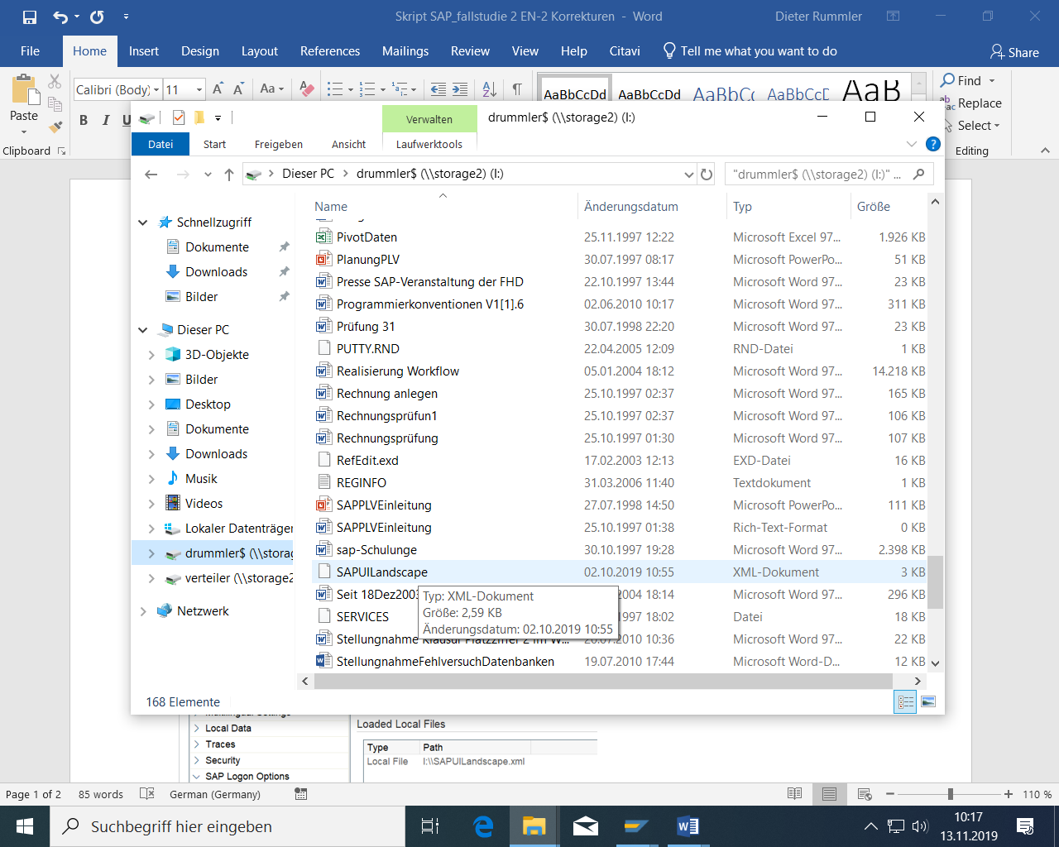

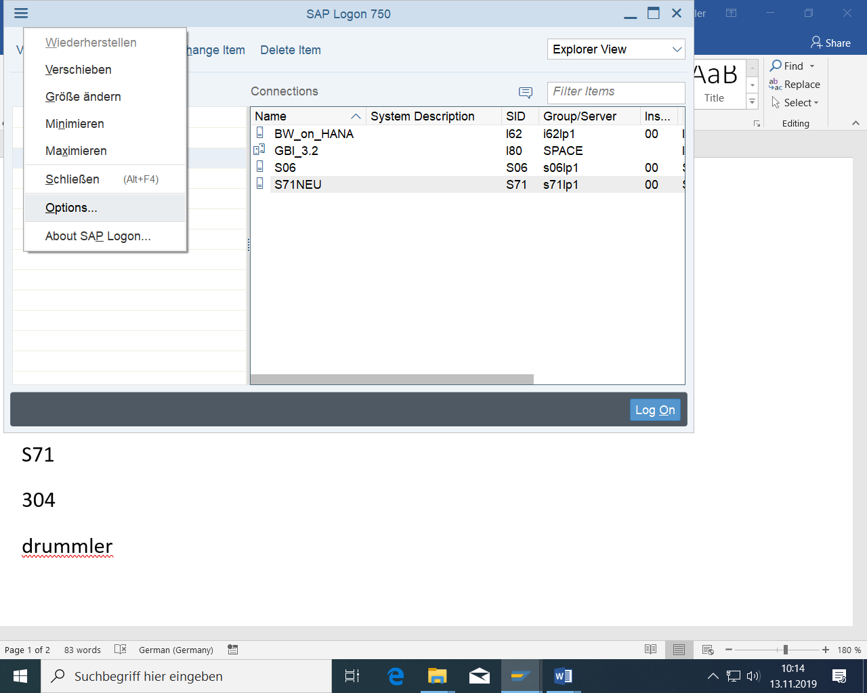

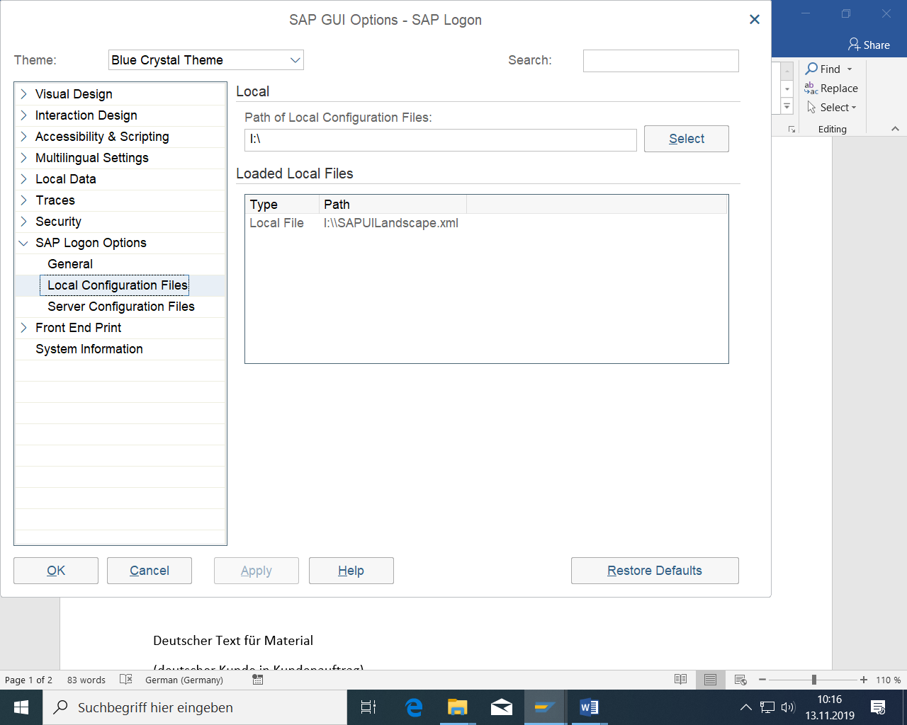

Then: Apply

## Logins

S71NEU

Client 304

User: PLVDR-000 to PLVDR-070 with restricted authorizations

drummler with all authorizations

Password: plv321

## Important transactions

SPRO Customizing (IMG)

SE11 or SE16 Content of tables and table structure

## Tipps

Sometimes you also have to leave a transaction and call it up again to make changes made to another transaction effective.

It is better to select F4 from the list than direct entry.

Use the blank key to select the previous value.

If you receive an error, search the Internet using the error number (for example, F5011).

If you can’t leave a transaction, do it with /n.

Be careful with filtering or F4:

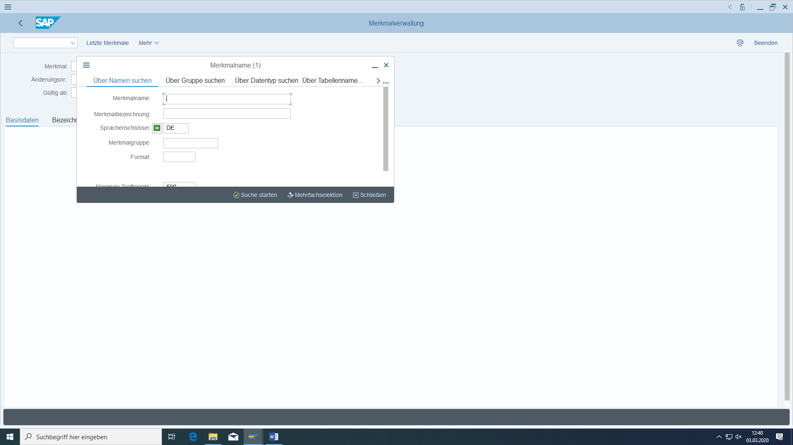

Because of preassigning (here with DE)

# Master data

## Organizational data

Client 304 S4HANA GBI Mandant

Company Code DE00 Global Bike Germany GmbH

Plant HD00 Plant Heidelberg

Sales organization DS00 Germany South

Storage location FG00 Finished Goods (at HD00)

SF00 Semi Final Goods (at HD00)

RM00 Raw Material Goods (at HD00)

Sales Organization DS00 Germany South

Distribution sales channel WH Wholesale

Division BI Bicycles

Purchasing organization DE00 GBI Germany

Controlling area EU00 GBI Europe

Cost center EUPR1000 Production costs

Work center ASSY1000 HD Assembly

Work center INSP1000 HD Inspection

Activity type Labor Labor hours

## Already existing masterdata

You can always compare or copy with my master data:

THD-992 (25037) Customer

THW-211 Vendor

DXTR-900 Bike

TRWA-900 Wheel

TRTR-902 Tire

## New Master Data in Materials Management

### Create material master

#### Basic



Figure 1: Organization of Materials Management (Source: SAP AG®)

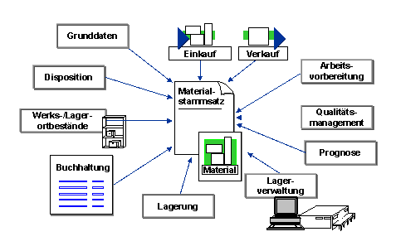

Figure 2: Structure of Material Master Data (Source SAP AG®)

#### Preconditions

#### Creating a Class in a Classification System

Already created.

**Please only go with Display in class Characteristics and Material view definition.**

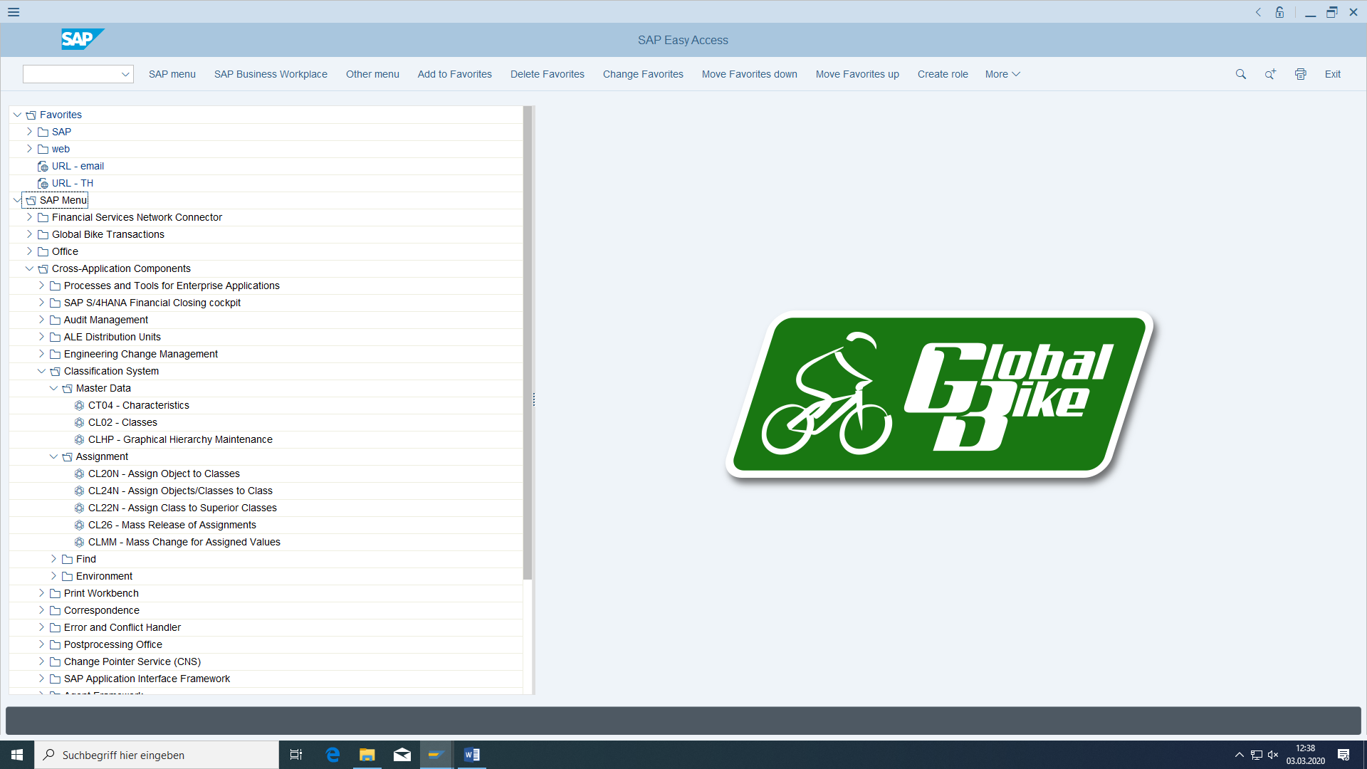

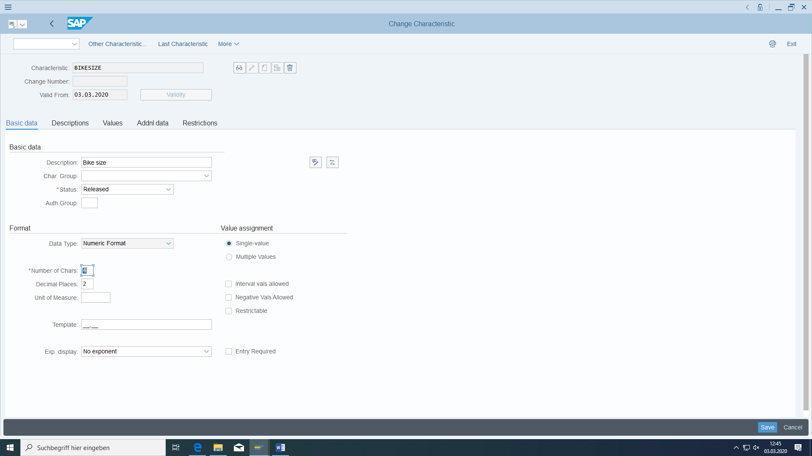

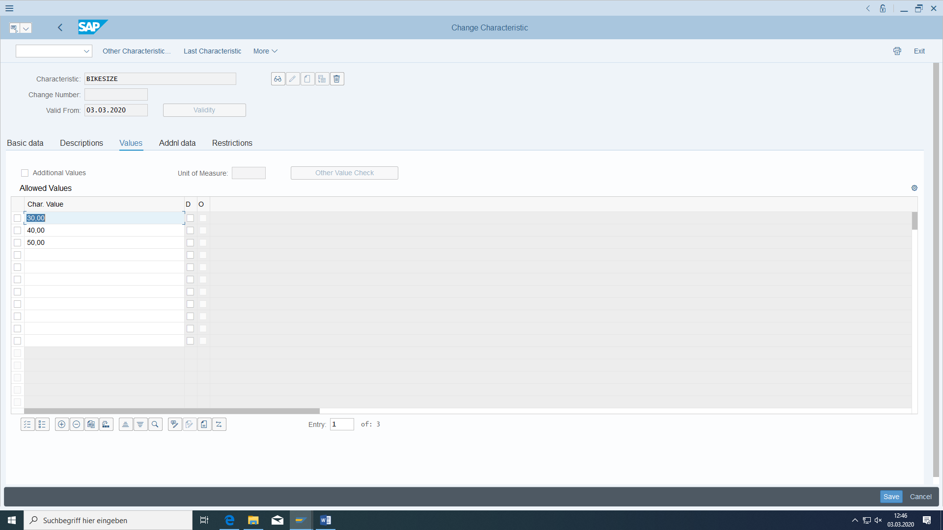

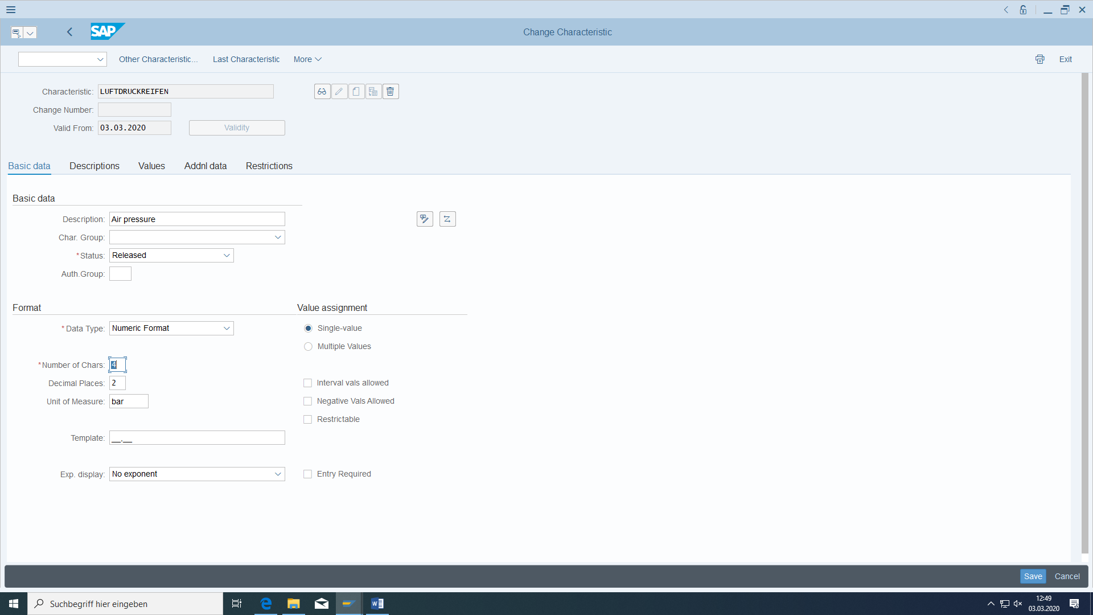

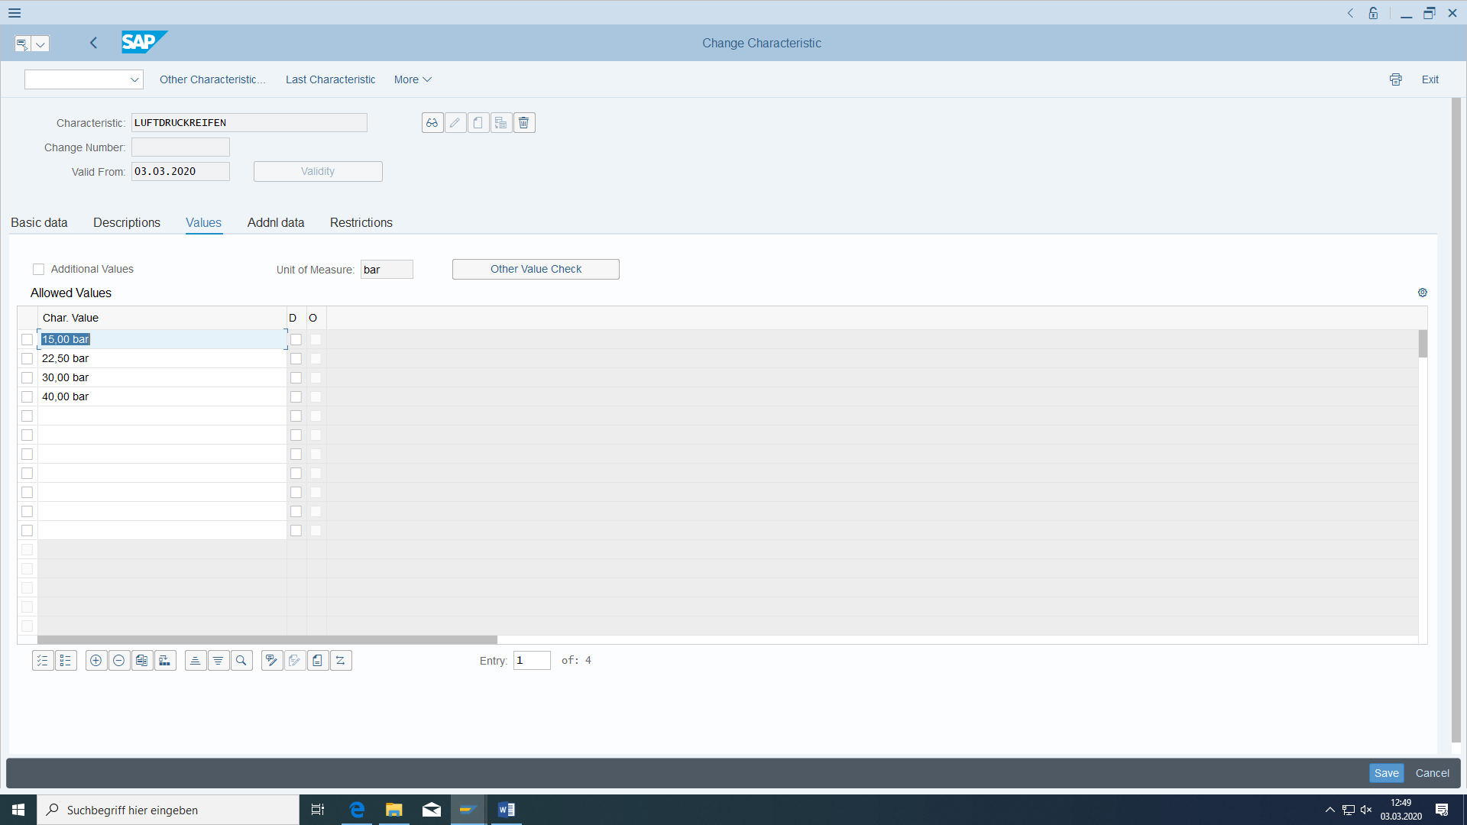

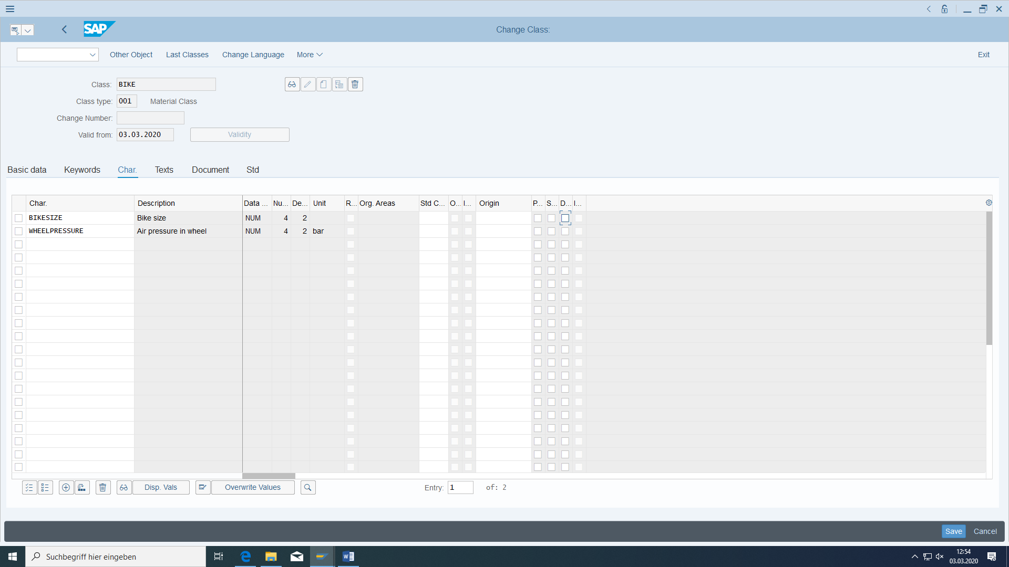

#### Make Classification view available for FERT

Already done

Include classification view in customizing for FERT:

OMS2

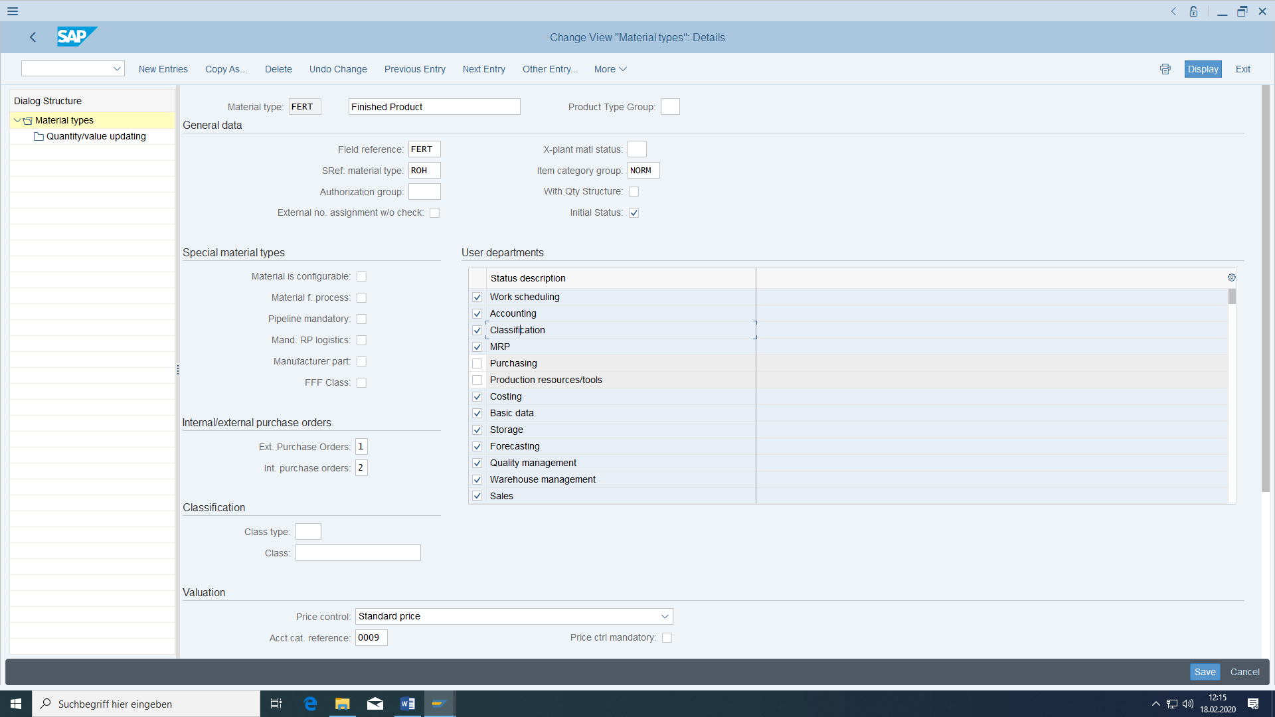

#### Task

A deluxe touring bike is to be created which is made of an aluminium wheel and this in turn is made of a tyre. The 3 material masters required for this must be created. These are required in a later exercise for bills of material to be created.

**For all materials maintain German and English text. The description in the not login language please enter later with MM02 (because you cant continue with Enter button)**

#### Required transactions

|  |  |  |
| --- | --- | --- |
| **transaction** | **menu path** | **TAC** |
| Create finished product | Logistics > Materials management > Material master > Material > Create special > Finished product | MMF1 |
| Create raw material | Logistics > Materials management > Material master > Material > Create special > Raw material | MMR1 |
| Create trading goods | Logistics > Materials management > Material master > Material > Create special > Merchandise | MMH1 |
| Copy material | Same menu path as when you create it |  |
| Display material | Logistics > Materials management > Material master > Material > Ads > Ads current status | MM03 |
| Change material | Logistics > Materials management > Material master > Material > Change > Immediately | MM02 |
| Expand Material | Same menu path as when you created it |  |
| Display change documents | Logistics > Materials management > Material master > Material > Display changes > Active changes | MM04  Or MM03 |
| Enter storage locations | Logistics > Materials management > Material master > Miscellaneous > Enter storage locations | MMSC |
| Display material list | Logistics > Materials management > Material master > Miscellaneous > Show material list | MM60 |
| Find objects in classes | Cross-Application Components > Classification > Search > Object Search in Classes | CL30N |

**Instead of MMx1, you can also use MM01** (and then define the material type)**.**

**MM01 whenever**

* **New material**
* **New view for existing material**
* **New organizational data for existing view of an existing material**

**MM02**

**Otherwise**

#### Data for this example

|  |  |  |
| --- | --- | --- |
| **fields** | **basic data** | **Description** |
| Plant | HD00 | Plant Heidelberg |
| material number | DXTR-###  TRWA-###  TRTR-### | ### Deluxe Touring Bike  ### Aluminium wheel  ### Tyres |
| storage location | FG00 | Finished Goods (at HD00) |
| sales organization | DS00 | Germany South |
| distribution channel | WH | Wholesale |

#### Creating the Material Master for the Touring Bike

Tipps:

When entering the storage location using the F4 help, make sure that you do not select a storage location in the wrong plant (the same storage location number also exists in other plants).

**If you always confirm all input screens with Enter, the system automatically switches to the next selected view.**

**Confirming the selected views with Enter is particularly important during copying, since only views that have been processed are created.**

Enter "DXTR-###" as the material number for the finished product and select mechanical engineering (matchcode) as the industry sector. No reference material is to be used; the data is entered completely manually. Confirm with 'Enter' or click on .

The system offers you a selection of the views to be created. Select the Basic Data (1 and 2), all 3 Sales Views, all 4 MRP Views, Work Scheduling and Costing (1 and 2) views by clicking on the small square in front of each line. Continue with 'Enter'.

In the next step, the system must be informed of the organizational units for which the new material is to be created:

Plant: HD00 Plant Heidelberg

Storage location: FG00 (**at HD00 plant**) Finished Goods

Sales Org: DS00 Germany South

Sales channel: WH (**in Salesorg DS00**) Wholesale

(storage type: 002 Pallet storage)

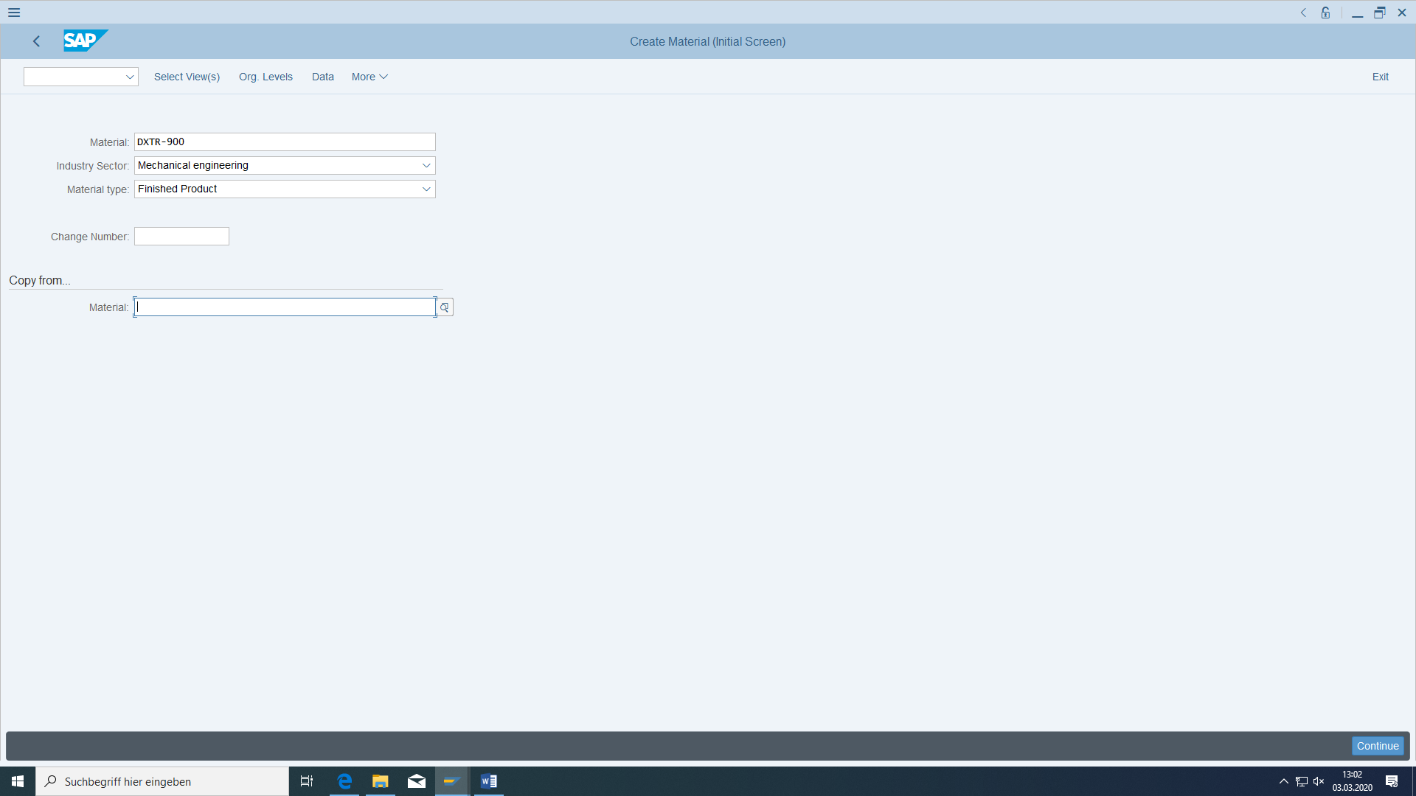

The MRP profile field does not need to be filled. Continue with 'Enter'.

In the 'Basic data 1' view, the short name is '### Deluxe touring bike'. To be able to switch to the next view, all required fields must first be filled.

Enter also an article name: '### Deluxe Touringbike'. English and German. **The description in the not login language please enter later with MM02 (because you cant continue with Enter button)**

In the 'Basic data 1' view, this is the 'Base unit of measure' field (very important field!!!). This should be 'Each' (look carefully not only in the top).

The material should belong to the division 'Bicycles'. To do this, use the matchcode (alternatively 'F4') in the respective field.

By pressing the 'Enter' key, you automatically jump to the next view that you have selected above.

Plant Heidelberg is to be specified as the delivering plant in the 'Sales: sales org. 1' view. Furthermore, the material is **fully** taxable.

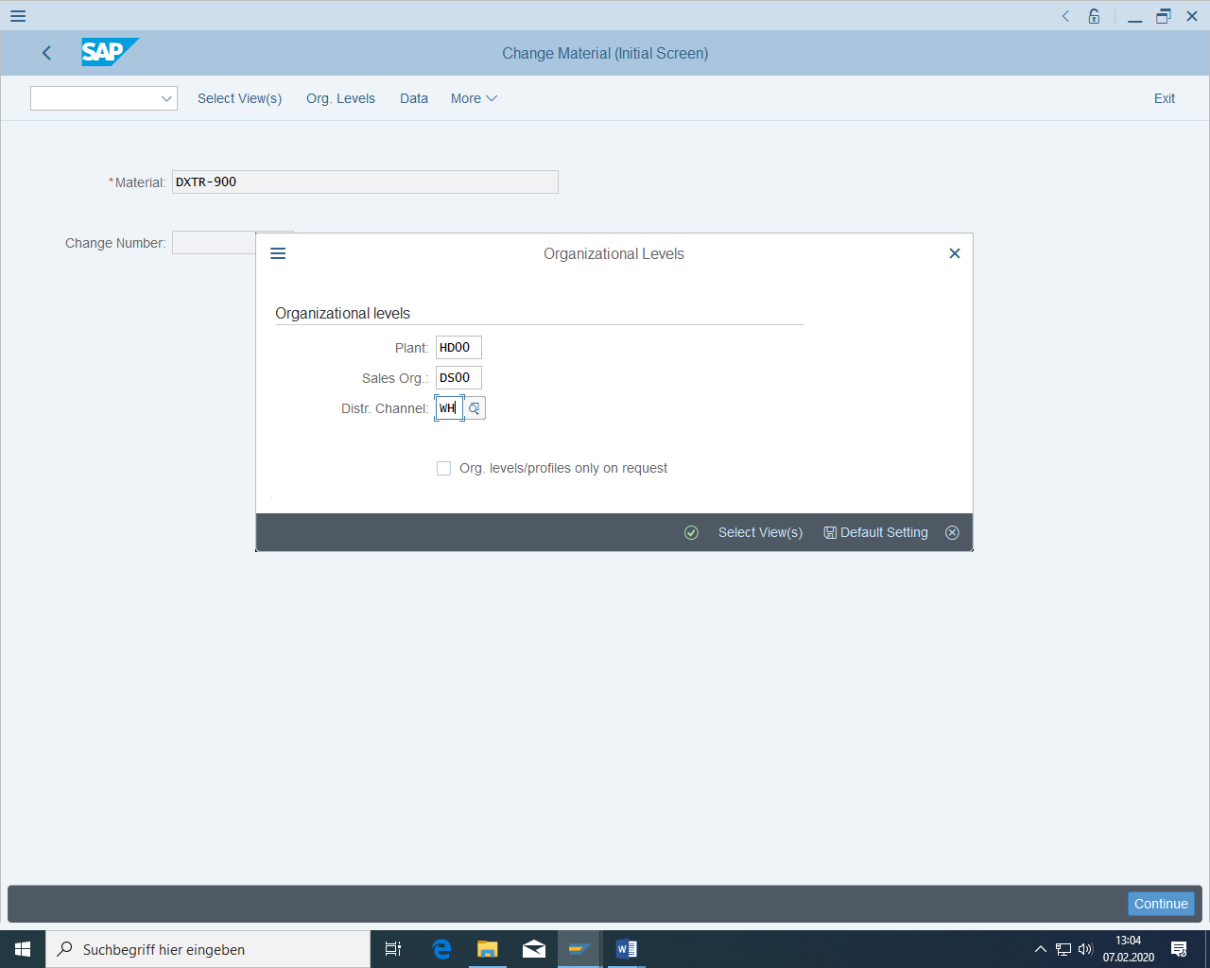

Delivering plant:

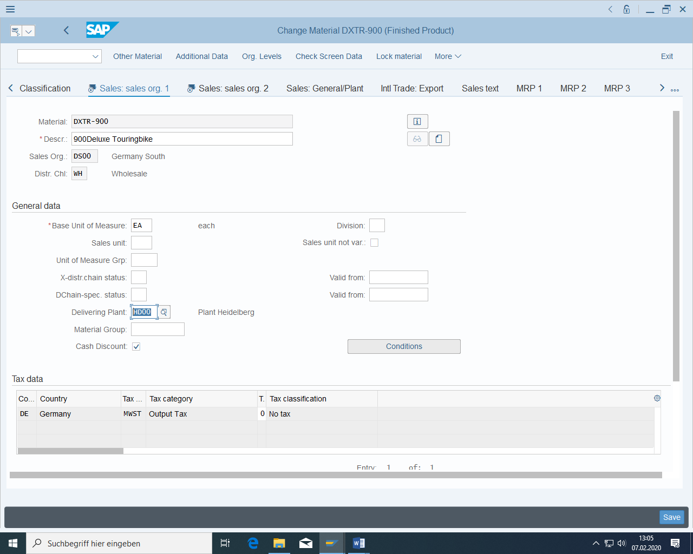

Now switch (2 times 'Enter' key) to the view 'Sales: general/Plant'. The individual requirements should always be checked with regard to the stock, the loading group should be manual:

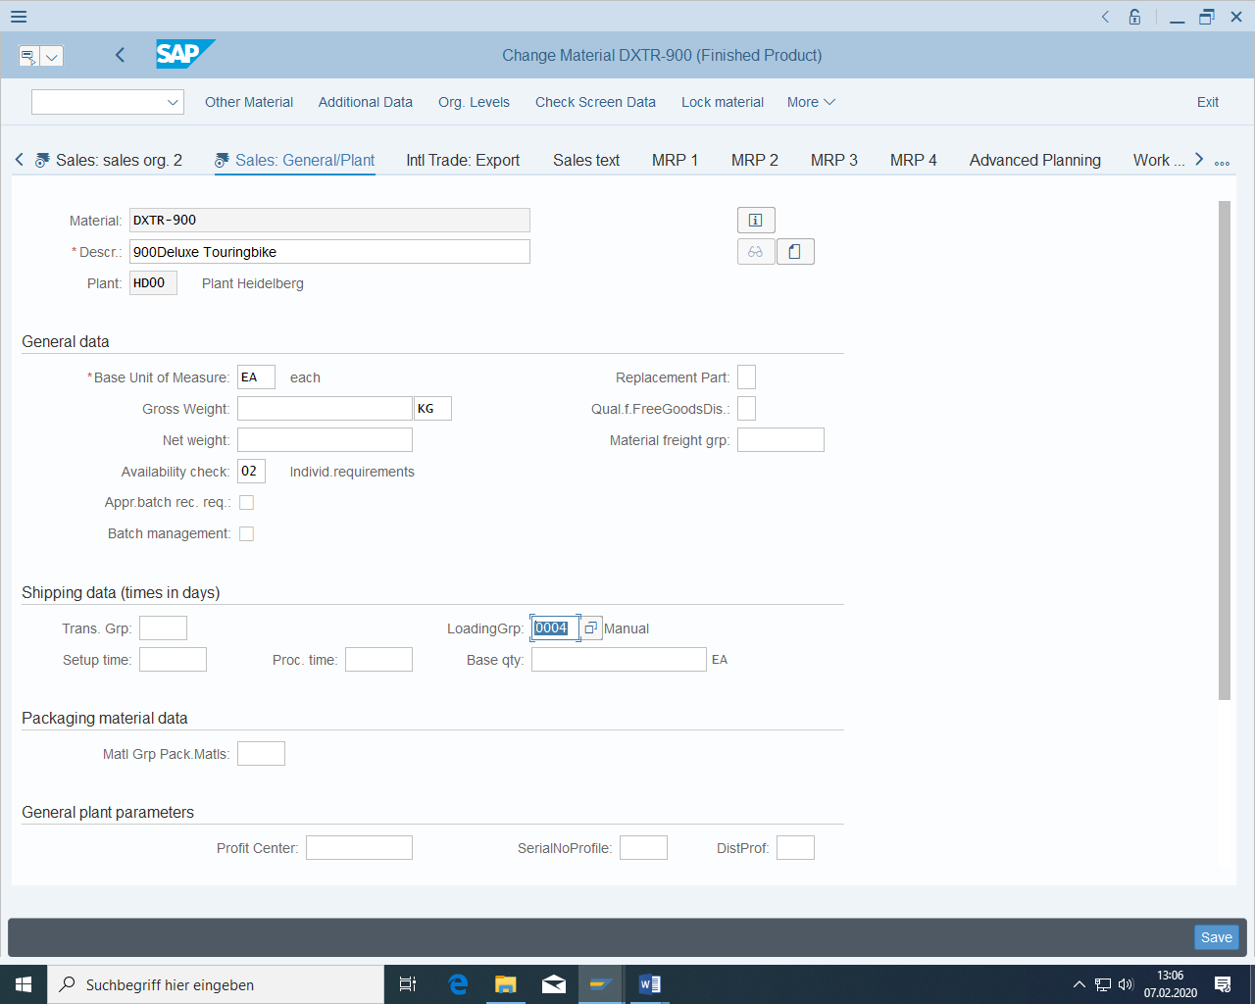

It is transported on pallets and loaded manual.

Continue with 'MRP 1': MRP type PD is to be entered as the MRP type; the MRP controller is the MRP controller. The size of the Dispolot should be **exact.**

In the view 'MRP 2', enter 'in-house production' as the procurement type; the scheduling margin key is 001 and the in-house production time is 4 days.

In the 'MRP 3' view, you must define a total replenishment lead time of 5 days. The planned independent requirements are to be consumed with the final assembly, that is, planned independent requirements are consumed with sales order independent requirements. Therefore, choose **Planning with Final Assembly (look carefully via Strategy group)**. The consumption of planned independent requirements with sales order independent requirements should take place backwards and forwards with 20 days in each case.

The 'MRP view 4' is skipped.

In the Plant Scheduling view, you must specify the production storage location as the end product storage location. The production supervisor is the Production Scheduler. The production scheduling profile is 10.

In the view Cost estimate 1, set the flag "Material origin" and "With Quantity structure".

Calculation 2 is skipped.

Then save the new material.

**If you left the material before entering all views please always save data and enter the material again with MM01.**

**If you left the material before entering the correct organizational level of a view please always save data and enter the material again with MM01.**

**If you left the material before entering all data for a view in an organization level please always save data and enter the material again with MM02.**

Be sure that you have these sales data for sales organisation DS00 and warehouse sales:

Loading group:

The system confirms that the material was created.

#### Classification of the material

Classify the material in the corresponding new view with the type **Material class** and the class **Bicycle** (language English) and release this classification with item 10. You then enter the characteristic values below:

Size 40 cm

Air pressure 30 bar

**You can store the data even there are red frames.**

Search for materials:

After saving the material, search for this material in MM03 by going to the corresponding search help and filtering for all materials whose air pressure is 30 bar.

Search the class system:

You can also search for objects with characteristic values in the Classification System:

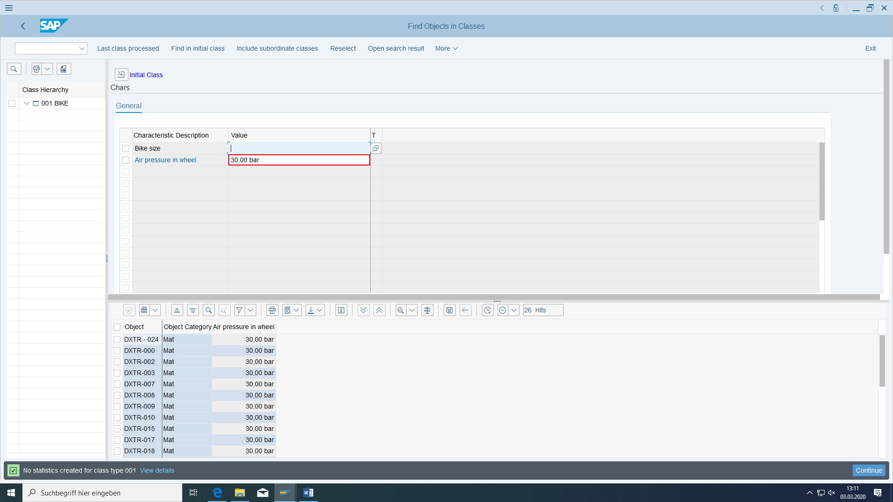

After executing you can see the materials being found.

You can use characteristic values also to configure the variants of materials from super BOMs and super routings.

#### Assign Document

The following has already been carried out in Customizing

Because the customizing data are cross-client the allowance has to be given via SM30 for T000 in 304:

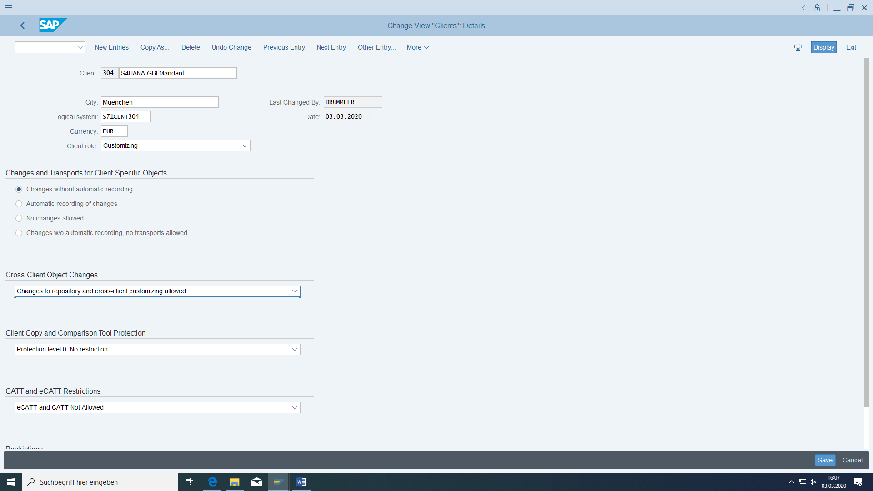

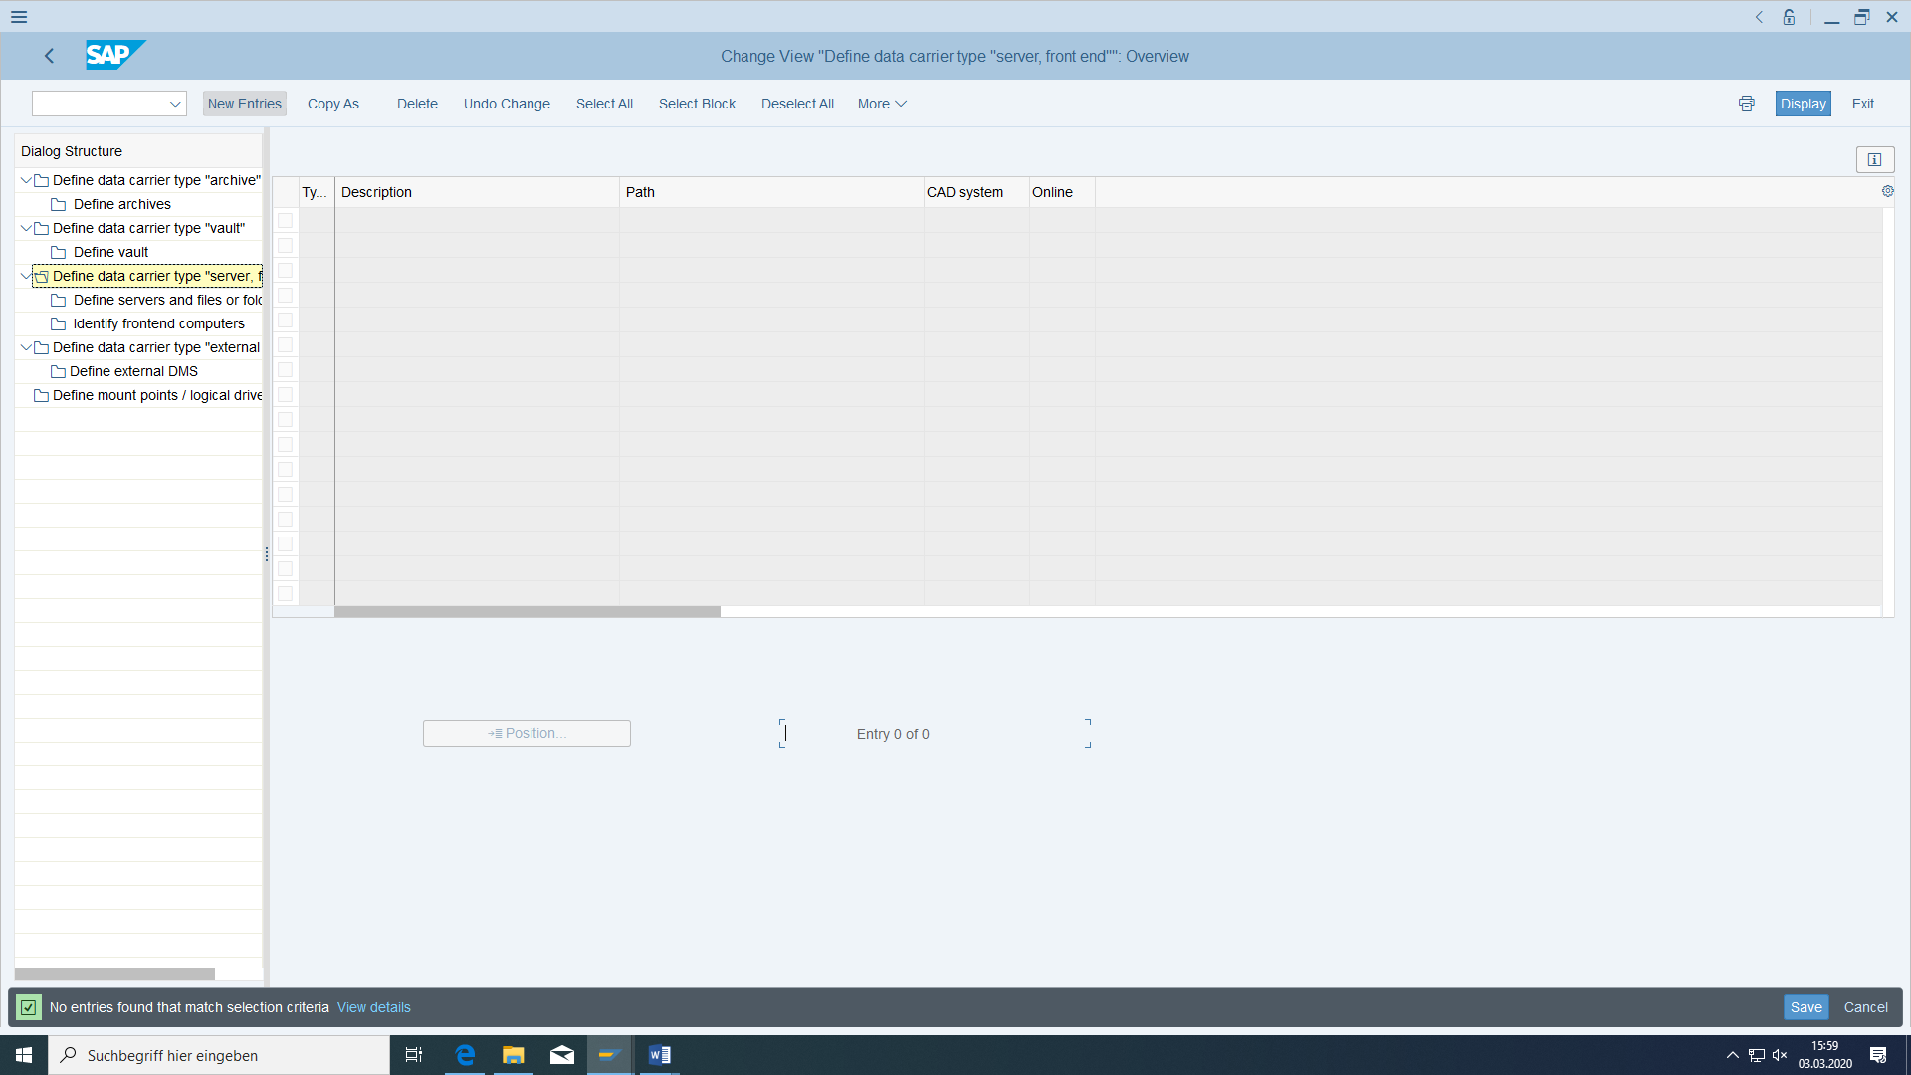

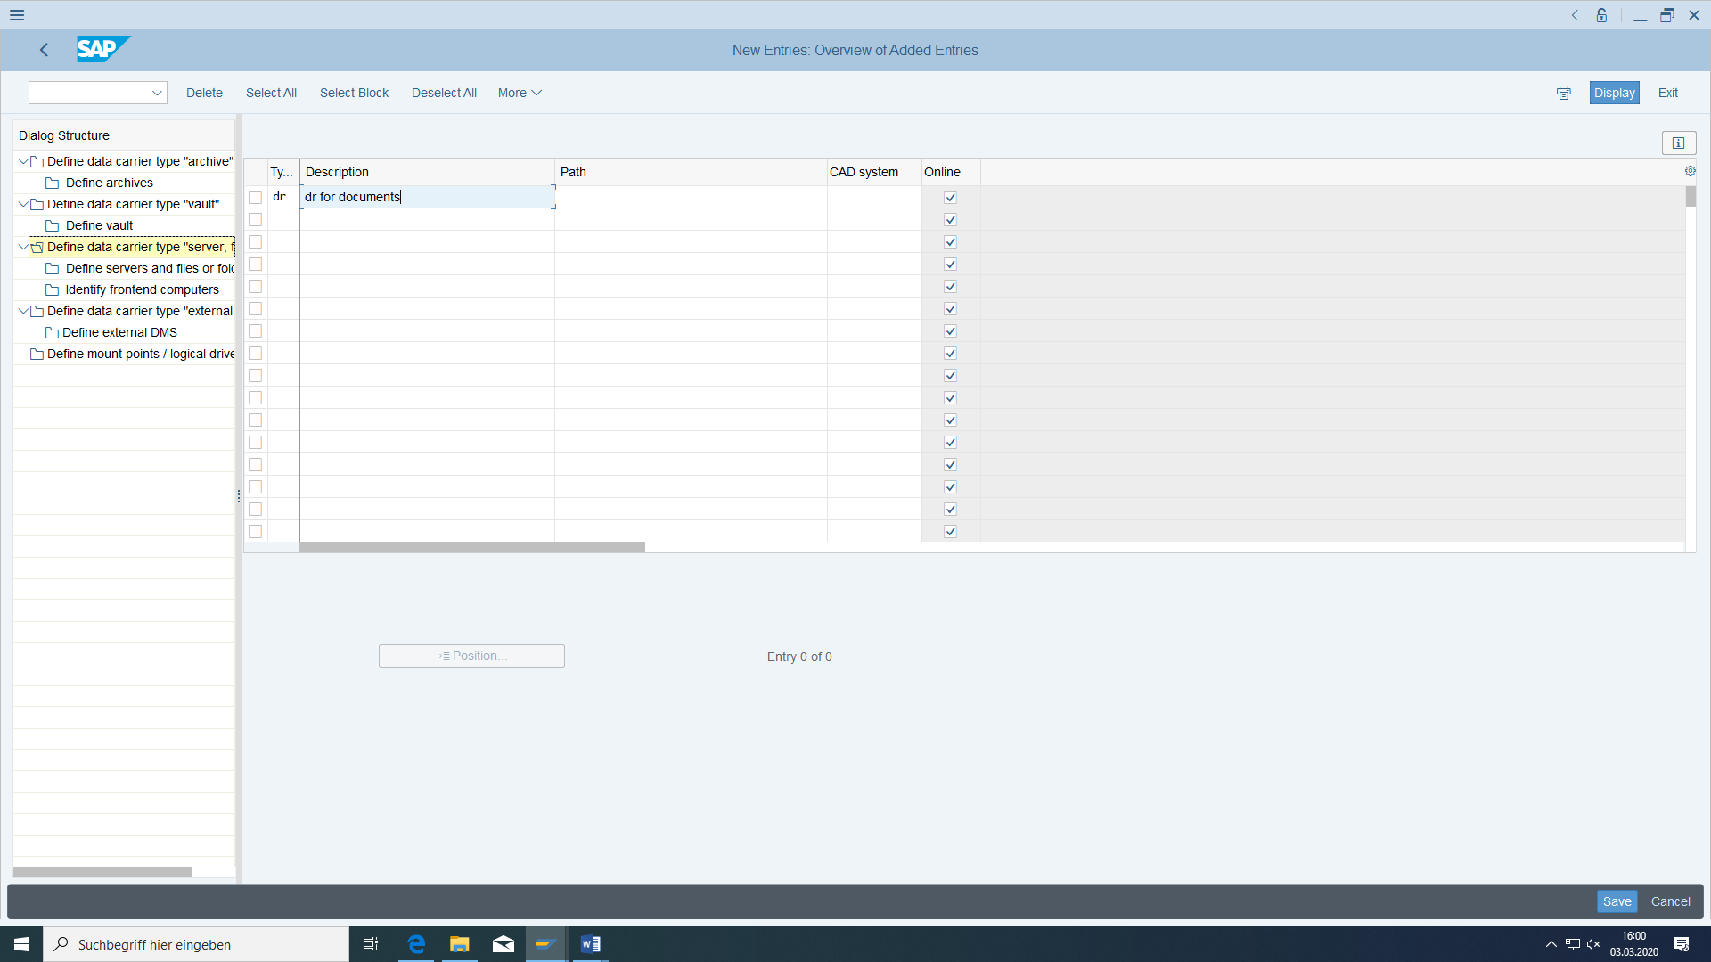

After selecting this entry:

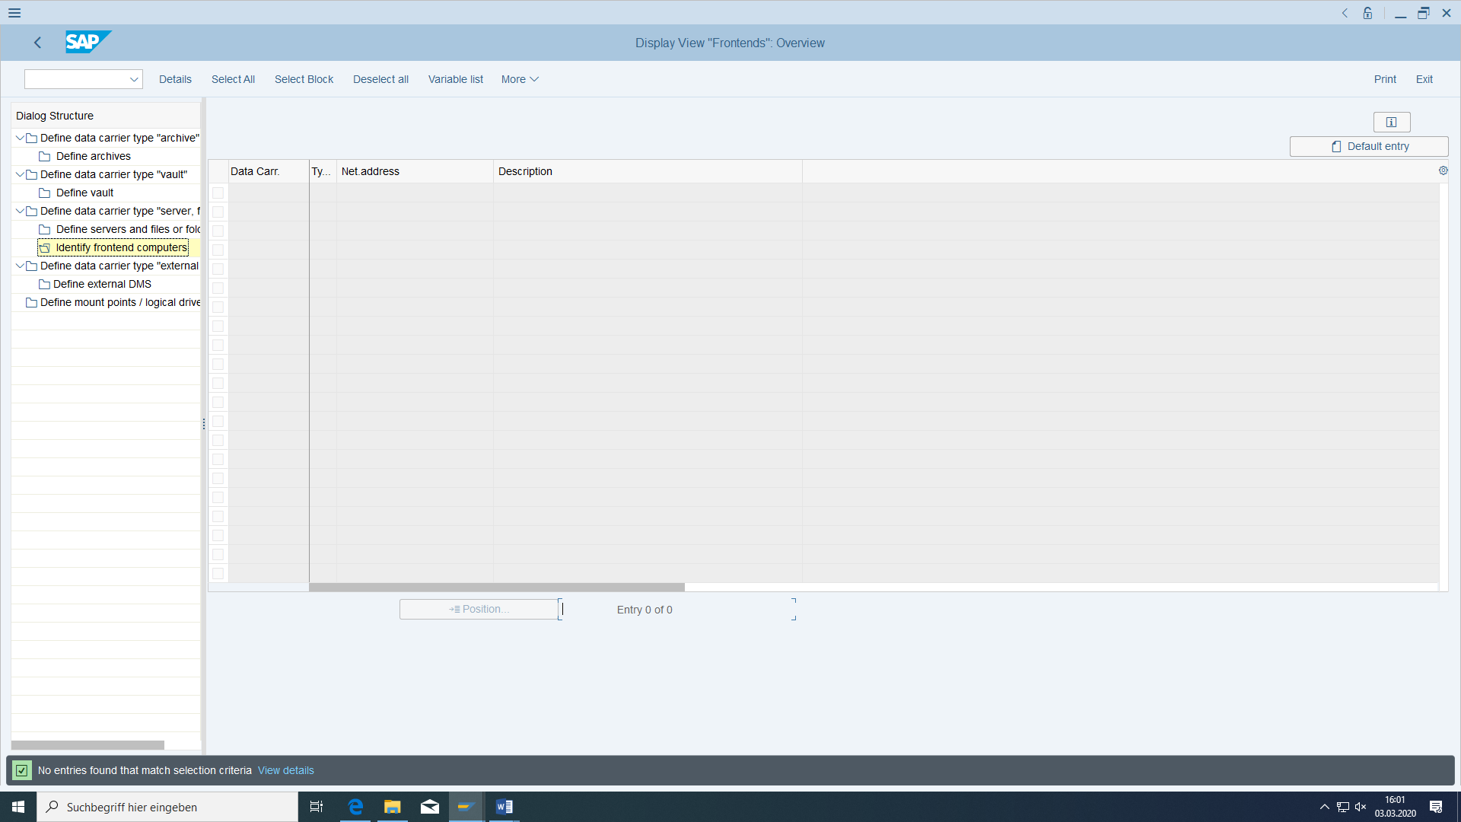

After Click on Default entry:

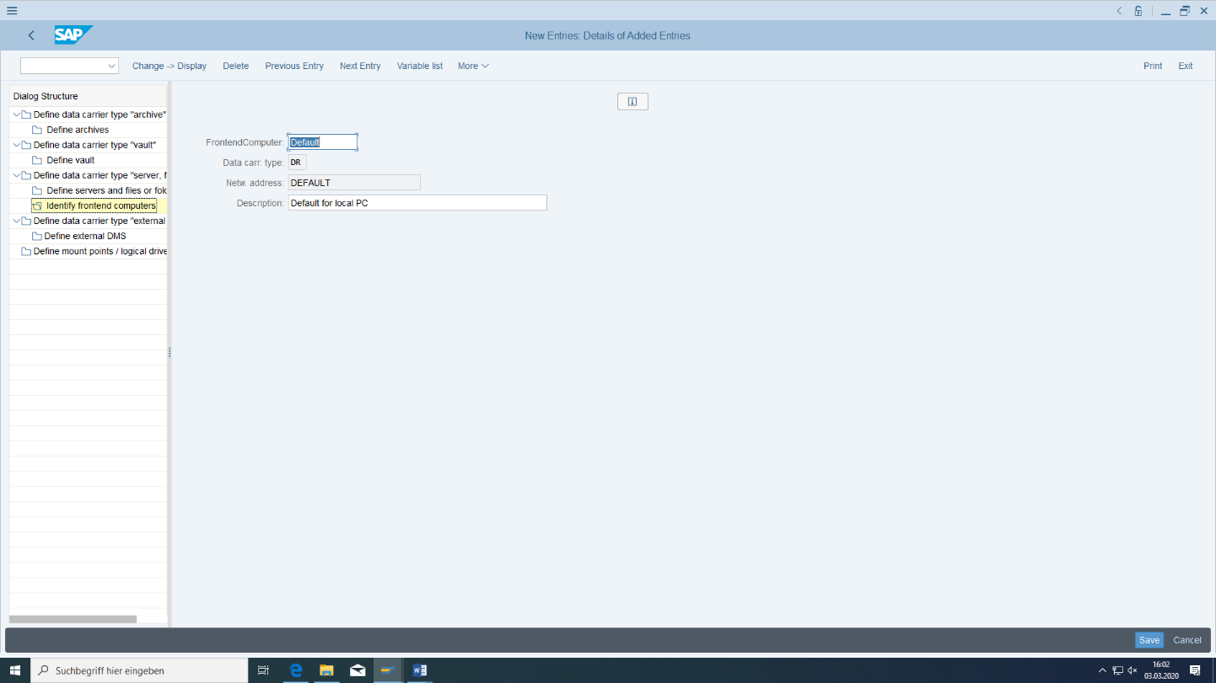

First, create a test document with the name ZNG-###, which refers to a stored file on your computer:

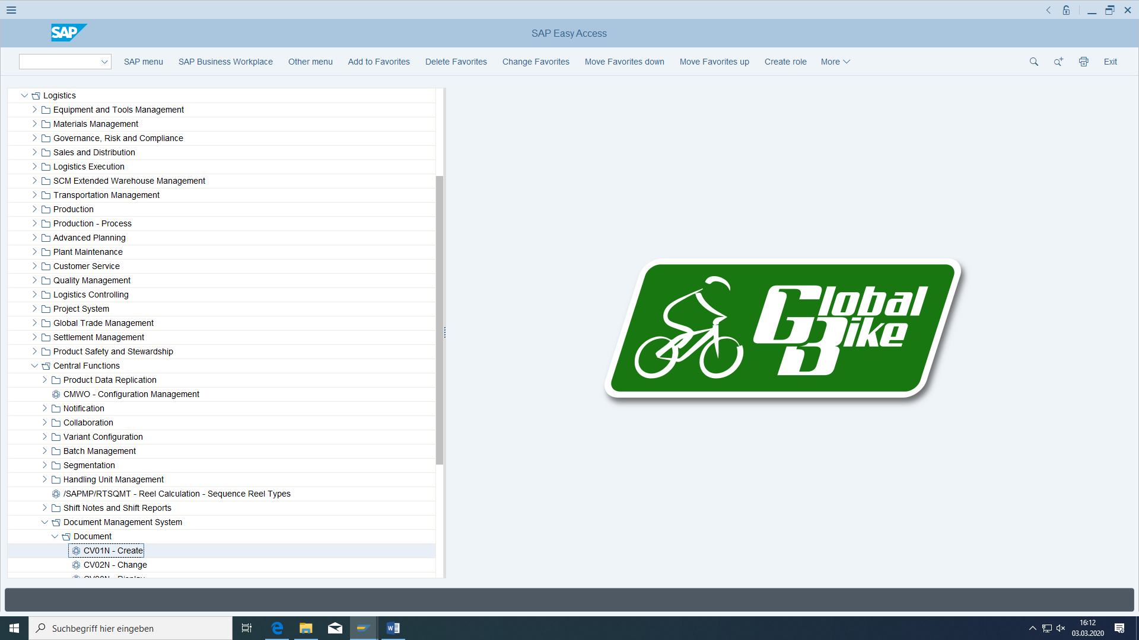

Maintain description and status:

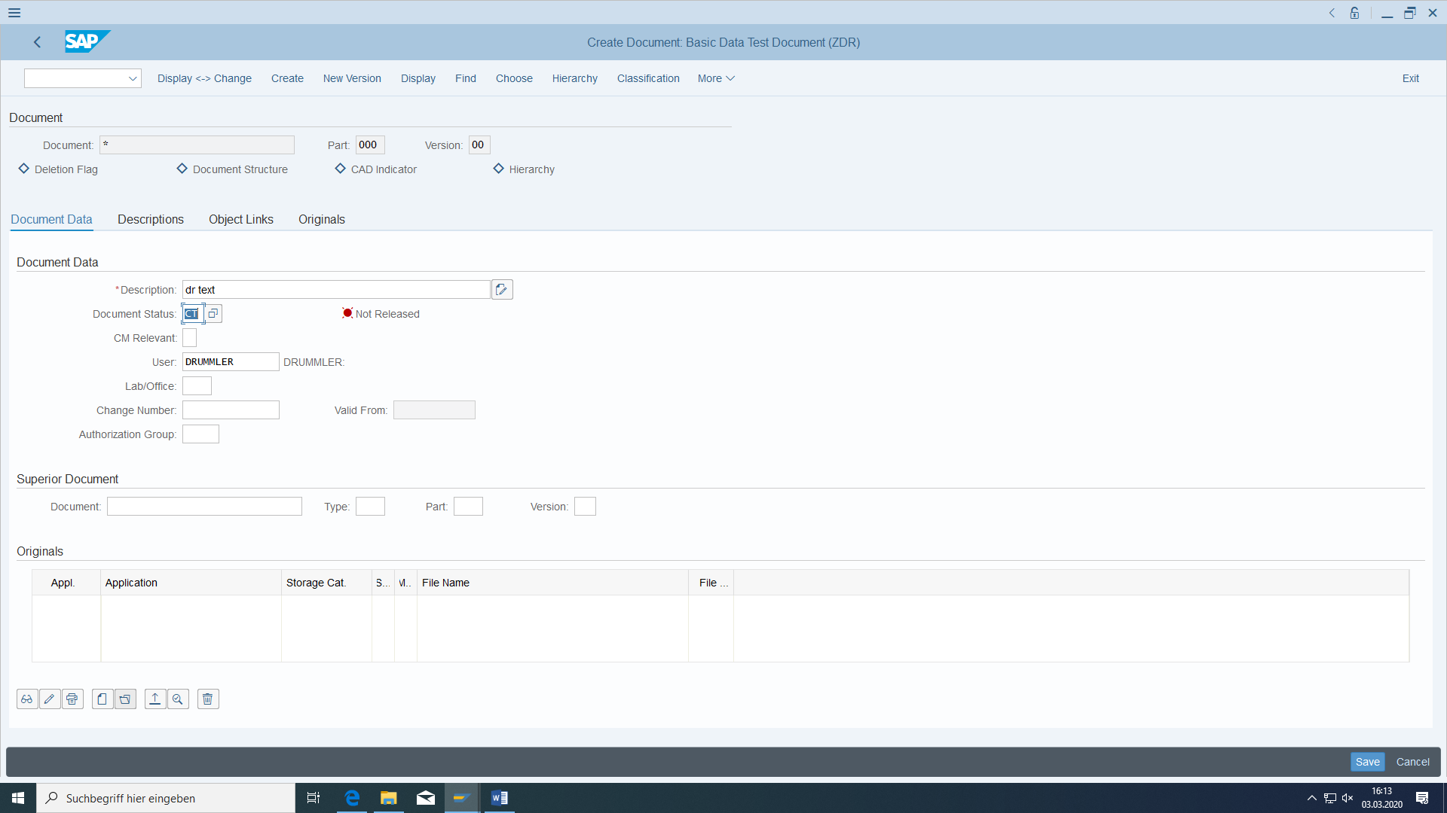

Open Original x.txt from your PC:

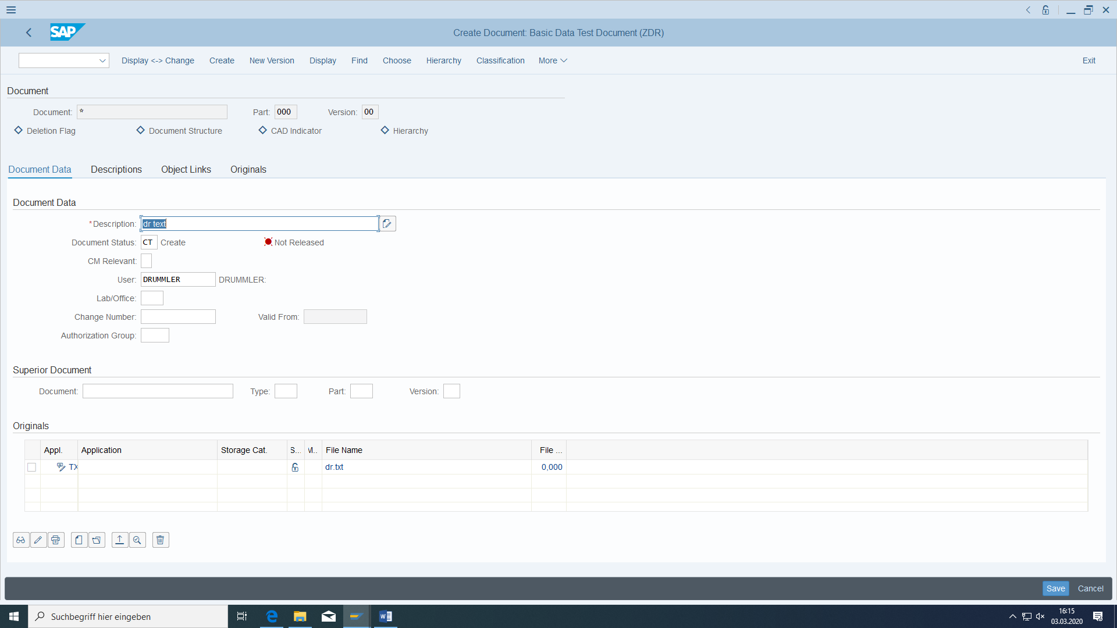

Add this document to the material. Document type ZDR (using ADDITIONAL DATA in the basic data view) and display it:

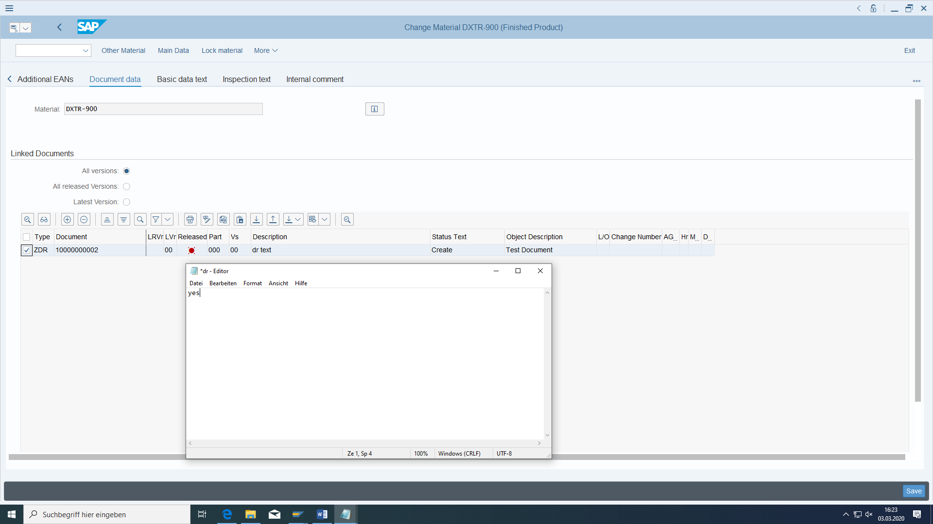

Save.

#### Creating the material master for the aluminium wheel

Go to the material master again and choose the Create **Semi finished Product** transaction this time.

The number should be 'TRWA-### ', where ### should again be replaced by year/login number. The industry sector here is also mechanical engineering.

The views to be selected are basic data (1 and 2), purchasing, MRP (1 to 3), Work scheduling, accounting 1 and 2, and costing 1 and 2.

The material short text (English and German) is '### Aluminium wheel', base unit of measure is 'each'.

Produced in Heidelberg

Stored in Semi Final Goods in Heidelberg

Bicycles division

Material group Wheel

Weight 2695 grams (gross and net)

Scheduled dispatching through HD MRP controller and exact lot size

In-house production in three days

Planning time fence 001

Monthly period indicator

Check individual requirements

Production scheduler is the Production Scheduler.

Shop Floor Control profile 10

Standard price 113

Cost Estimate with With Quantity Structure and Material Origin

After saving, the system confirms that the new master record has been successfully created.

#### Creating the Material Master for the Tire by Copying

You must create a material of the type **raw material** for the mechanical engineering industry with the number 'TRTR-###'.

This time you are Planting with a reference material 'TRTR-902'. Confirm with 'Enter'.

The views to be selected are basic data (1 and 2), purchasing, materials planning (1 to 4), accounting 1 and costing 1.

**In the following window 'Organizational Levels', enter the plant Heidelberg and its storage location Raw Material in the template fields.**

In this way, you can also copy the same data for an existing view of an organizational unit but for another organizational unit of the same view within the same material.

Please replace the name of the material - initially copied from the template - in the 'Basic data 1' view with '### Tyres'. In english and german. The base unit of measure is grams.

In the following, please go through the previously selected views (repeated pressing of the 'Enter' key) in order to look at the values to be copied.

In the MRP 1 view, replace the MRP type with 'MRP-controlled planning' (PD). An **exact** lot size is to be calculated. The entries for reorder point and fixed lot size that were initially copied are now superfluous and can therefore be deleted.

Click through the remaining views to be copied

For the accounting view enter with valuation class 3000, moving price 10€ and standard price 10€.

Finally choose 'Save'.

### Extending the Material Master for the Deluxe Touring Bike

#### Accounting view

The accounting data for the bike to be purchased were now submitted later. Please update them for movement HD00:

The material is to be standard price-controlled. The provisional standard price shall be 1400.

#### Copying Material Master Views to Another Plant

Copy your material now for the Dallas Finished Goods Dallas plant.

This time, however, distribution will take place via wholesalers from US West.

You define San Diego as the delivering plant.

It always has to be fully taxed.

Create the same views (including accounting) as in the Heidelberg plant. (**Attention: Run through all views with Enter!** )

### Changing the Material Master

When changes are made, you can specify whether they are to be valid immediately or at a later date. Change the future price for your material to 1580 € from the first day of next year.

### Creating Material for Additional Storage Locations

Your material is to be stored at the Heidelberg plant at additional storage locations. You also enter data using collective entry:

Storage location: Other

Storage location: Returns

### Display change documents

Let us show your price change:

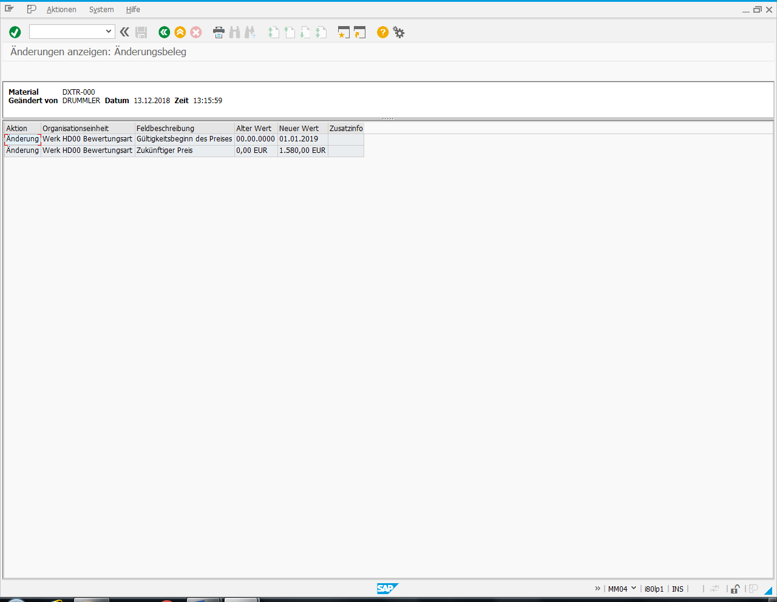

### Display material list

Check whether your material is available in both plants.

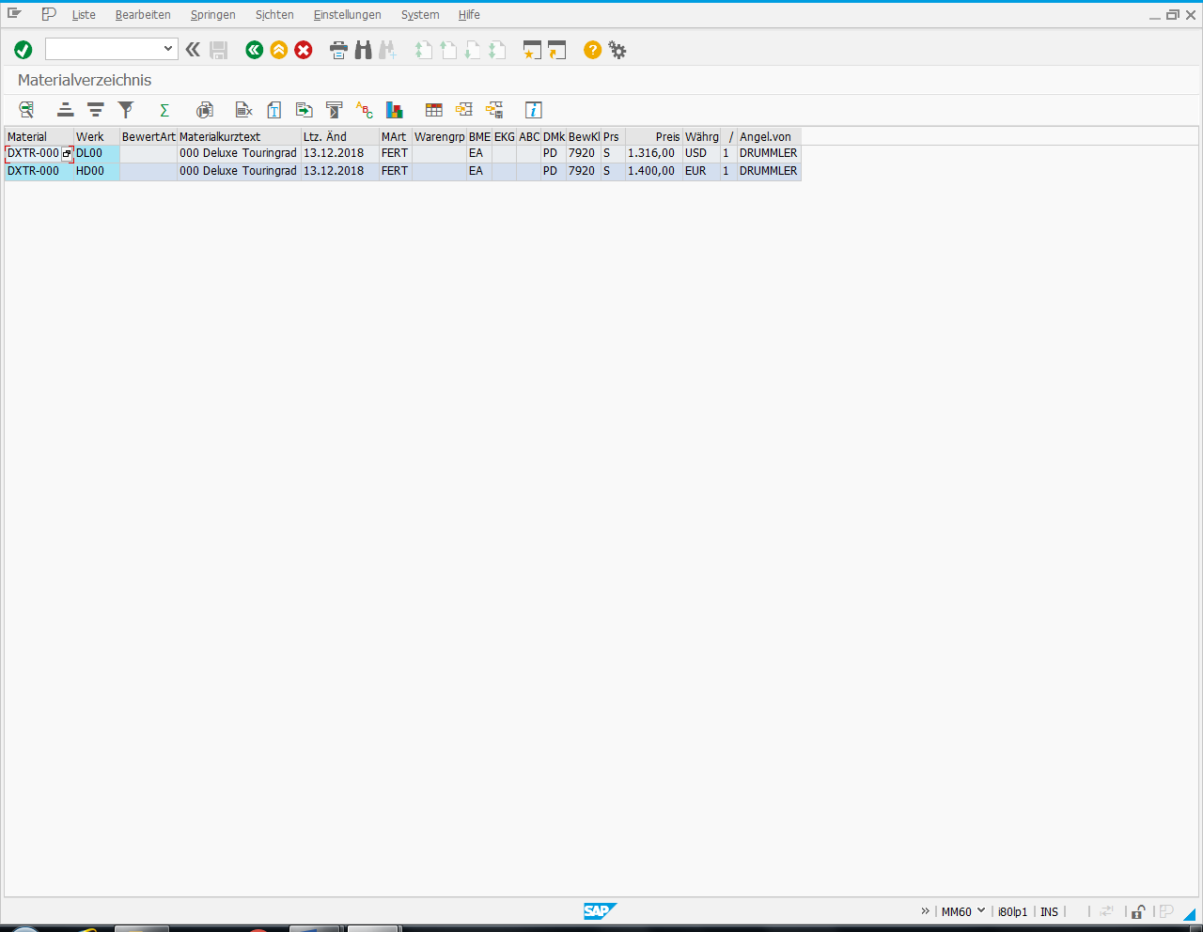

## Master data for sales and distribution



Figure 3: Sales organization

### Customer master data

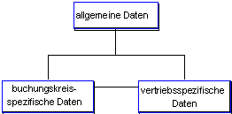

Figure 4: Structure of the customer base (source SAP AG®)

#### Basic

#### Preconditions

None

#### Task

A customer master record and roles are to be created for a customer who will order a larger quantity of the bicycle at a later date.

#### Required transactions

|  |  |  |
| --- | --- | --- |
| **transaction** | **menu path** | **TAC** |
| Create customer master record | Logistics > Sales > Master data > Business partners > Customer > Create > Total | XD01  New:  **BP** |

#### Data for this example

|  |  |  |
| --- | --- | --- |
| **fields** | **basic data** | **Description** |
| company code | DE00 | Global Bike Germany |
| sales organization | DS00 | Germany South |
| distribution channel | WH | wholesale |
| division | BI | bicycles |

#### Create a customer master record

All Busines Partners have general data and many roles. We need BusinessPartnerGeneral, Customer and FI Customer.

Choose the transaction "Create customer master record". Then select the accounting group 'Sold-to party' - this also determines the input type for the customer number (here: manual). The new customer to be created should have the name 'THD-###', where the character string '###' stands for year/login number.

You must maintain general data, sales area data, and company code data.

Shipping condition is standard.

The Sales and Distribution Data you find at **Customer** with right mouse click.

On the 'Address' tab page, you maintain all required fields with any data.

The sales tax identification number is 'DE123456789'.

It will be charged in Euro.

This is an A material customer.

Deliveries for this customer should be made by Heidelberg as standard and not high.

It is delivered free on board from the inland port of Heidelberg.

Payment must be made immediately without deduction.

Domestic revenues are recognized.

The customer is fully taxable.

And output tax:

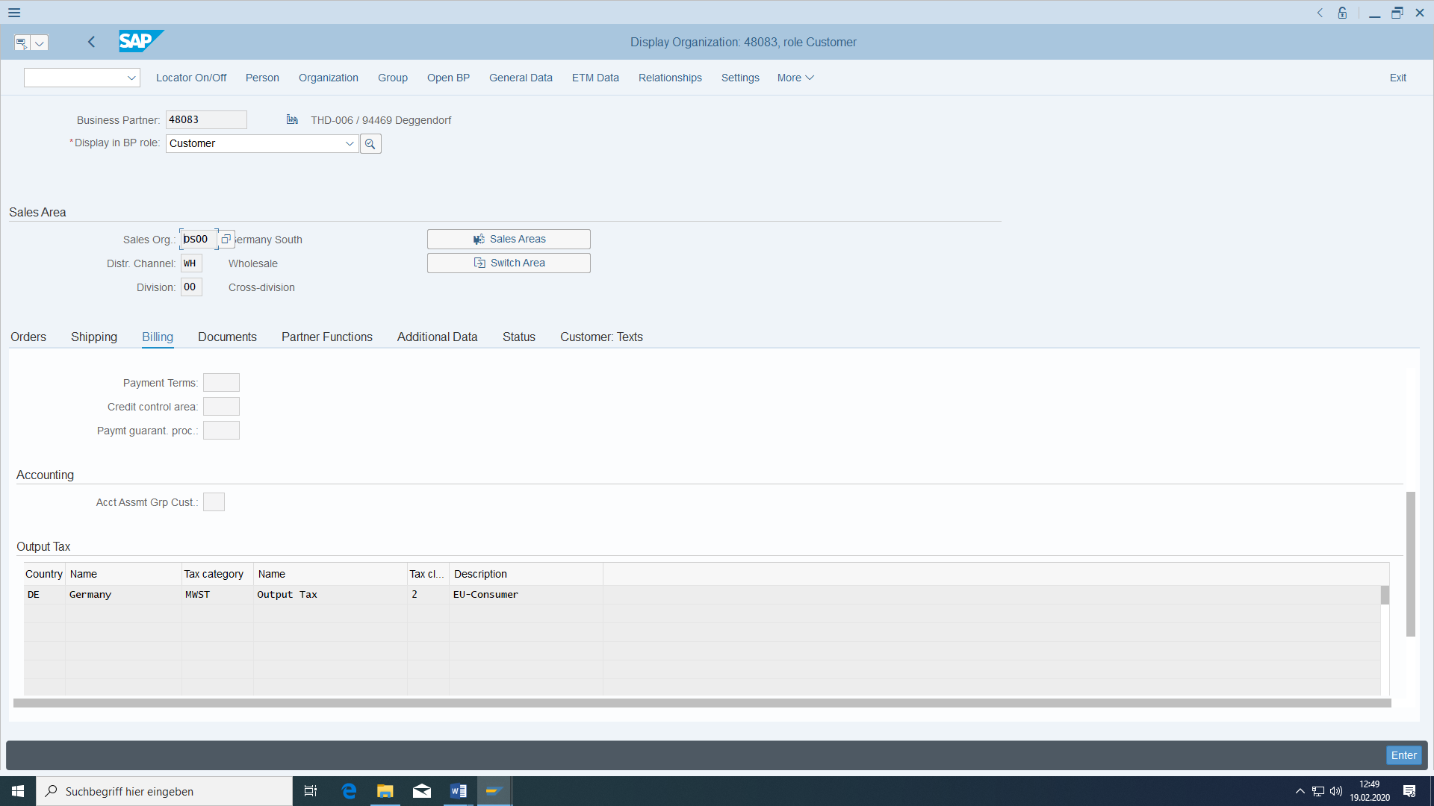

In the FI Customer you have to specify CompanyCode DE00 and for this the Reconciliation Account is “Trade Account receivables”.

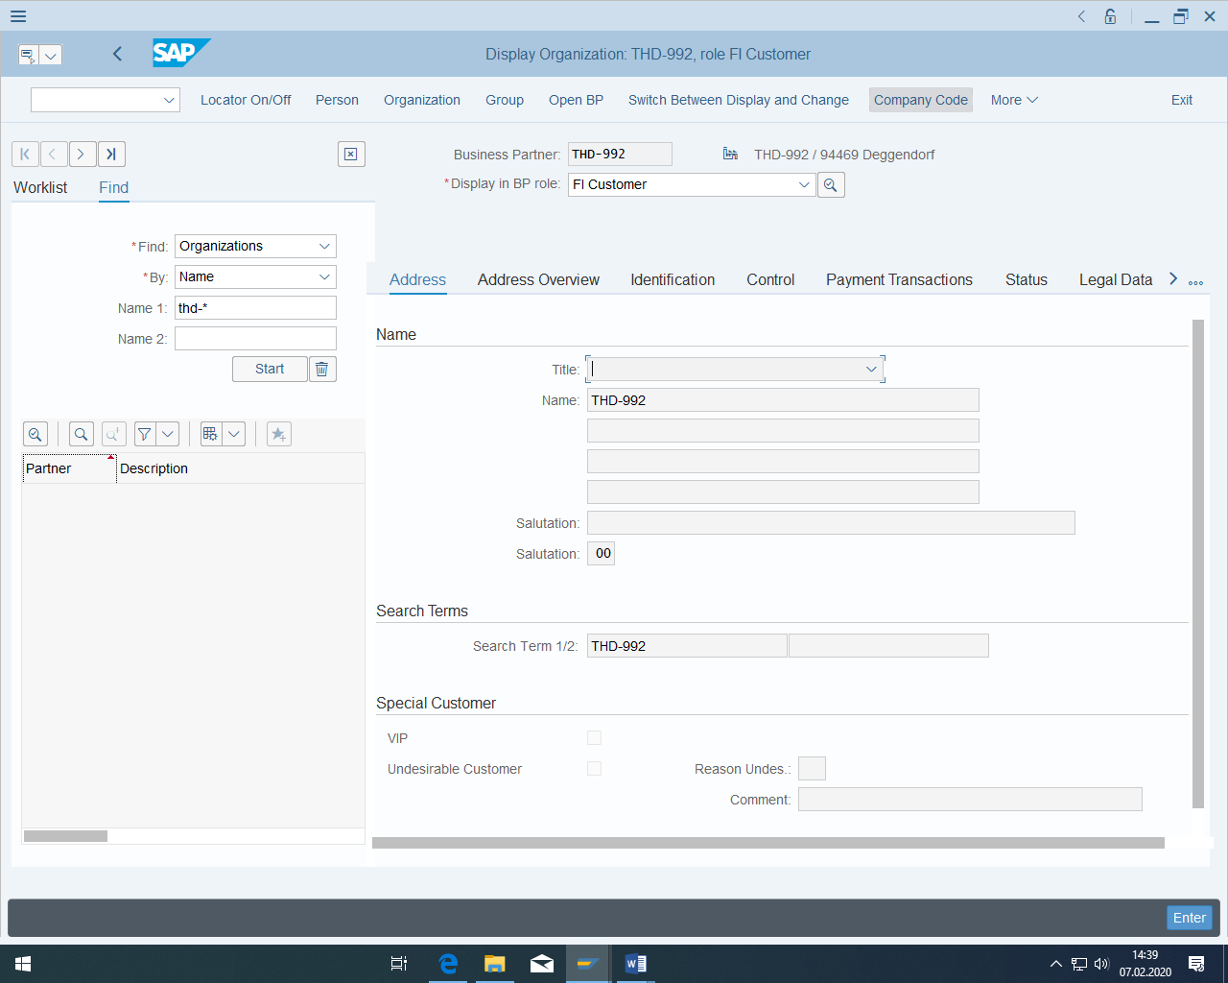

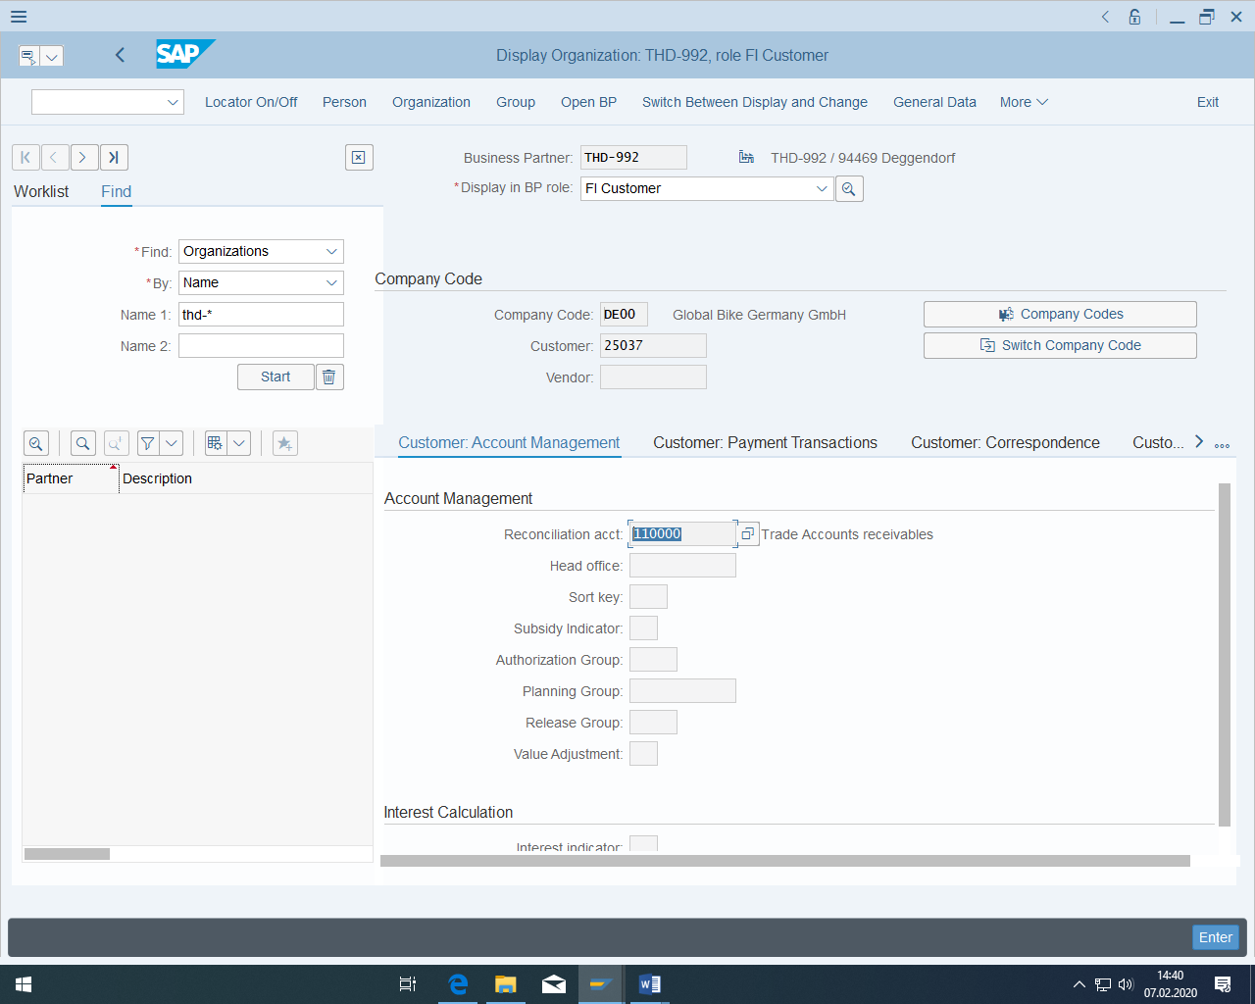

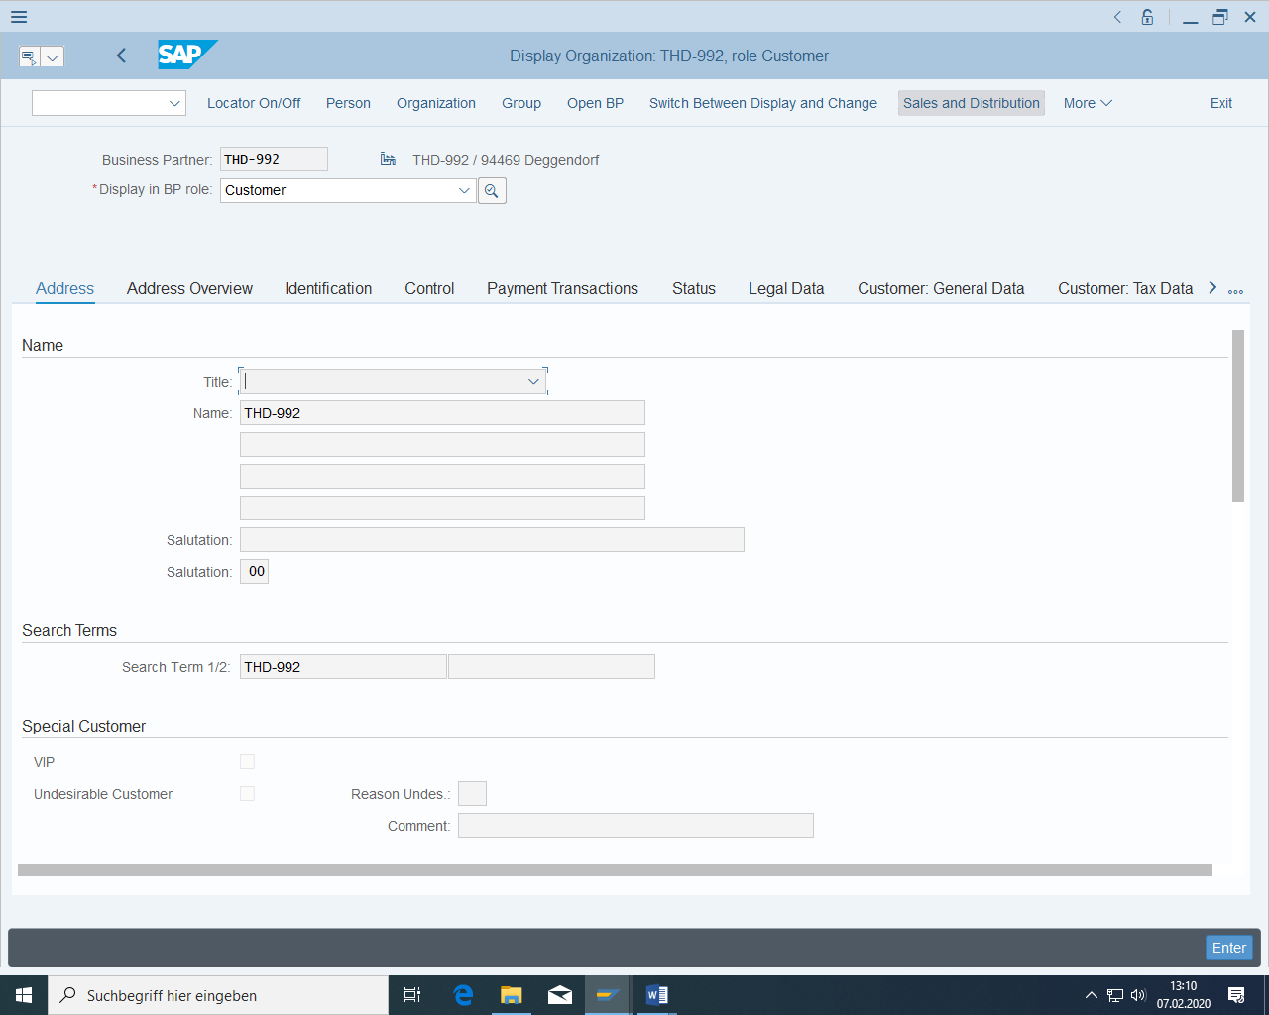

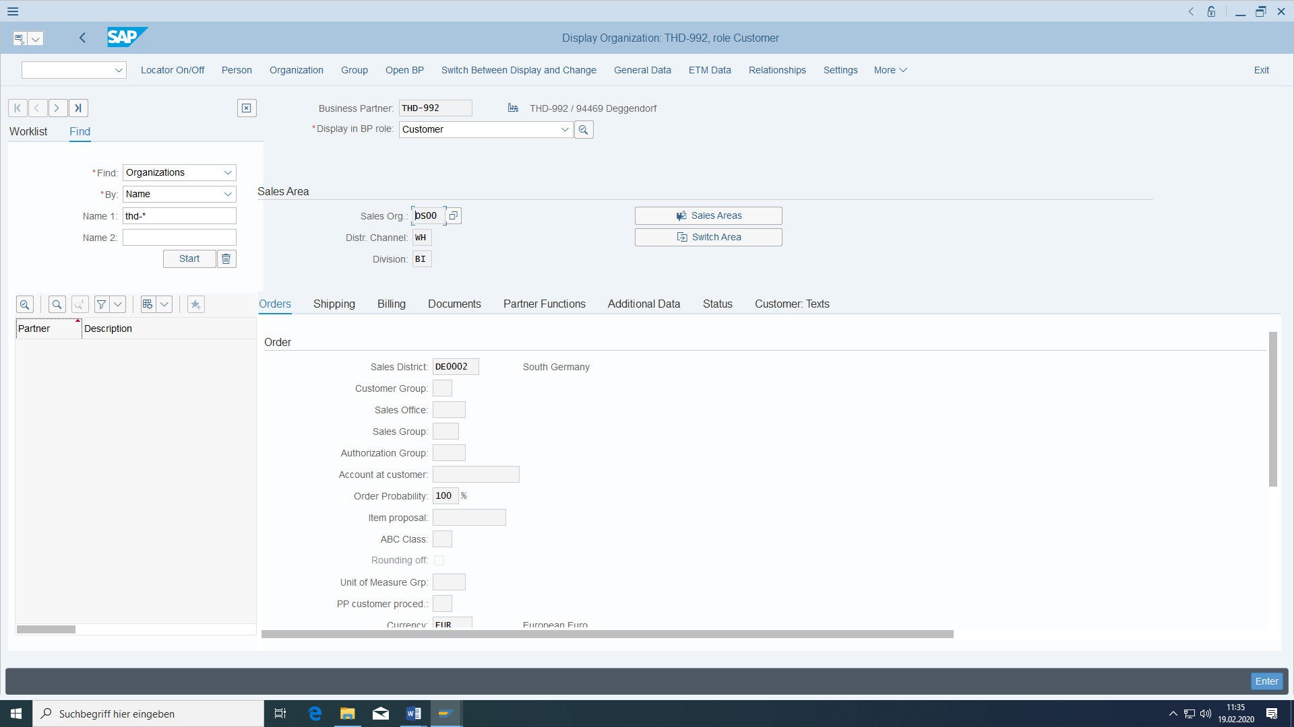

The shipping condition has to be standard:

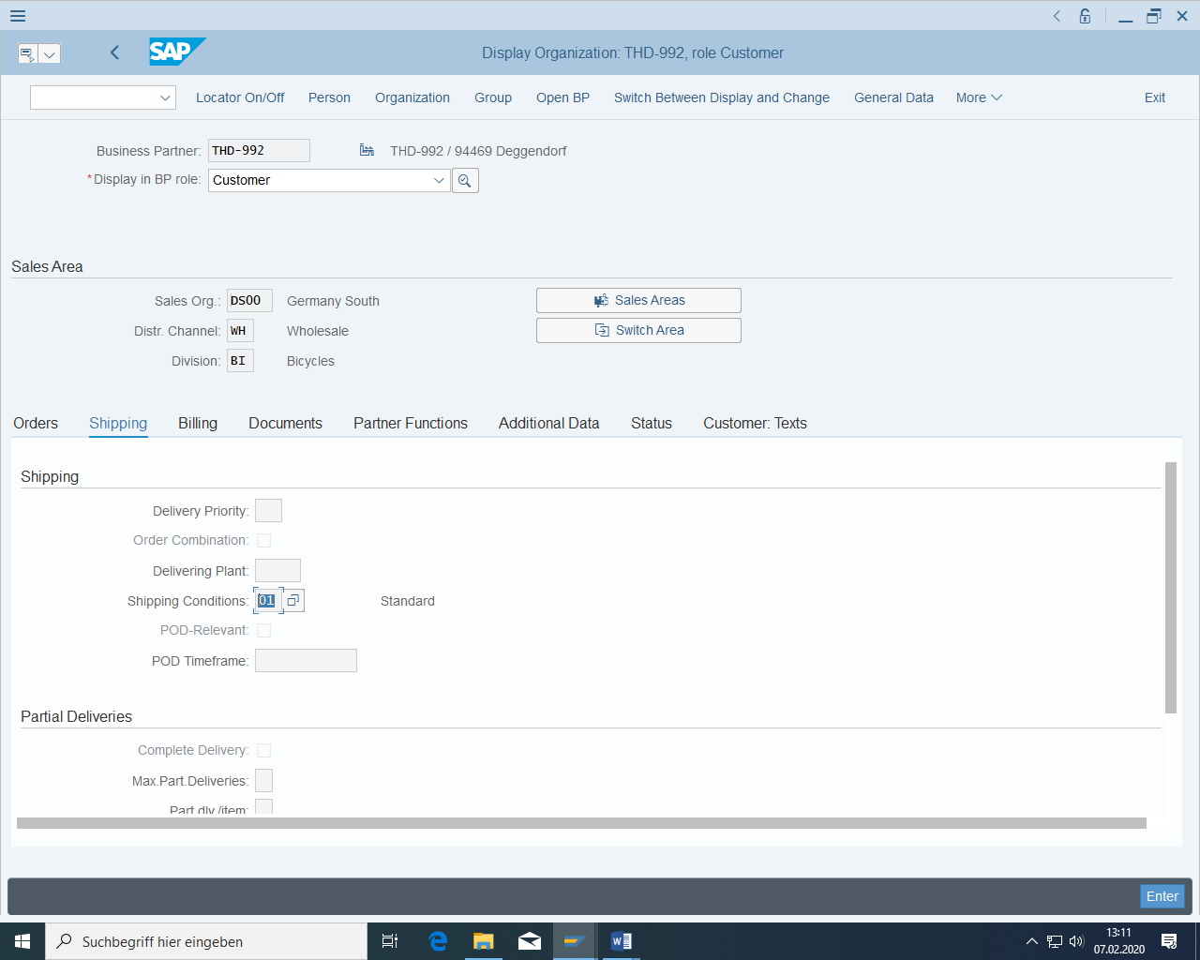

Then choose Save.

Remember the assigned customer number.

### Condition records

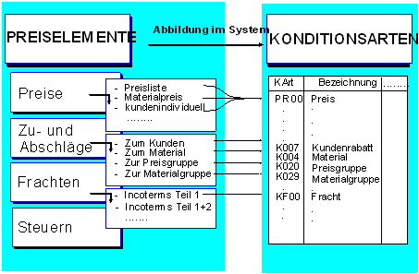

Figure 5: Structure of conditions (source SAP AG®)

#### Basic

##### preconditions

The material for the bicycle must have been created.

##### task

You want to create a condition record, that is, a sales price, so that the headlamp can be sold.

##### Required transactions

|  |  |  |
| --- | --- | --- |
| **transaction** | **menu path** | **TAC** |
| Create condition record | Logistics > Sales > Master data >Conditions > Create | VK31 |

##### Data for this example

|  |  |  |
| --- | --- | --- |
| **fields** | **basic data** | **Description** |
| sales organization | DS00 | Germany South |
| distribution channel | WH | Wholesale |

#### Create a condition record for the sales price

In order for the bicycle to be sold, a material sales price for the sale must be stored in the system. A new condition record must be created for this.

To do this, choose the transaction "Create condition record" and then Material price.

The price is therefore dependent on the condition type, sales organization, distribution channel and material.

The price is to be valid for sales organization DS00 and distribution channel WH.

PR00 must be selected as the condition type. For your material, enter a price of 250 € per 1 piece and a validity from the current date to 31.12.

Configure this condition so that the price of 250 € is valid from a quantity of 1 piece; from a quantity of 501 pieces, the price is to be reduced to 200 € per piece:

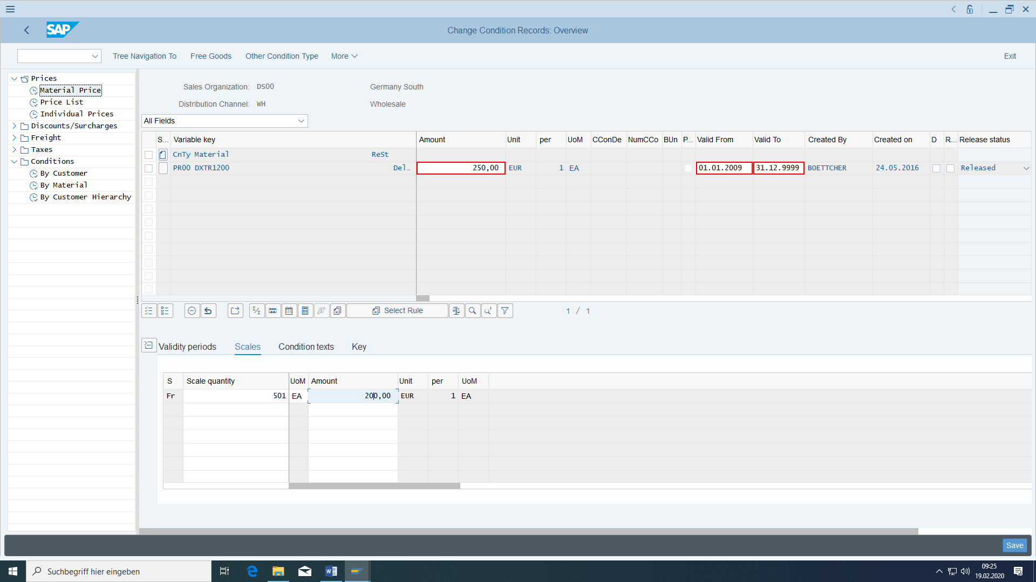

Choose Save.

## Purchasing master data

### Basic

#### Basic

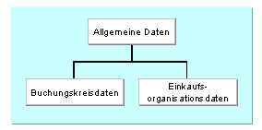

Figure 6: Structure of the supplier master (source SAP AG®)

#### Preconditions

In customizing the purchasing organization is already assigned to the company code:

#### Task

A vendor master record is to be created from which the externally procured material can be ordered in the subsequent exercises. Instead of a vendor master record, you also use the term creditor (as opposed to debitor).

#### Required transactions

|  |  |  |
| --- | --- | --- |
| **transaction** | **menu path** | **TAC** |
| Create vendor | Logistics > Materials management > Purchasing > Master data > Supplier > Central > Create | XK01  New: **BP** |
| Change vendor | Logistics > Materials management > Purchasing > Master data > Supplier > Central > Change | XK02  New: **BP** |

#### Data for this example

|  |  |  |
| --- | --- | --- |
| **fields** | **basic data** | **Description** |
| company code | DE00 | Global Bike Germany GmbH |
| purchasing organization | DE00 | GBI Germany |
| account group |  | supplier |

#### Purchasing organization and company code

In customizing already defined:

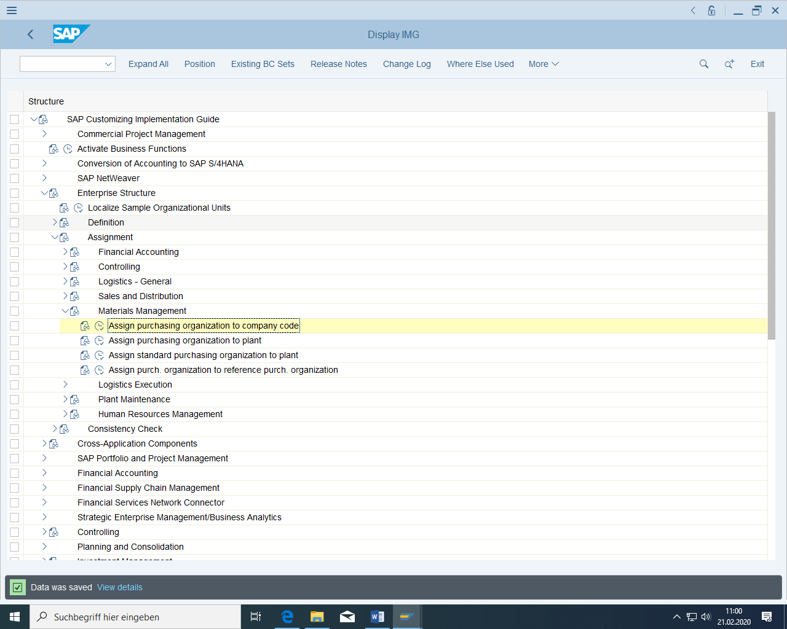

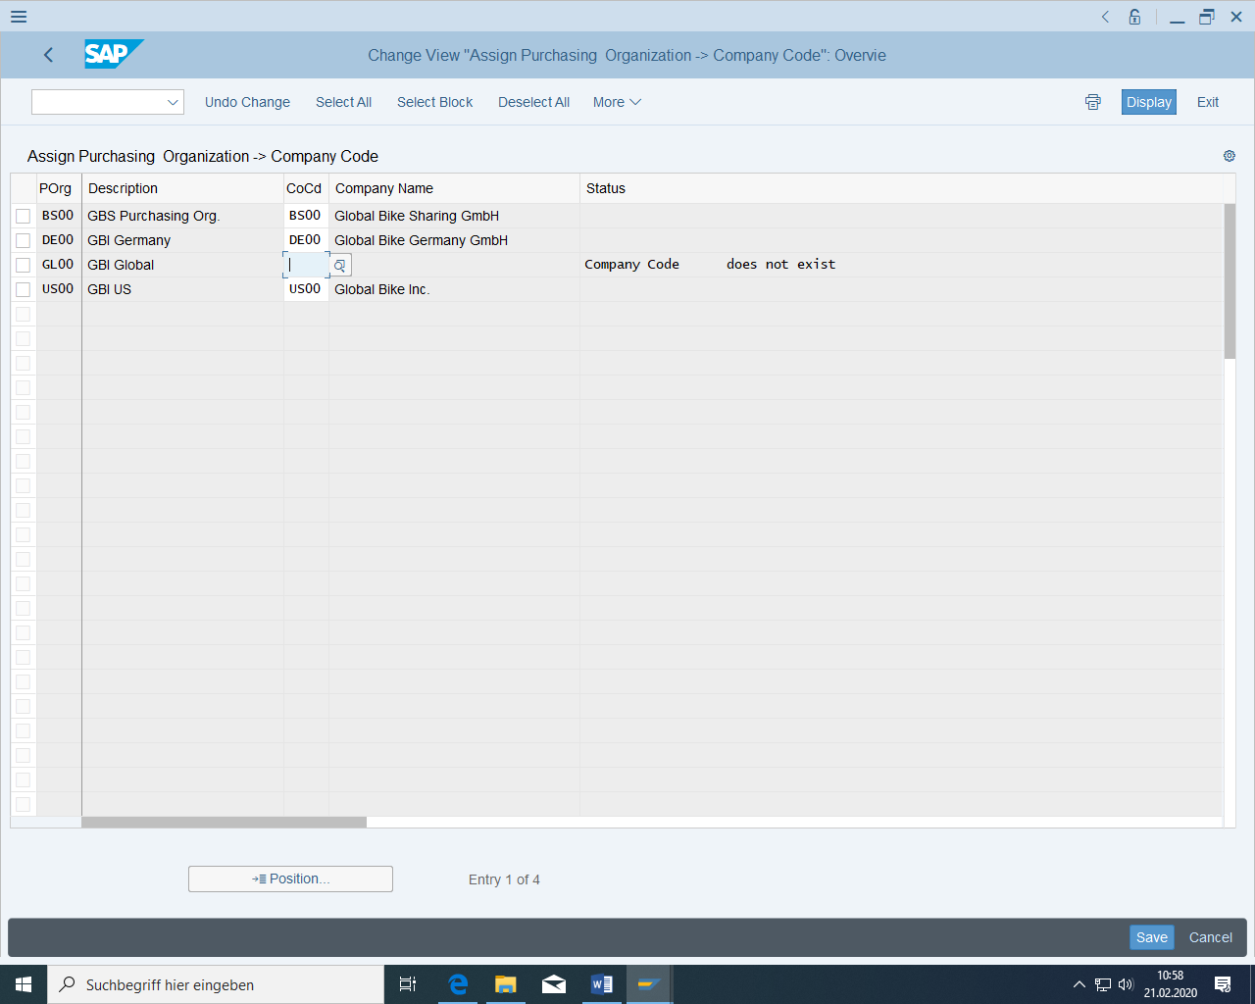

### Create vendor

The vendor number is "THW-xxx".

In the 'Address' screen, maintain the fields Name, Search term 1/2, Postal code and City with any data.

The accounting account is liabilities.

It must be paid immediately without deduction and in euros.

No plant at the vendor, because then it will be created a restocked order later at goods movement.

You need the following roles for this Business Partner:

Creditor

FI Vendor

Vendor

Vendor (Purchasing)

(Invoicing Party)

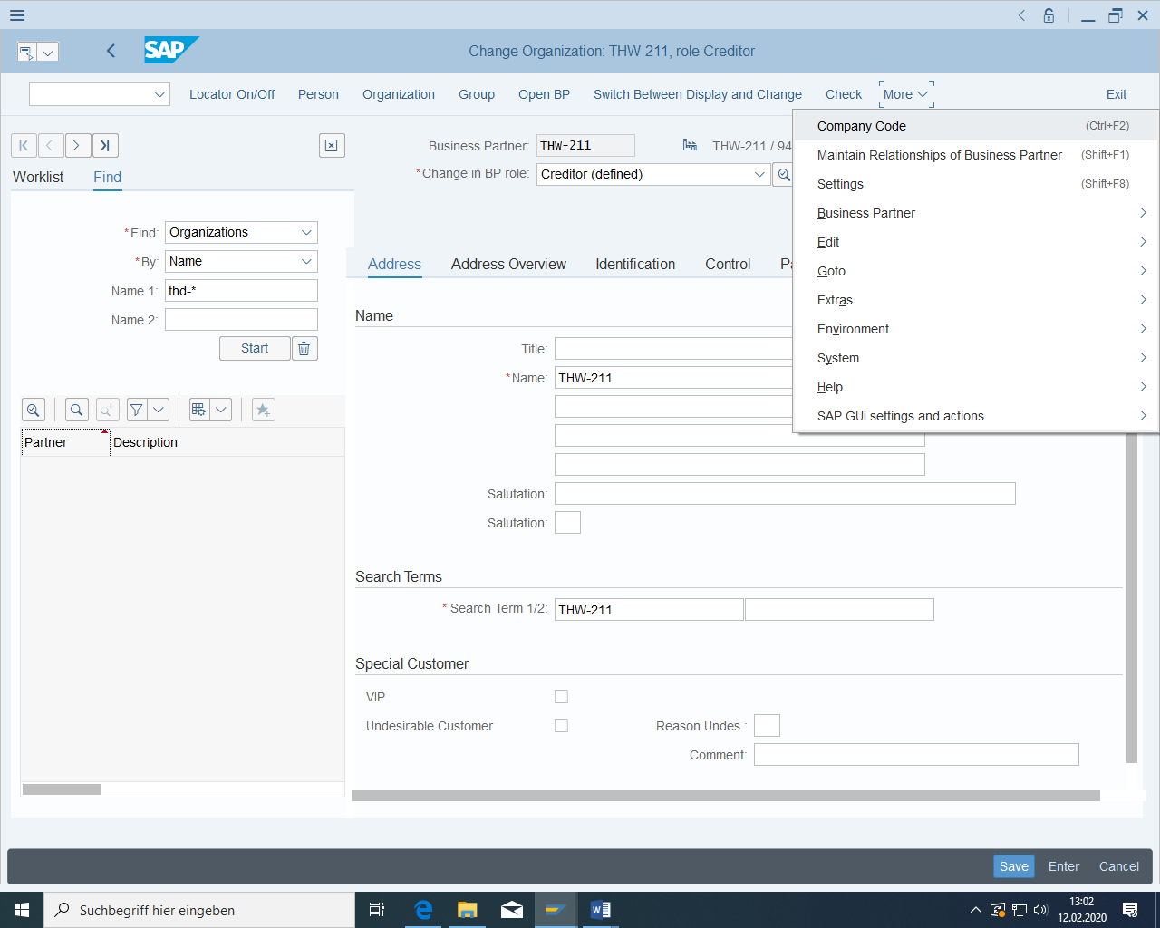

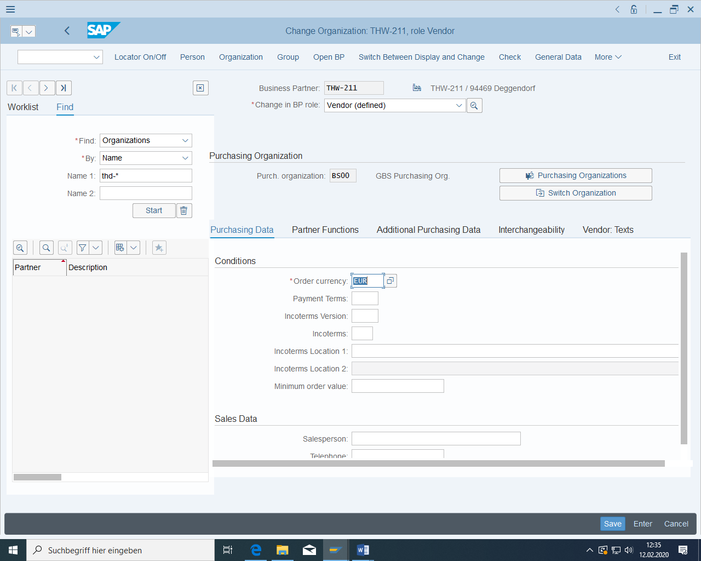

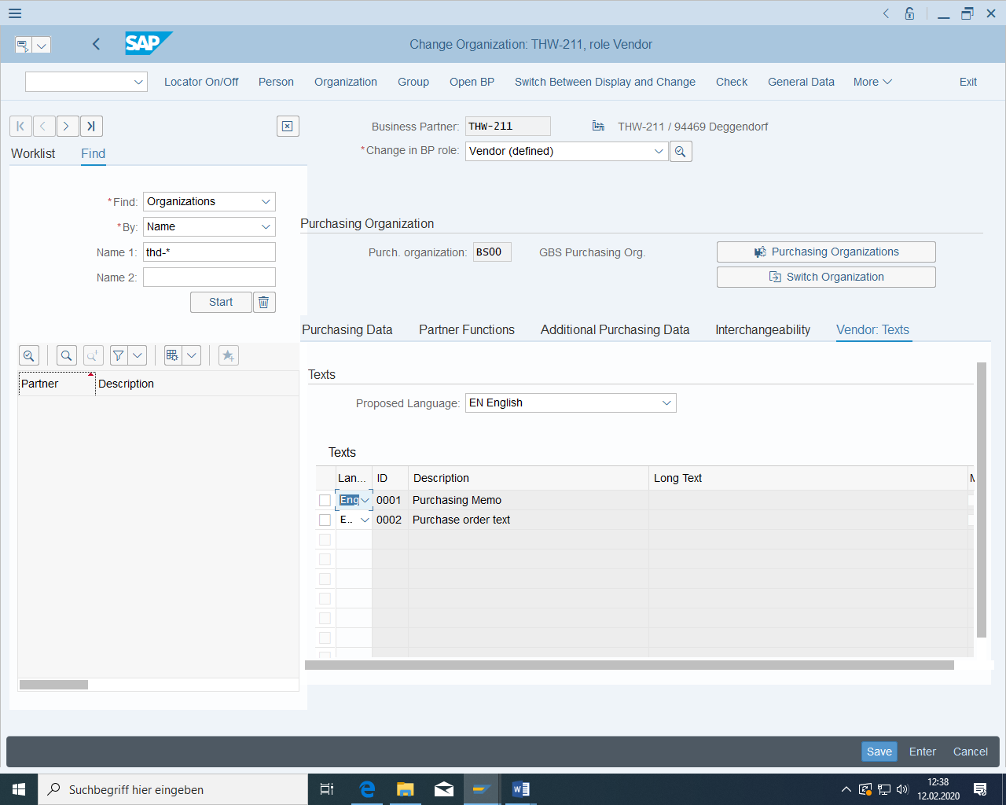

(at the second vendor)

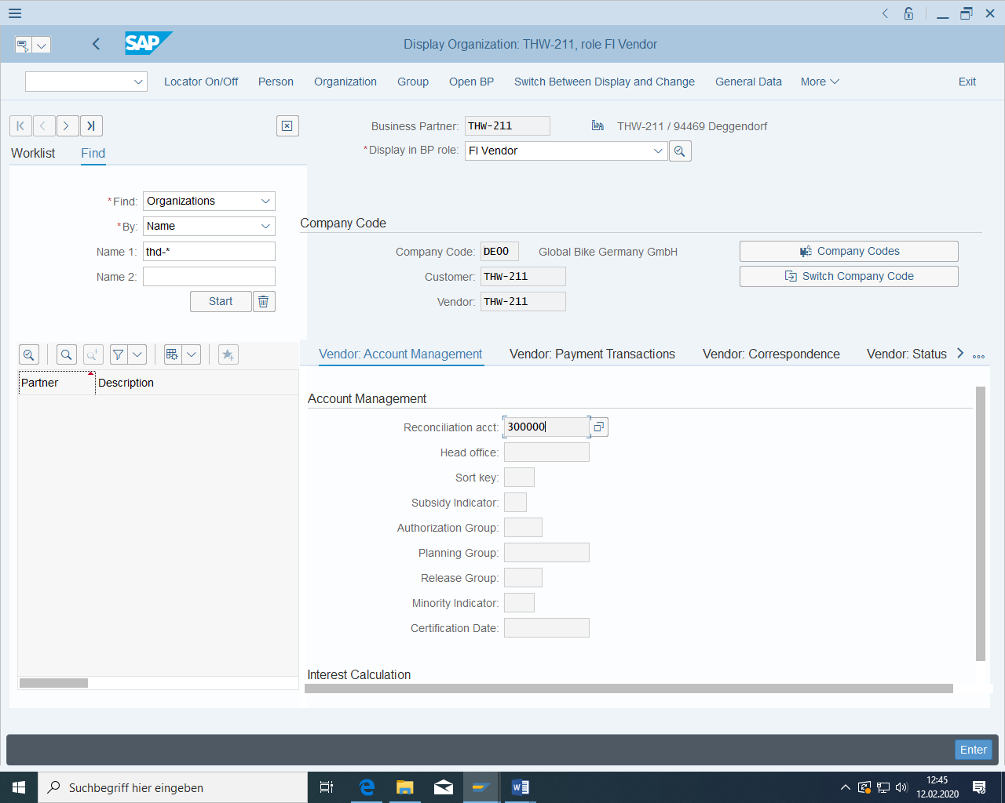

### Change vendors

The address of your vendor has changed. To do this, switch to the transaction "Change vendor".

Enter an address of your choice.

Also enter a contact person for Purchasing with the relevant telephone number.

Save your entries.

### Purchasing info records and source list

#### Basic

##### preconditions

Material for the tire must have been created.

Vendor must have been created.

##### task

A purchasing info record and a source list entry are to be created. Some of the **purchasing info records** in the MM module correspond to the condition records in the SD module. Among other things, the price that you have to pay a certain supplier for a certain material / service is stored here.

In order for purchase order replenishment to be carried out automatically in the subsequent business process using an MRP run, a **source list entry for the** materials to be procured must also be maintained for the scenario of this case study. This enables the system to generate purchase requisitions automatically if necessary and assign a source of supply to them.

##### Required transactions

|  |  |  |
| --- | --- | --- |
| **transaction** | **menu path** | **TAC** |
| Create purchasing info record | Logistics > Materials management > Purchasing > Master data > Info record > Create | ME11 |
| Create source list | Logistics > Materials management > Purchasing > Master data > Order book > Maintain | ME01 |

##### Data for this example

|  |  |
| --- | --- |
| **fields** | **basic data** |
| Plant | HD00 |
| purchasing organization | DE00 |
| creditor | THW-### |
| material | TRTR-### |

#### Create a purchasing info record

Call up the transaction "Create purchasing info record". Enter the number of the vendor you have just created, the material number of the tire, the purchasing organization, and the plant. Then choose 'Enter'.

On the following screen, you can see some default values copied from the material master that you do not need to change. The orderME must be in grams. Then click on "Purch.Org.Data 1. Enter a standard quantity of 10 grams and a net price of 40 € per gram. The planned delivery time is one day.

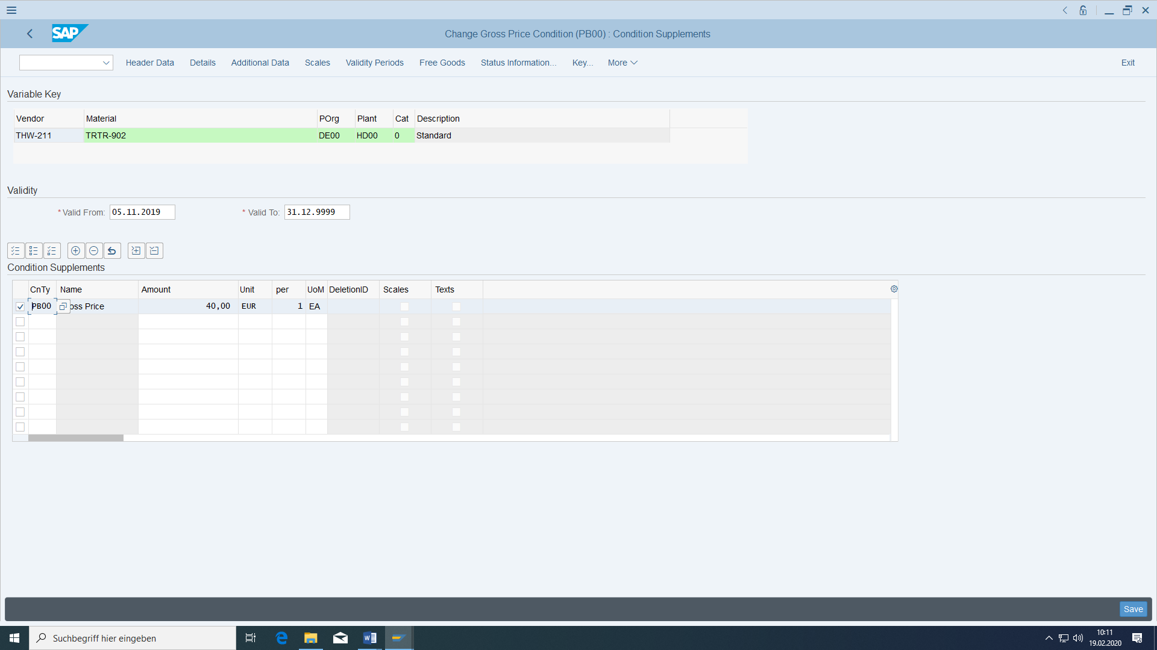

From 1001 grams, the purchase price is to be reduced to 15 €.

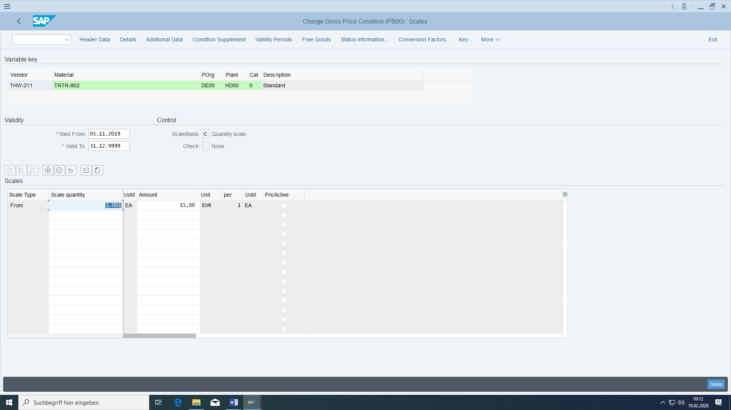

Then choose Save.

#### Maintenance of the source list.

Navigate to the transaction "Maintain source list". Enter the material number of the tire and the plant HD00 and press 'Enter'.

In the top row, enter a validity period from January 1 to December 31 of the current fiscal year, the number of your vendor and the purchasing organization DE00. In addition, select the 'Fix' checkbox and ensure that the entry is relevant for materials planning.

No plant at the vendor, because then it will be created a restocked order later.

Then choose Save.

## Master data for production



Figure 7: Organization in production

### Parts list

#### Basic

##### preconditions

The three material masters must have been created.

##### task

A BOM is created from the material masters. This means that you define which material identifies the assembly and which materials it consists of. A document is also included in the BOM.

##### Required transactions

|  |  |  |
| --- | --- | --- |
| **transaction** | **menu path** | **TAC** |
| Create BOM | Logistics > Production > Master data > Parts lists > Parts list > Material parts list > Create | CS01 |
| Create document | Logistics > Central Functions > Document Management > Document > Create | CV01N |
| Display BOM Structure | Logistics > Production > Master data > BOMs > Analyses > BOM explosion > Material BOM > Multi-level structure | CS12 |

##### Data for this example

|  |  |  |
| --- | --- | --- |
| **fields** | **basic data** | **Description** |
| Plant | HD00 | Plant Heidelberg |
| material number | DXTR-###  TRWA-###  TRTR-### | ### Deluxe touring bike  ### Aluminium wheel  ### Tyres |

#### Creating the BOM

The BOM is to be created for the ### Deluxe Touringrad in plant HD00 for use in production. It is valid from January 1 of the current fiscal year.

As a component in position 10 of the parts list, please carry your ### aluminium wheel. Two wheels are required; these are stock items.

Then choose 'Save'.

Then you create the BOM for the ### aluminum wheel in plant HD00 to be used in production. You need 450 grams of tire material per wheel. Here you also create the document created above as a BOM item:

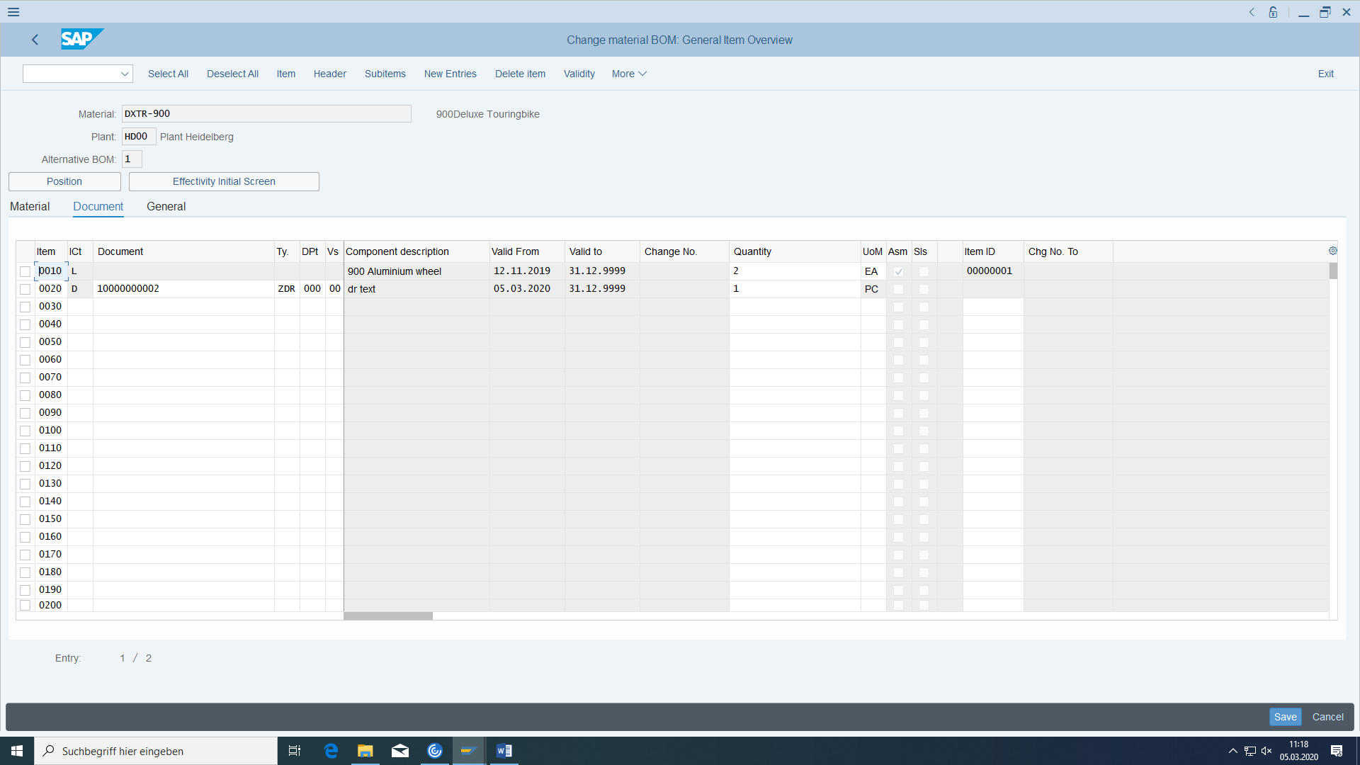

Display this document via Environment.

#### Display structure BOM

To see for yourself the success of the BOM creation, choose the transaction "Display BOM structure" from the menu.

Then enter the header material of the BOM (DXTR-###), plant HD00 and as application 'Production - general' and click on 'Execute' (alternatively 'F8'). You see the BOM in text form.

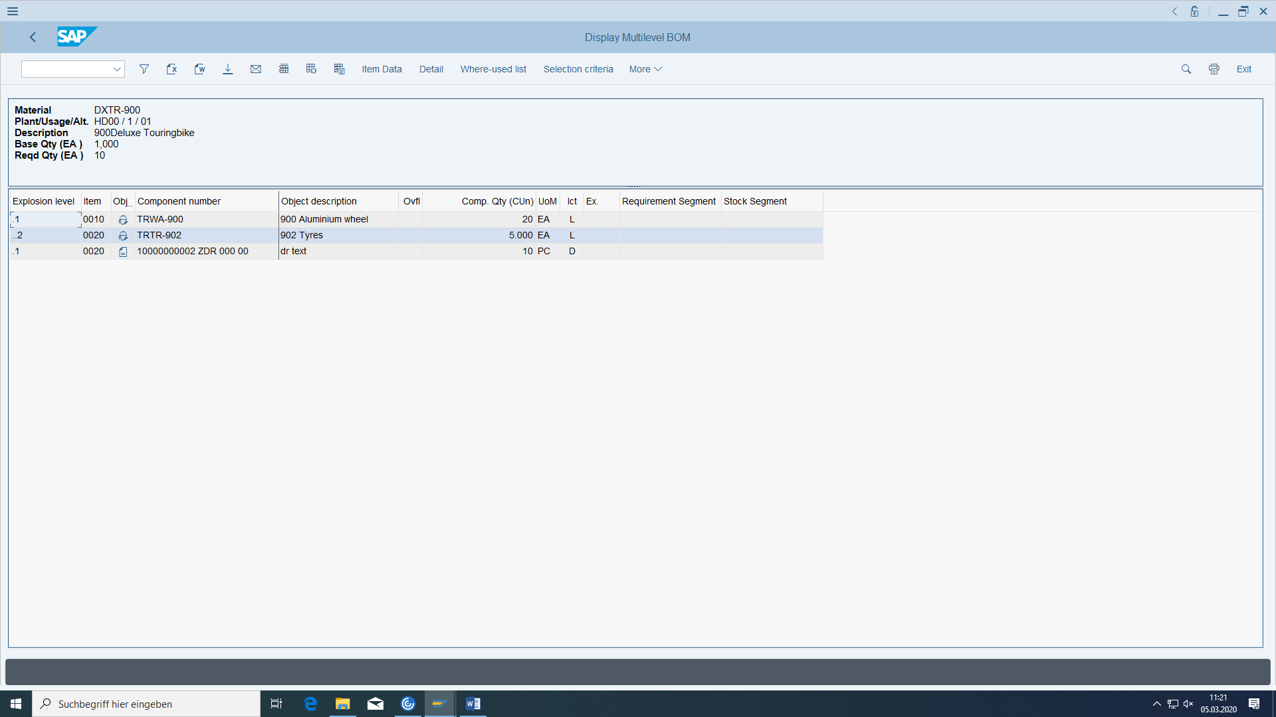

### Plant schedules for DXTR and TRWA

#### Basic

##### preconditions

The material for the bicycle must have been created.

##### task

You want to create a routing that determines the production process for the bike assembly.

(alternative) Routings (alternative) Sequences Operations

##### Required transactions

|  |  |  |
| --- | --- | --- |
| **transaction** | **menu path** | **TAC** |
| Create routing | Logistics > Production > Master data > Task lists > Task lists > Standard task lists > Create | CA01 |

##### Data for this example

|  |  |  |
| --- | --- | --- |
| **fields** | **basic data** | **Description** |
| Plant | HD00 |  |
| material | DXTR-### | Assembly to be created |
| work centers | ASSY1000 HD Assembly  INSP1000 HD Inspection | work centers at which the work is performed |

#### Creating the routing for DXTR

Switch to transaction CA01. Again, the material shall be DXTR-### and the Plant HD00. Please enter January 1 of the current fiscal year as the key date and confirm with 'Enter'. The routing is used for production and is to be given the status 'Released general'. Then click on 'Operation overview' (alternatively 'F7'). The system displays the operation overview, which is still empty.

Operation **0010** is to be assigned to work center HD assembly. Double-click on line. In the 'Operation details' screen that now appears, enter 10 minutes as the standard value for setup time, 15 minutes for machine time, and 2 minutes for labour time. Then return to the operation overview with the back key or by pressing the function key 'F3'.

The work center HD inspection is to be assigned to operation **0020.** Then double-click the line you are currently editing. In the 'Operation detail' screen that now appears, enter 15 minutes as the standard value for the labour time. Then return to the operation overview.

Then assign the BOM component Aluminum wheel to operation 20 (operation detail then Material Assignement):

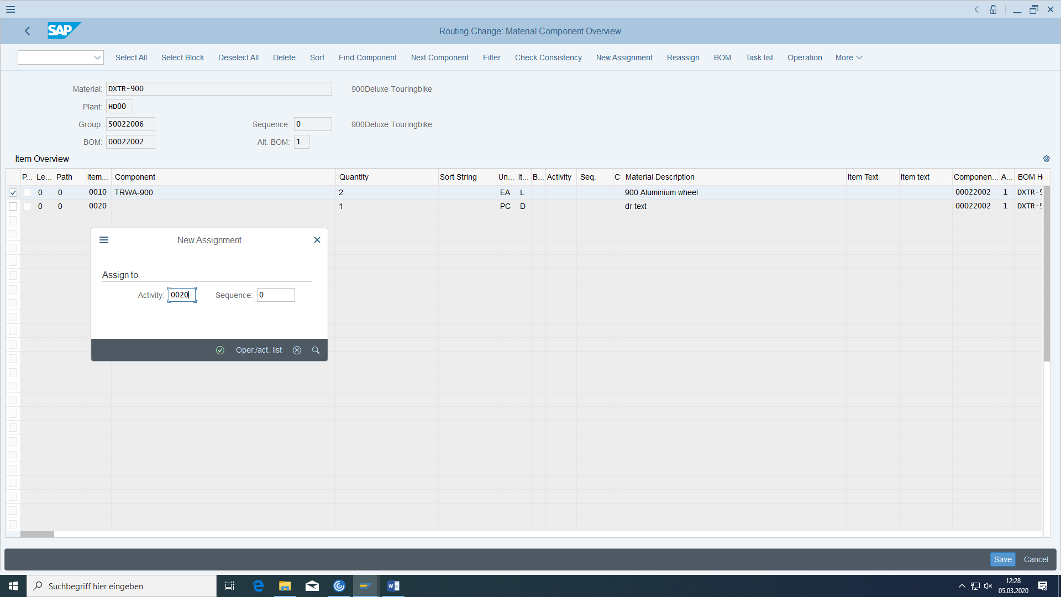

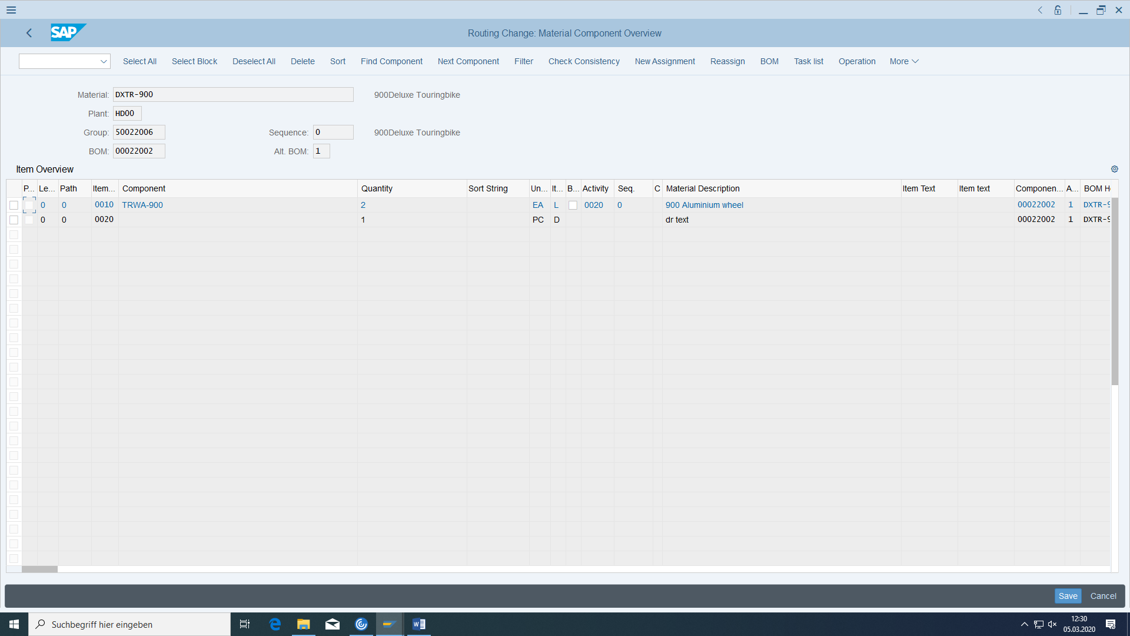

In the first screen of the standard sequence, create an alternative sequence for operations 10 to 20 from a quantity of 3000 pieces.

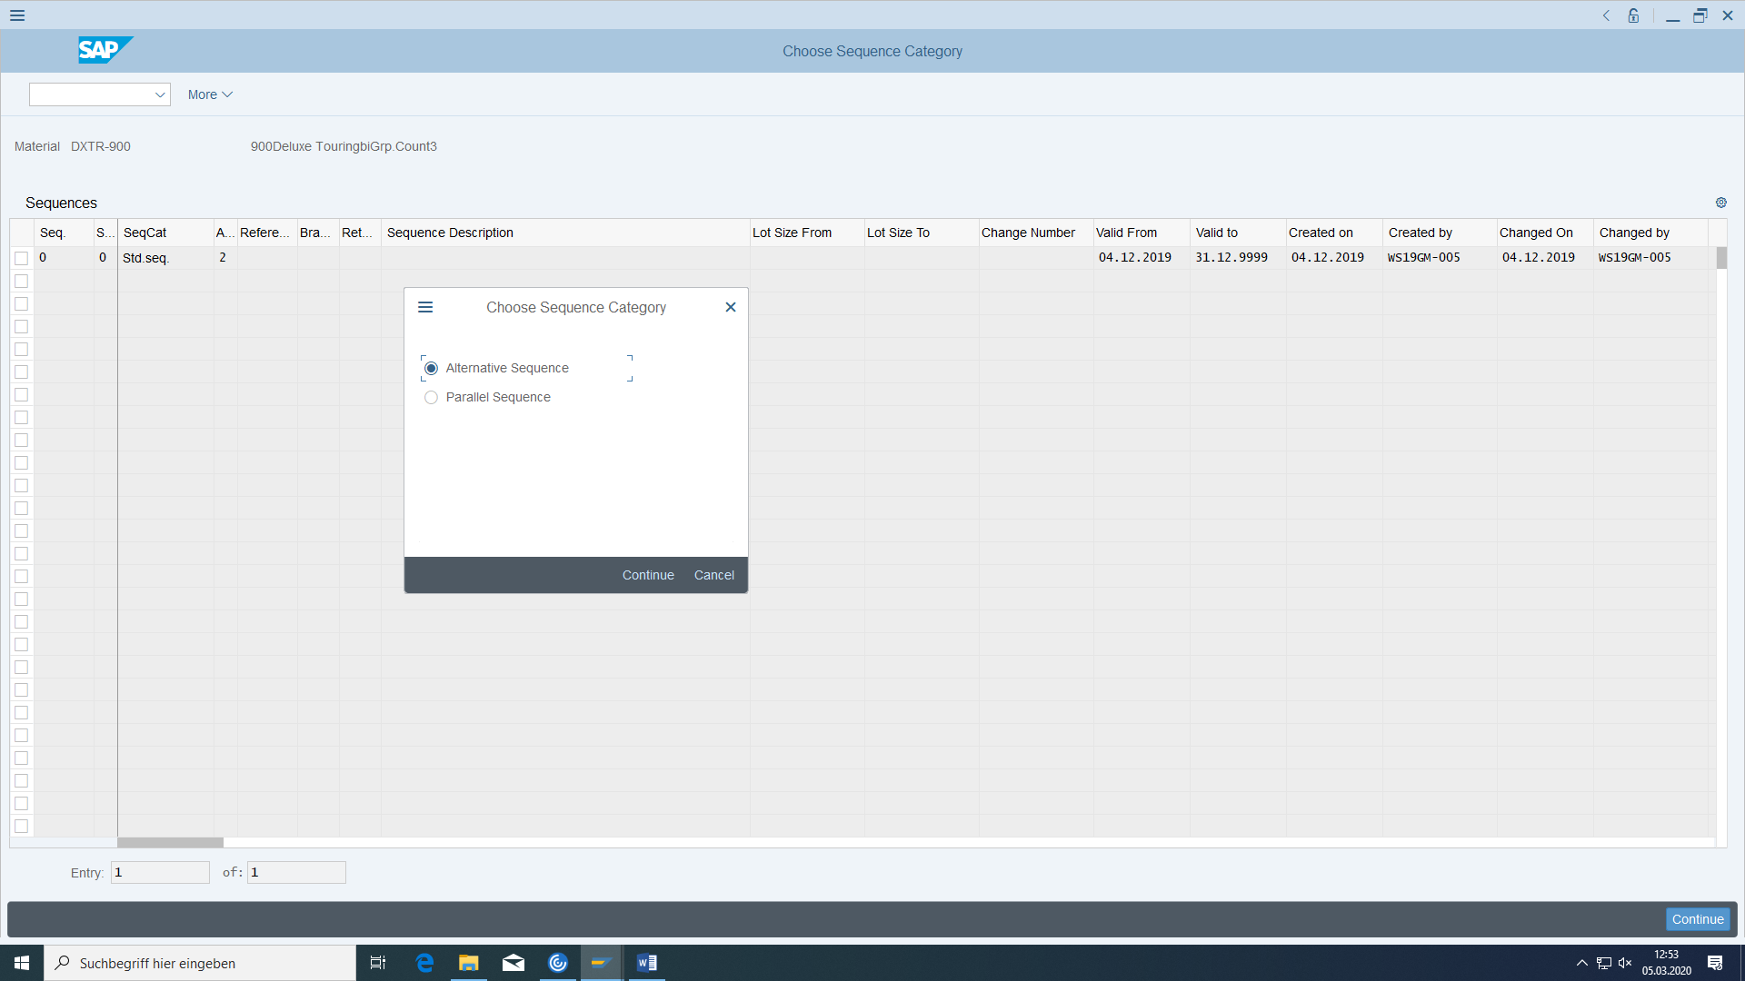

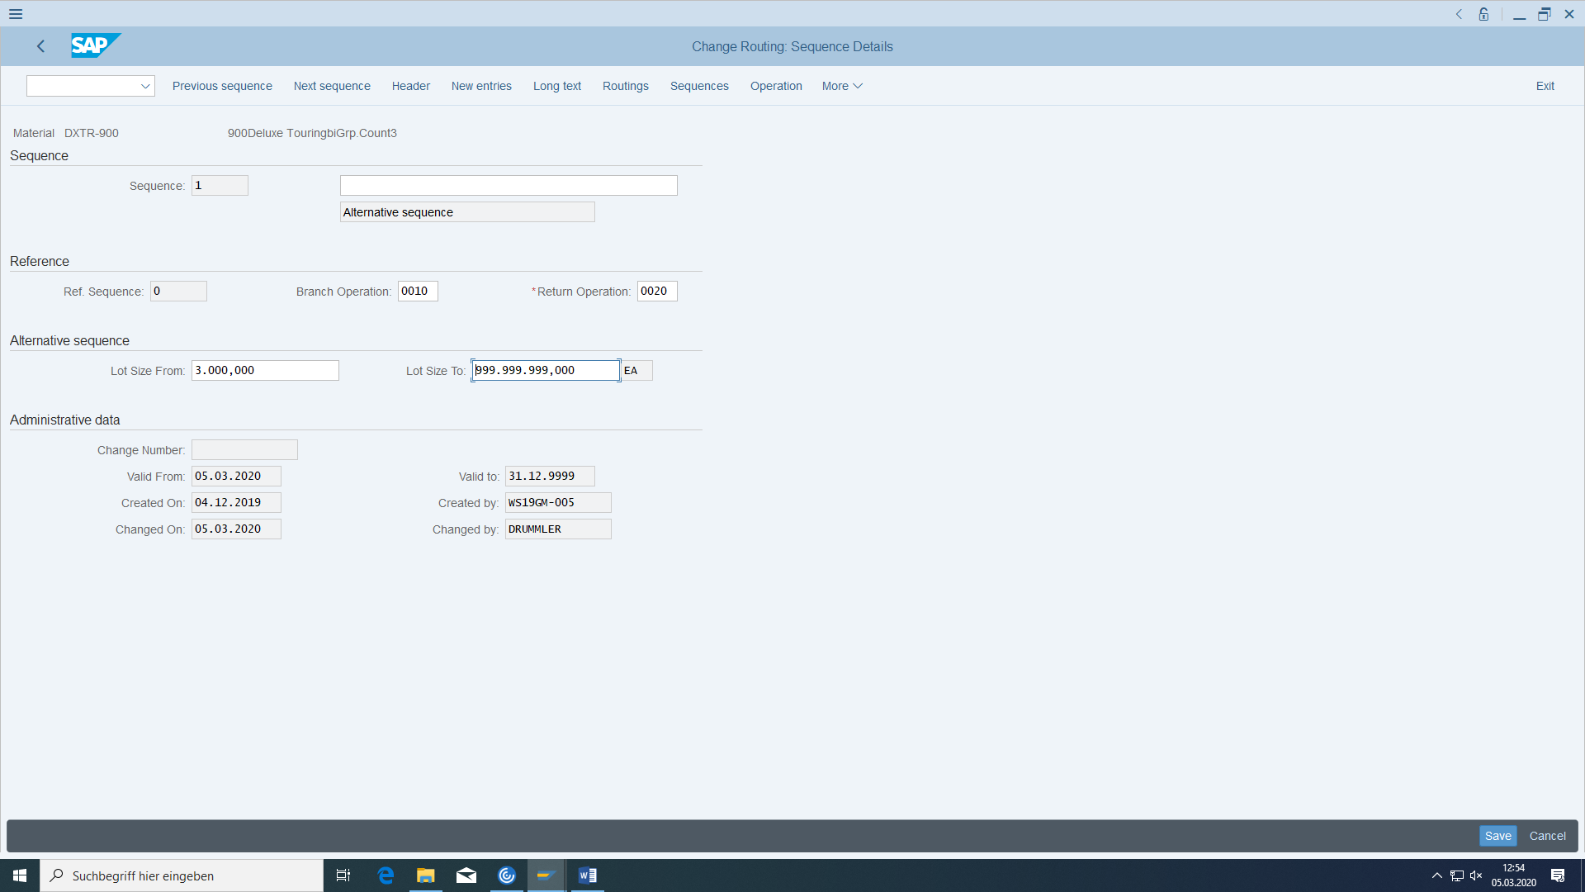

Then enter operation 0010 with work center HD maintenance. Then double-click the line you are currently editing. In the 'Operation detail' screen that now appears, enter 10 minutes as the value for the labor hours.

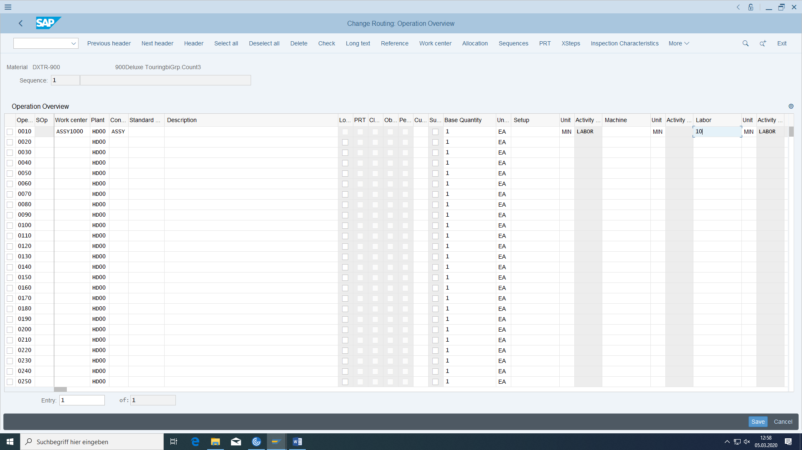

After saving, check again whether both sequences have actually been created.

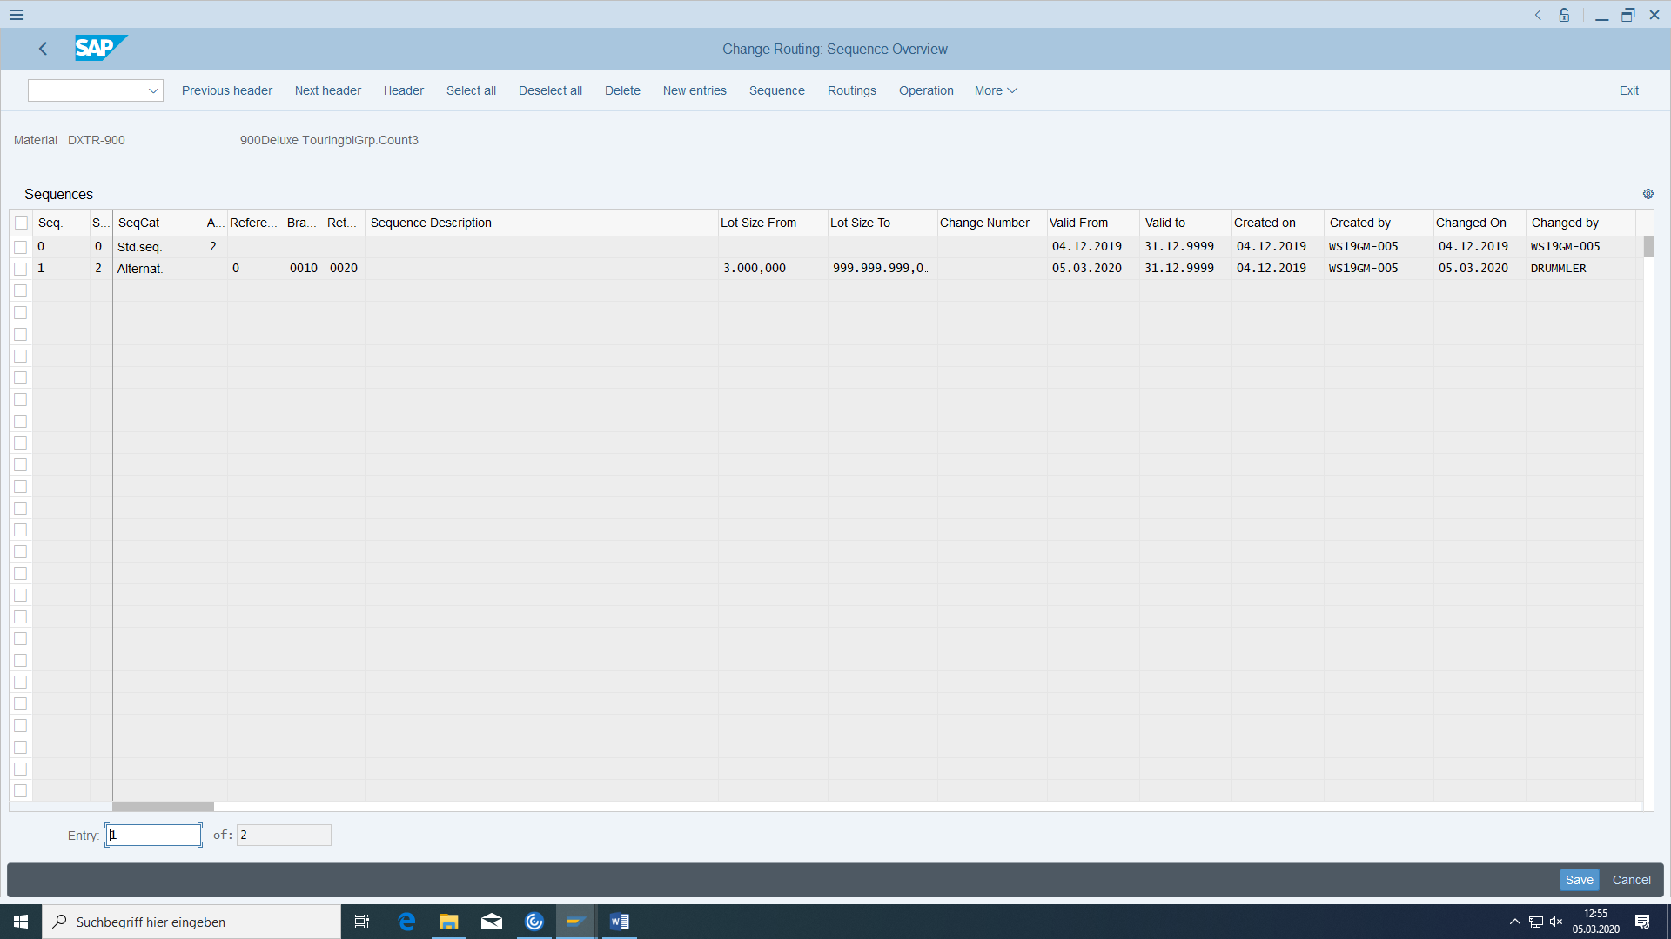

#### Production version for DXTR

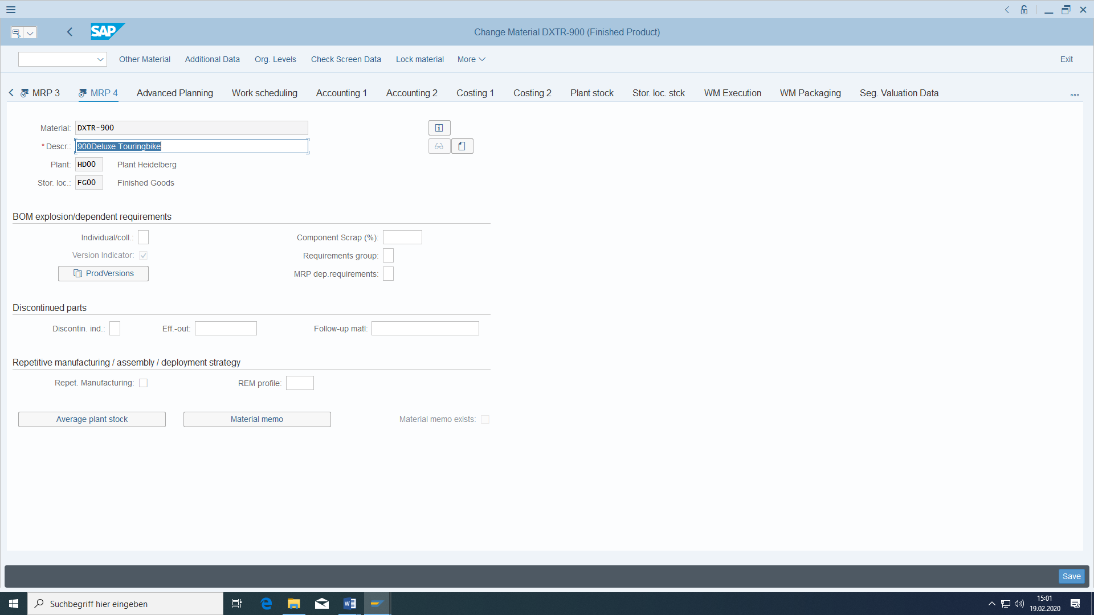

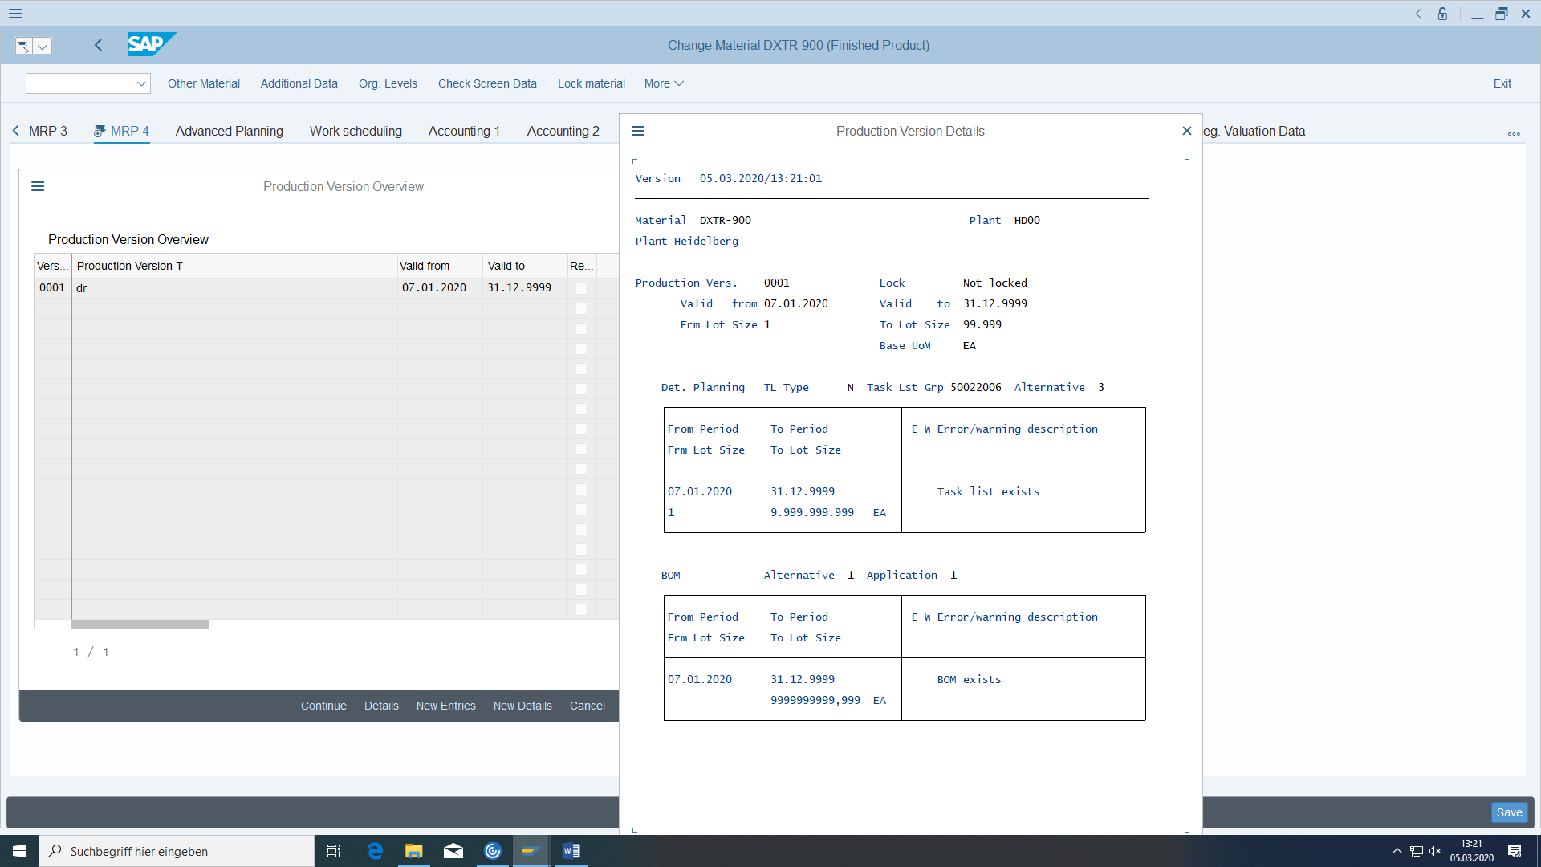

Date and lot size intervals must be okay.

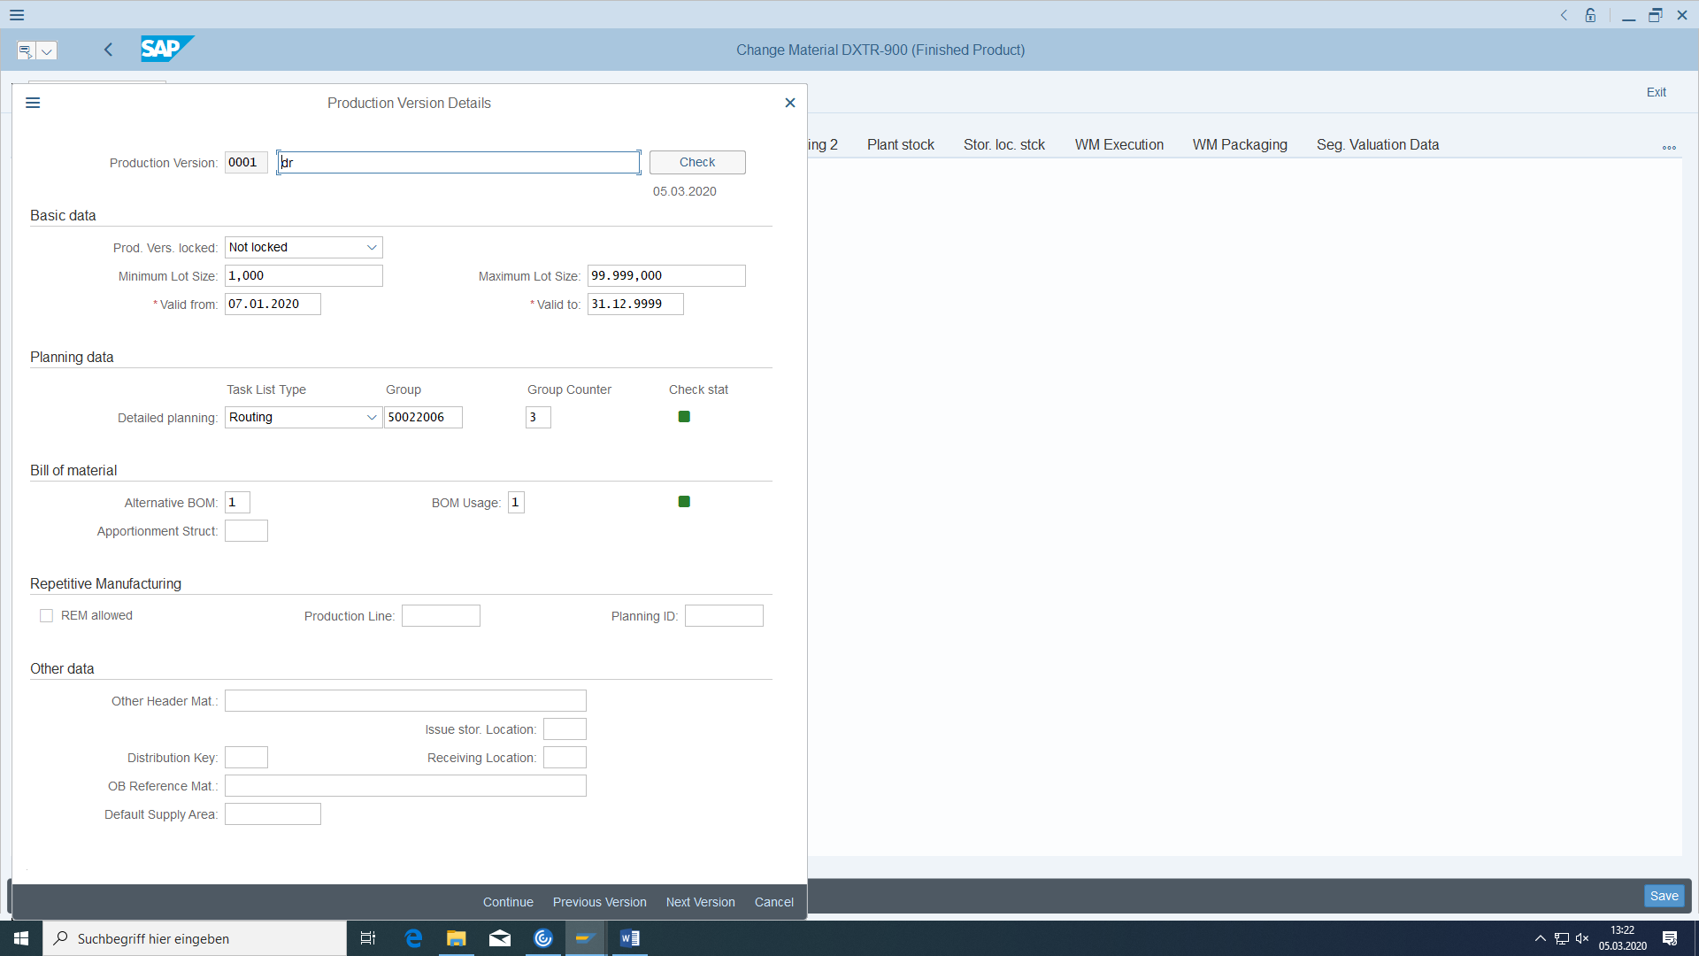

In the production version you have to store which version of the BOM and which version of the routing fit together for one material. The check stati have to be green both.

Also possible in:

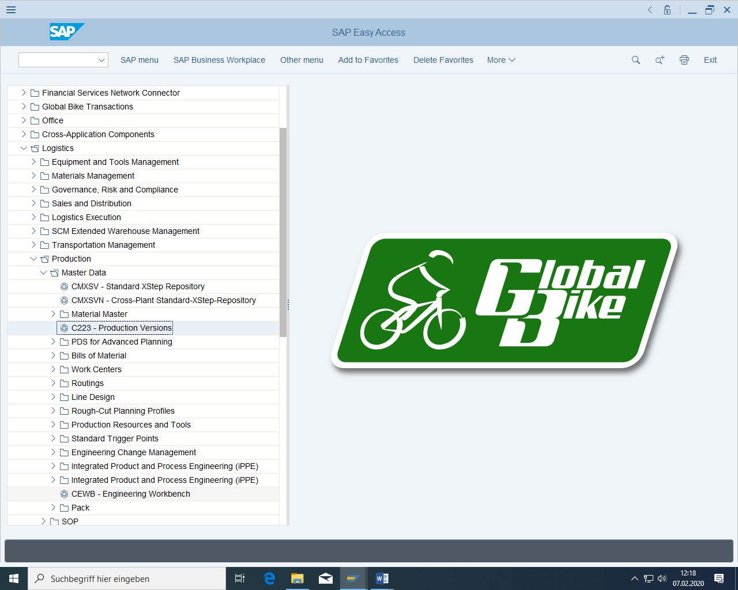

#### Creating the routing for TRWA

For Material TRWA-### use the same routing.

With Create from:

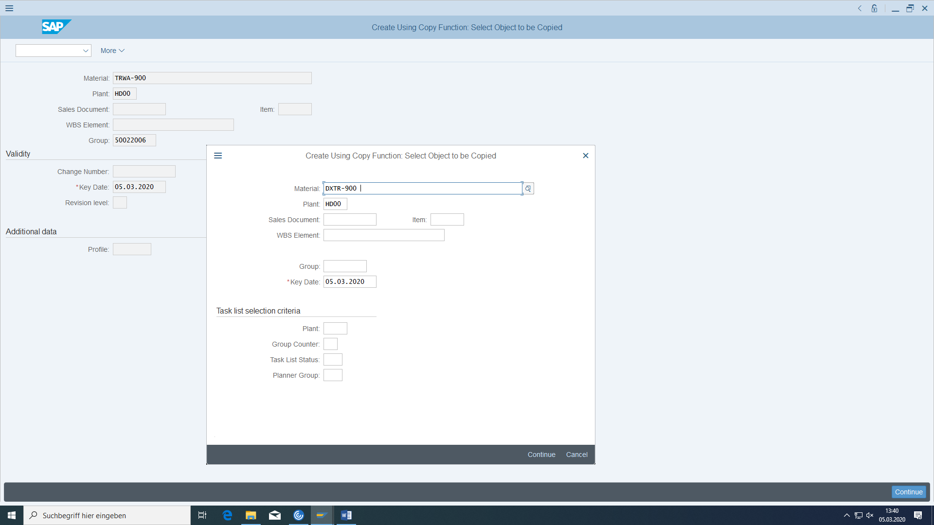

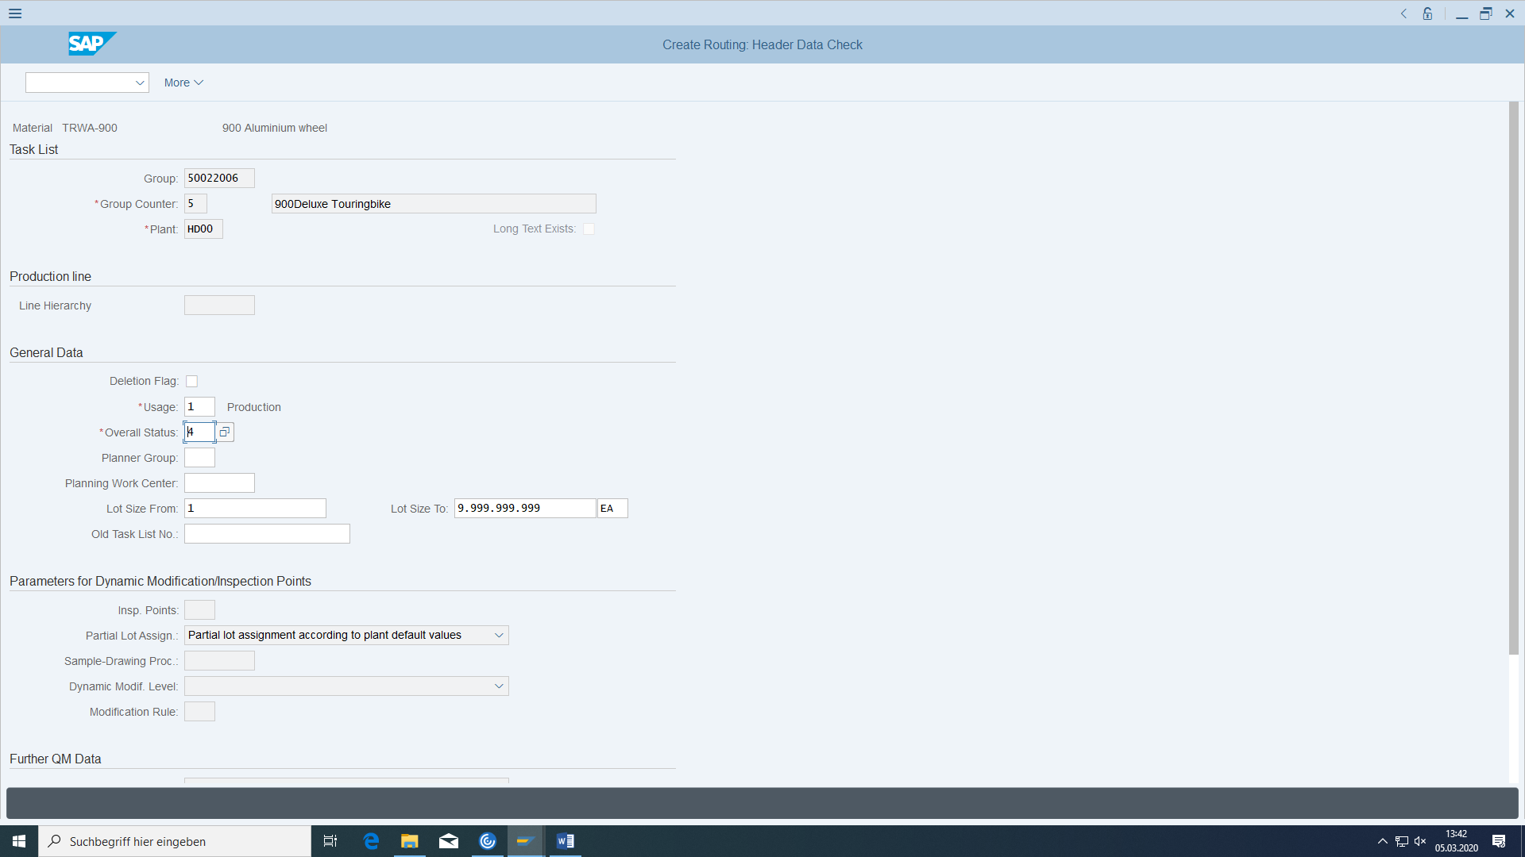

Group counter is 5.

#### Production version for TRWA

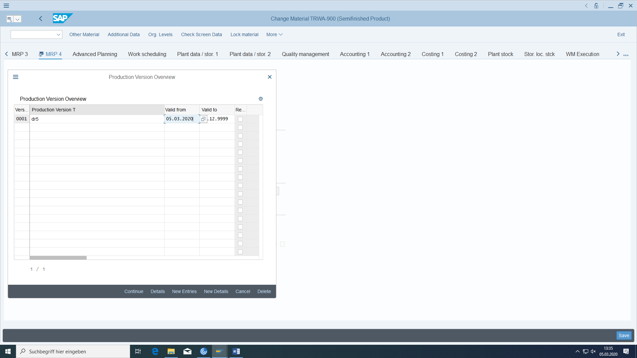

New production version dr5 with correct Valid from date.

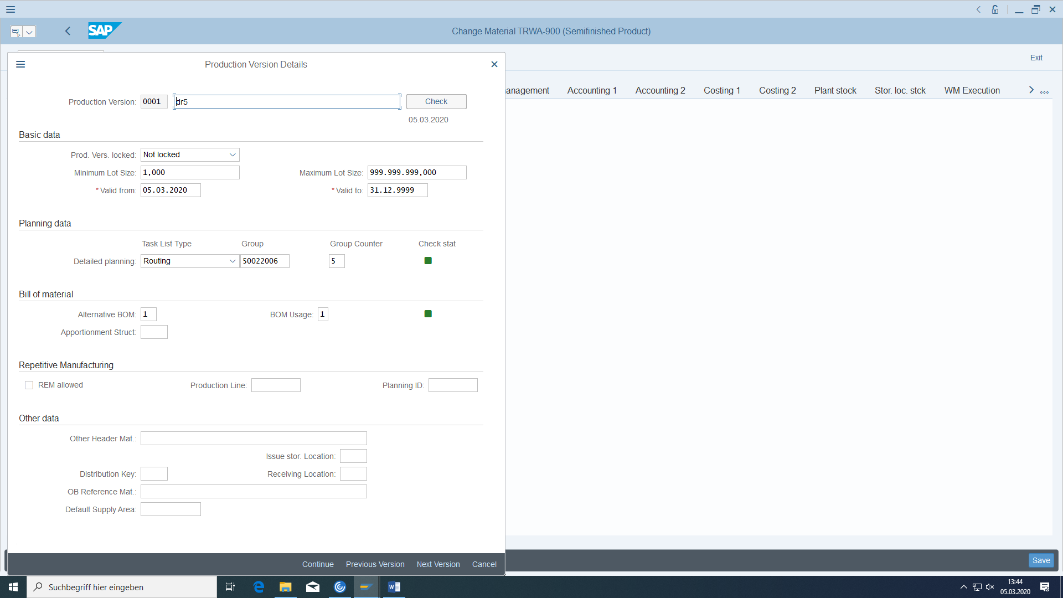

Minimum lot size is 1 like in routing.

## Product structure browser from Life Cycle Data Management

### Required transactions

|  |  |  |
| --- | --- | --- |
| **transaction** | **menu path** | **TAC** |
| product structure browser | Cross-Application Components > Engineering Change Management > Environment > Product Structure | CC04 |

The product structure browser is the most important tool for navigating and informing in Life Cycle Data Management. All data belonging to a material is displayed in the form of a tree structure:

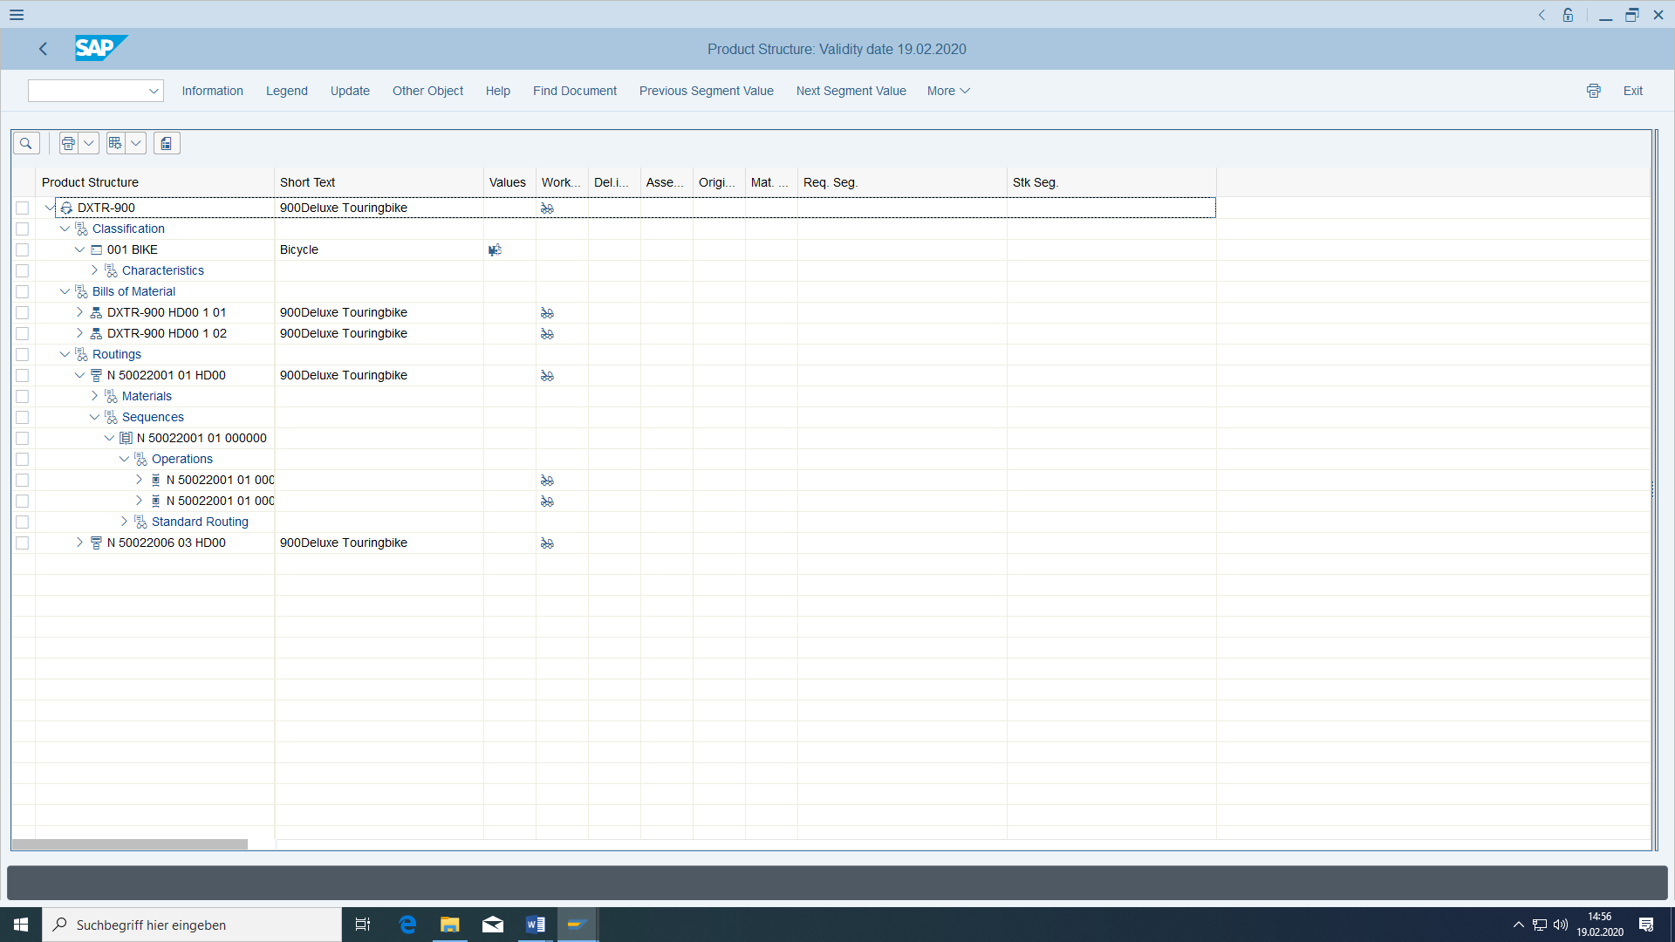

Display the original documents.

From this transaction, try to change the BOM of the material.

# Forecast and customer orders

## Basic

#### Preconditions

All master data from the previous exercises is required (materials, bill of material, routing, customer, vendor, price conditions, purchasing info records, source list).

#### Task

In the following, a complete logistics process is carried out for the bicycle you have created, from creating a sales forecast and sales order to delivery and billing. The initial situation is that your customer wants to order 1200 bicycles from you. This is done first as a declaration of intent, then later through an actual sales order. The declaration of intent is entered by Sales and Distribution as a sales forecast in Sales & Operations Planning and then passed on to Production Planning as a planned independent requirement (so that purchase orders or assembly production can be carried out on time). The sales order (sales order independent requirement) is then consumed.

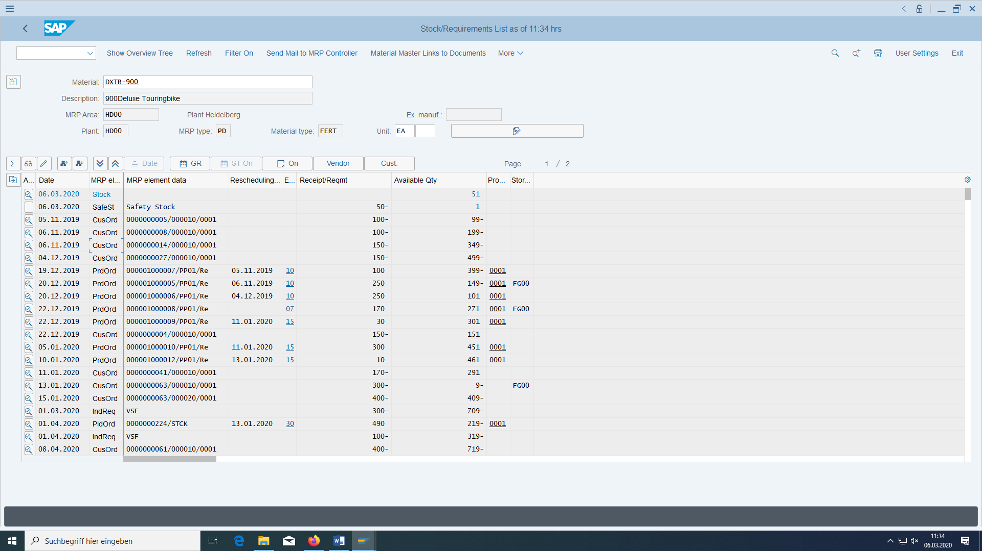

In MD04 you can see the sales forecast as independent requirement (IndReq), the sales order as customer order (CusOrd). The material requirement planning run reacts in creating planned orders for production to be able to deliver later the bike to the customer (PldOrd). The dispatcher then transfers the planned order into a concrete production order (PrdOrd). After the goods have been produced the stock amount will increase.

To be able to produce the material the BOM parts have to be on stock.

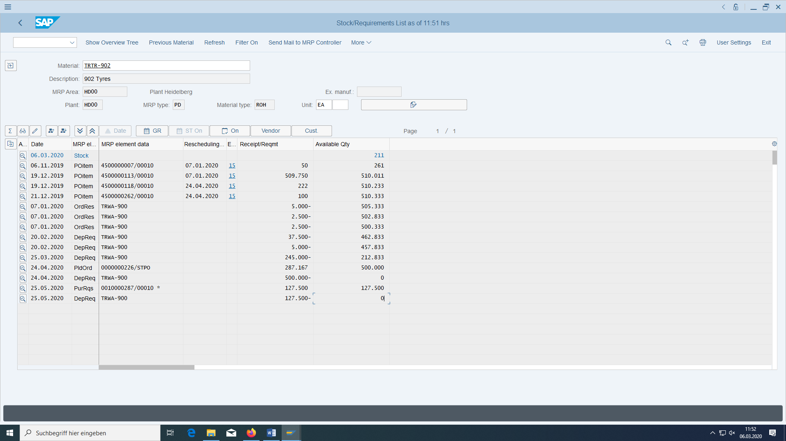

The moment a planned order has been created the system automatically build a dependant requirement (DepReq) for all parts in the next level of the BOM. This will cause via the material requirement planning run planned orders for production or purchase requirements for delivering (PurRqs).

The moment you create a production order (for example by transferring the purchase requirement) the system automatically build an order reservation (OrdRes) for all parts in the next level of the BOM.

The moment the dispatcher creates a purchase order (for example by transferring the purchase requirement) you can see it here as a purchase order item (POitem). When the supplier delivers the material the stock amount goes up.

#### Required transactions

|  |  |  |
| --- | --- | --- |
| **transaction** | **menu path** | **TAC** |
| Create sales plan | Logistics > Production > Sales & Operations Planning > Planning > For Material > Create/Change | MC87/MC88 |
| Checking the Schedule | Logistics > Production > Production planning > Program planning > Planned primary requirements > Advertisements | MD63 |
| Create sales order | Logistics > Distribution > Sales > Order > Create | VA01 |
| Check Settlement of Sales Order with Program Schedule | Logistics > Materials management > Inventory management > Environment > Inventory > Akt.Bed./Best. list | MD04 |
| Customizing | In Customizing: Production > Production Planning > Demand Management > Planned Independent Requirements > Planning Strategy > Define Strategy | SPRO, F1 in MM03 |
| List of orders | Logistics > Distribution > Sales > Infosystem > Orders > List of orders | VA05 |
| Check stock quantities, result of MRP run with updates | Logistics > Materials management > Inventory management > Environment > Inventory > Akt.Bed./Best. list | MD04 |
| Result of the MRP Run frozen | Logistics > Production > Demand planning > Evaluations > MRP list | MD05 |

## Enter a sales plan

In the month following the current month, enter 1200 pieces for the bike at the factory HD00 and with version ### (one version can only be edited by one user at a time – independent of material -). The sales values can originate, for example, from the Sales Information System VIS or from Profitability Analysis CO/PA.

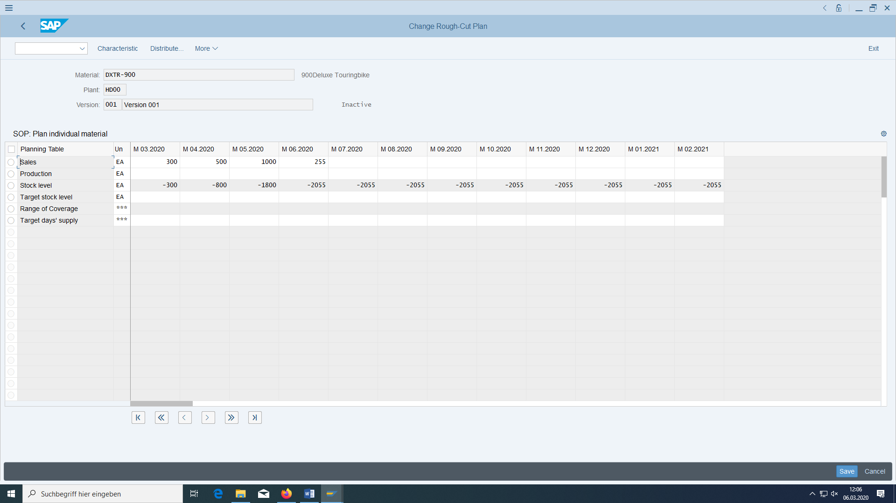

### Transfer the sales plan as planned independent requirements to Production Demand Management.

In the same transaction, transfer the sales plan to Demand Management (menu option Extras):

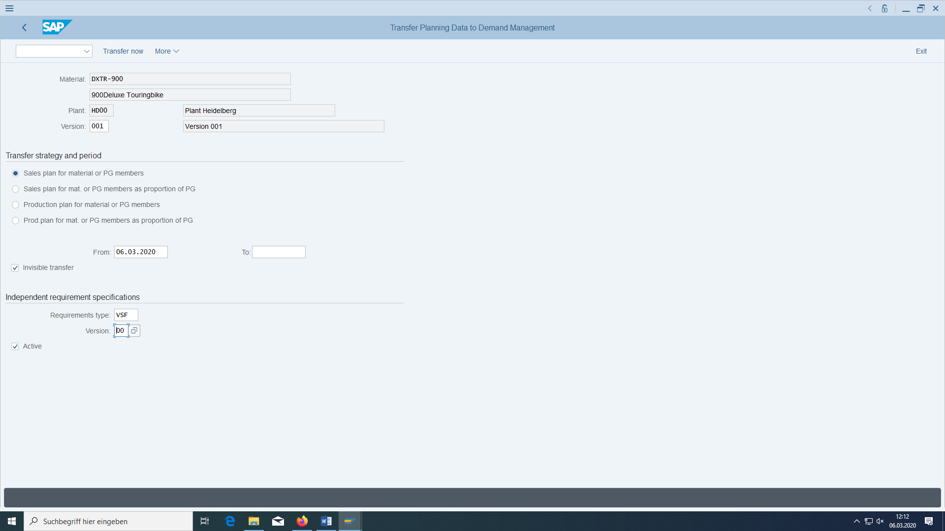

Enter your Version.

### Check Demand Management

Then check whether this planning requirement was actually transferred to Demand Management and on what date. The requirements type must be set to VSF (under Items) because of the 40 strategy group of the material.

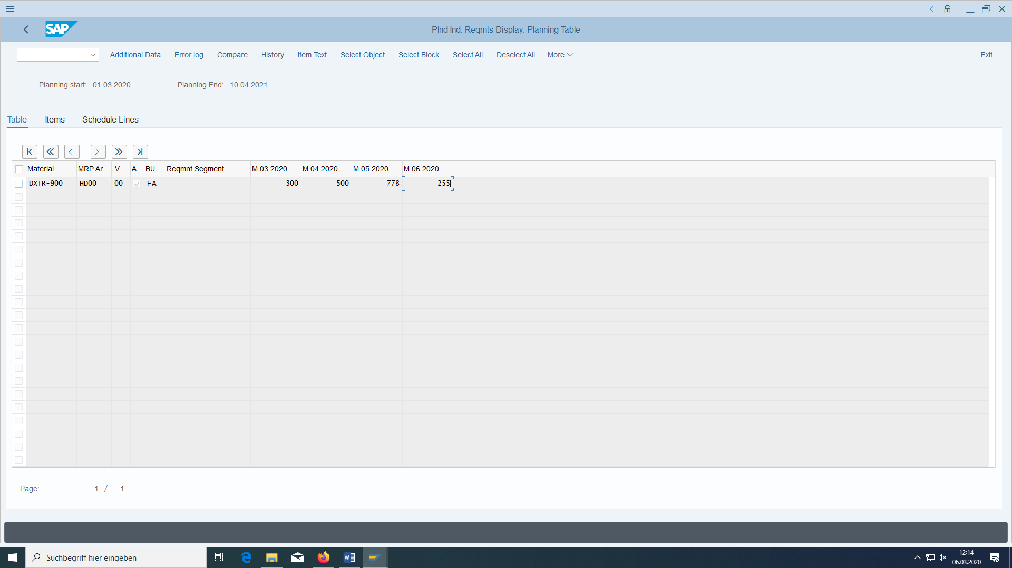

Thus the forecast is not only given in Sales, but also in Production/Logistics.

### Check whether there is a requirement for MRP

The requirement was saved as a planning requirement and will later trigger planned orders at the lower levels of the BOM (or purchase requisitions) during the next MRP run to fill the stock deficits.

## Enter a sales order



Figure 8: Schematic process display Enter sales order

You receive a call from your customer 'Customer ###'. He wants to order 400 bikes.

Switch to the Create sales order function.

A order has a head with positions with schedule lines.

As order type, enter OR for standard order and confirm with 'Enter'. Enter your new customer with the name 'THD-###' and enter an order number of your choice (also alphanumeric).

Then choose 'Enter'. The system then copies relevant information from the customer master record to the order. The customer role has to be stored in the sales area.

Pay immediately w/o deduction.

Free House incoterms.

Enter the bicycle and an order quantity of 400 pieces as the material. Here you have to select TAN for position type, because only then you can calculate with IndReq. This is possible, for example, with OR standard order.

Also enter a weight for shipping.

Confirm these entries with 'Enter'. Since the warehouse stock is not sufficient to cover the requirements of the order, you should find yourself in the availability control screen. Accept the delivery proposal of the system for a later date and quantity of 400 pieces by clicking on the green tick next to the proposal for full delivery. You then return to the overview screen. Select the line entered here (item 10) and choose 'Conditions item'. Here you can have a look at the details of price determination in the background. The system should have selected the price you previously created of €250 per piece (**if you entered in the price conditions PR00**):

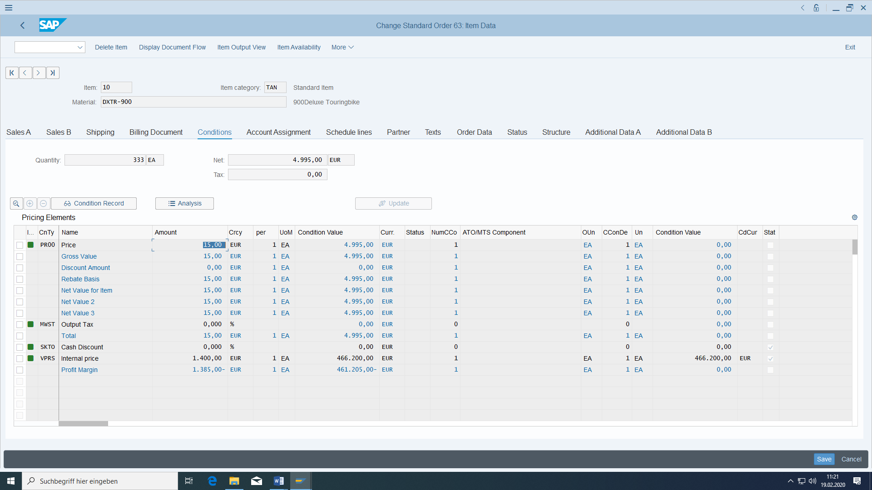

Choose Back to return to the overview screen.

Your customer spontaneously realises that he actually needs 1000 and not only 400 wheels. Change the order quantity to 1000 pieces and then choose 'Enter'. Confirm the delivery proposal of the availability check again. On the overview screen, select item 10 again and check the conditions again. Now you can see that the selling price has been changed to 200€ due to the larger quantity.

**You should solve all problems in the incompletion log:**

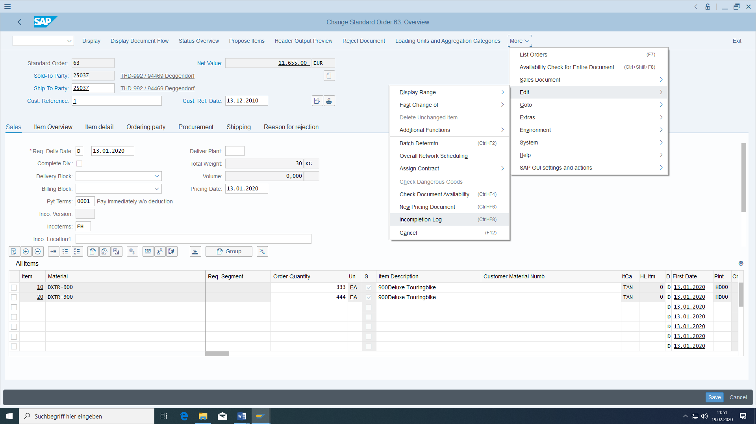

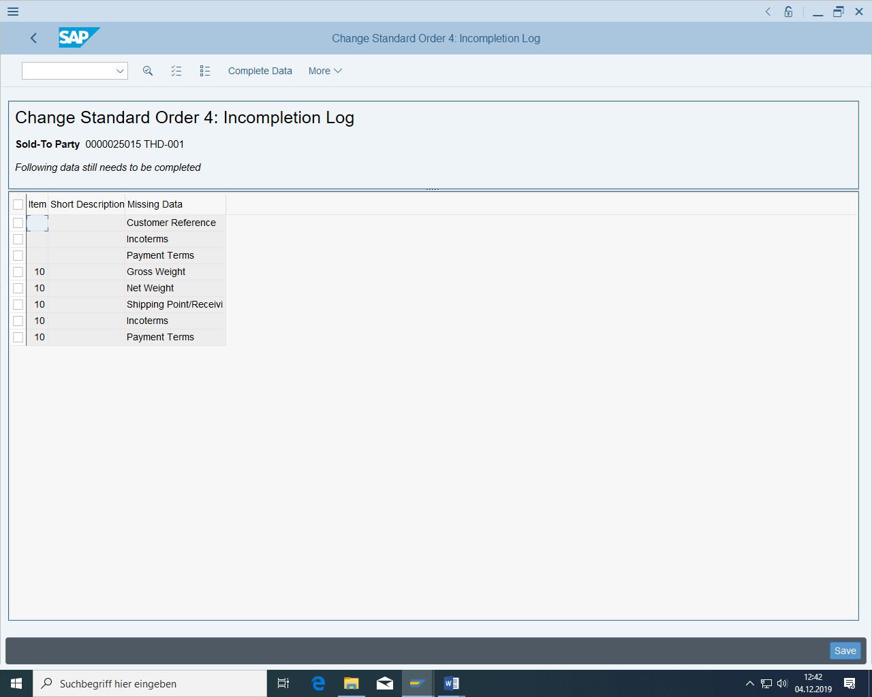

Just click on all the items and enter missing values. Especially the plant HD00 for the shipping data in positions, because otherwise the customer order positions cannot be confirmed:

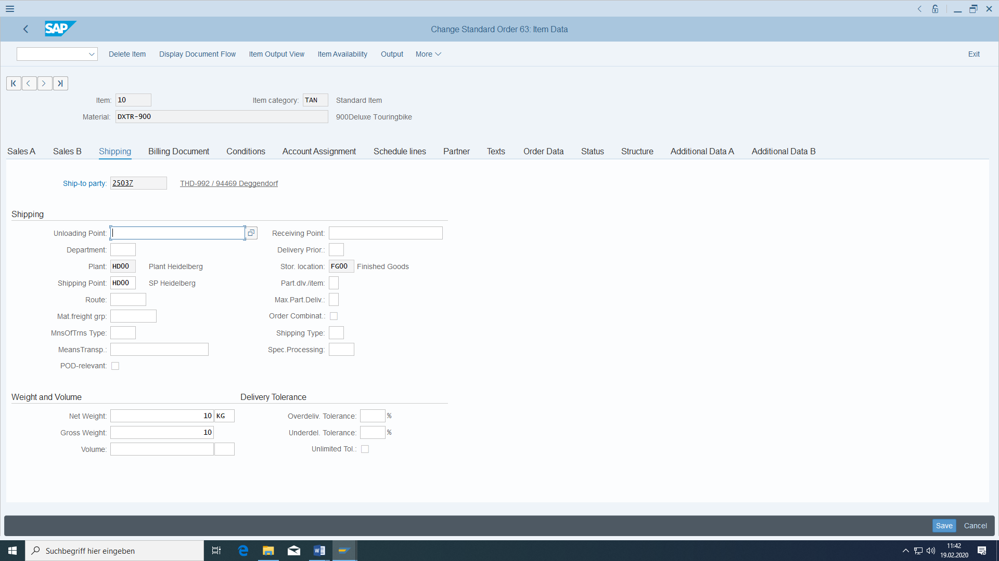

Only with the shipping plant the order position can be confirmed for the amount and date:

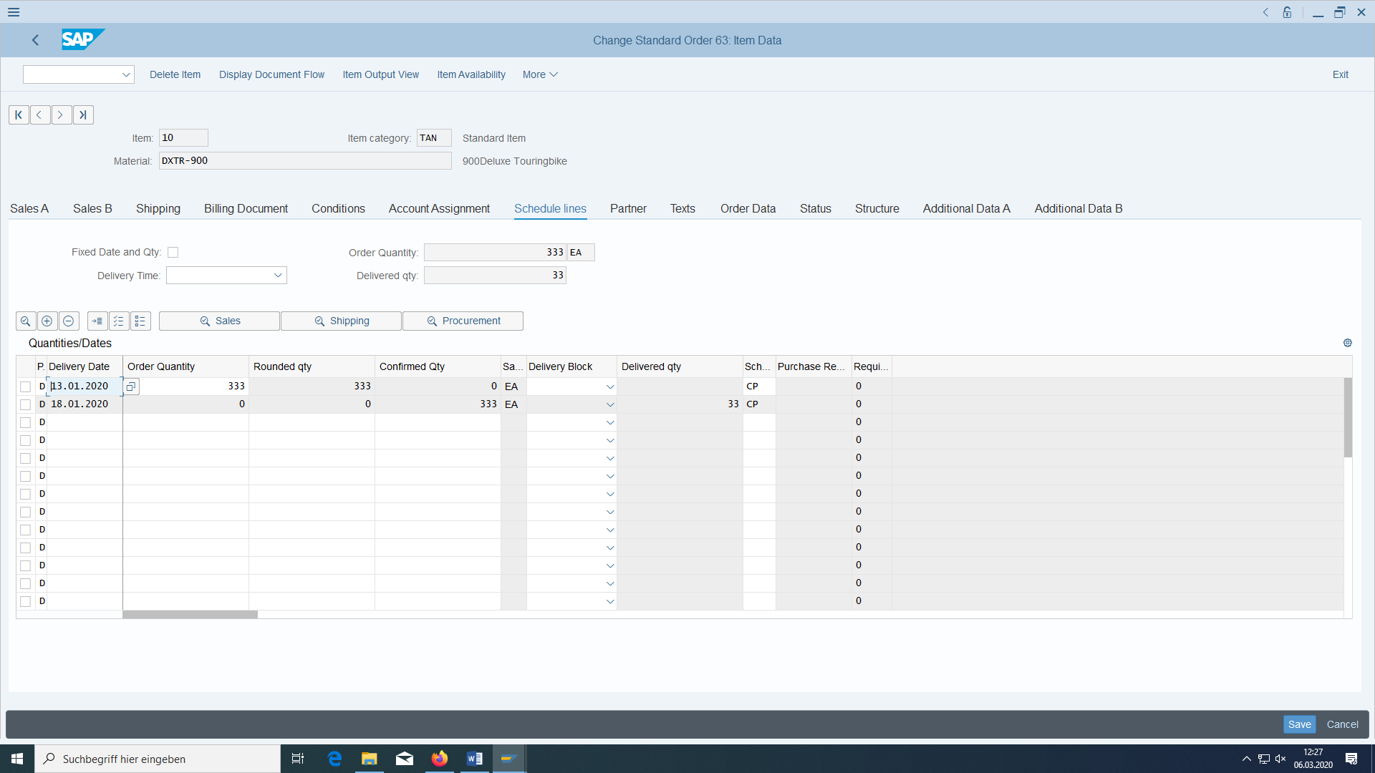

The second line is significant:

It shows the confirmed date and confirmed quantity (here 333)

When we later deliver the good to the customer the shipping point will be determined. If there are problems, then look if:

in material:







In customer:





This combination has been customized already:

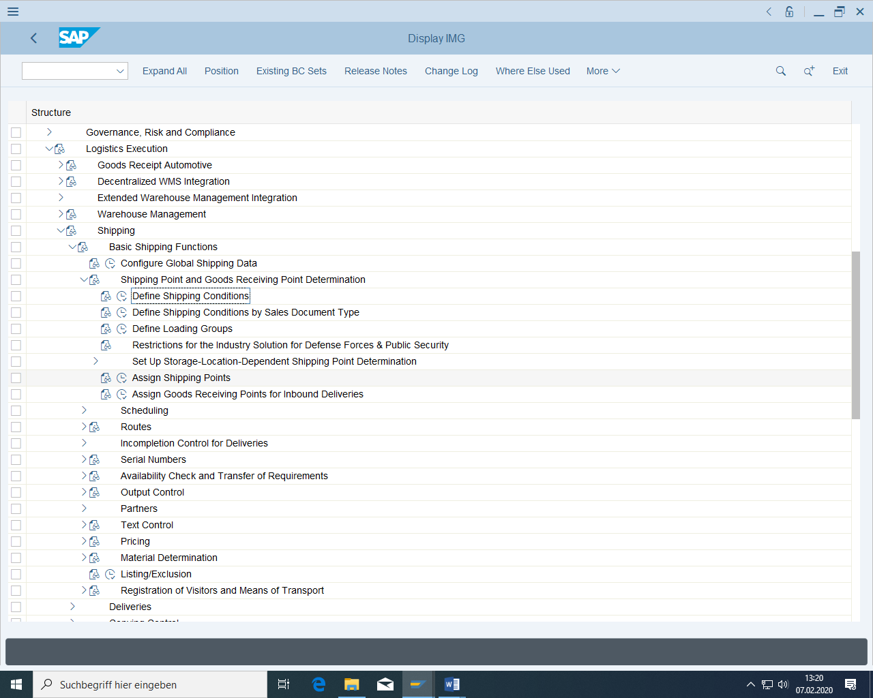

at Assign shipping points:

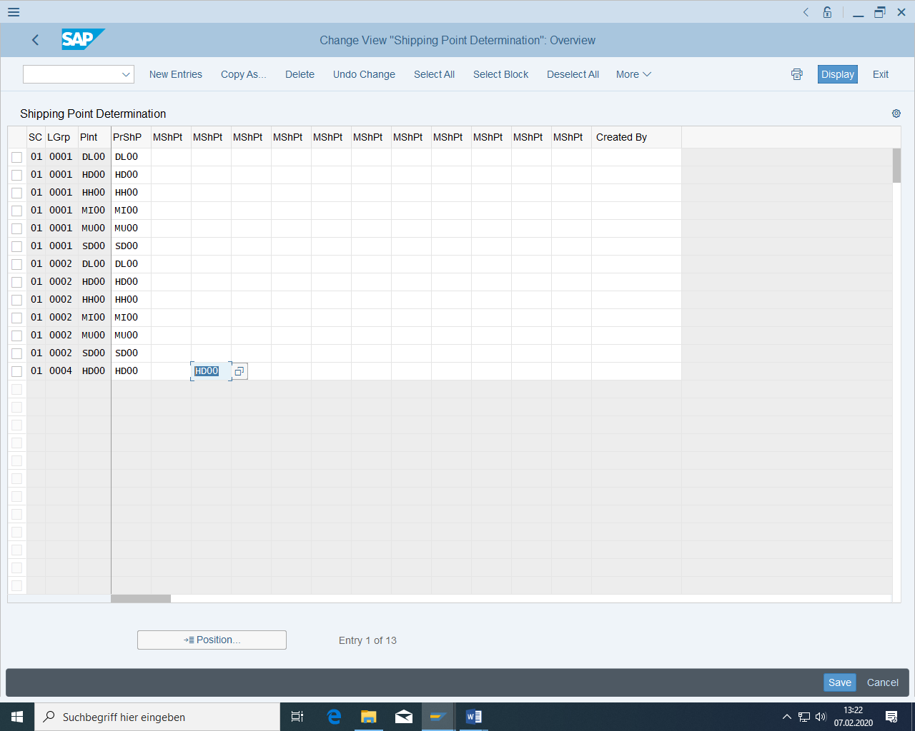

Dial back, save the sales order and note the order number.

Forward order: ___________

Check whether the system finds requirements type KSV (under the Procurement tab title), since the strategy group has been set to 40. Only then is the planned independent requirement consumed.

### Check whether the sales order was consumed with planned independent requirements.

After entering the sales order, the nearest planned independent requirement must have been reduced automatically. Of the 255 pieces at 06/2000 in planning:

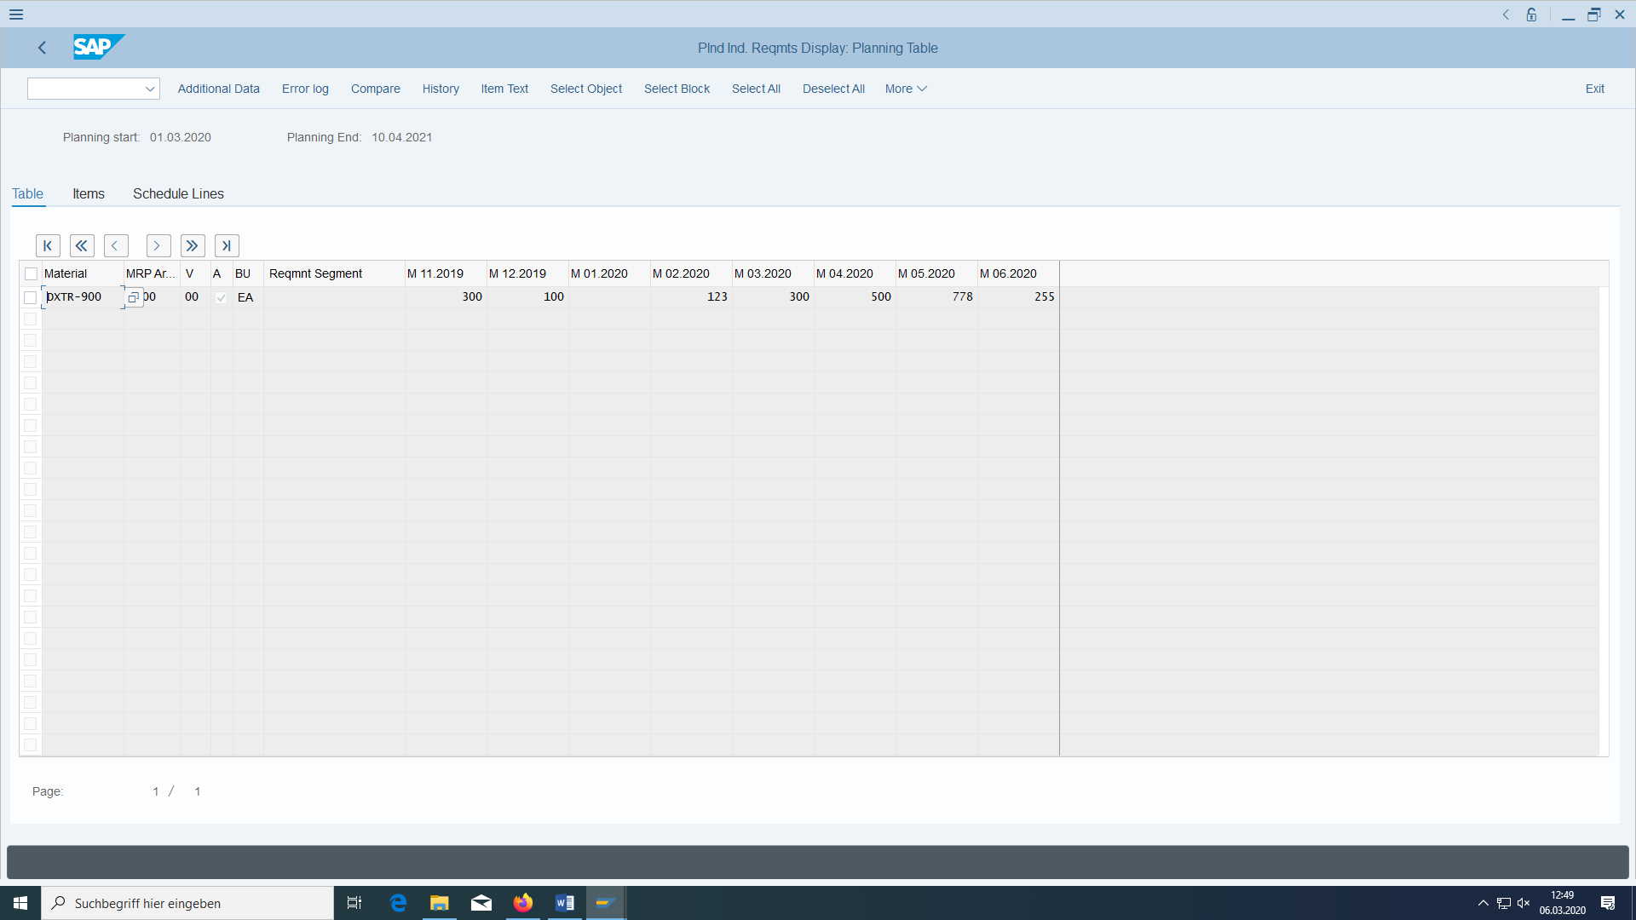

only 5 pieces may now be relevant to requirements with a nearby customer order of 250:

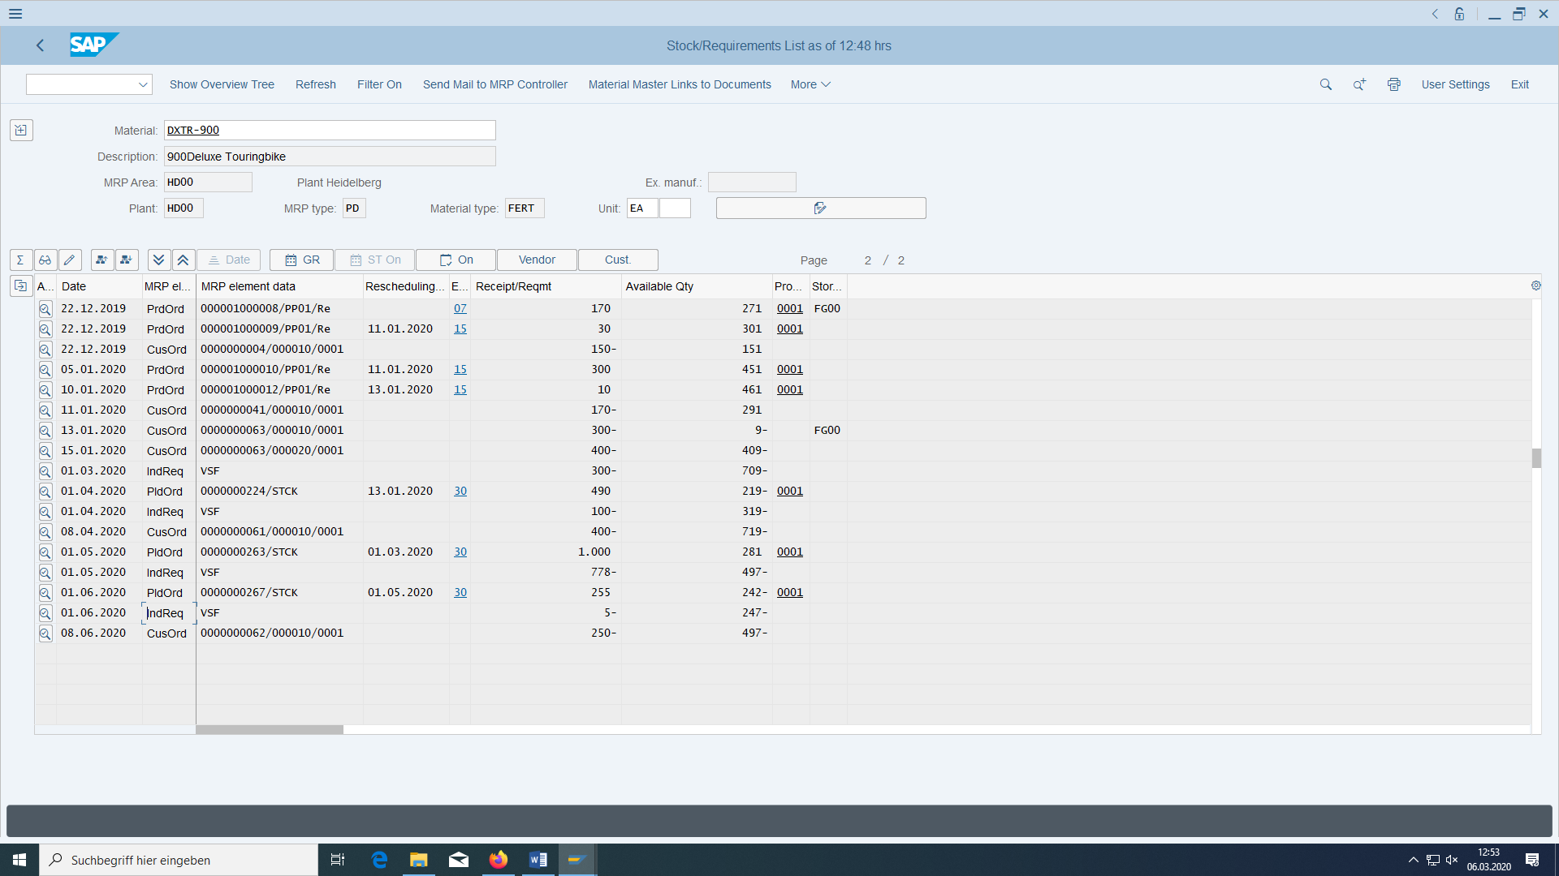

Also check in Customizing whether planning strategy 40 is set correctly:

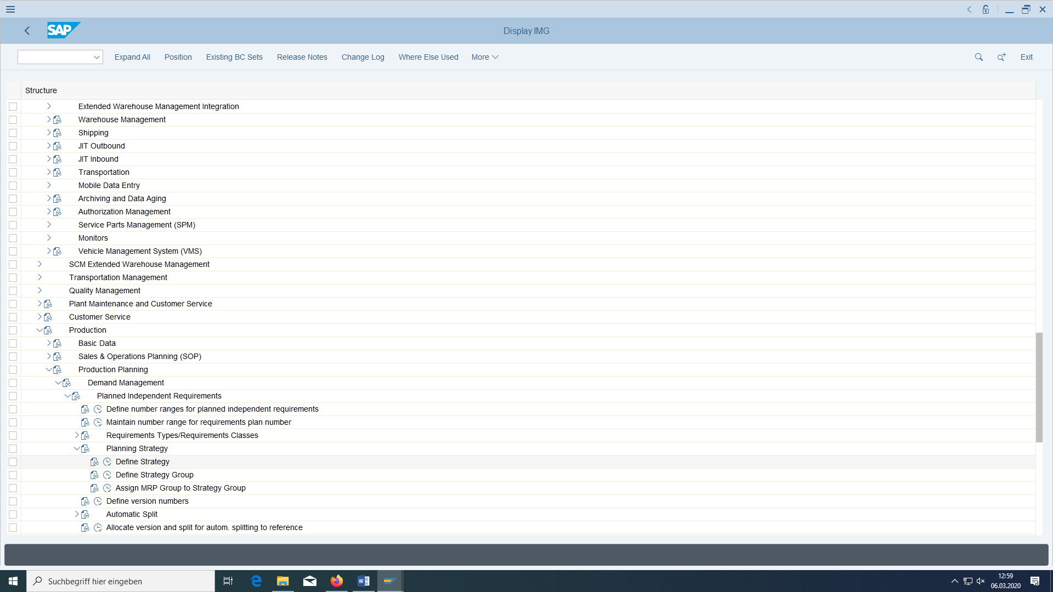

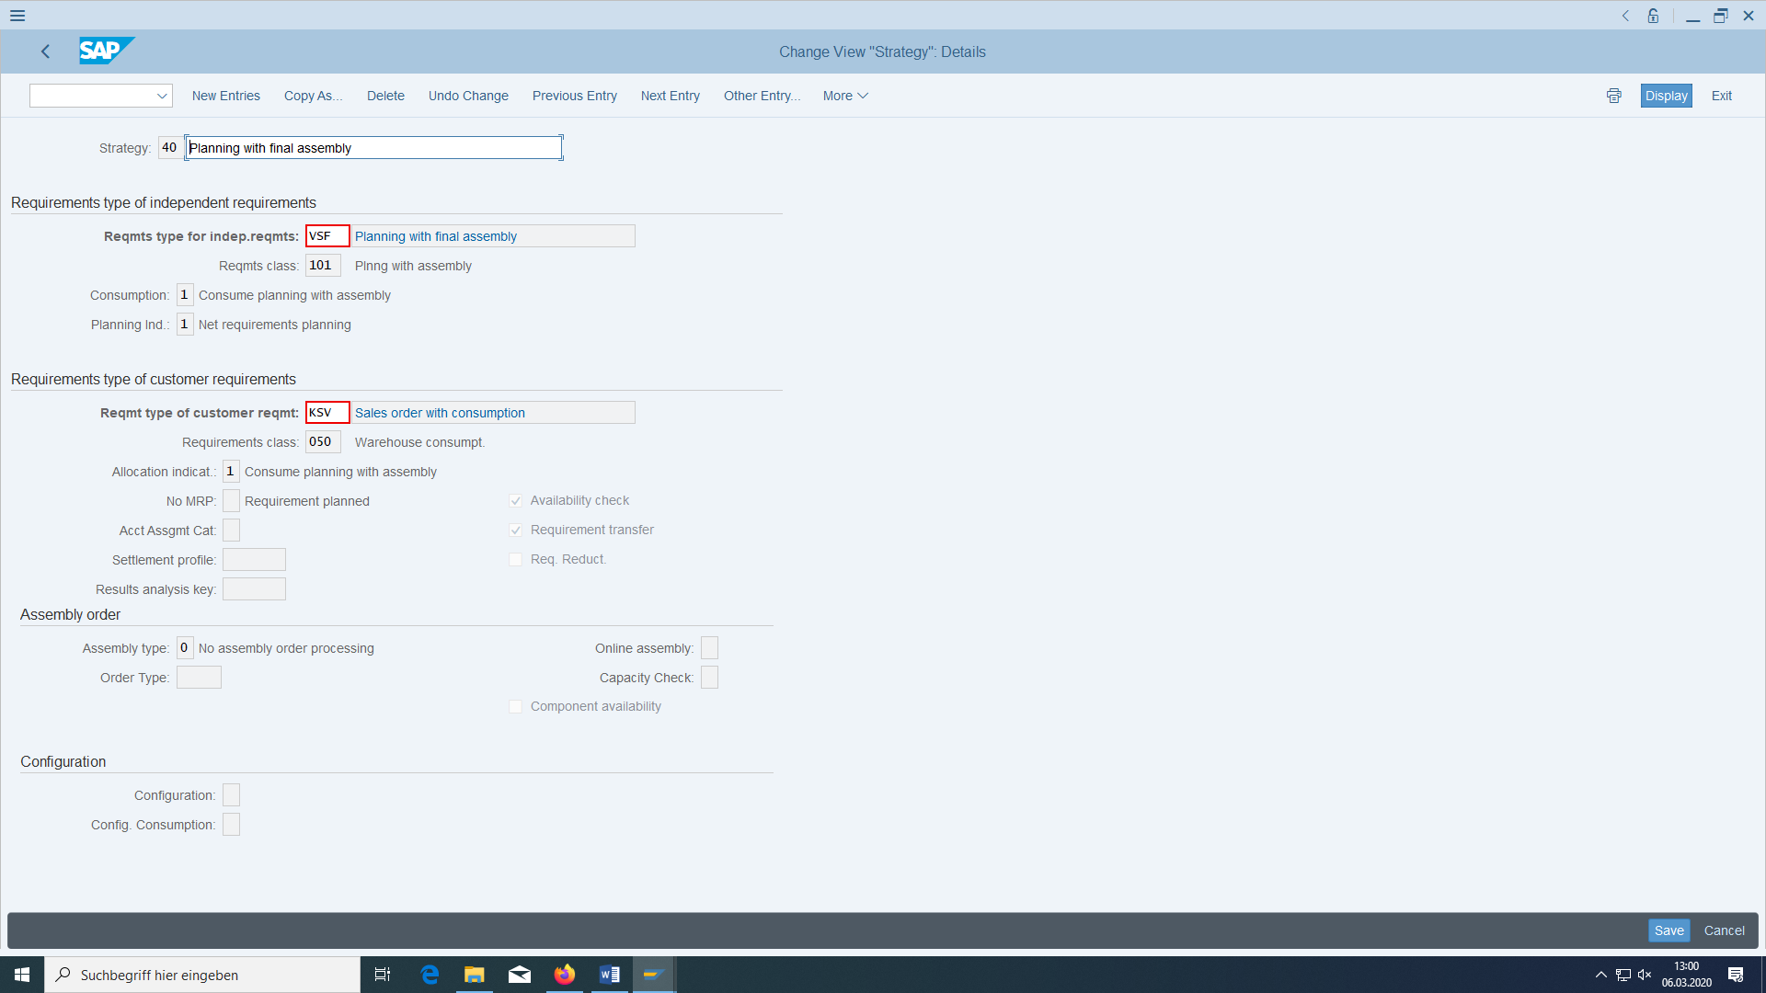

### List all orders for customer

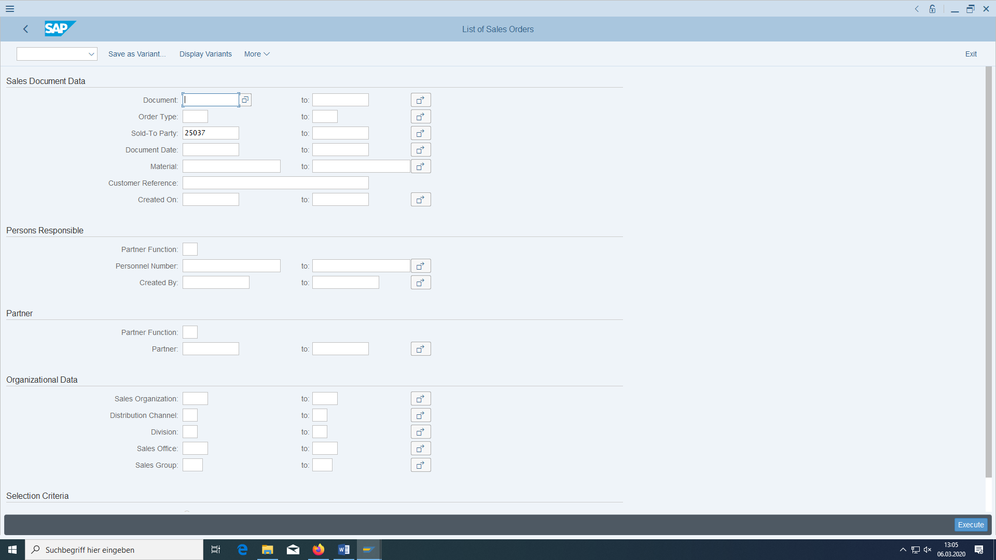

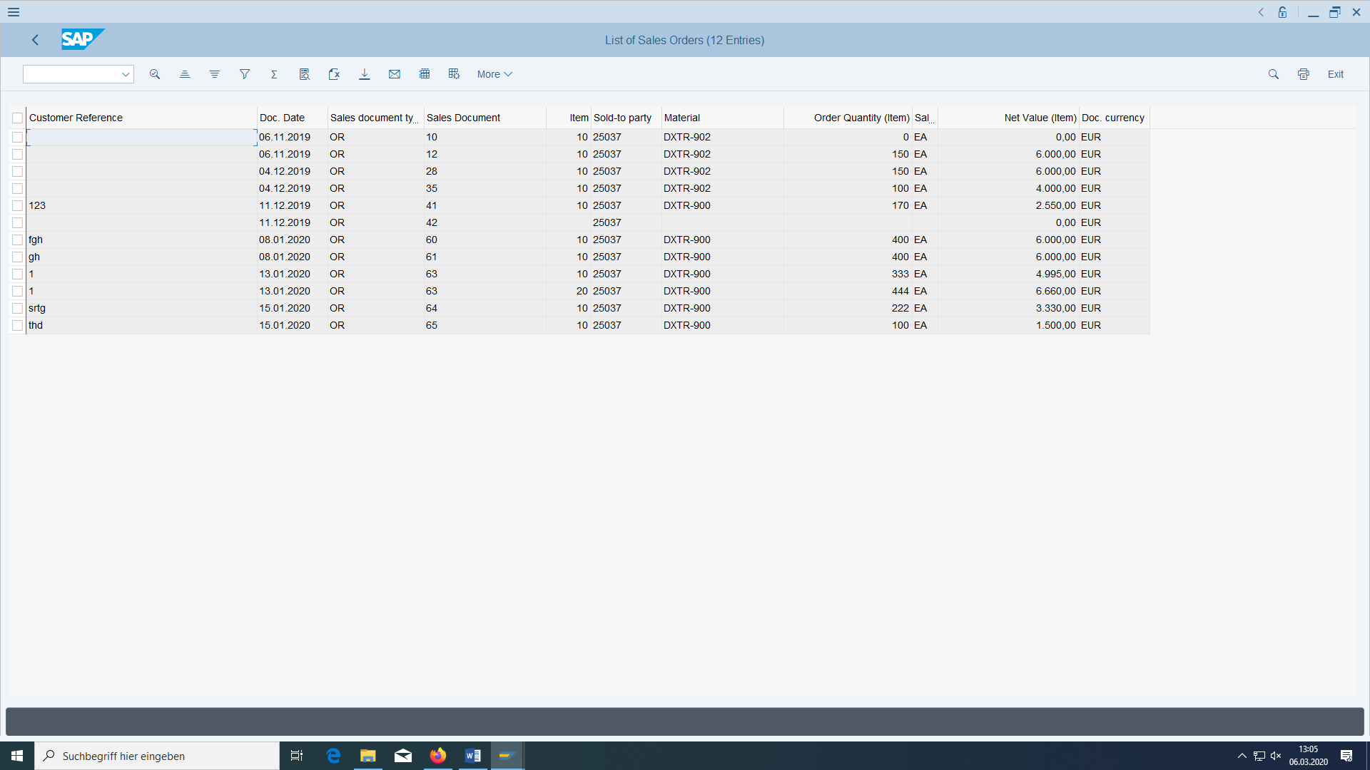

# Material requirements planning run

|  |  |  |
| --- | --- | --- |
| Check stock quantities, result of MRP run | Logistics > Materials management > Inventory management > Environment > Inventory > Akt.Bed./Best. list | MD04 |
| Result of the MRP Run | Logistics > Production > Demand planning > Evaluations > MRP list | MD05 |
| MRP run | Logistics > Production > Demand planning > Planning > Single plan multi-level | MD02 |
| Open a production order | Logistics > Materials management > Inventory management > Environment > Inventory > Akt.Bed./Best. List > Convert planned order to production order | MD04 |



Figure 9: Schematic process representation of demand planning

Always leave transaction MD04 open.

## Checking the stock quantities

Call up the transaction for the current stock/requirements list.

First enter the material Bicycle, plant HD00 and confirm with 'Enter'. You see the available quantity and the requirements caused by the sales order you just entered, as well as the planned independent requirements. Also check the stock levels of the wheel and tyres. No of your material should be available in sufficient quantity to completely supply the sales order or the production orders (so different from my materials).

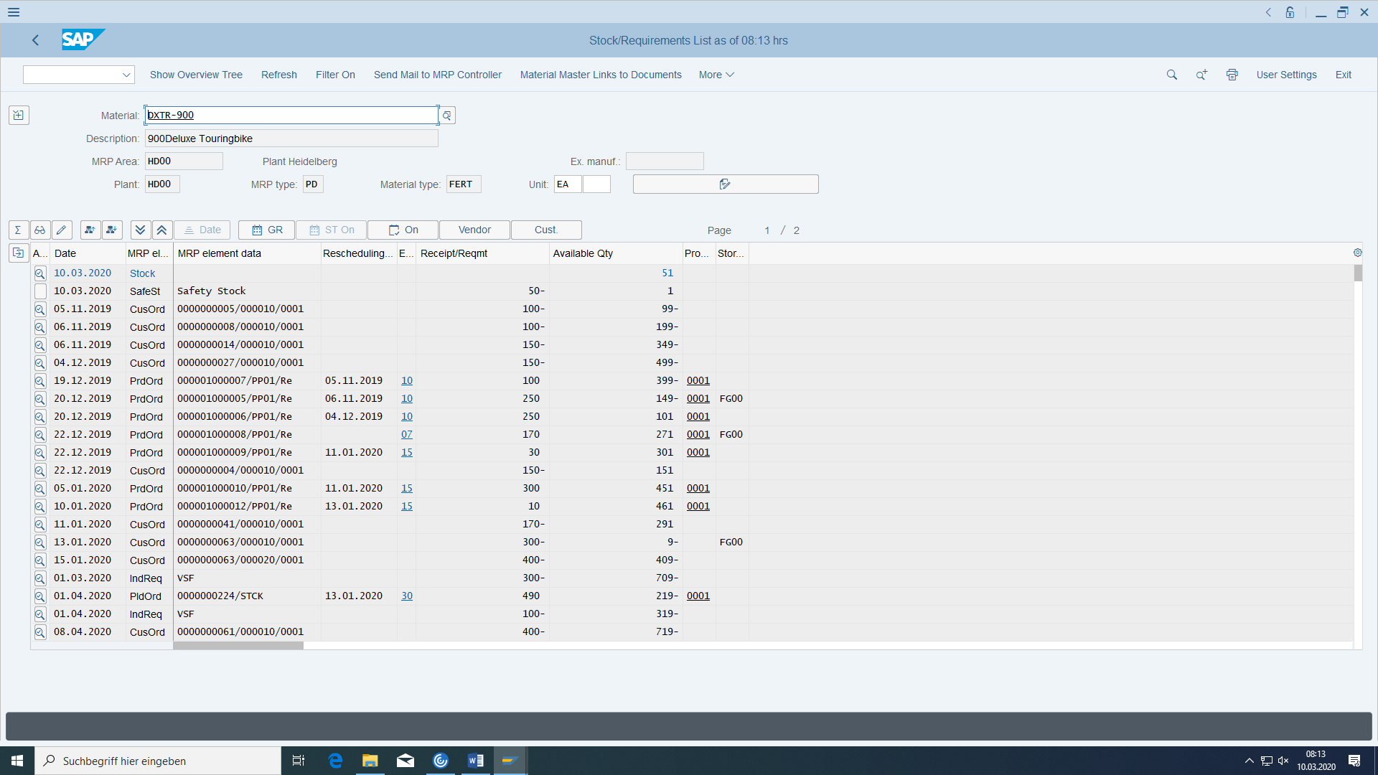

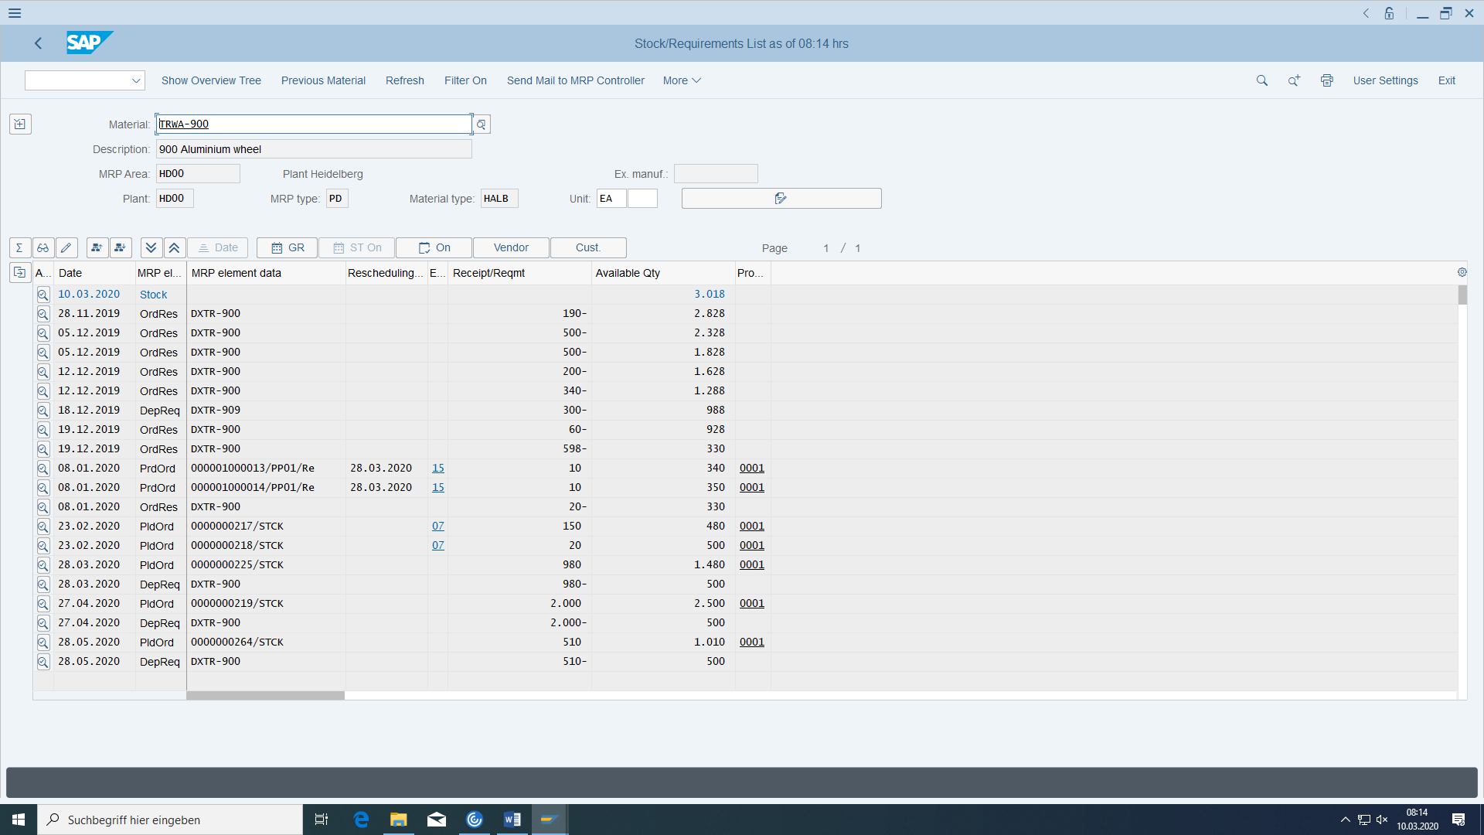

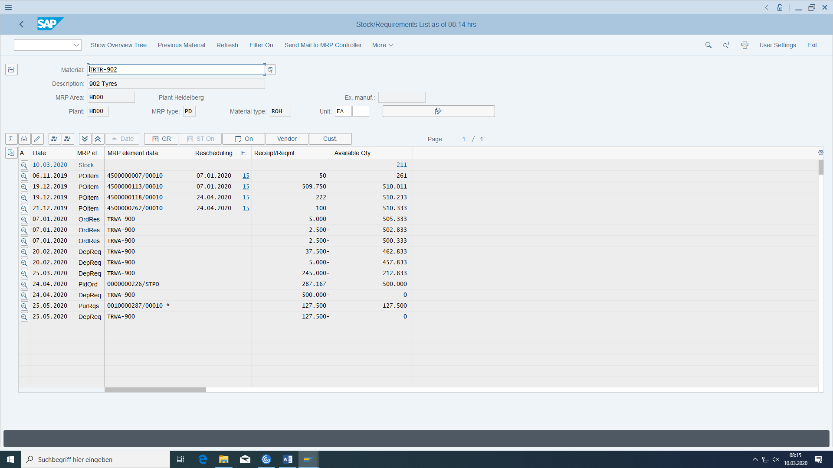

## Unplanned increase of stock

You can always enter stock quantity for a material with

MIGO:

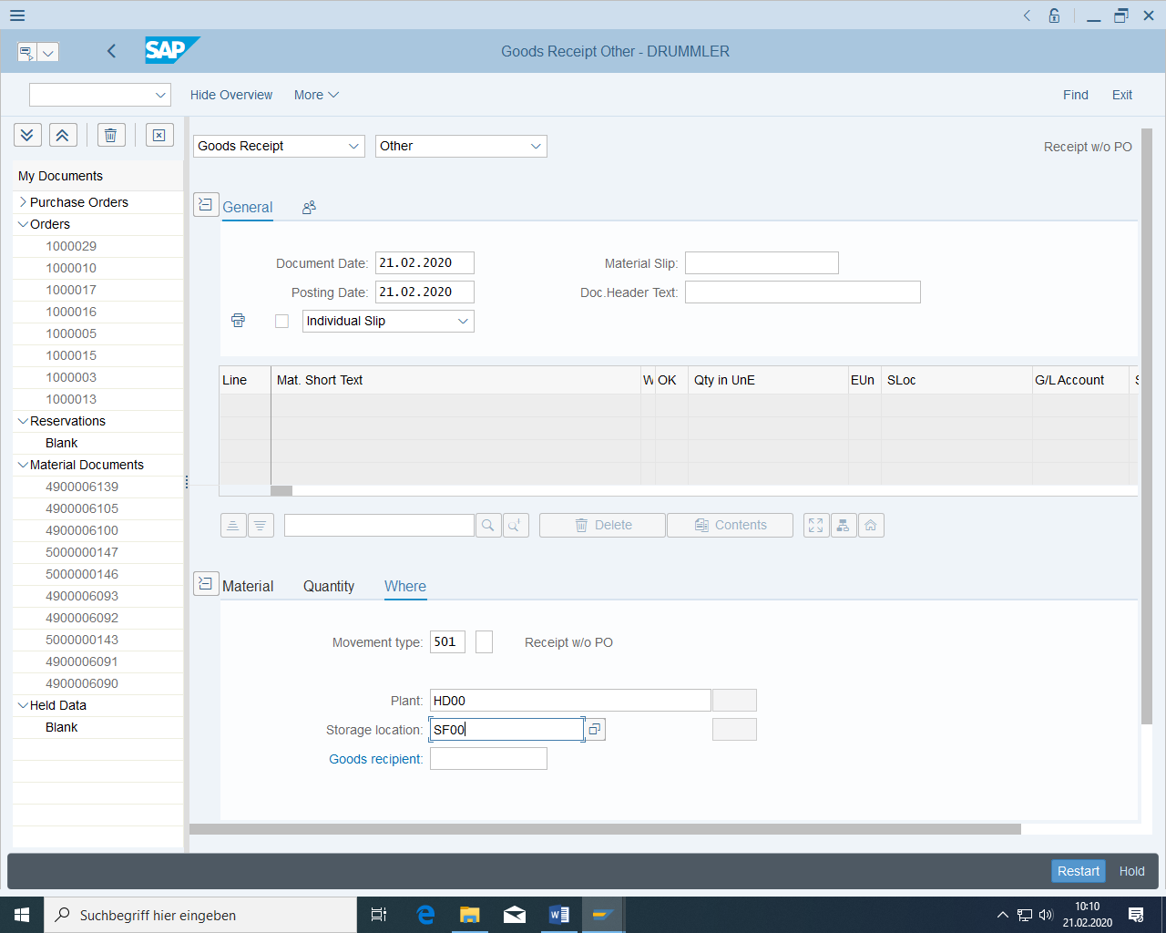

## Material Requirements Planning via the MRP Run

### Calling the MRP Run

Choose the transaction for single-item, multi-level planning.

Carry out planning only for the wheel in the production plant (single-item planning, not overall planning). Select Netchange (only materials with MRP-relevant changes since last MRP run are taken into account) and not Rescheduling (all materials are recalculated). In the 'Requisition' field, choose Alternatively, you can first create planned orders, which then have to be converted manually into purchase requisitions – 2 eyes approval -) and select below that unchanged components are also to be planned. Confirm with 'Enter'. The system now warns you to check the input parameters. Confirm with 'Enter'.

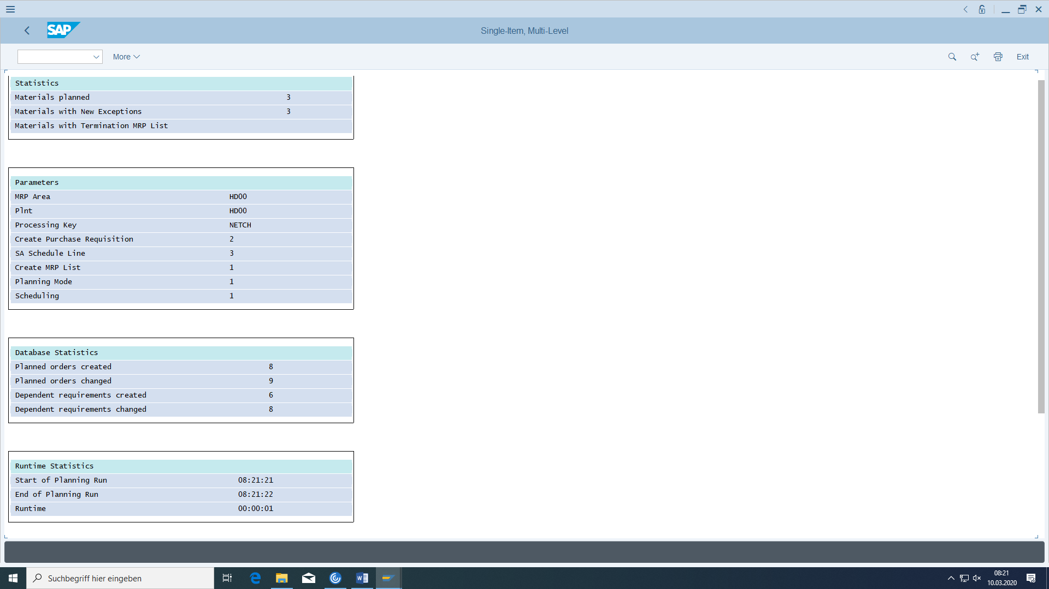

The system now executes the planning run and should inform you that your 3 materials were planned and new exceptions occurred for 3 materials. The results of the planning run are exceptins and planned orders and purchase requisitions in the amount of the material lot size. In the case of planned orders, dependent requirements (multiplied by the BOM component quantity and shifted forward by the lead time) are transferred to the components of the assembly BOM. The materials are processed in the order of the disposition stages according to Gozinthograph.

At the start of a planning run, the planned orders, purchase requisitions and dependent requirements are deleted because they are recalculated. This does not apply to planned orders or purchase requisitions, who have been fixed by the dispatcher before.

Then check the current stock/requirements situation and MRP situation for all 3 materials. In particular, determine the **sources of** dependent requirements. Which planned orders, which purchase requisitions were created with which quantities and which dates?

### Result of MRP Run in Current Stock/Requirements List and MRP List

The purchase requisitions could then be released as purchase orders directly in the current stock/requirements list. This list is as current as possible. So it actualize all operative data.

The MRP list is in contrast to the MRP list the status of the last MRP. It is even possible to compare both lists:

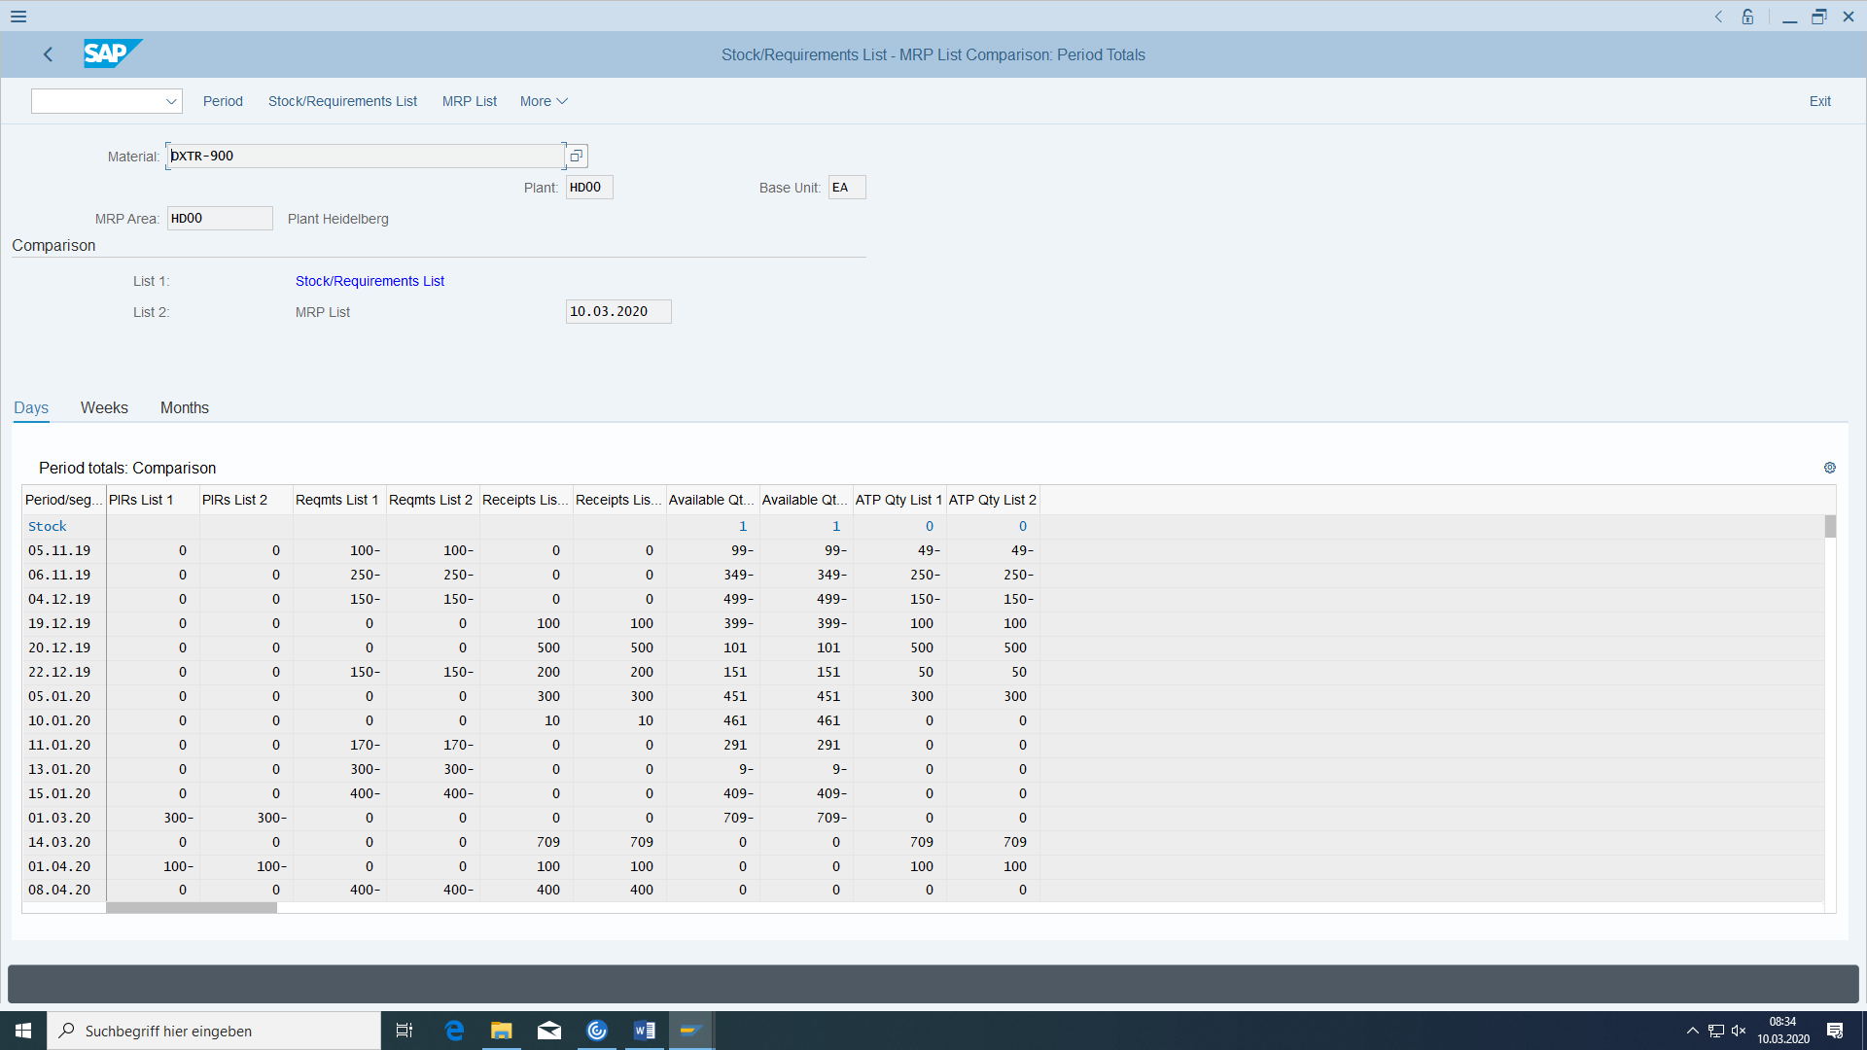

# Purchasing of components

|  |  |  |
| --- | --- | --- |
| Create purchase order | Logistics > Materials management > Inventory management > Environment > Inventory > Akt.Bed./Best. List >Details of the MRP element | MD04 |
| Display stock overview | Logistics > Materials management > Inventory management > Environment > Inventory > Inventory overview | MMBE |
| Display purchase order history | Logistics > Materials management > Purchasing > Ordering > Advertisements | ME23N |
| Enter goods receipt | Logistics > Materials management > Purchasing > Purchase order > Follow-On functions > Goods receipt | MIGO_GR |
| Display material document | Logistics > Materials management > Purchasing > Purchase order > Follow-On functions > Goods receipt | MIGO (action Display) |

## Create purchase orders for the components

First call up the stock/requirements list.

Select the material tire and plant HD00 and choose 'Enter'. Double-click the row with the purchase requisition. A window appears (Details for MRP Element) in which you can convert the purchase requisition into a purchase order.

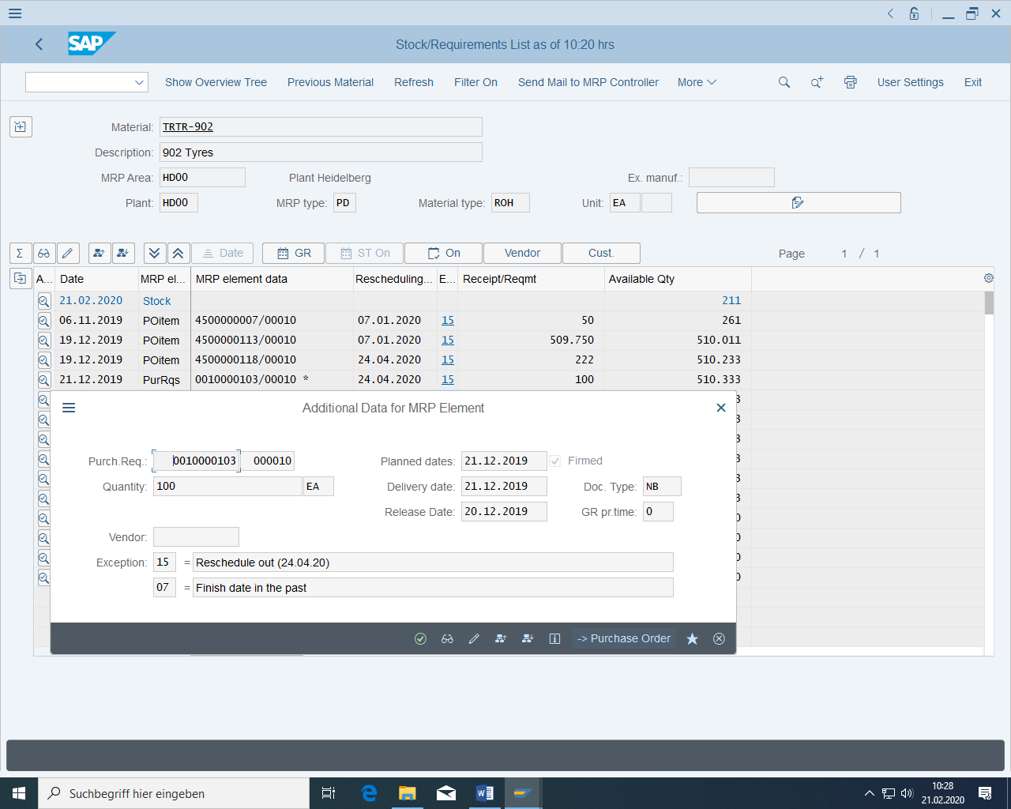

In the following main mask, in order to be able to establish a reference to the requisition, the requisition number (far left and below) must be selected, and the "Adopt" button must be clicked at the top above it (this will then show the position on the right).

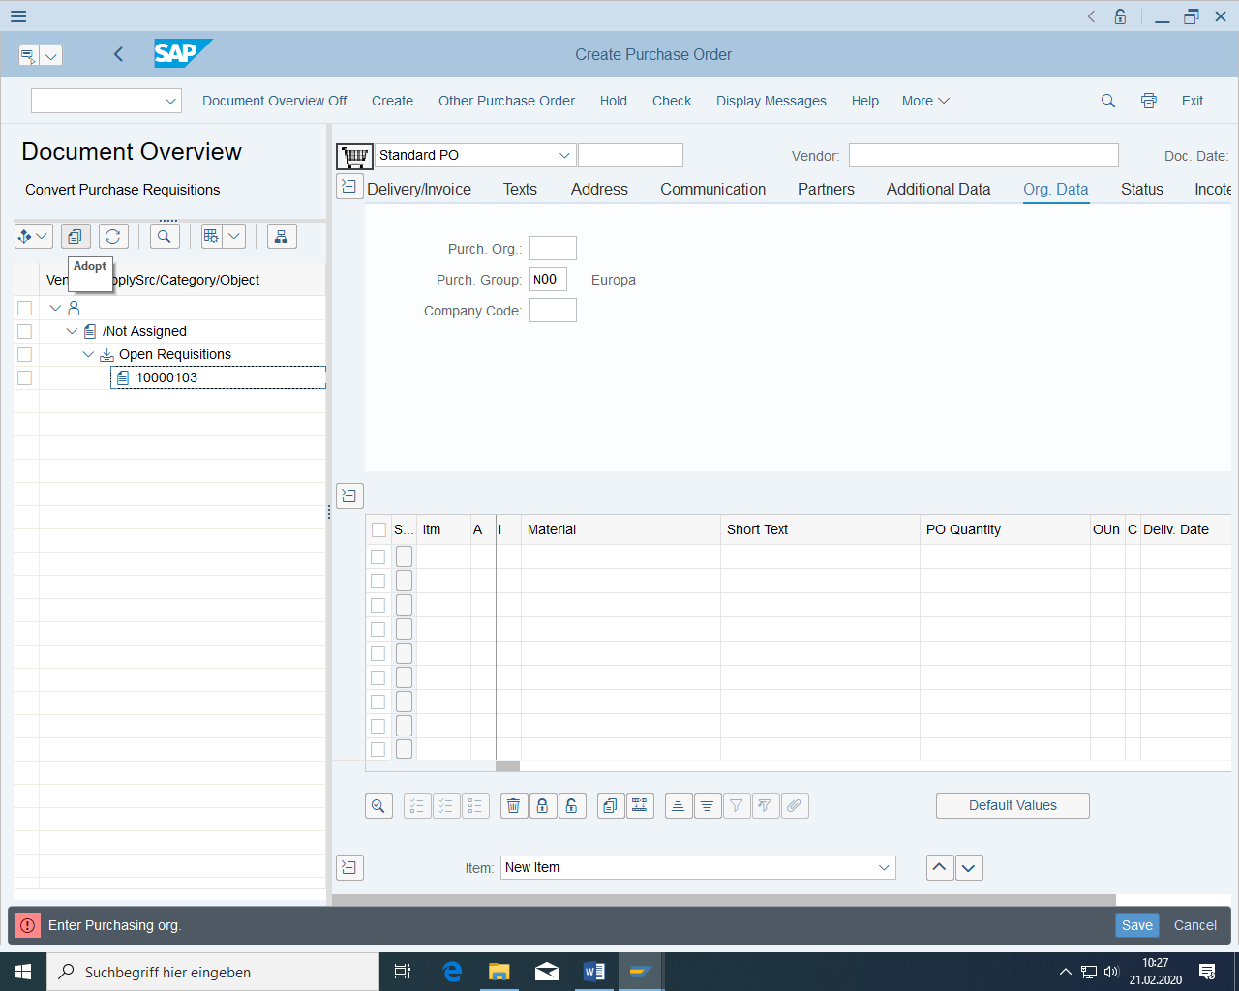

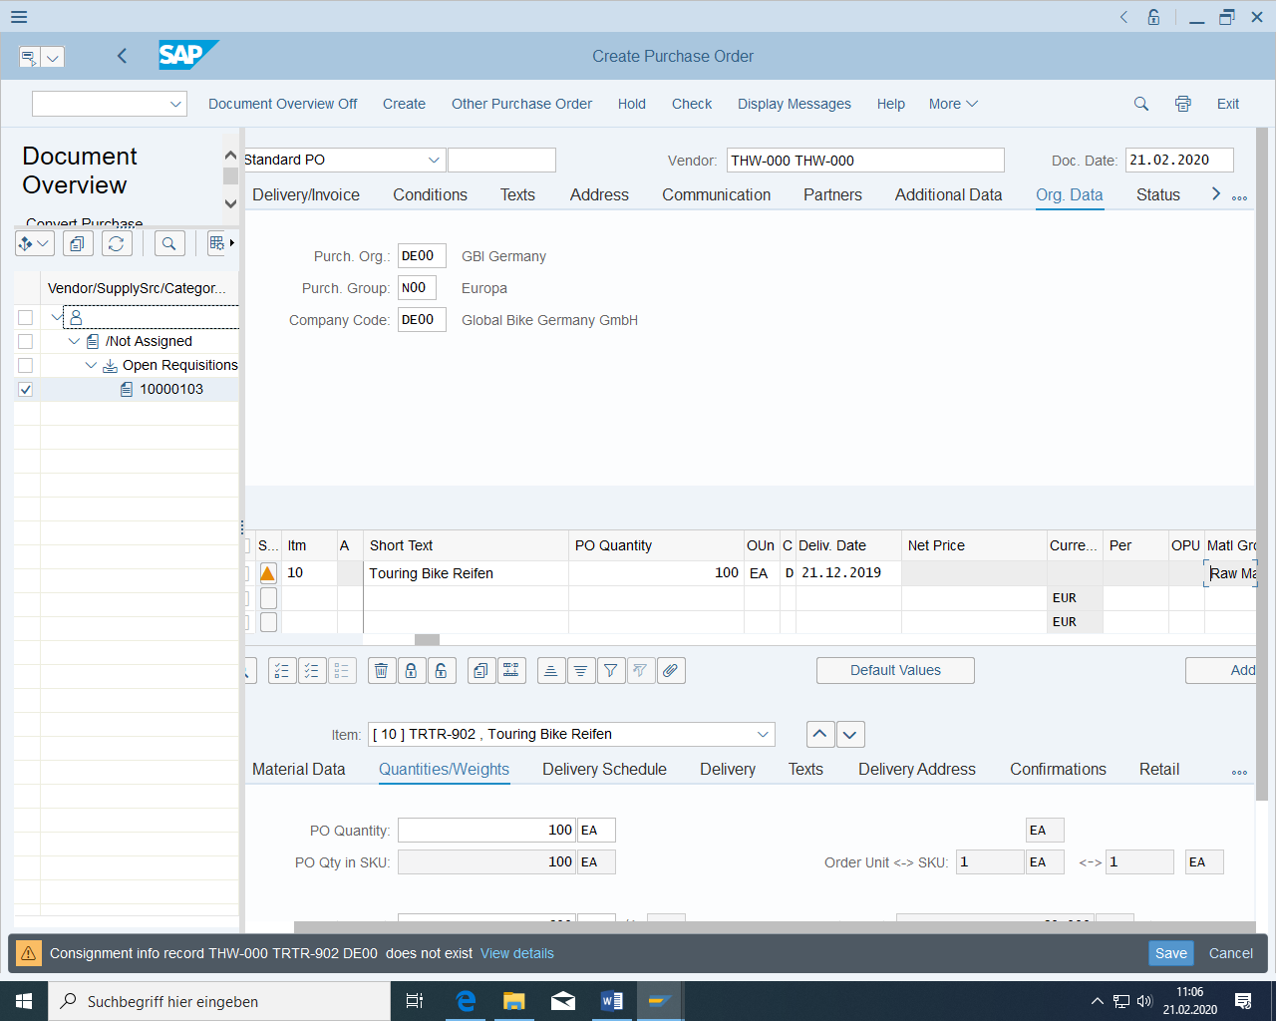

The vendor should be copied from the source list. If this is not the case (for example, because the purchase requisition was created without this vendor in the source list),

* You must first assign the source of supply for the purchase requisition (cancel the purchase order and double-click again on the line with the purchase requisition, select "Change element", in the screen for the purchase requisition choose "Edit > Assign source of supply", now the vendor and price are automatically copied from the source list, save) before you again convert them into a purchase order.
* or alternatively and quicker: you select a vendor directly in the generated purchase order for the corresponding purchasing organization.

Enter raw materials as the storage location in your purchase order. Conditions for pricing are copied automatically,

* From contracts, if the purchase order is a release order
* From purchasing info records for this vendor/material
* From extended conditions that refer to certain criteria

Then save the purchase order and note the number.

Normal order: ____________________

Then refresh current stock/requirements list. Instead of the purchase requisition, you should now have your standard purchase order displayed here.

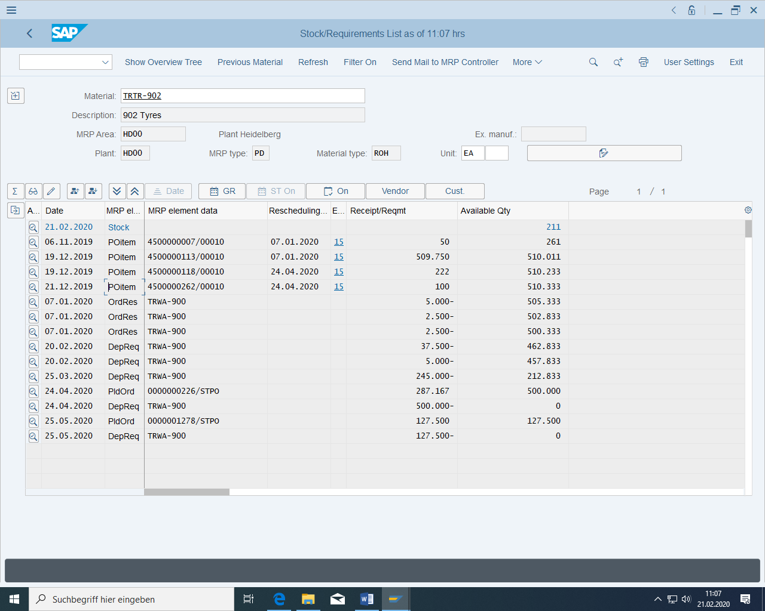

Of course, a purchase order can also be created without reference to a purchase requisition or refer to another purchase order or to a customer inquiry.

A material master record does not necessarily have to be created for a purchase order item if the **consumable materials are** purchased directly for an account assignment object (project, cost center, asset, production order, sales order...), for example, measuring instrument for asset, megaphone for project manager.

However, if **no material is** created for a consumable, neither quantity nor value-based inventory management is possible. In addition, a description text, an order unit and a material group (which would otherwise have been taken from the material master record) must also be entered in the purchase order item.

If a material master record is created, the material types non-stock material NLAG and nonvaluated material UNBW exist.

Depending on the item category, a purchase order item can be sent externally to a **vendor** (standard item category) or internally to another plant as a **stock transport order** (advantage over stock posting: monitoring of the purchase order, specification of freight costs), or it can be a **drop shipment** (vendor delivers directly to customers), or it can be a **subcontracting transaction** with materials provided or **consignment goods**.

## Enter goods receipt for purchase order

The MIGO transaction is very powerful because it includes a lot of actions:

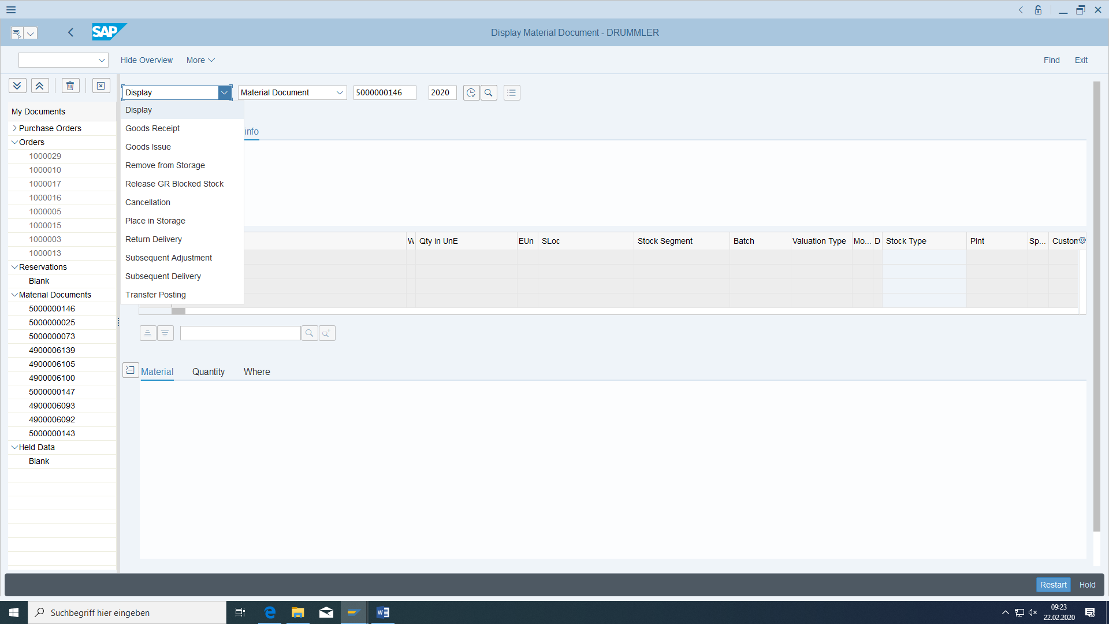

The vendor now delivers the components. Enter the goods receipts for the purchase orders you have just created.

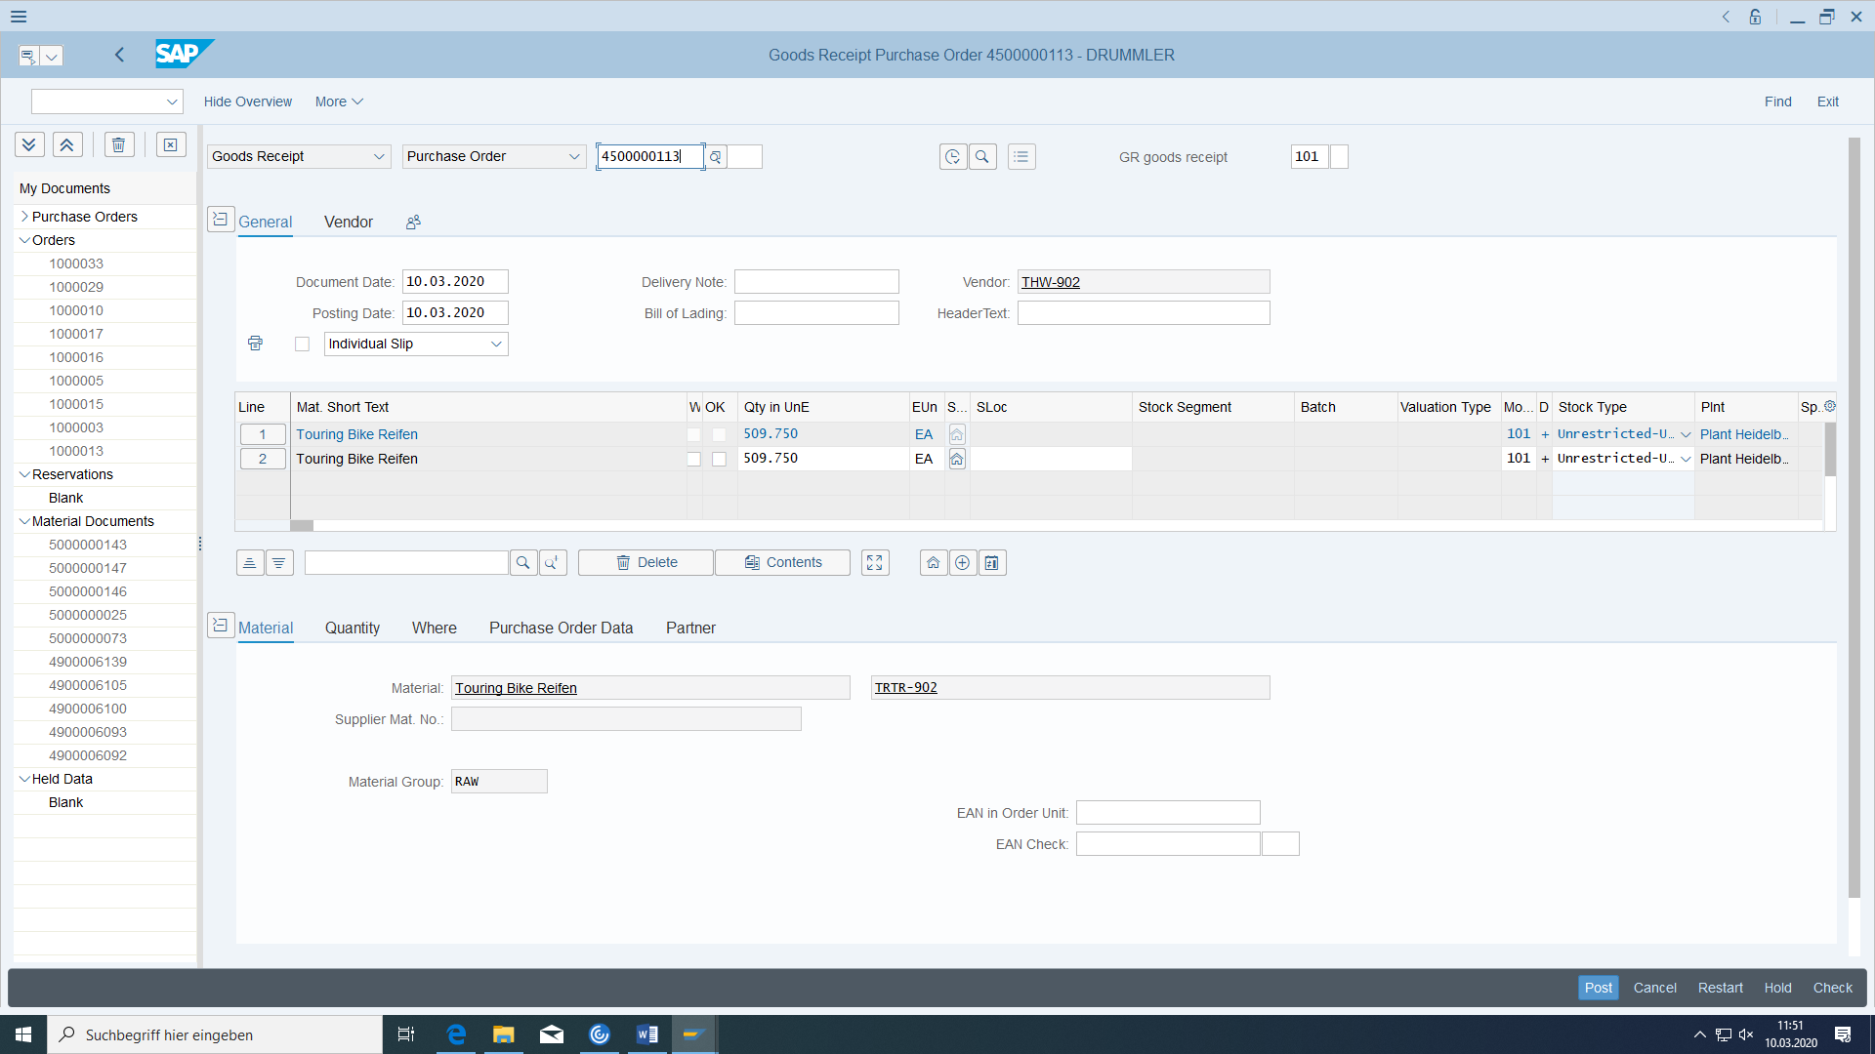

Set the OK flag and enter the storage location raw material. After post:

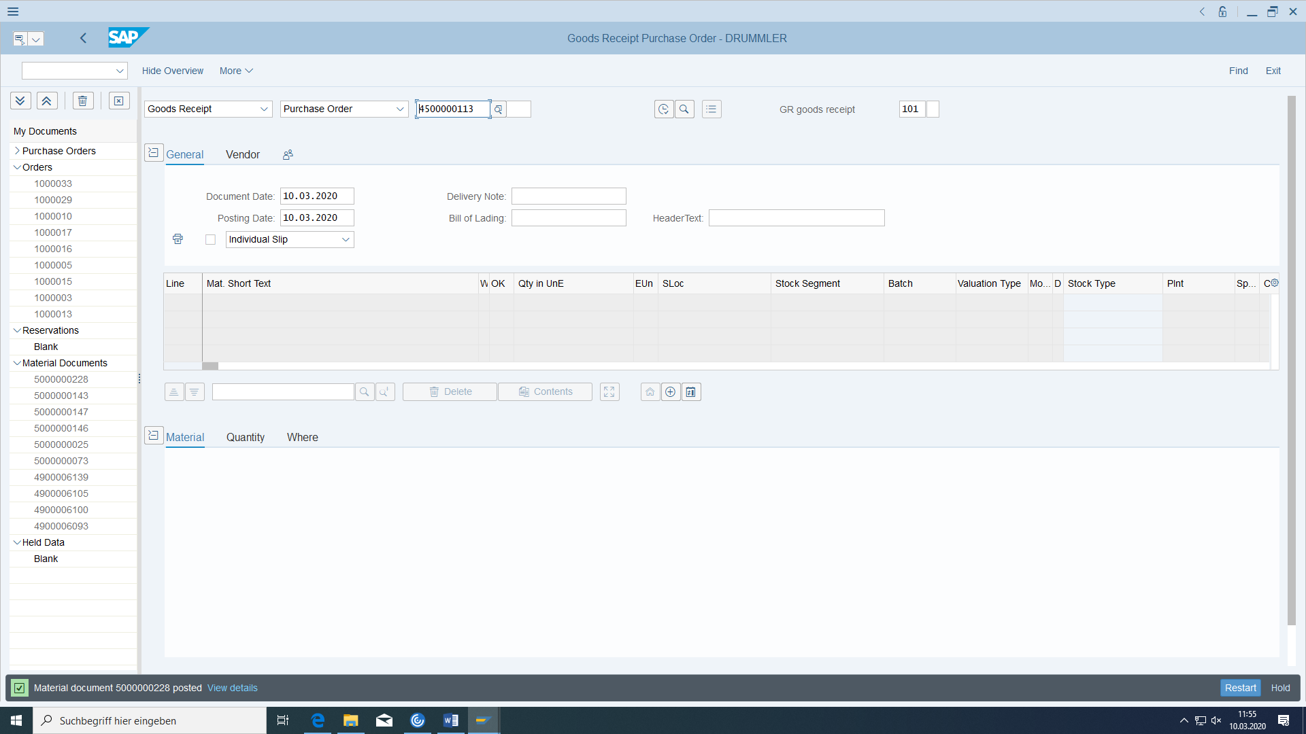

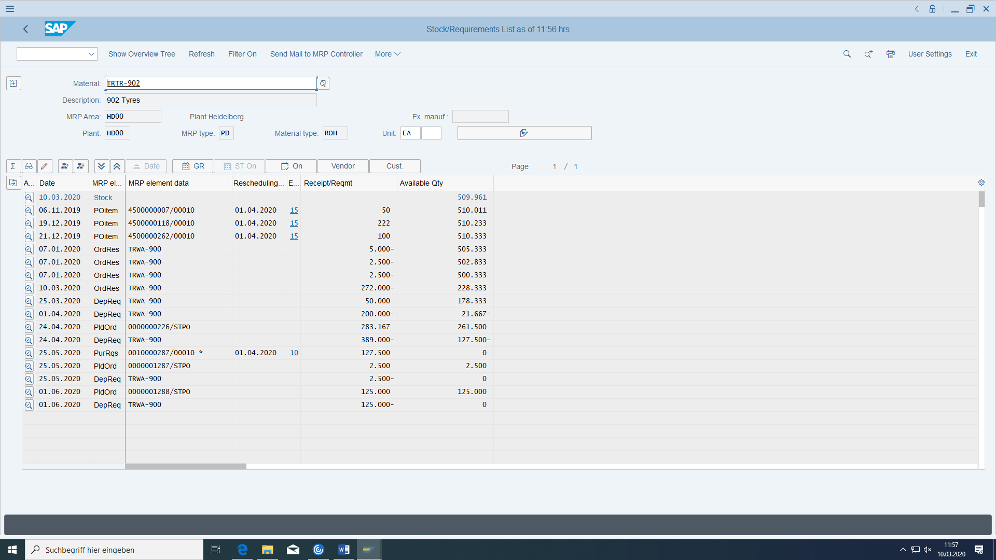

Now the purchase order disappeared but the stock amount increased.

Be sure that for cost element 760000 a cost centre has been defined in customizing (OKB9):

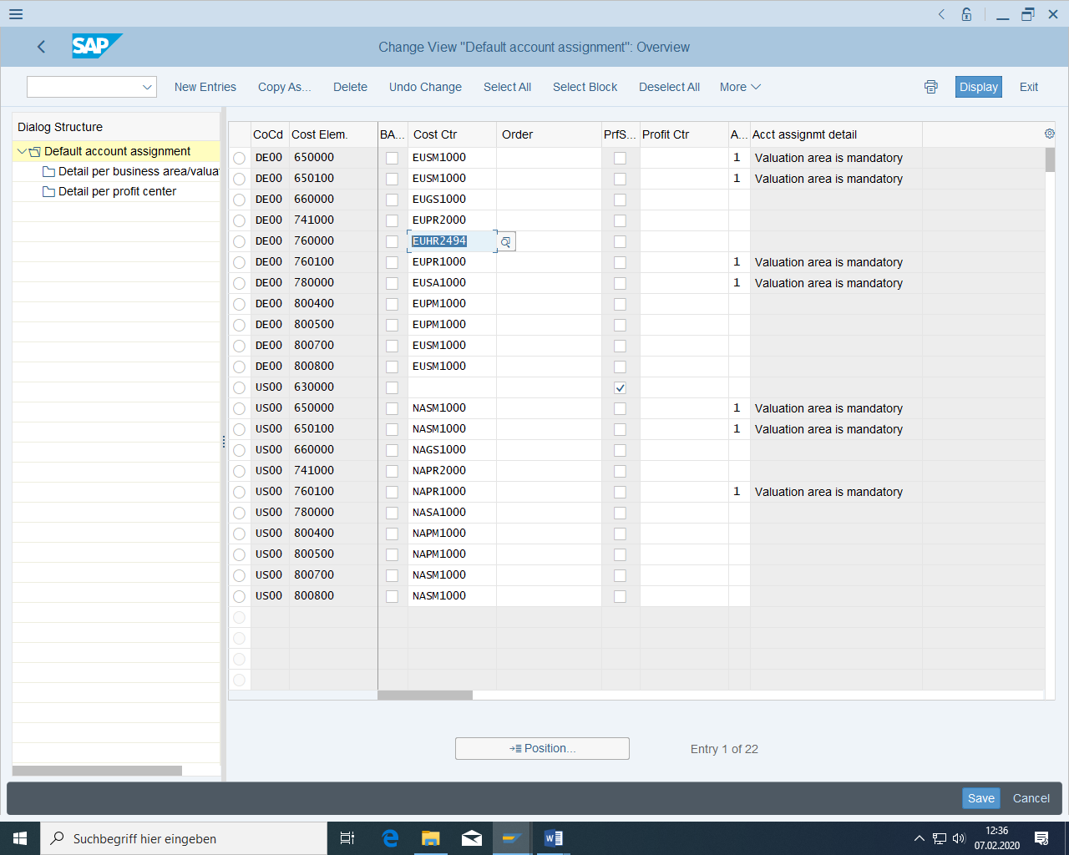

Choose the appropriate transaction for receipt of goods.

Movement type is 'Goods receipt for purchase order in the warehouse' (101), select number of purchase order.

OK Check the box Position.

Confirm with 'Enter'. The **goods receipt posting with reference to a purchase order** has several advantages:

* The system proposes the goods receipt quantity according to the purchase order. In addition, any delivery note number must be entered and the check mark "Pos. OK" set.
* Checking the delivered quantity with the ordered quantity
* Updating of order data
* Reminders for date escalation

Choose Save next.

This creates a **material document** (with possibly several items) and at least one **accounting document** (material stock or material consumption to GR/IR clearing). The flow type is used for automatic account determination.

You can then display the material document:

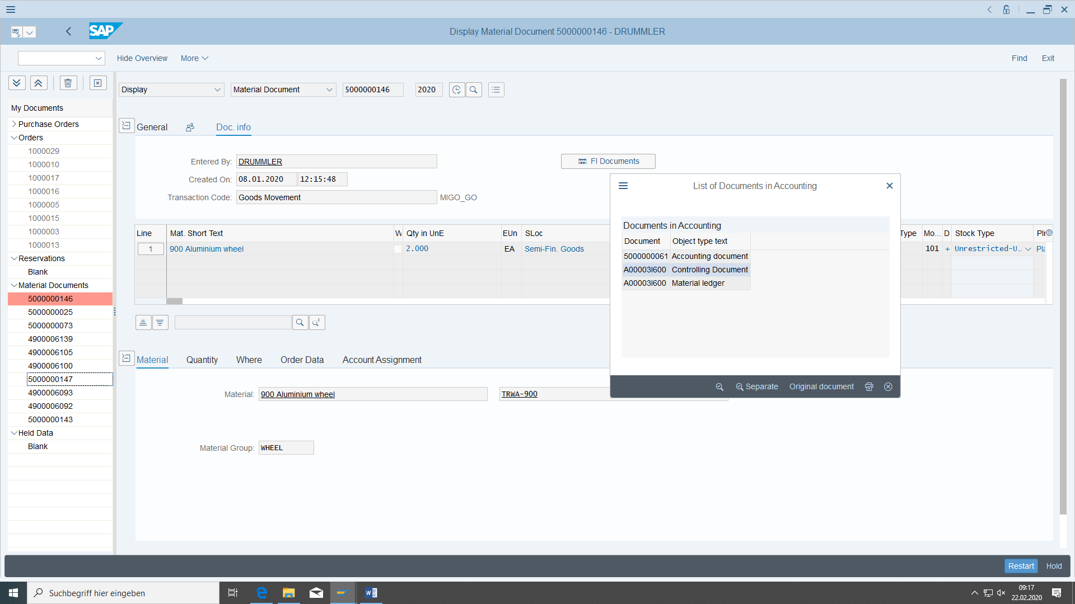

Click on FI documents to trace the FI posting:

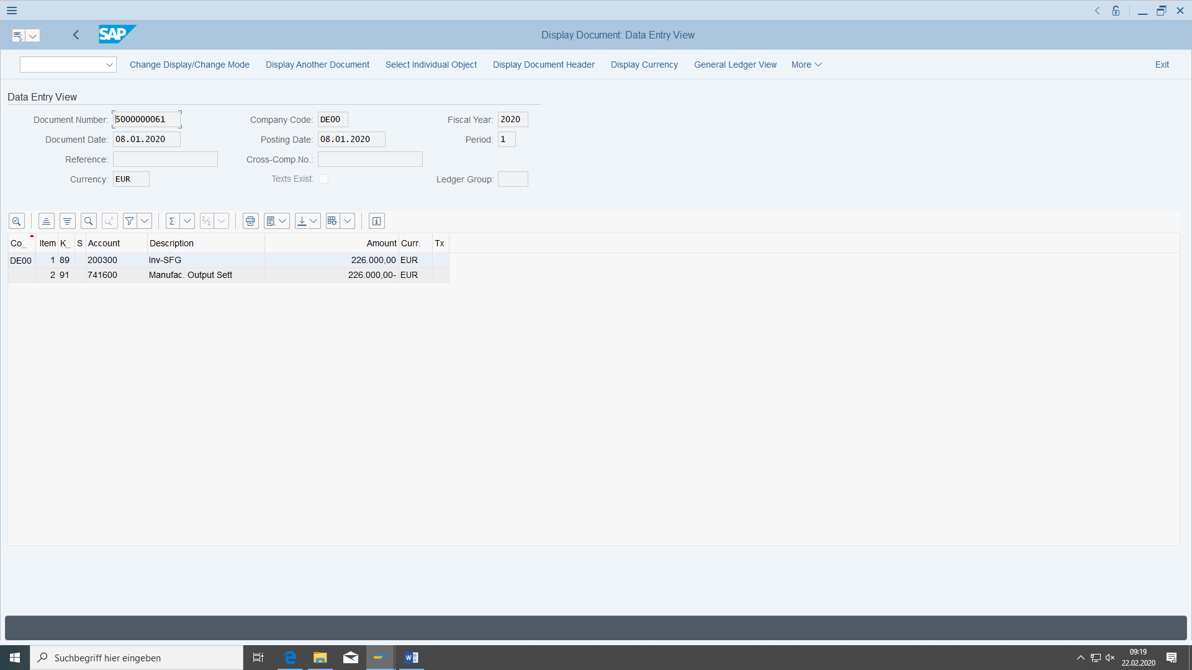

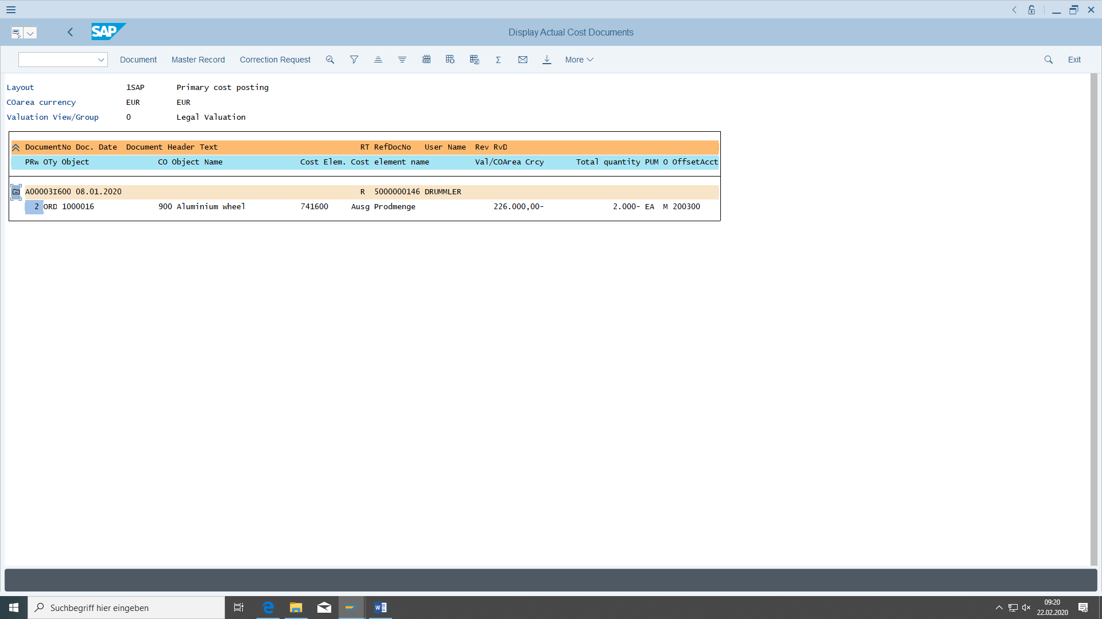

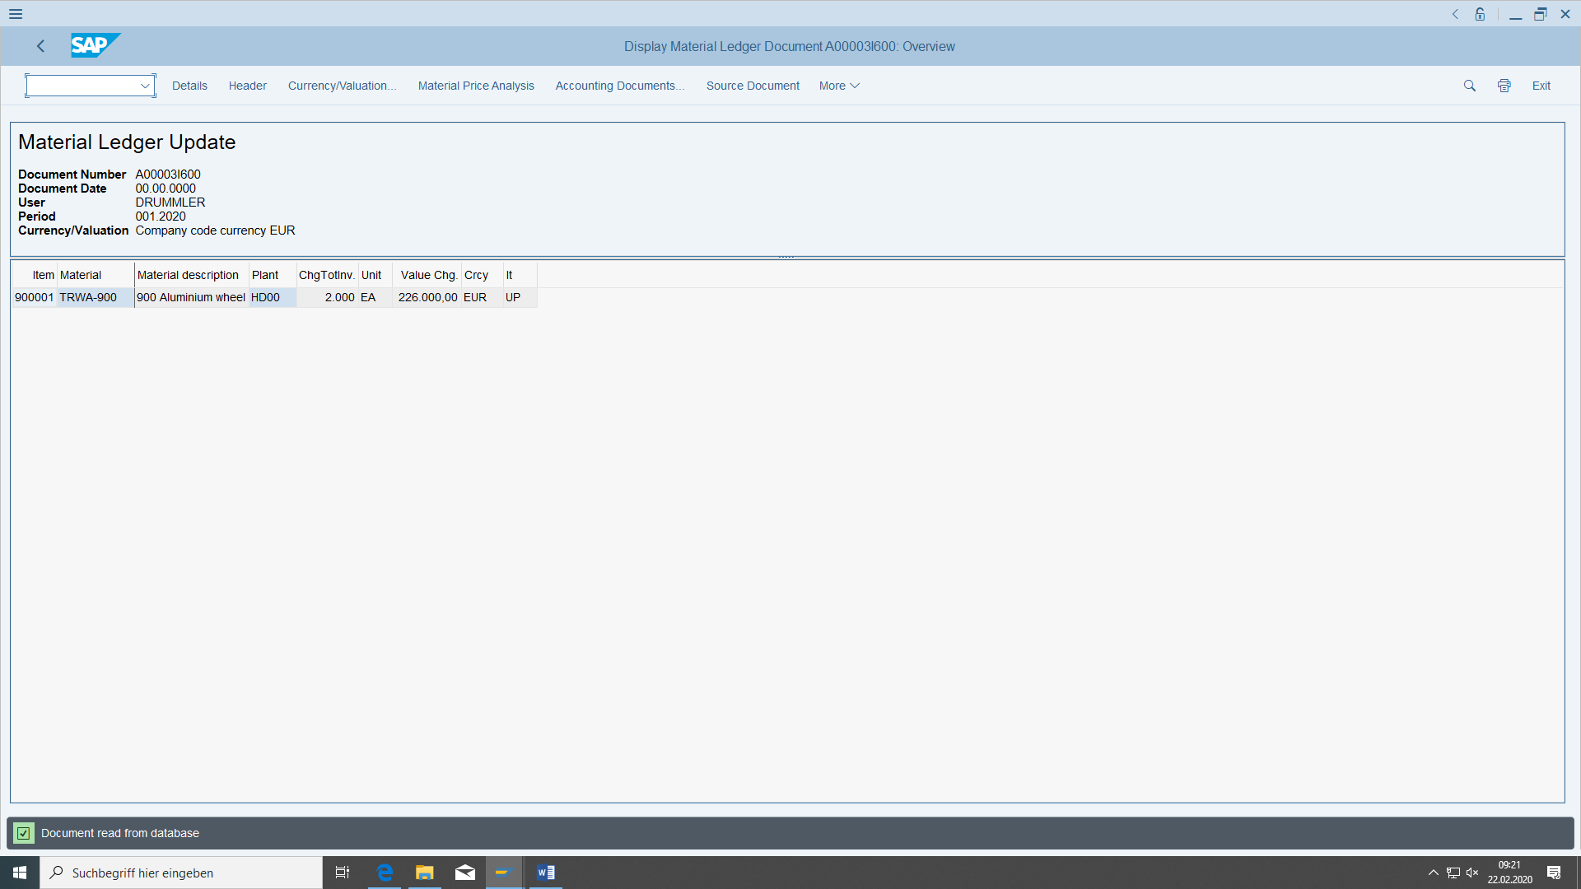

In contrast to a goods issue (material withdrawal, consumption, shipping), goods receipts (for example, also from production when a production order is confirmed) always increase the warehouse stock (stock types: unrestricted-use stock, quality inspection stock, blocked stock), depending on what is specified on the Delivery tab page of the purchase order item details - is copied from the purchasing view of the material. You can then automatically create a quality inspection lot, which must then be processed by Quality Management.

There are also **stock transfers** between storage locations (of different or the same plant) and **transfer postings** (these include stock transfers as well as goods movements from one material to another or between different stock types of a material).

The system informs you if the material was a missing part and the MRP controller would therefore be informed of the goods receipt (for example, if you had released the production order before the component parts arrived).

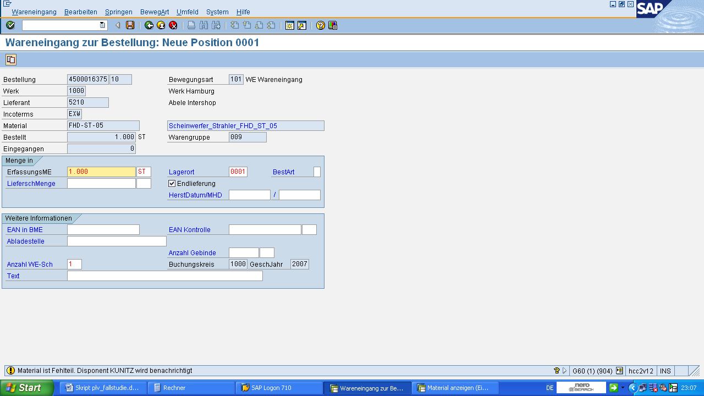

The system then displays the number of the goods receipt document, which you should note down.

Goods receipt document 1: ________________________

The goods receipt results in the current stock/requirements list with higher stock quantity and less purchase order:

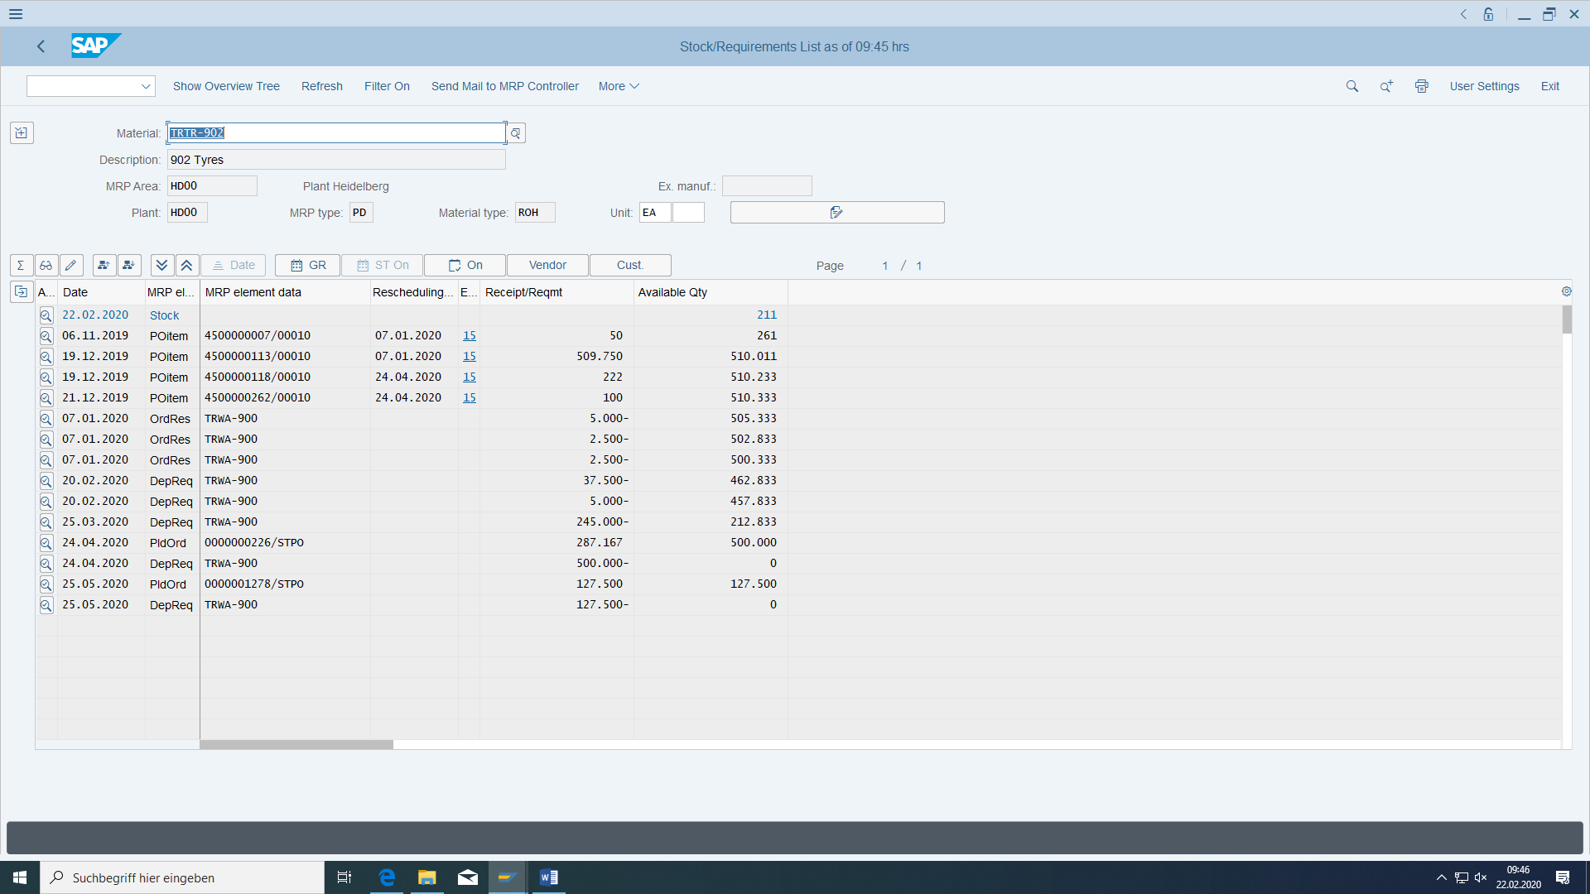

In the **purchase order history of** the purchase order, you can track all actions:

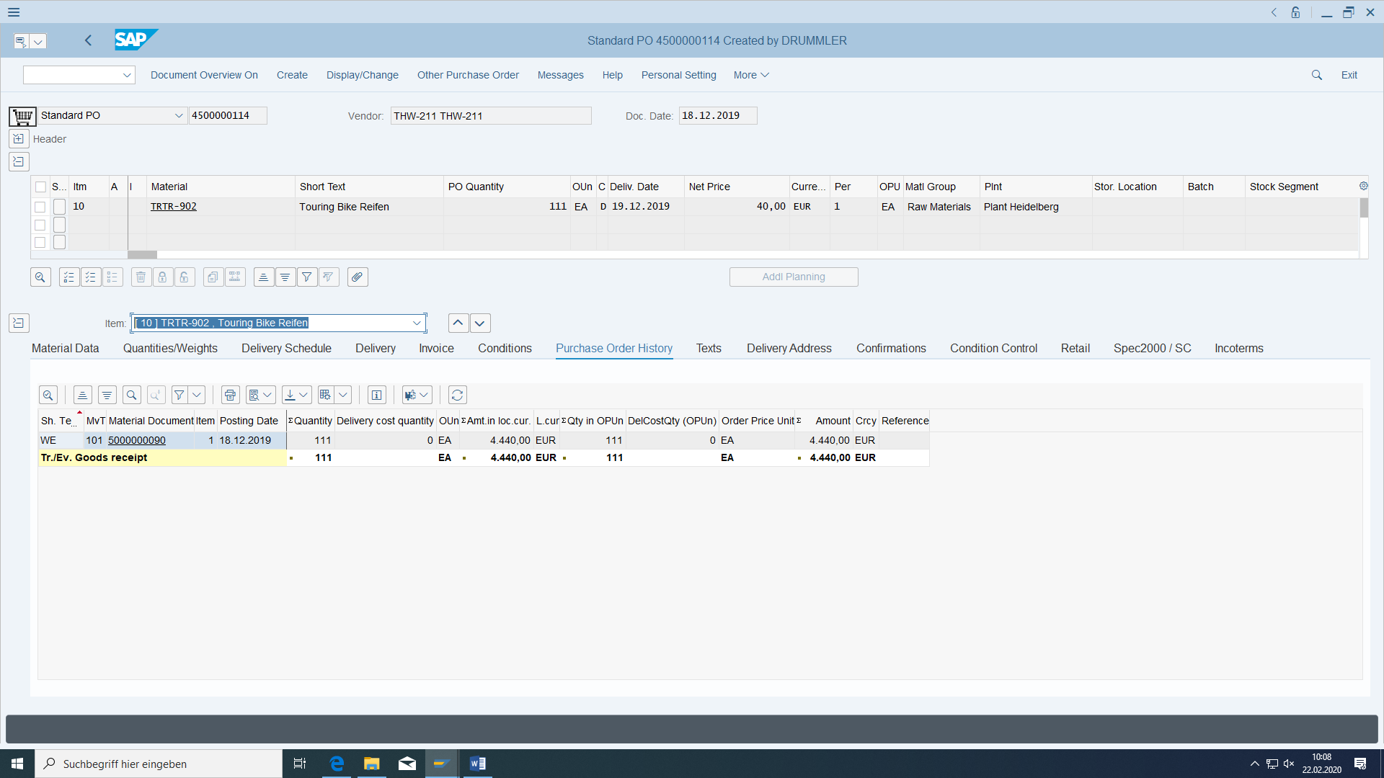

You can see that so far only one goods receipt has taken place.

In the stock overview, you can see the quantities available for a material per material stock type:

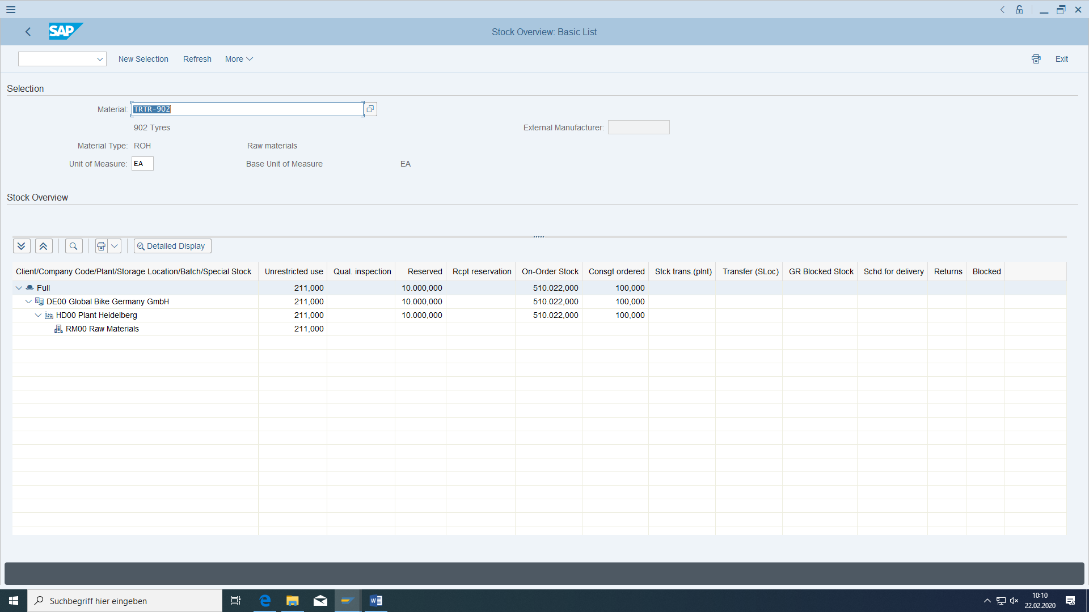

## Enter the vendor invoice

|  |  |  |
| --- | --- | --- |
| Invoice incoming | Logistics > Materials Management > Logistics Invoice Verification > Document Entry > Add Incoming Invoice | MIRO |

Invoice with MIRO for supplier only for the invoicing party of the vendor.

This can be done also later inside the purchasing order at Partners:

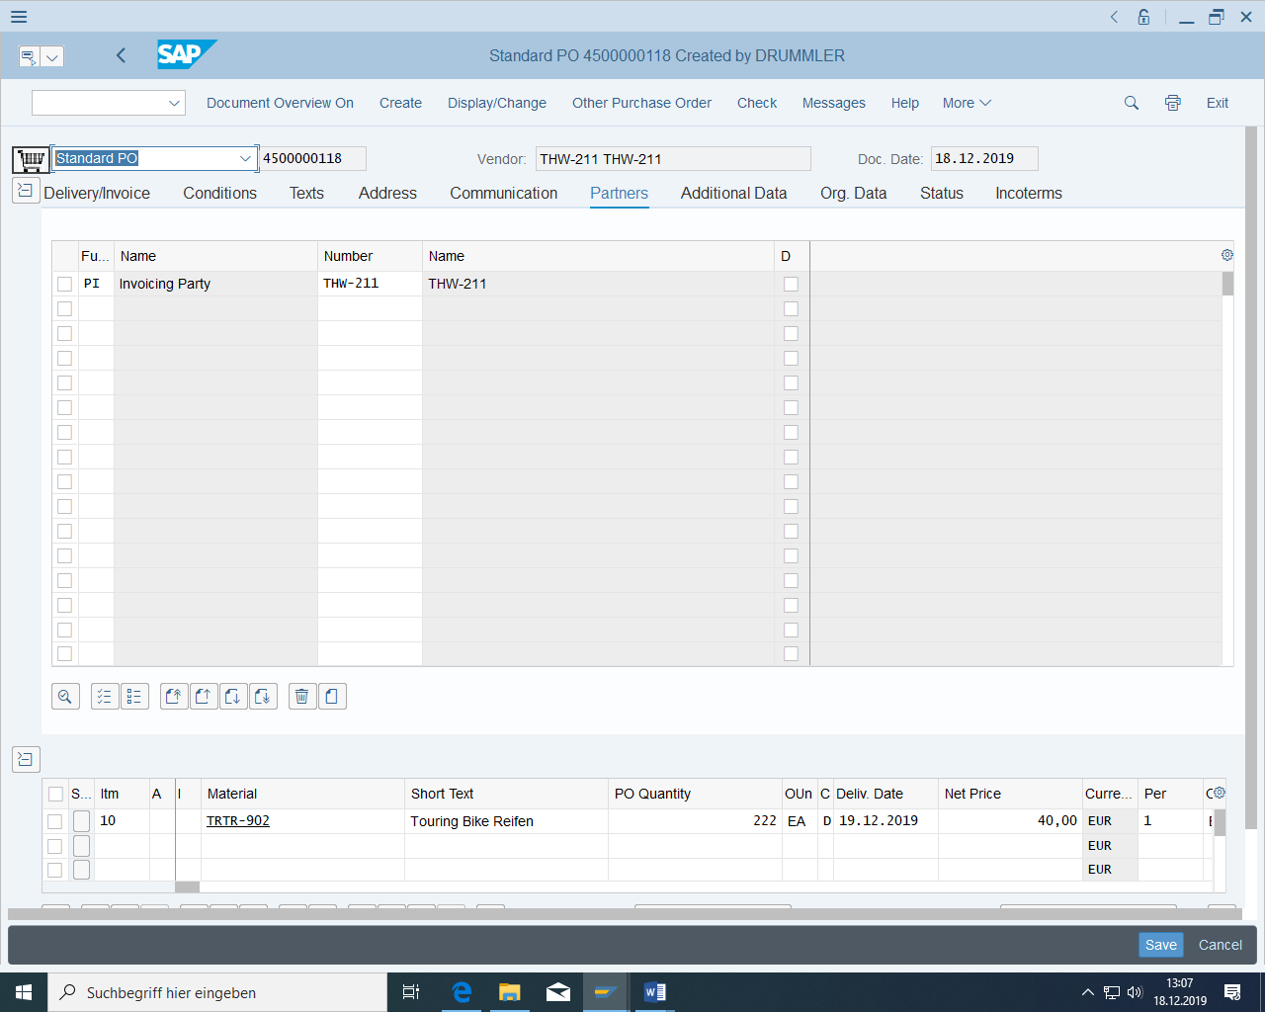

The invoice is to be issued in company code DE00. Enter your purchase orders as a reference, enter the invoice amount (corresponds to the value from the purchase order item) and then save with the quantities and amounts proposed from the purchase order. You must also enter a date for the payment deadline. See what the price is. First choose the simulation of the posting:

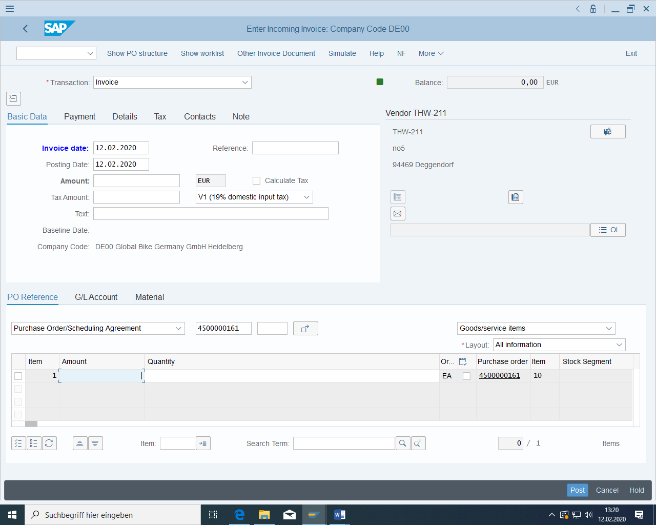

If this amount exceeds your eligibility, change this limit via OBA4 in customizing:

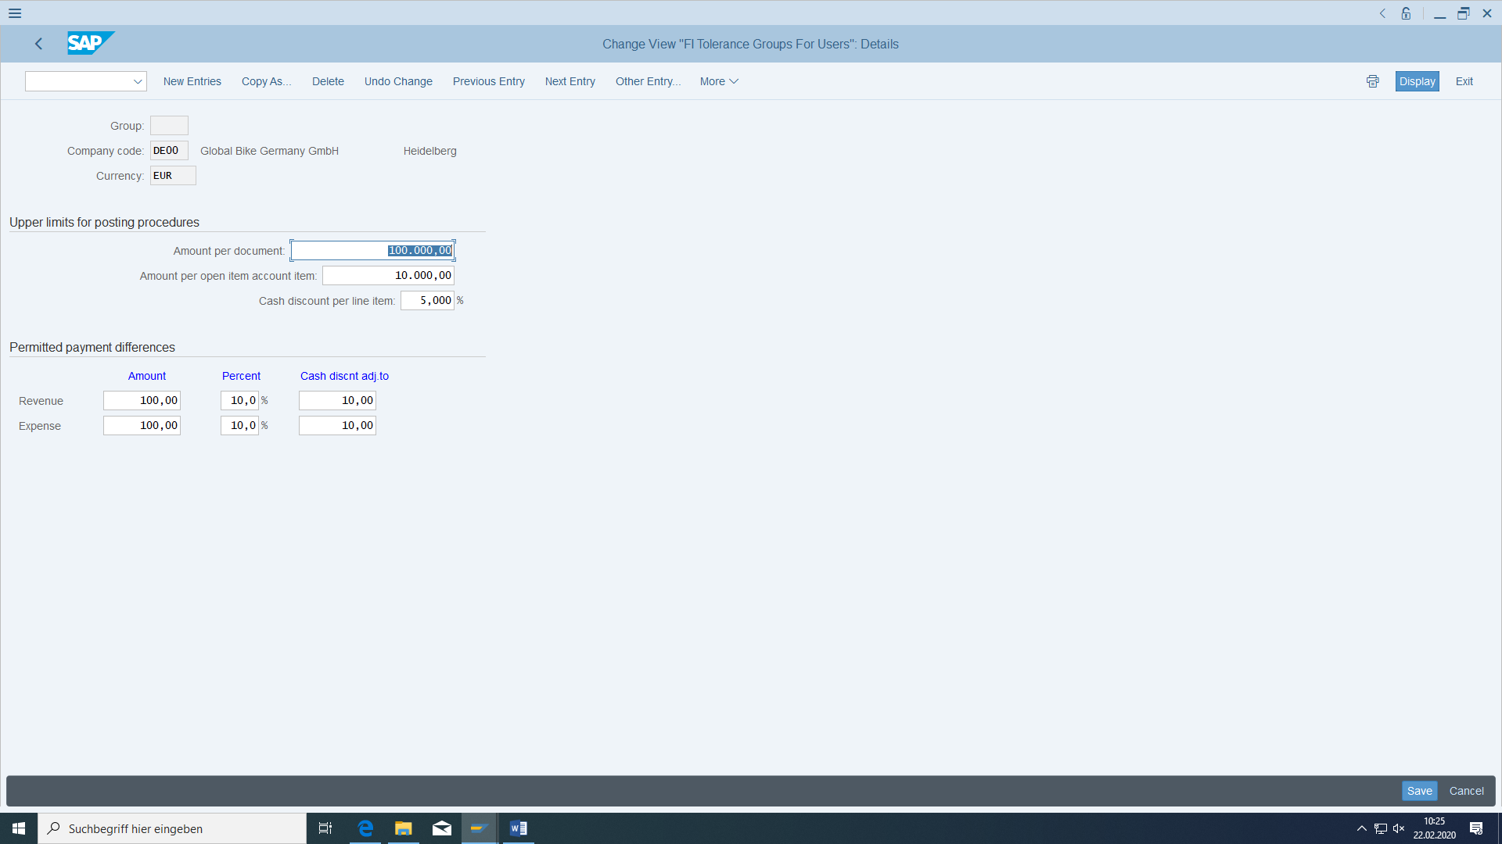

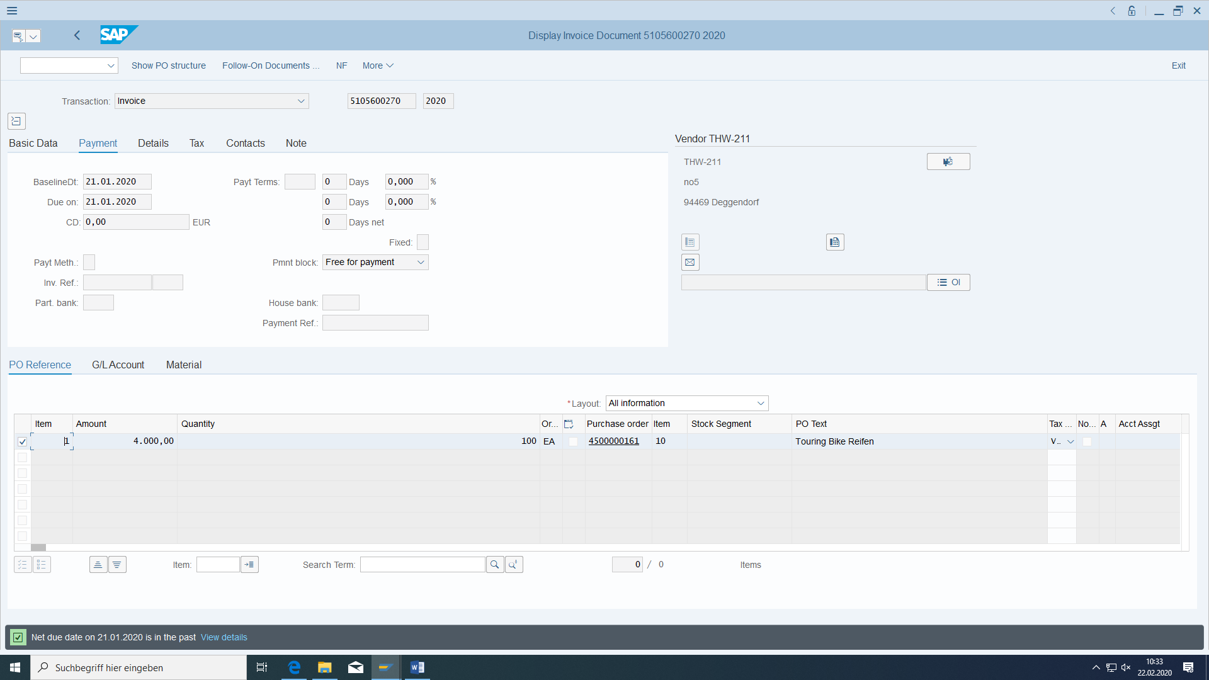

Before you post the invoice you should simulate it:

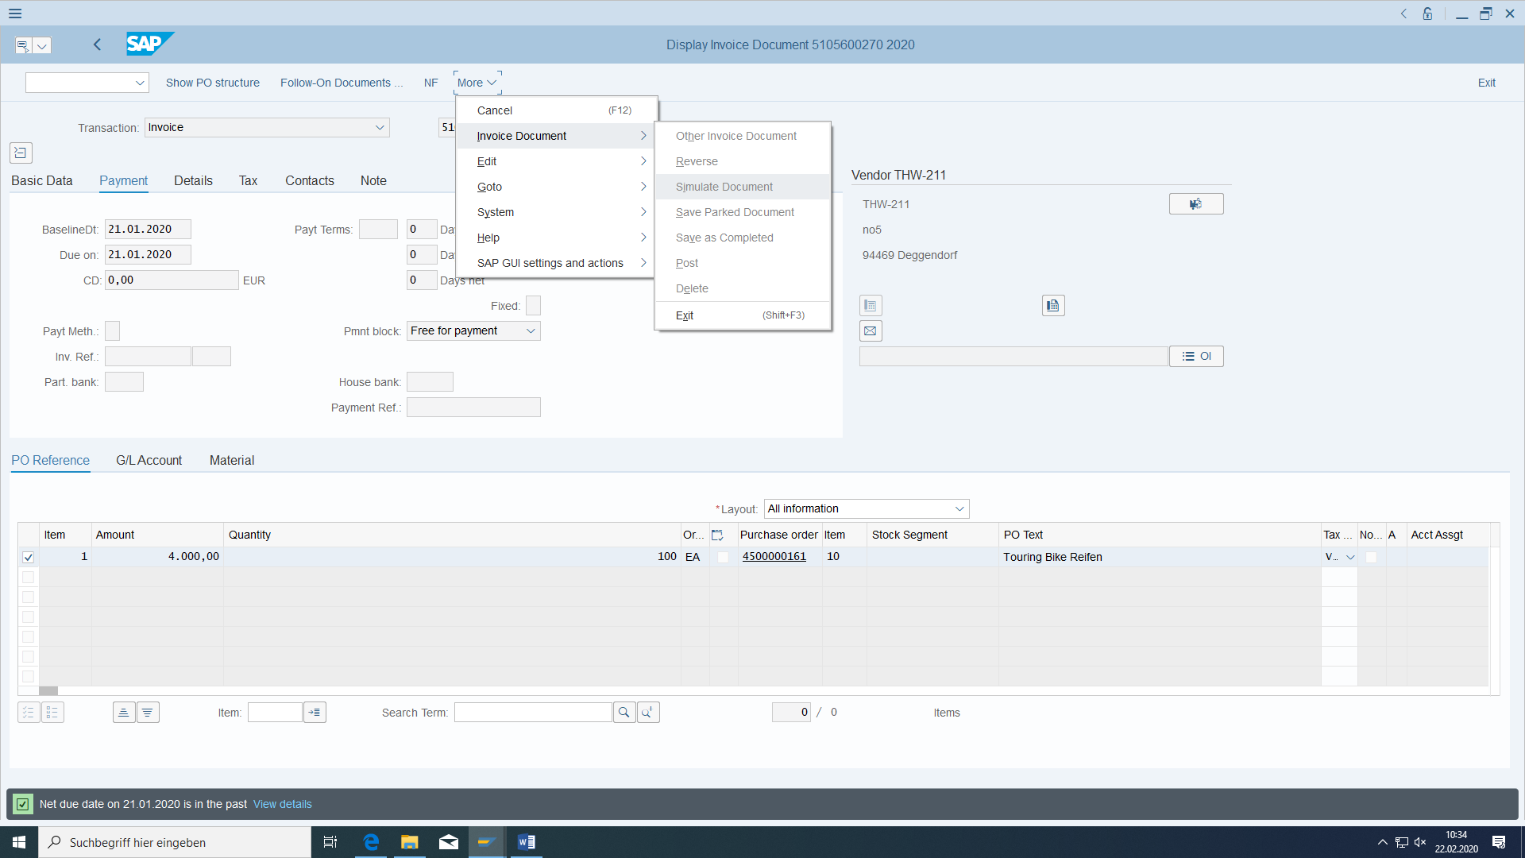

After posting you get documents in accounting.

**An accounting entry** with GR/IR clearing to vendor liability is also made automatically. You can see this under Goto/follow-on documents (MIR4):

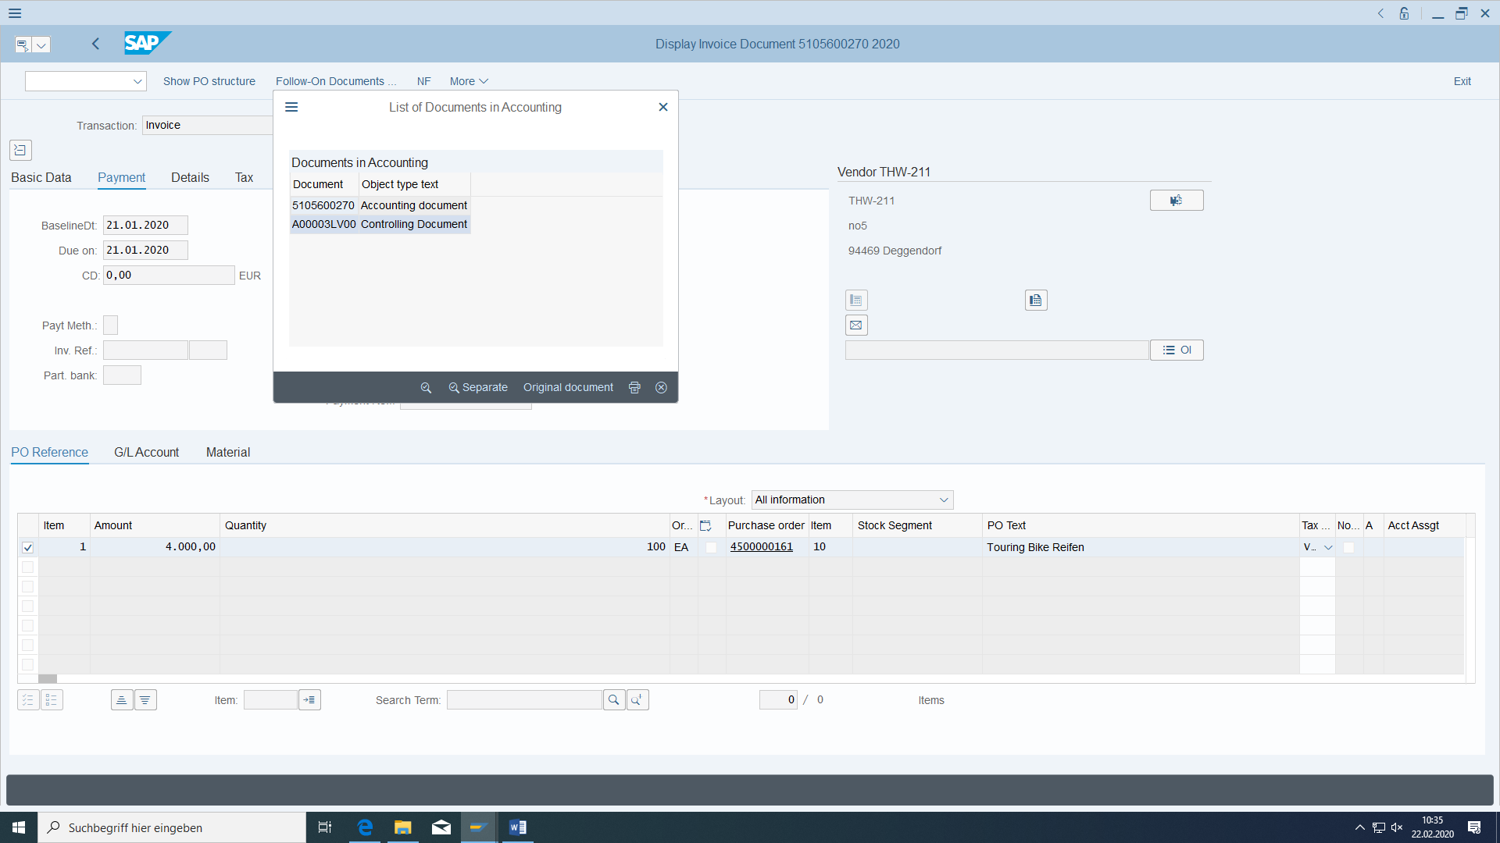

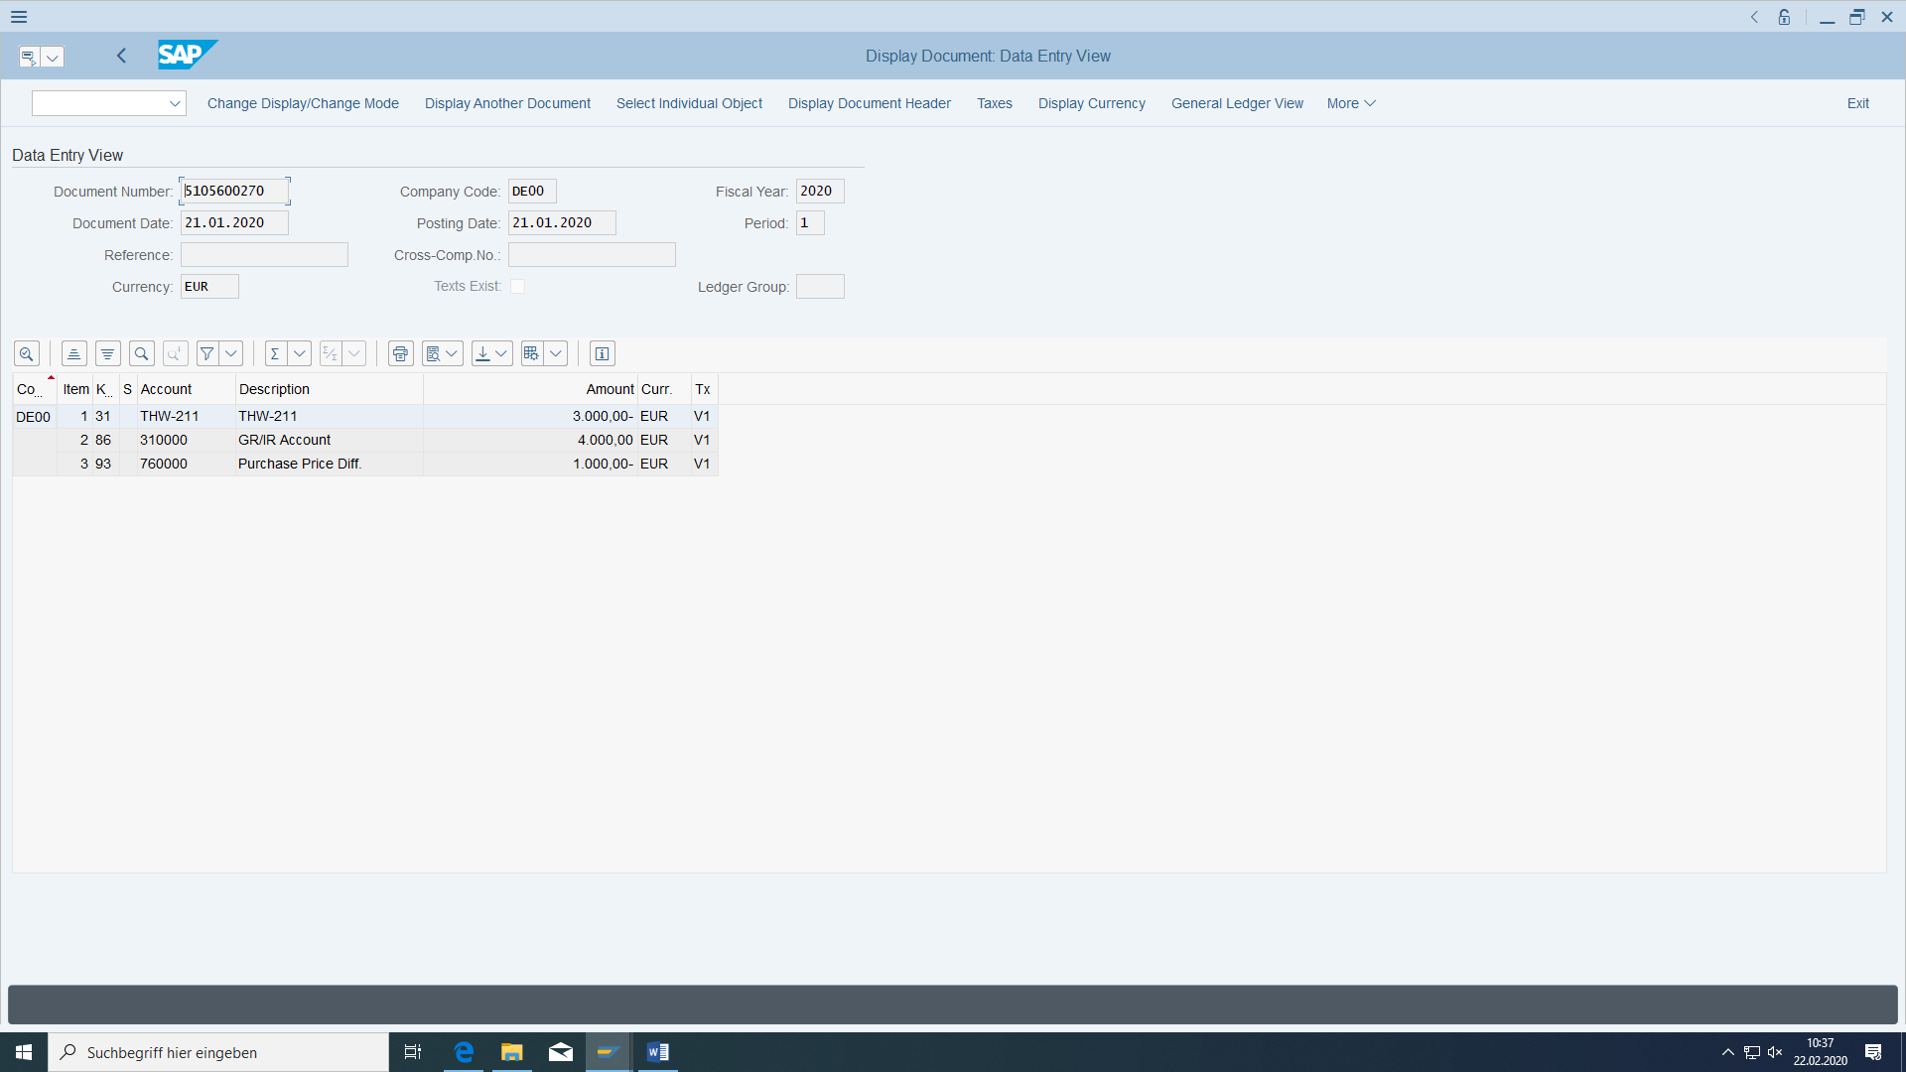

Why is posting made to two offsetting accounts?

At what costs/revenues does this cost accounting account belong?

KA02:

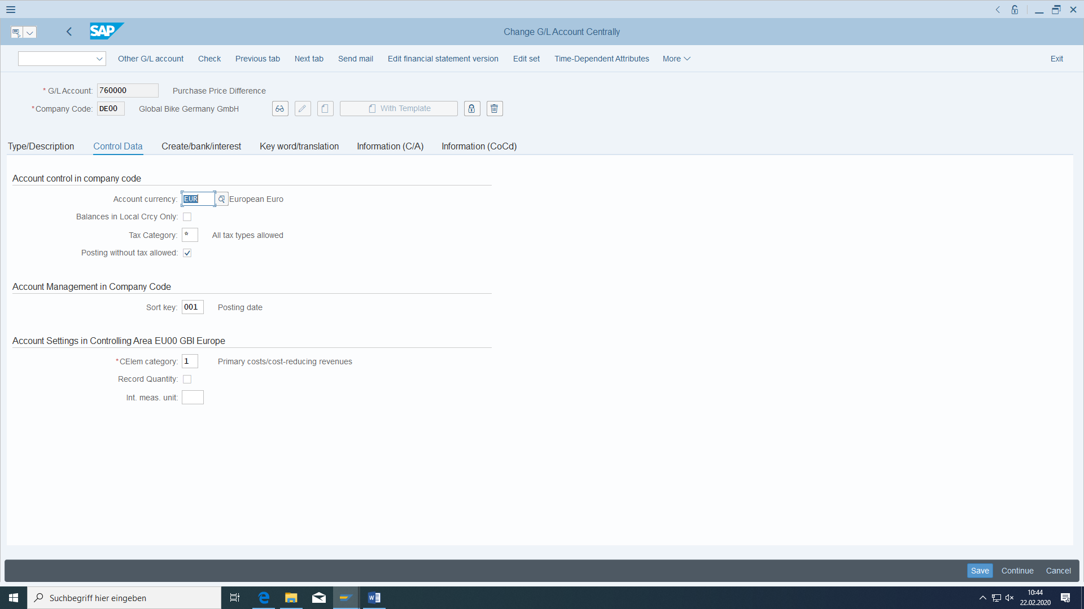

Accounts are now in SAP S/4 maintained central and not separated in FI accounting and controlling. You can see it only in the type if it is internal or external accounting.

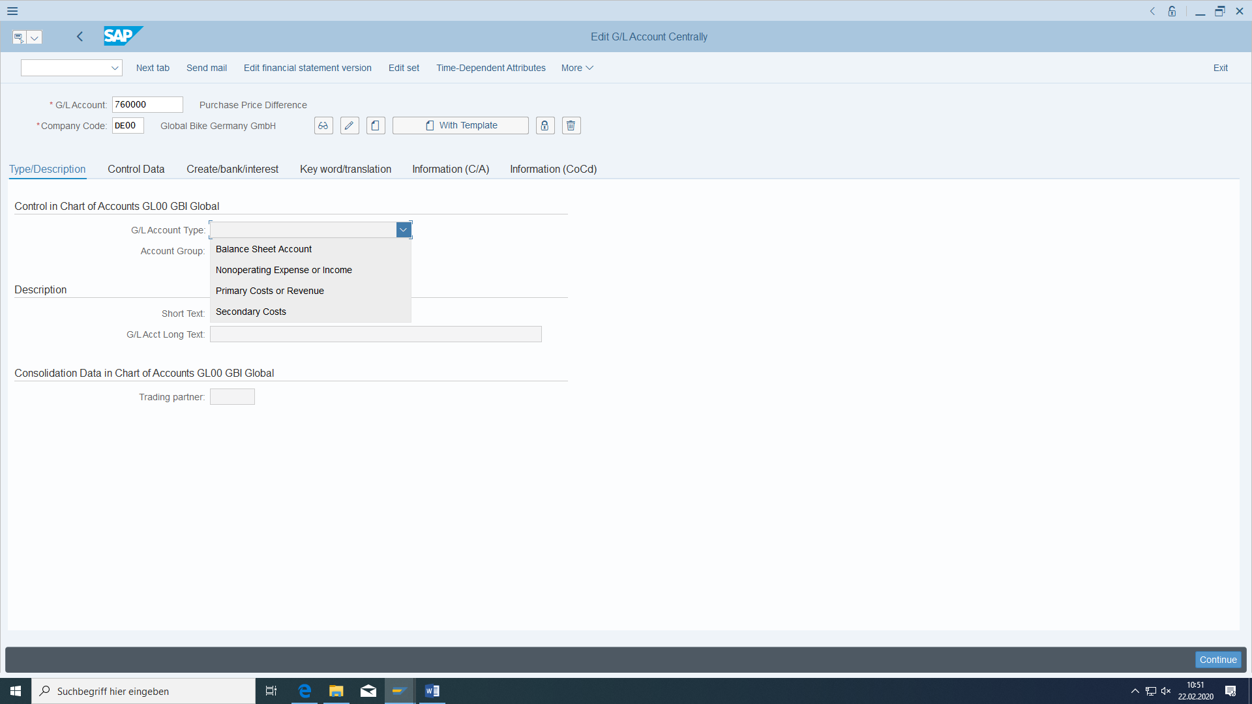

If an invoice is entered with reference to a purchase order, this is still part of Materials Management together with Invoice Verification. If there are variances between the invoice and the goods receipt or purchase order, the entered invoice is blocked and cannot lead to a payment to the vendor in the next payment run (but is then already part of FI).

Cost accounting posting:

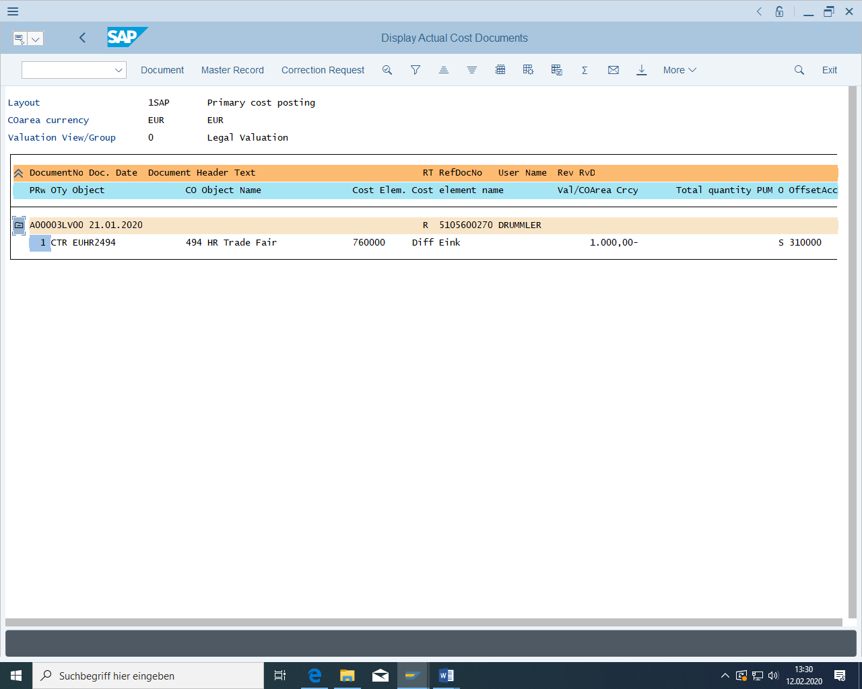

The invoice entry can also be seen in the **purchase order history:**

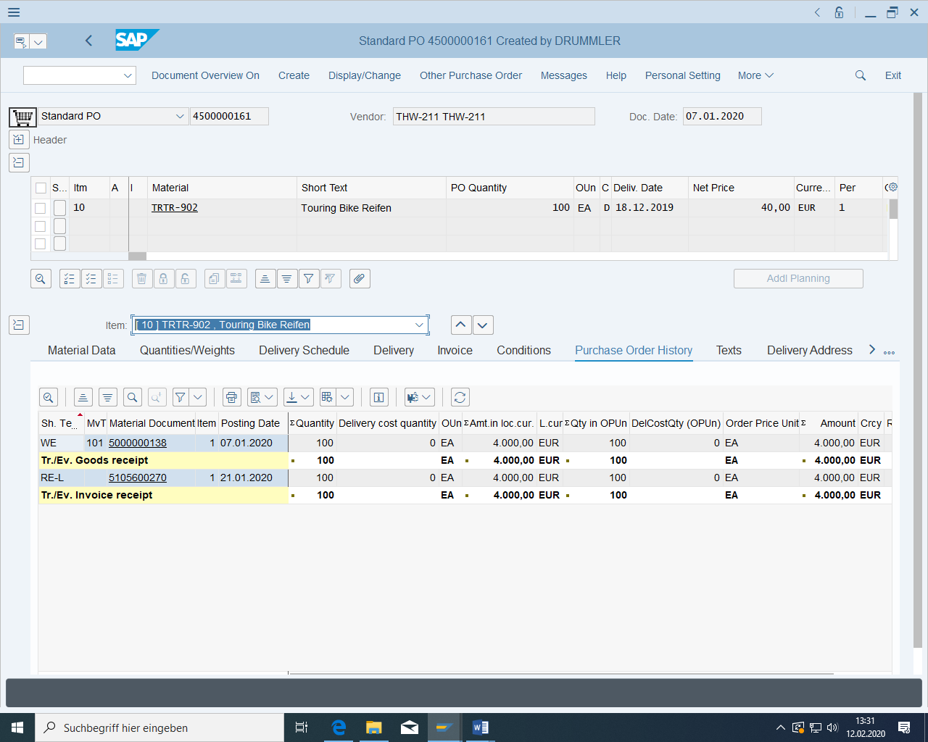

## Post outgoing payment

|  |  |  |
| --- | --- | --- |
| Manual outgoing payment | Accounts Payable > Posting > Outgoing Payments > Post | F-53 |
| Check vendor account | Accounting > Financials > Accounts payable > Account > Display/change items | FBL1N |

In FBL1N you can find out which invoices of a vendor still have not being payed:

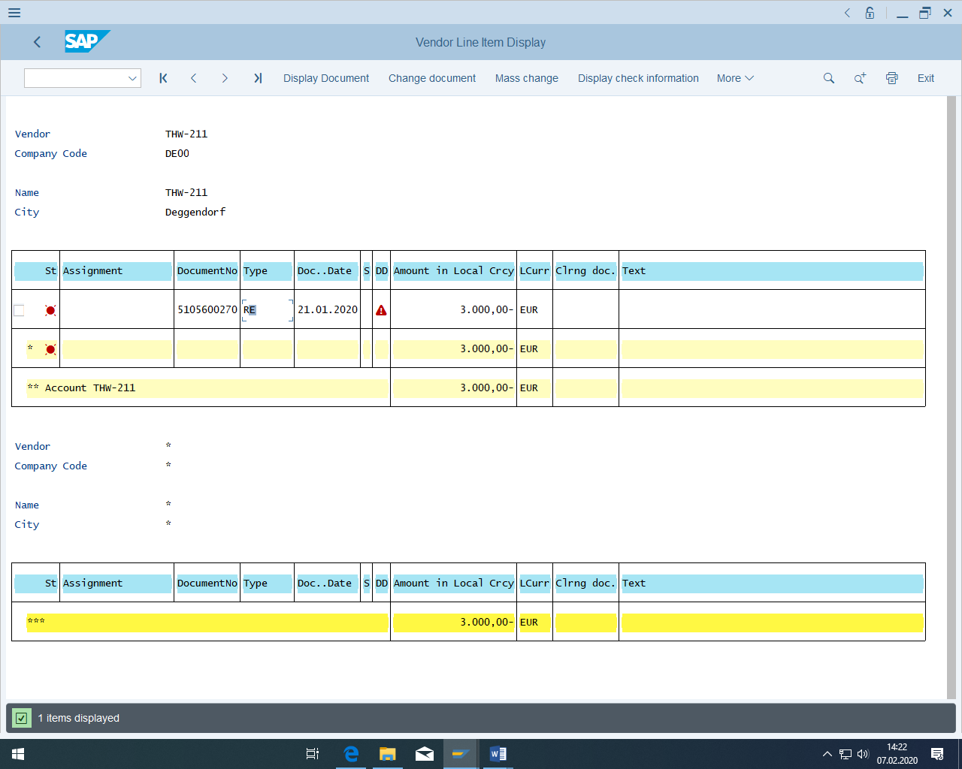

The payment is done either **manually** or automatically in the **payment run** for released invoices. The invoice is entered manually here.

Document date is current date. Specify the bank account of our chart of accounts. The account for the open items is our supplier. Enter the amount to be paid. This payment is independent of one invoice, one delivery or one purchase order.

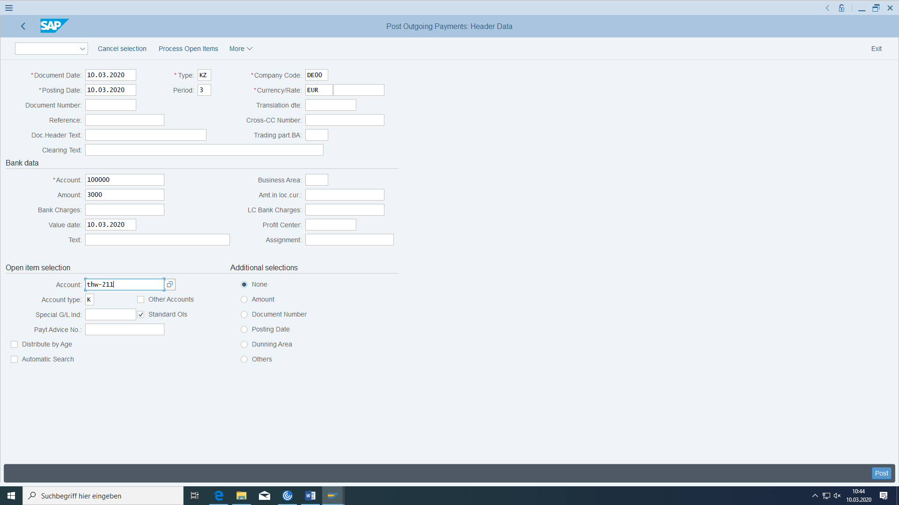

Simulate them before you book:

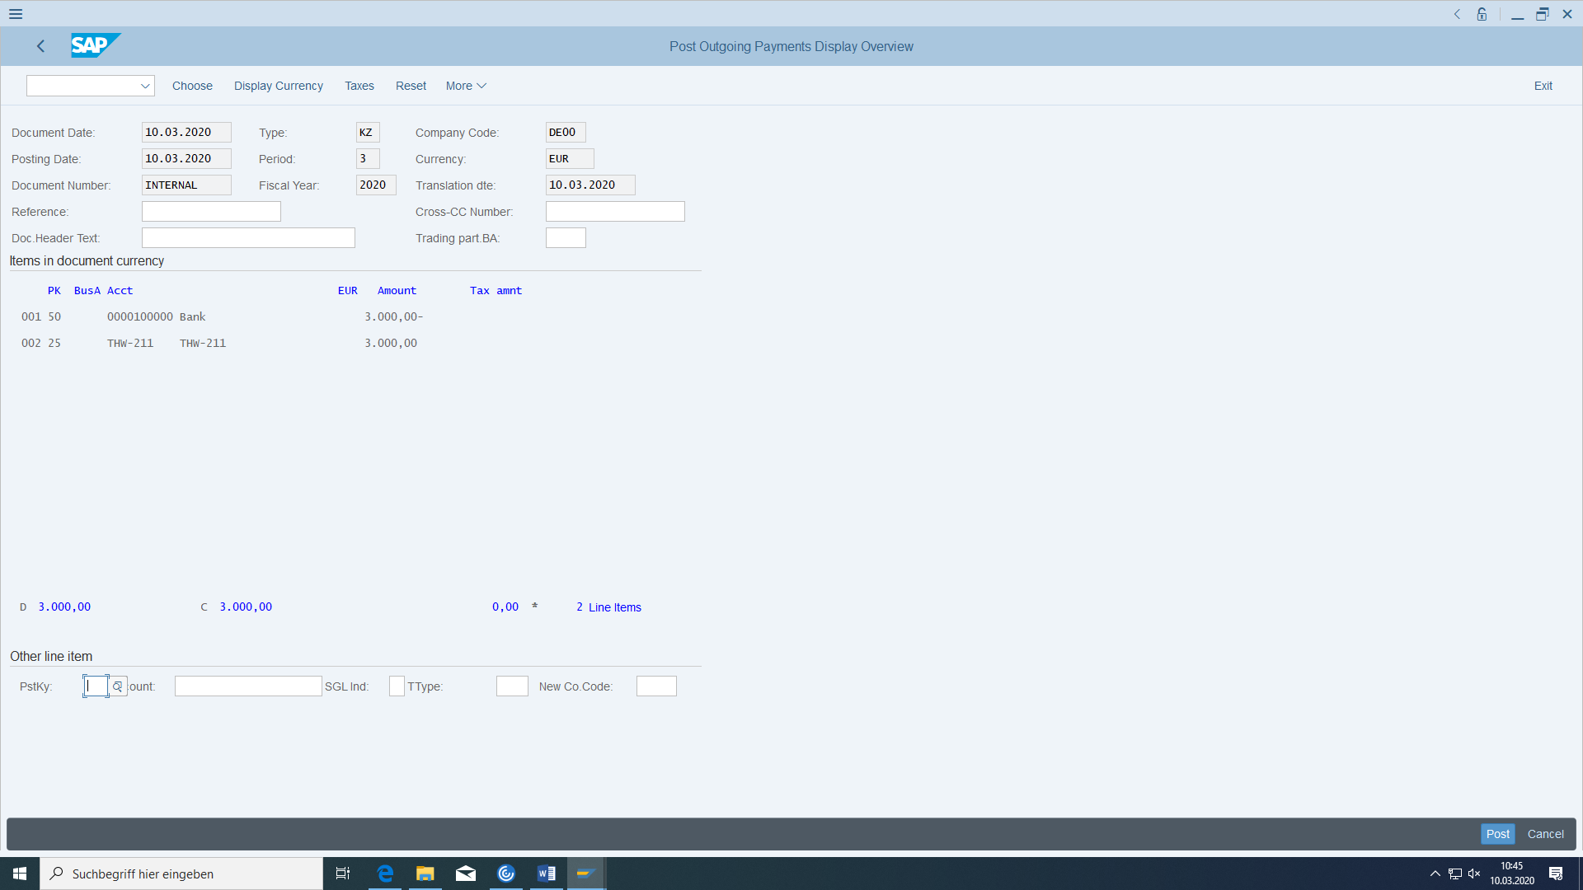

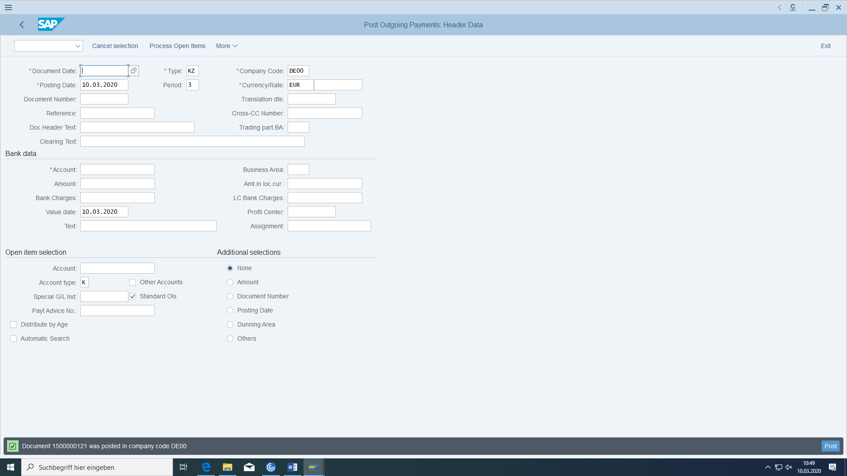

Check whether the vendor is balanced under cleared items:

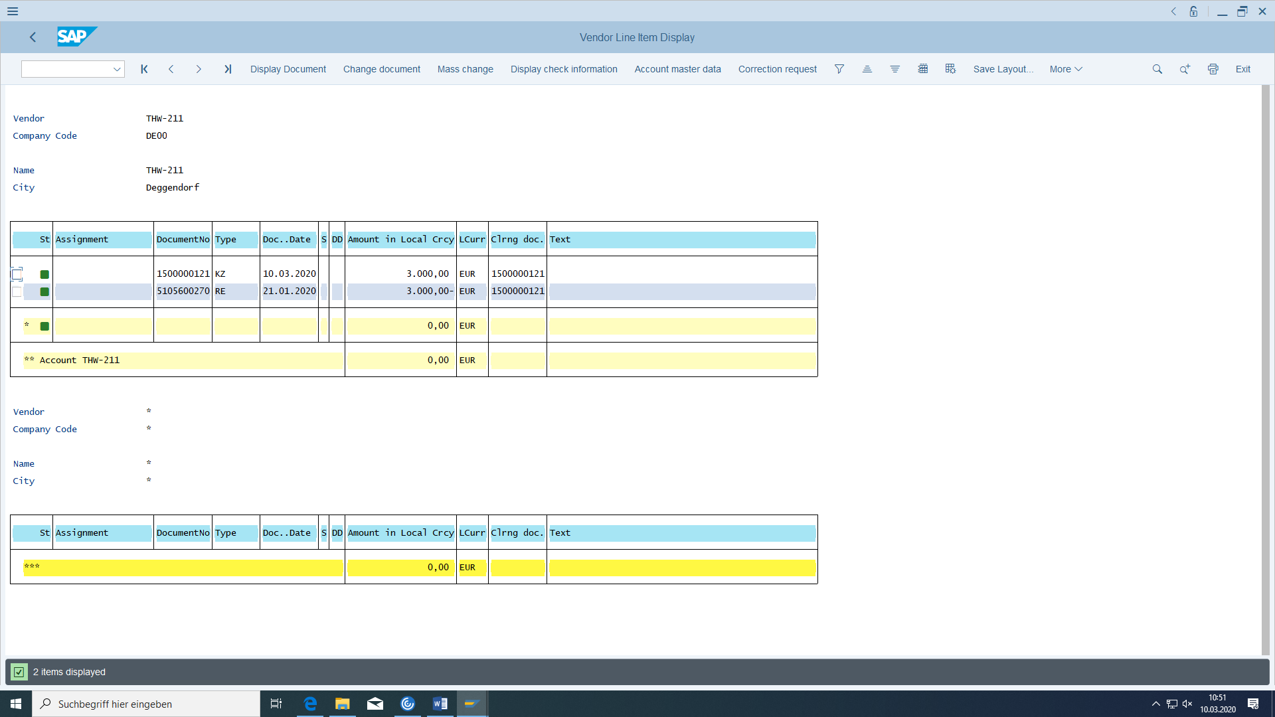

For the payment document you have just created (search for the FI transaction in the SAP menu tree), check whether an **accounting posting** with payable to bank has also been created:

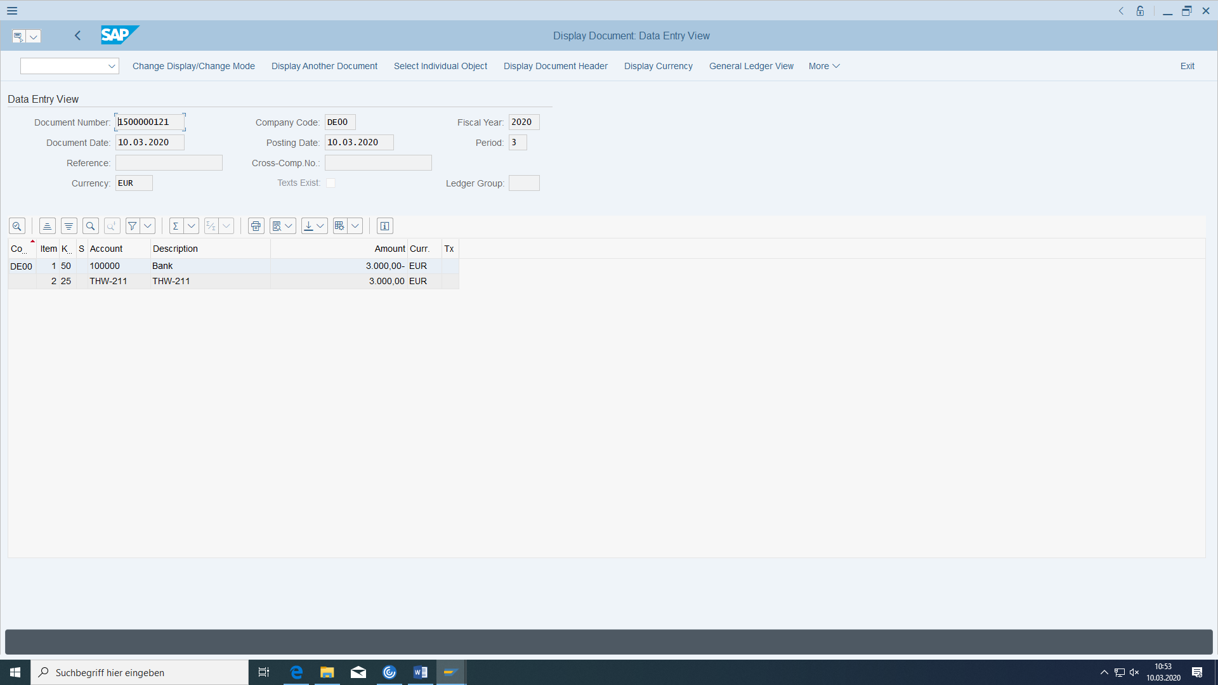

## FI payment

It is possible that the outgoing payment has not yet caused a direct payment. In this case, in contrast to the above, the FI posting would have been payable to bank clearing. If the actual payment is then caused, the **posting** Bank clearing is made to Bank.

# Production of the aluminium wheel assembly

|  |  |  |
| --- | --- | --- |
| Removal of­ components from the warehouse | Logistics > Materials management > Inventory management > Goods movement > Goods issue | MB1A/ MIGO_GI |
| Display production order | Logistics > Production > Shop Floor Control > Order > Advertisements | CO03 |
| Display production order cost variances | Logistics > Production > Shop Floor Control > Period-end closing > Variances > Individual processing | KKS2 |
| Display material document | Logistics > Materials management > Inventory management > Goods movement > Material document | MB03 |
| Production operation confirmation | Logistics > Production > Shop Floor Control > Confirmation > Enter > For operation > Time Ticket | CO11N |
| Production order confirmation | Logistics > Production > Shop Floor Control > Confirmation > Enter > For Order | CO15 |
| Production order goods receipt | Logistics > Materials management > Inventory management > Goods movement | MIGO |

The warehouse stock can also be increased unplanned using MBC1 with movement key 501 (unplanned). In this case, you do not have to create the production order for the wheel material, but only for the end product.

## Opening of the production order

The necessary quantities of components are now available to manufacture the wheel from the tire (delivery from the supplier). To control this, call up the stock/requirements list again.

Select the material TRWA-###and the plant Heidelberg and choose 'Enter'.

In customizing before has been defined:

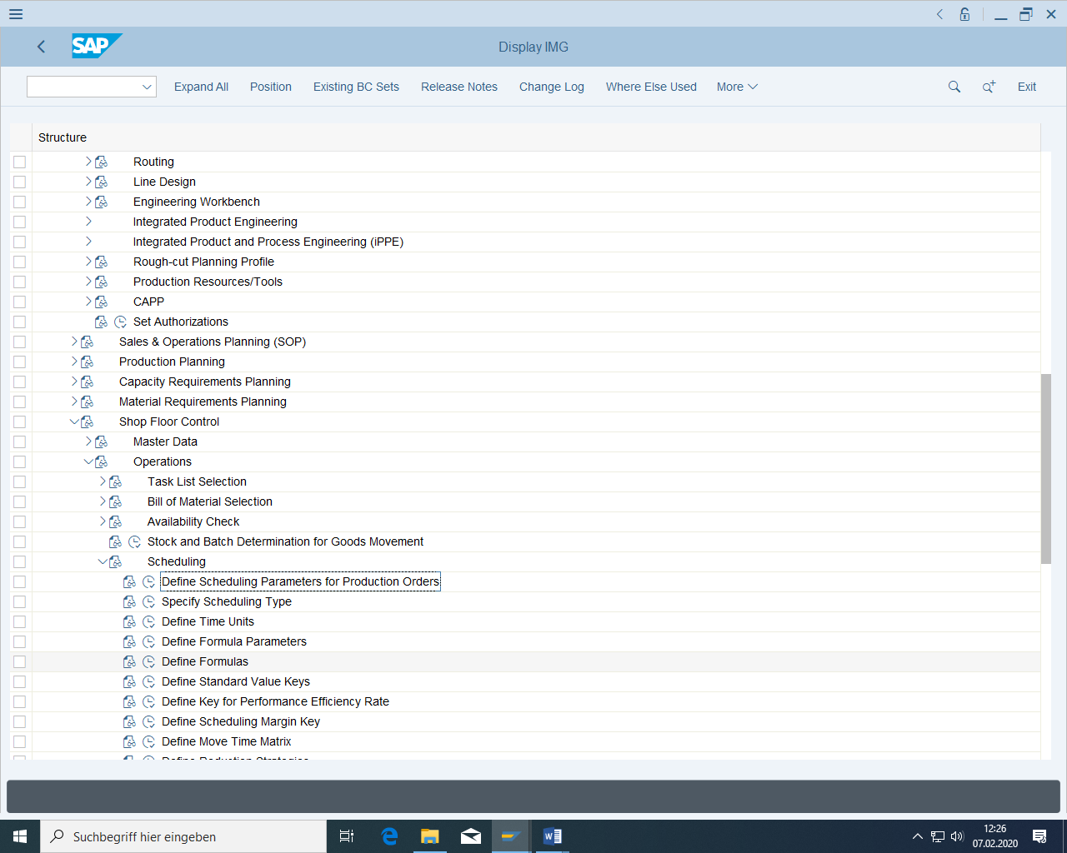

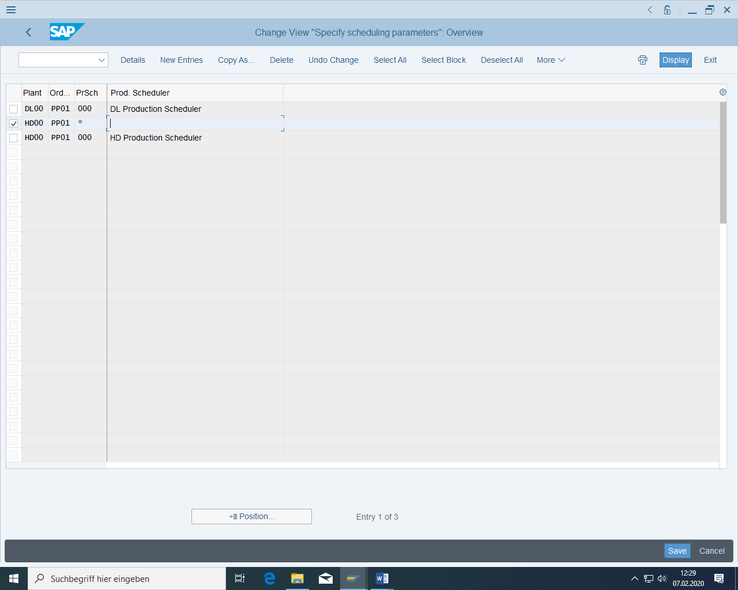

The planned order needs a production version:

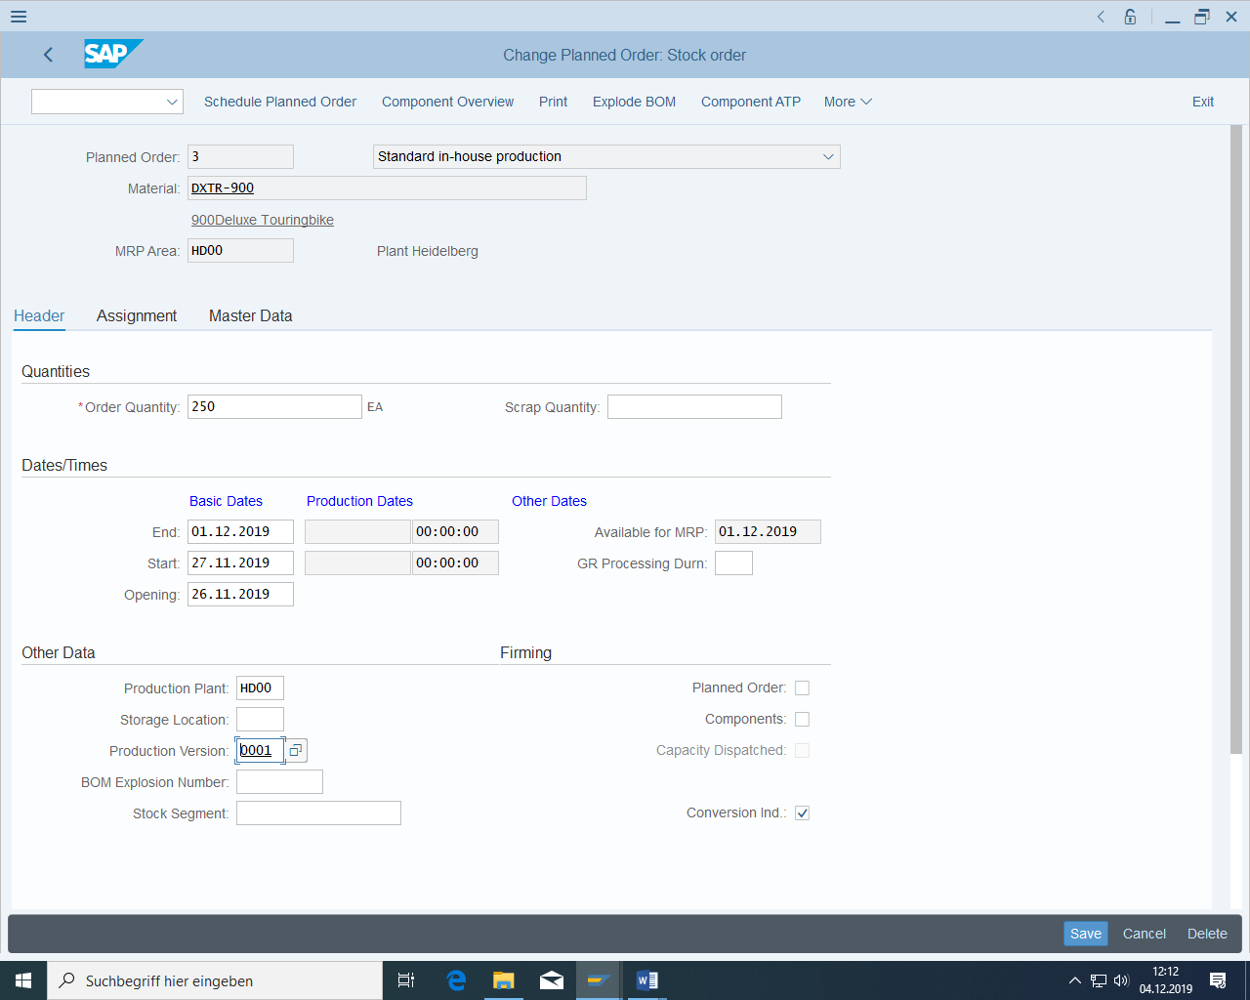

In planned order has to be the production version (perhaps it was not there because of missing production area to be defined in the material)

(Storage Location seems not be necessary)

Check which of the newly generated planned orders of wheels is generated because on the sales order of the deluxe touring bike by jumping to the source of the planned order:

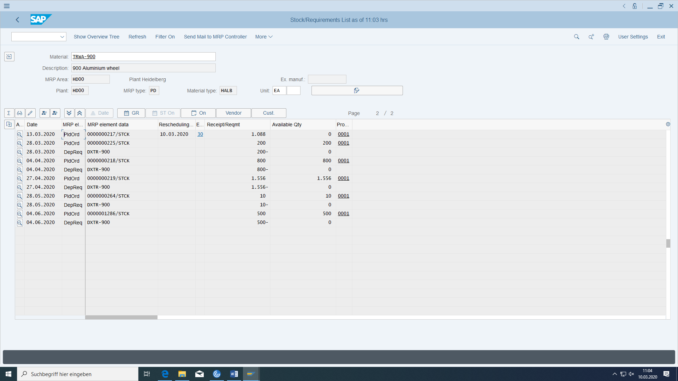

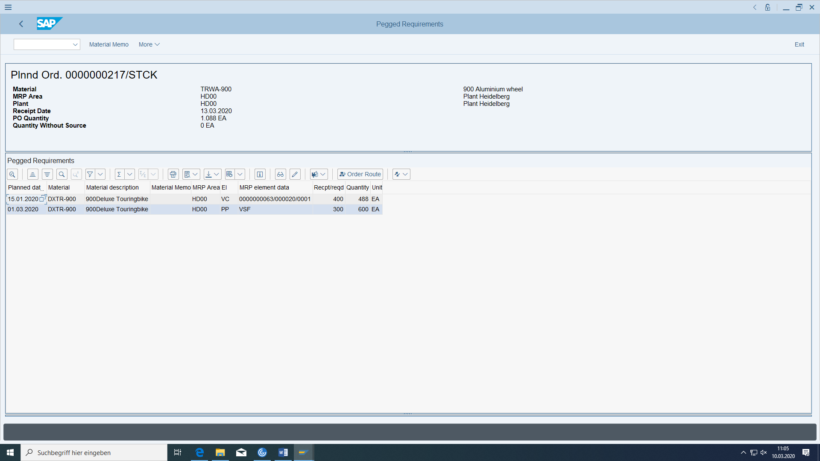

Please explain why the amount is 1088.

Then release the planned order as a production order by clicking on the button 'Convert planned order to production order' under 'Details for MRP element':

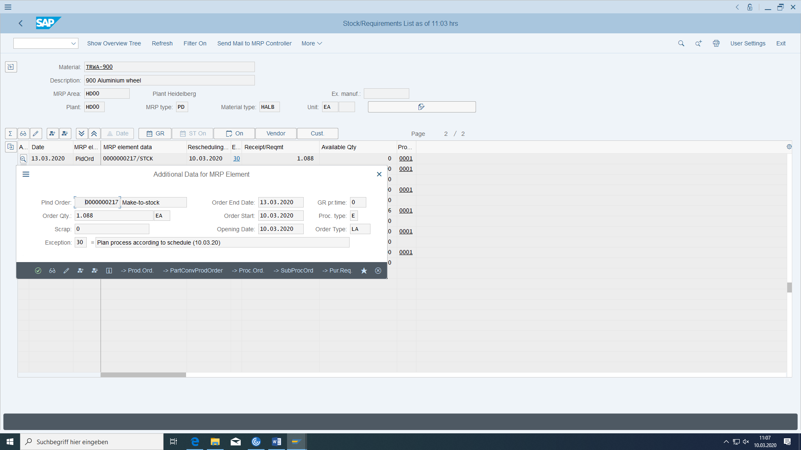

There must be a plant schedule for the aluminum wheel.

If there is none, create it by copying the plant schedule of the Deluxe Touring Degree, taking into account the deadline.

Then change the text to ### Aluminium wheel, release the routing and save.

If you get an error again, you may not be able to use the routing. Then delete the routing and create it correctly.

First check in customizing OPU3 whether the scheduling parameters for plant order type production scheduler already exists:

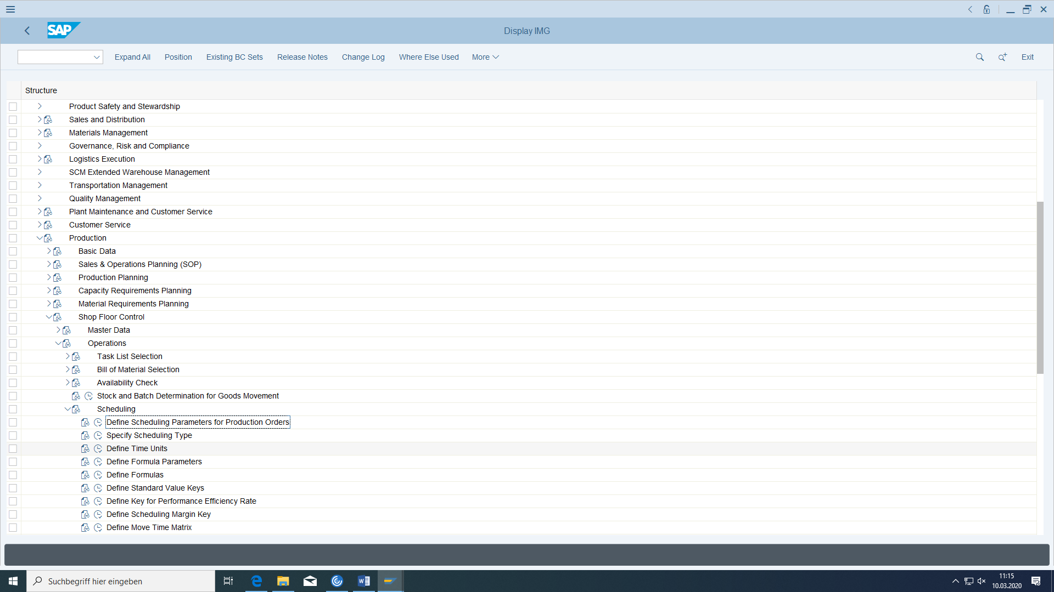

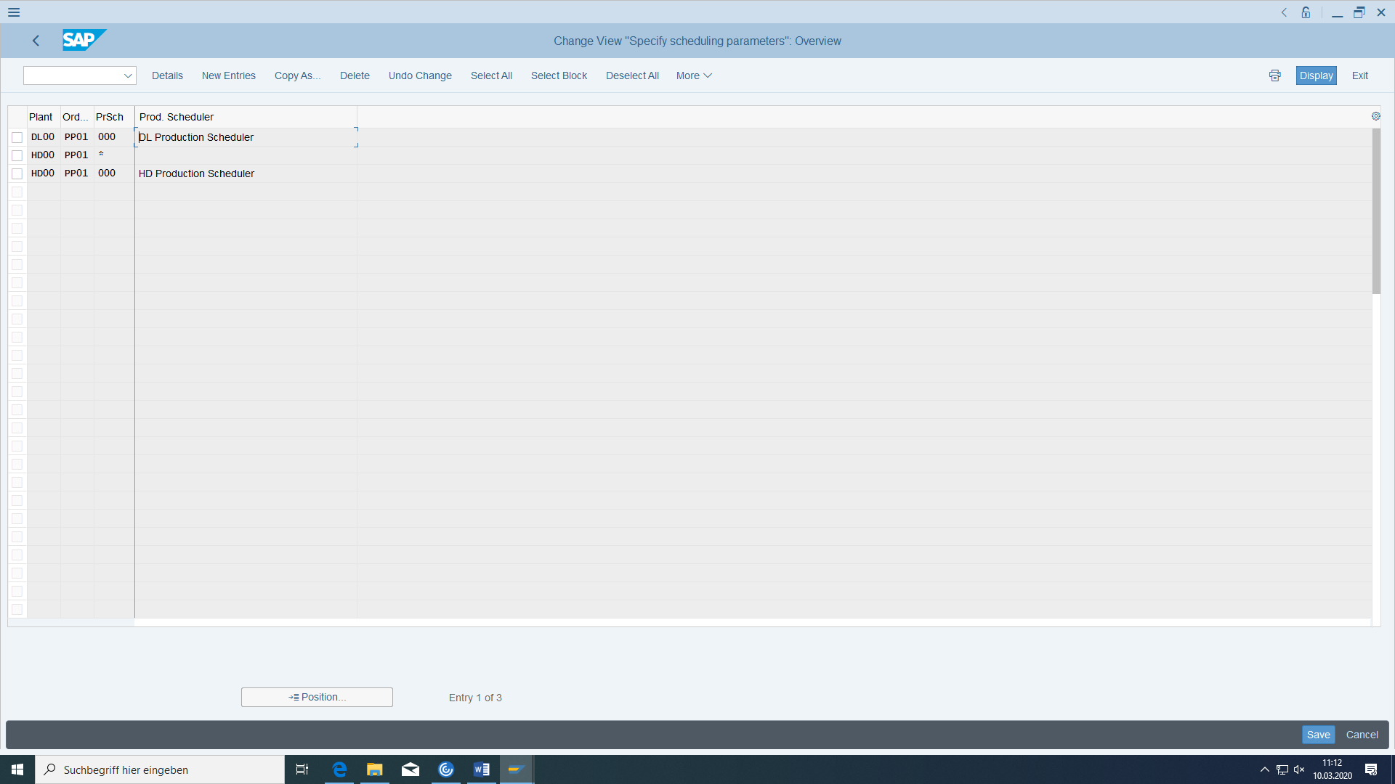

Now convert the planned order into a production order again.

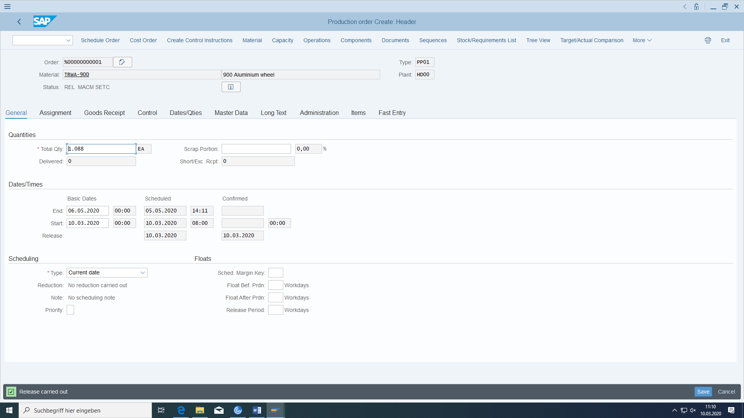

The system now creates a new production order and automatically copies all relevant data from the planned order.

Check the availability of the required components by clicking on "Material". Display the "Missing parts overview". You see that the available quantity of tires is sufficient (unless you have not yet posted a goods receipt for the purchase order).

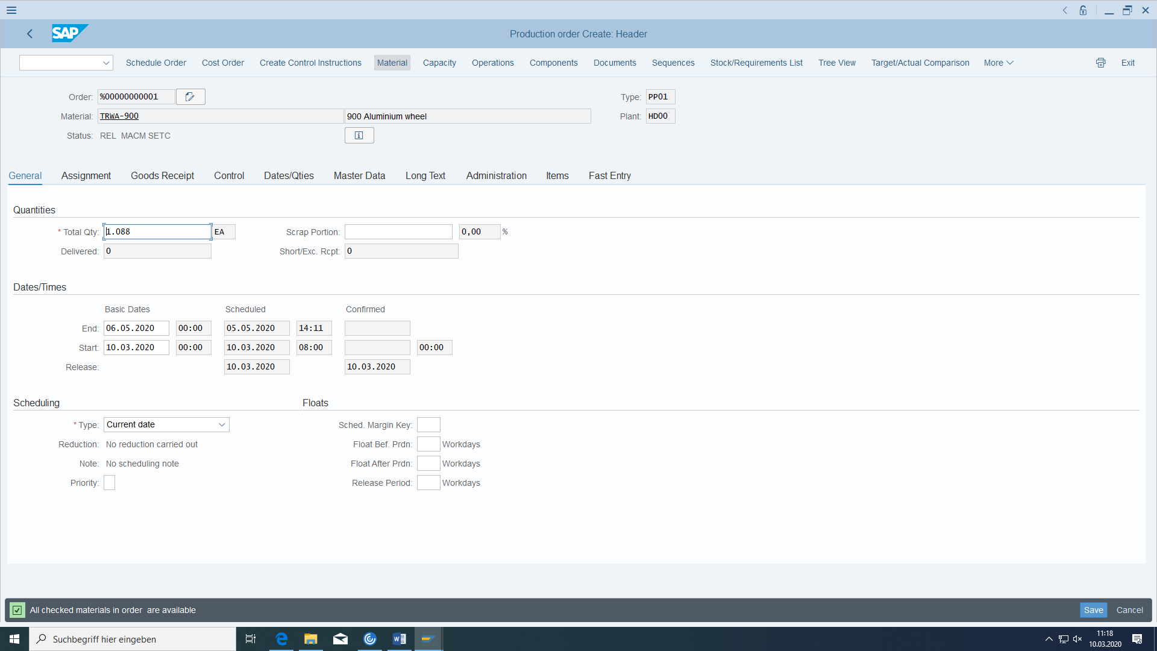

The production order must have the status REL (released). Save the production order and make a note of the number.

Production order: ____________________

In MD04 you can find now the production order 10000033:

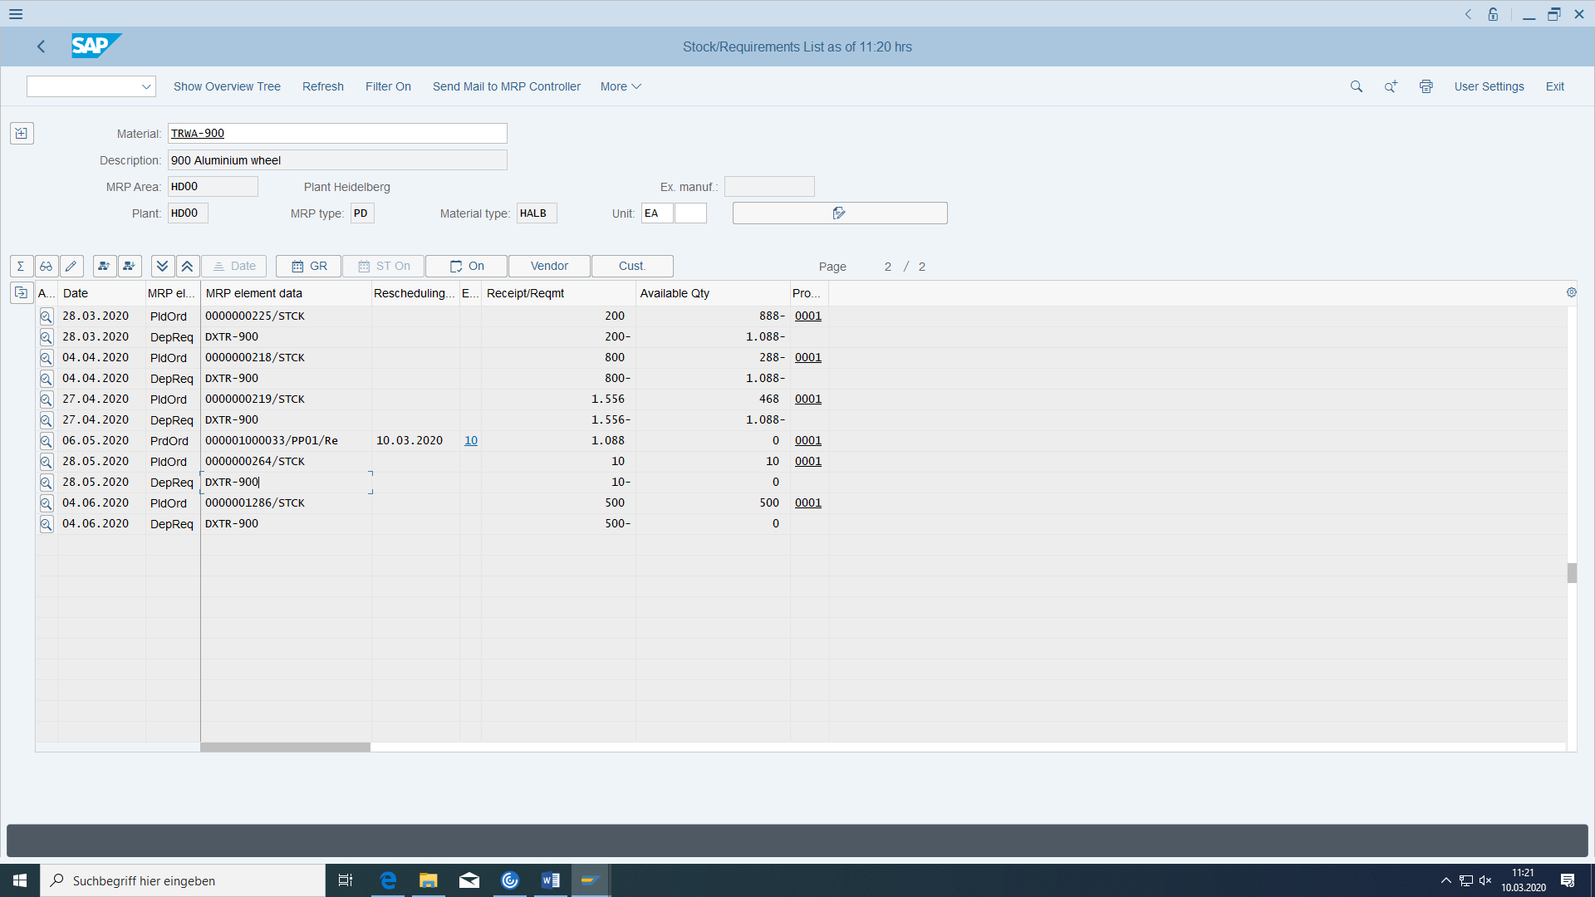

When you create a production order, the BOM and routing are also copied to it.

Find out at which work center the first operation of the production order takes place.

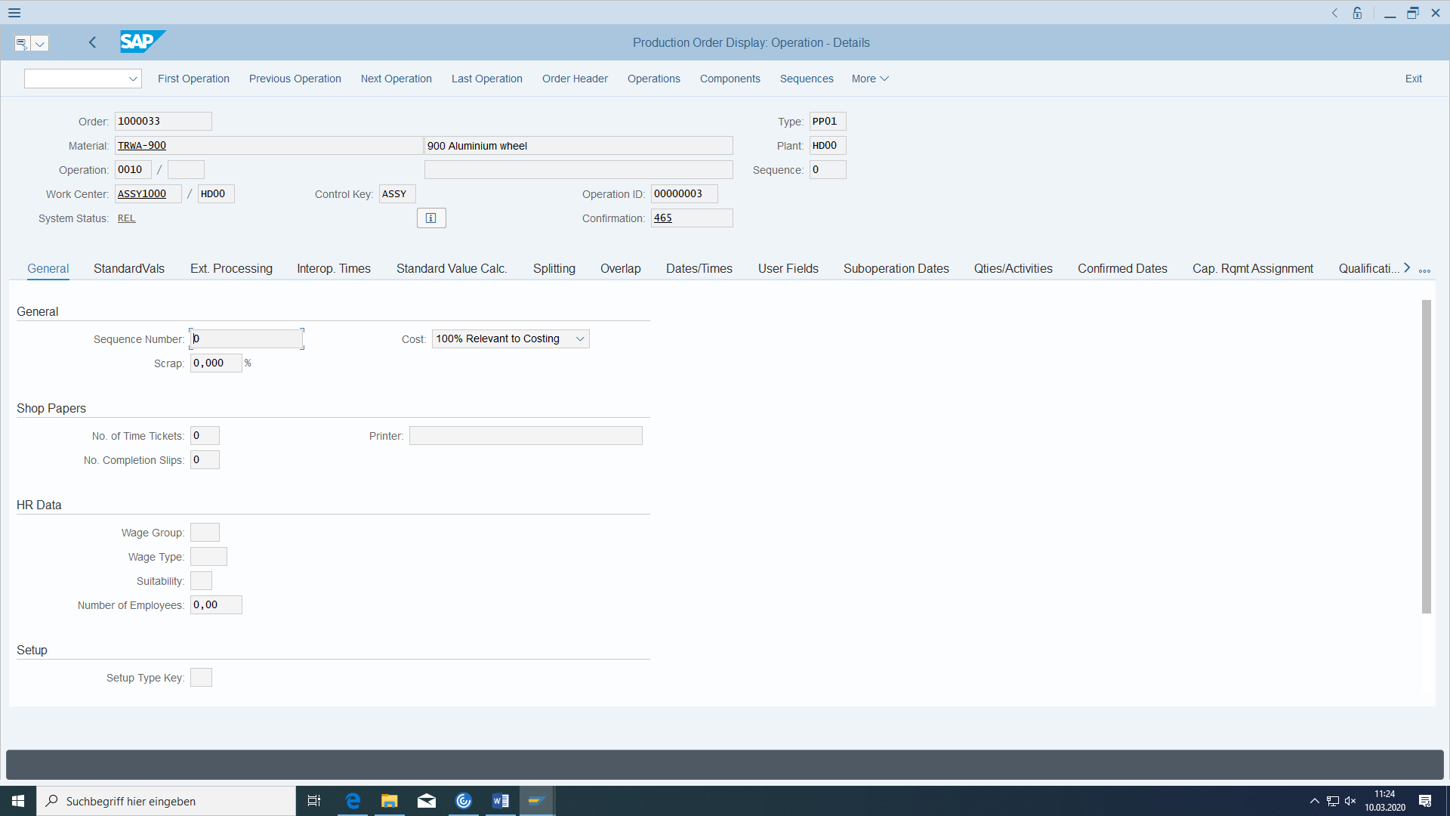

Where can you find the cost center of this work center?

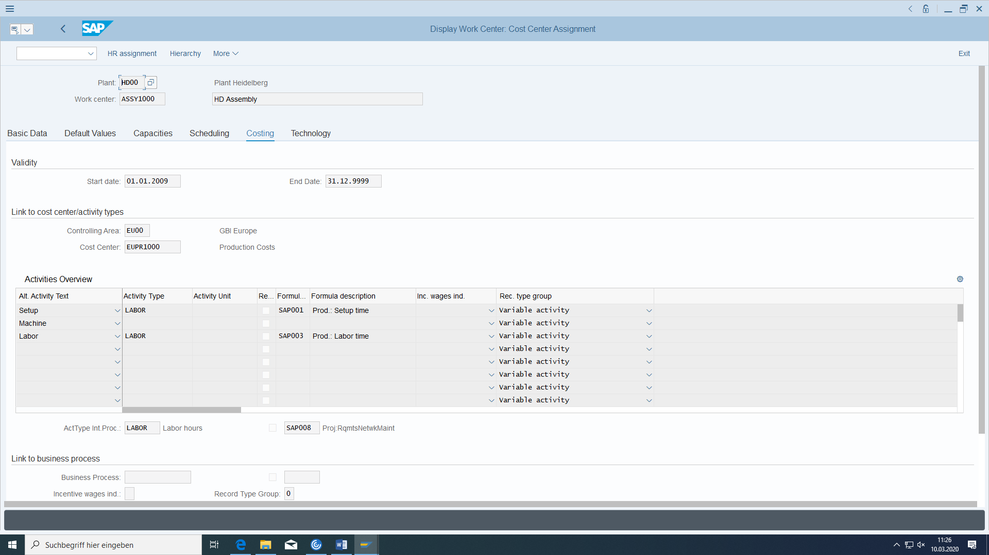

The availability check checks whether the required material components are available, whether the production resources/tools are available, and whether the capacity is sufficient.

Now also check the situation with the subordinate components.

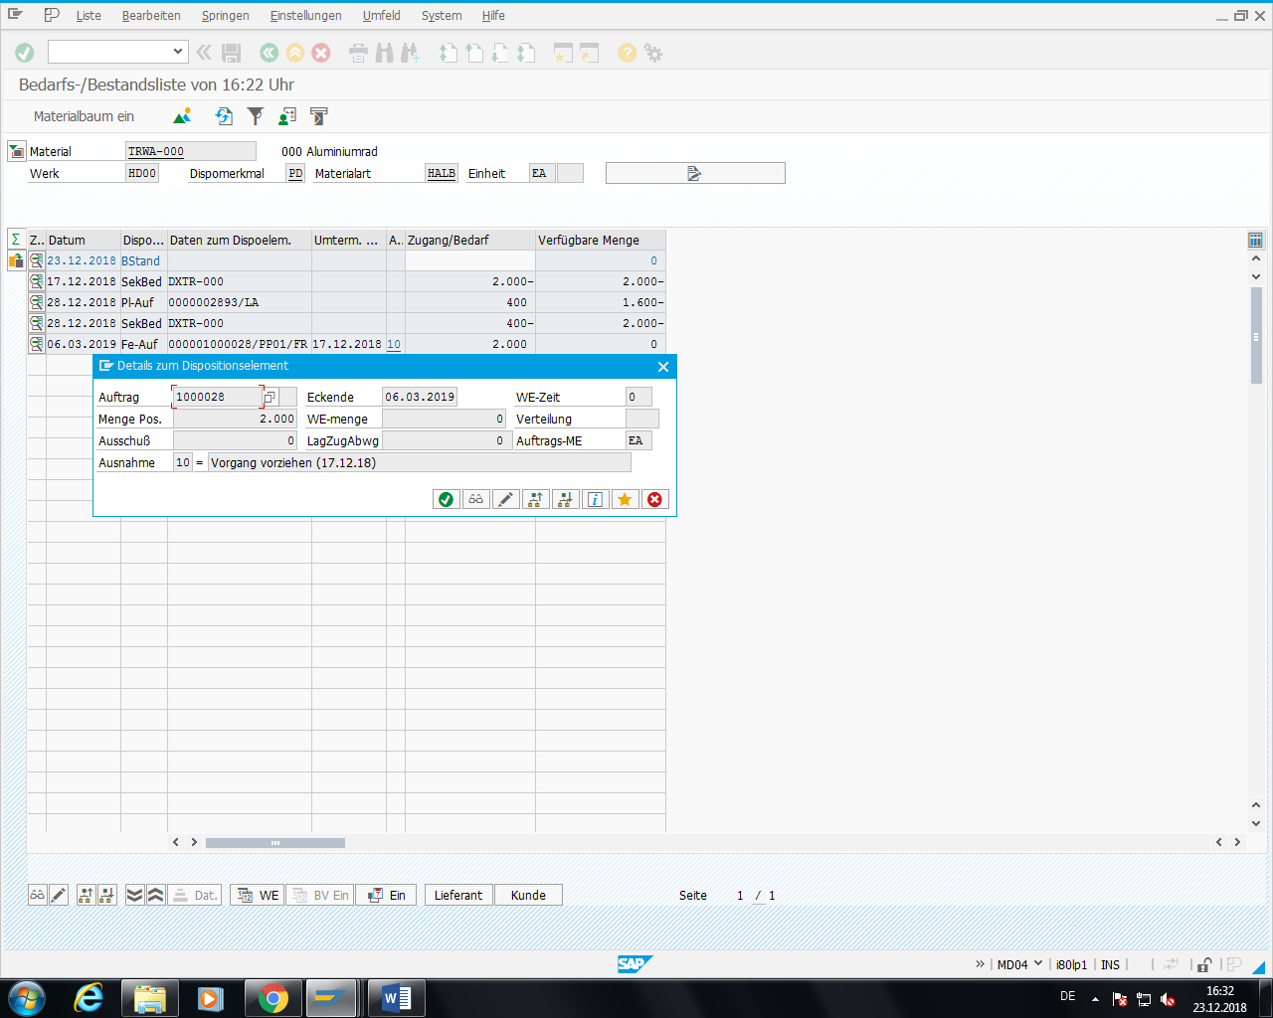

Production reservations were automatically created and displayed below for the released production order. These replace the previous dependent requirements:

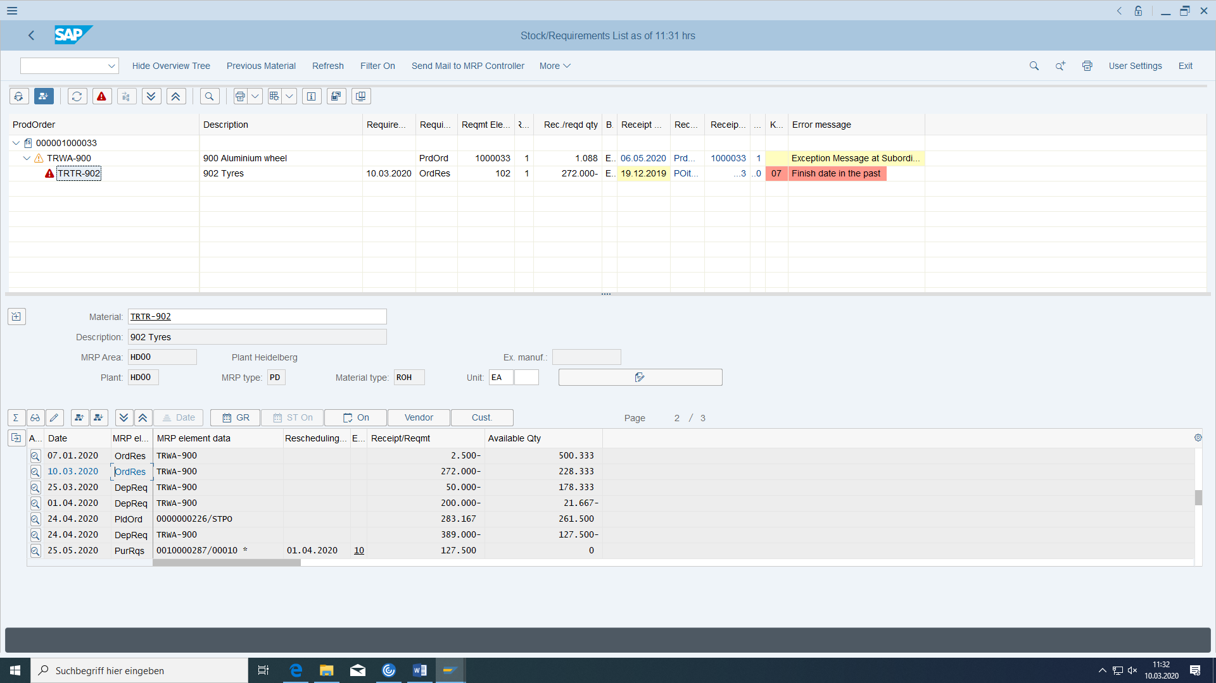

If you reduce the production order quantity, you can see how well or how poorly the current stock/requirements list functions without executing the MRP run.

How does this affect the production reservation below?

Is a corresponding planned order generated at the top for the reduced quantity and the corresponding BOM requirement at the bottom?

Compare the situation after performing another MRP run.

## Carry out tire material removal for the aluminium wheel

In order to manufacture your aluminium wheel, you must remove the required components from stock (only possible if the production order has also been released). Choose the appropriate transaction.

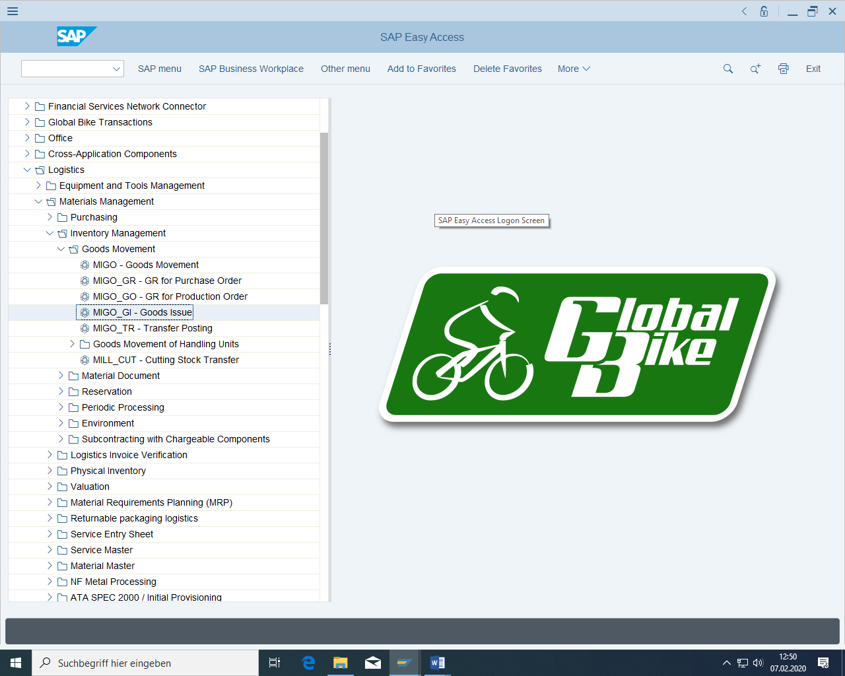

In the next screen, enter the number of your production order (behind the Order control list). The system proposes the correct material item from the BOM.

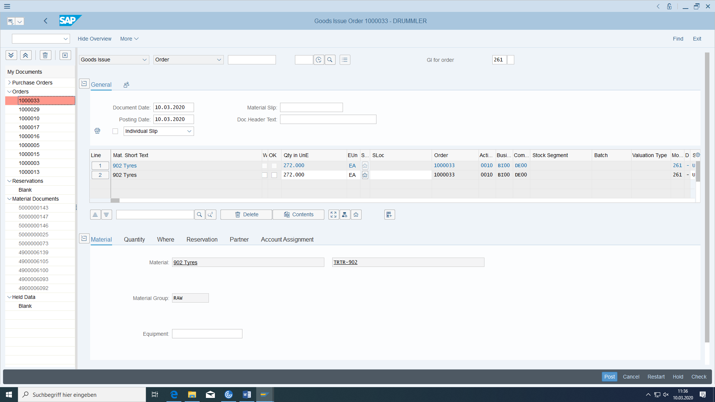

Now enter the number of your production order and confirm with 'Enter'. The system proposes the correct material item from the BOM.

After setting the OK flag and location from raw materials you can post.

If you get:

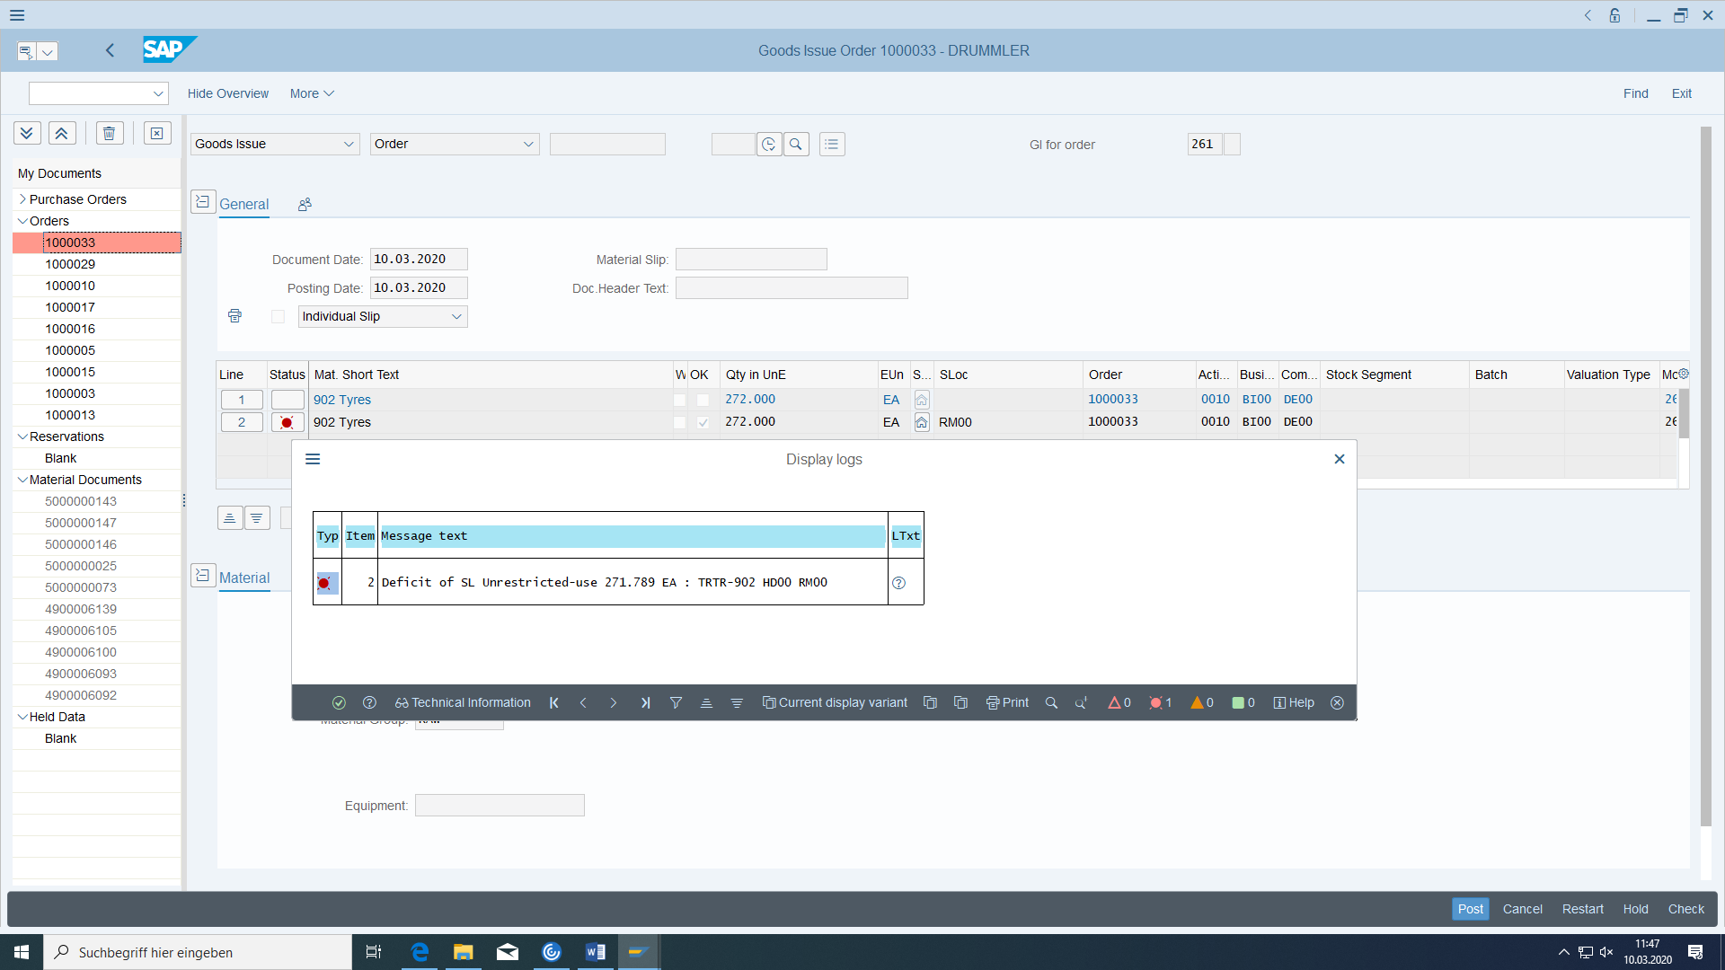

Your stock amount of the tyre material is not enough.

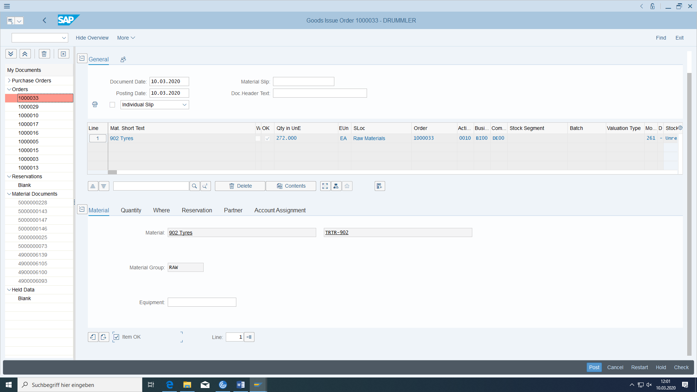

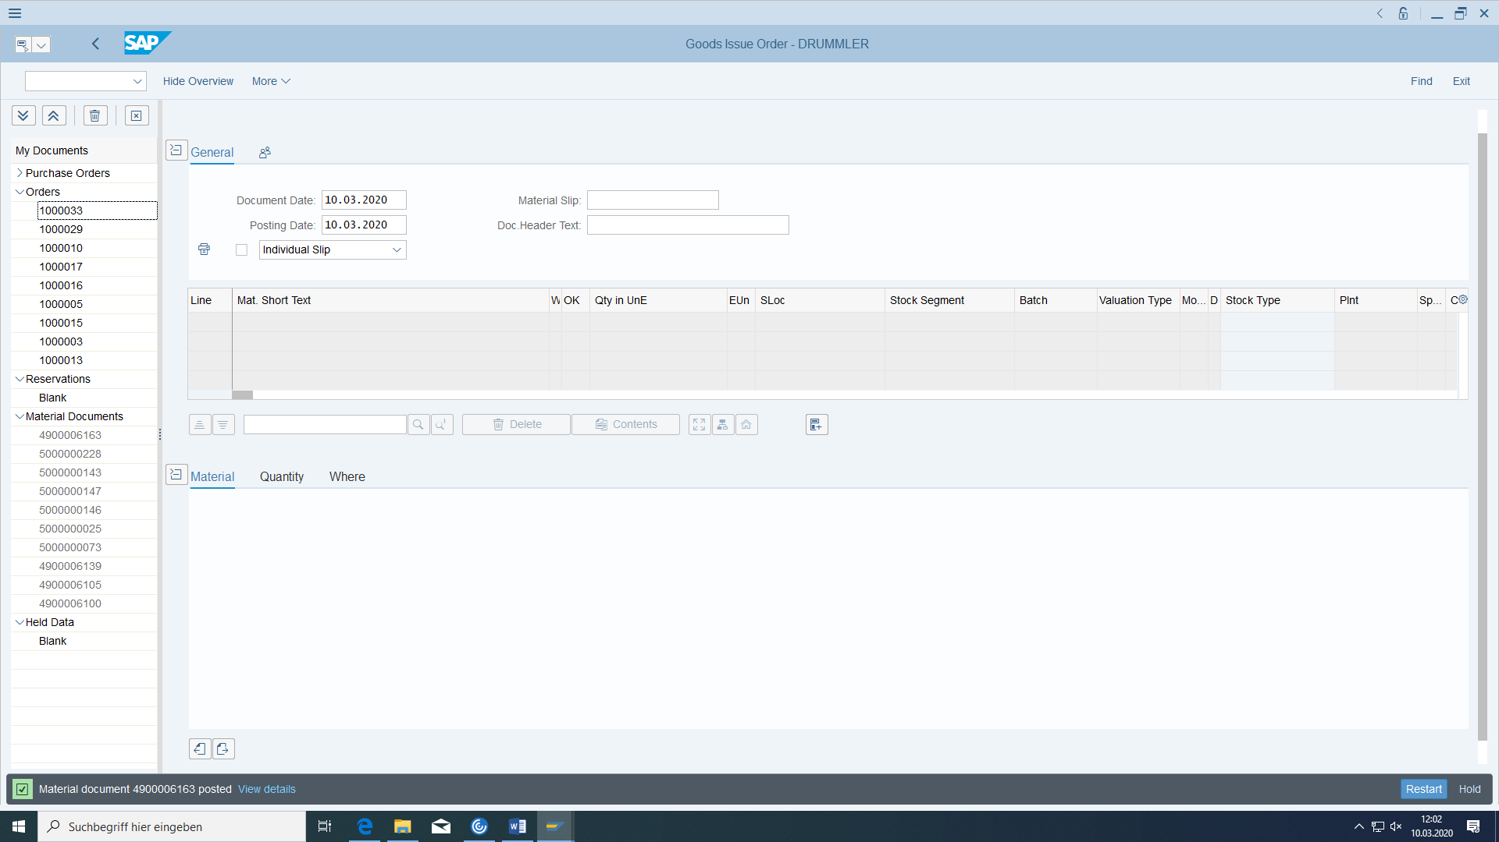

Is the storage location the tire material or wheel production?

Choose Save and note the number of the material document.

Material document no: __________________________________

Then check the MRP situation in the current stock/requirements list (where has something changed), particularly with regard to warehouse stocks and production reservations.

Before:

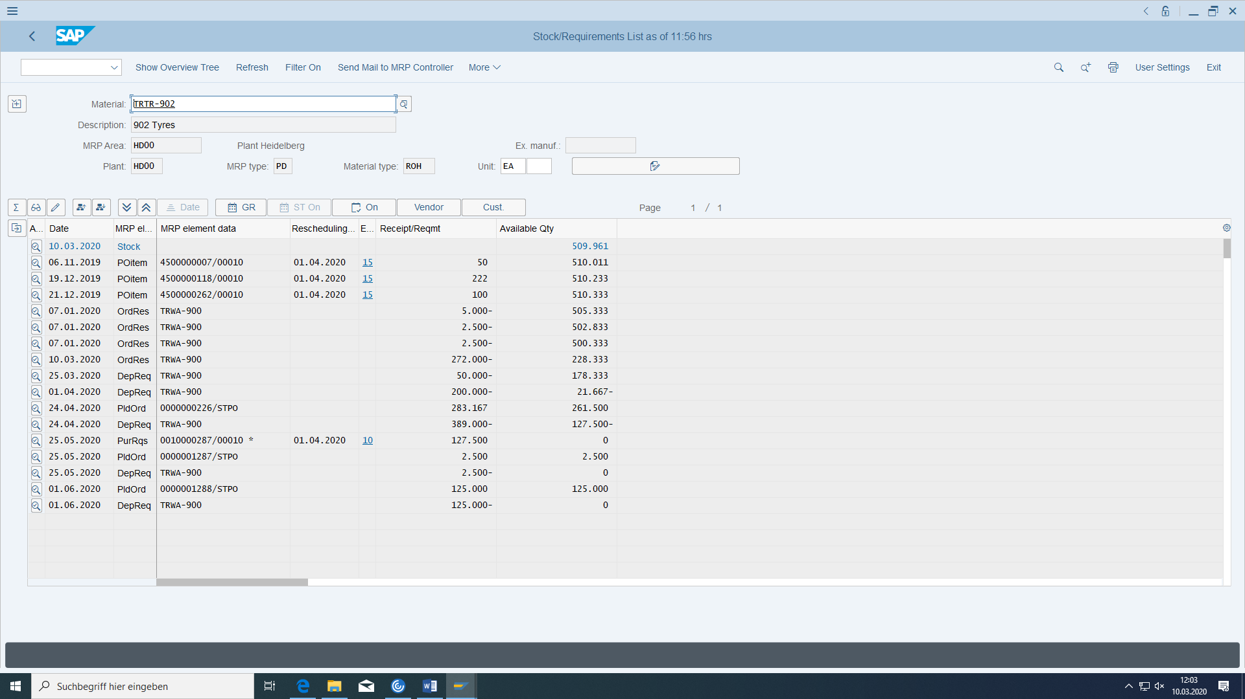

After:

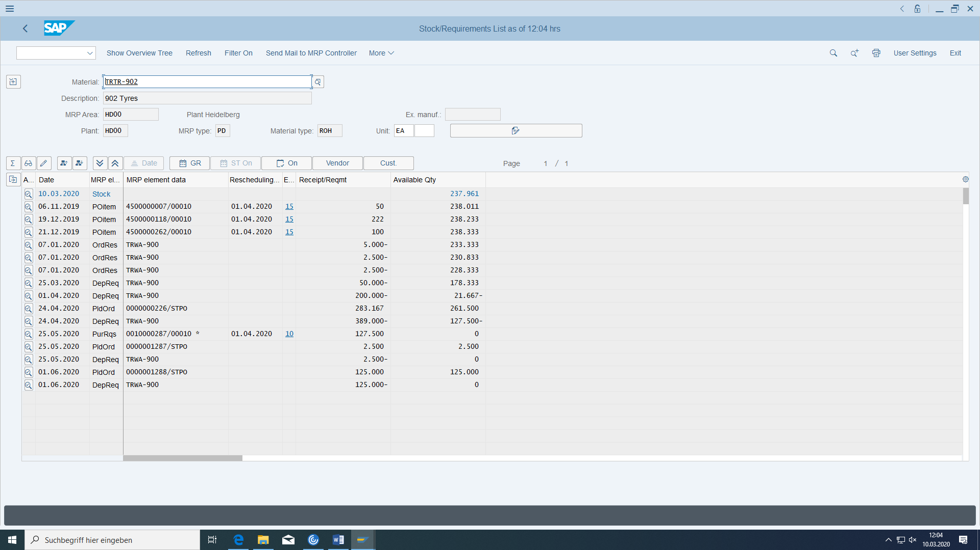

Which two facts changed?

Can I notice at the production order that material has already been removed for it?

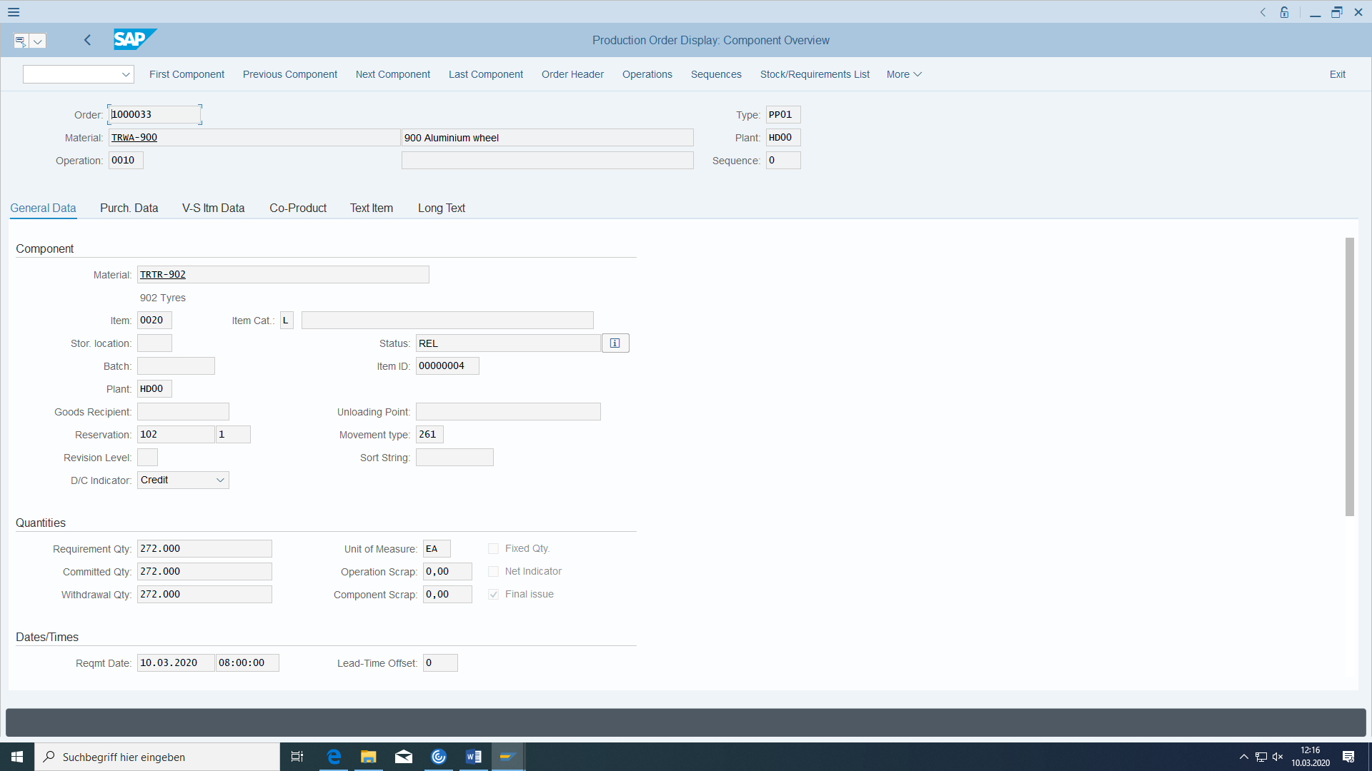

The movement type is 261, which not only updates **consumption and stock fields**, but also reduces **production reservations**, determines **actual costs**, and posts **controlling, accounting, and material documents**.

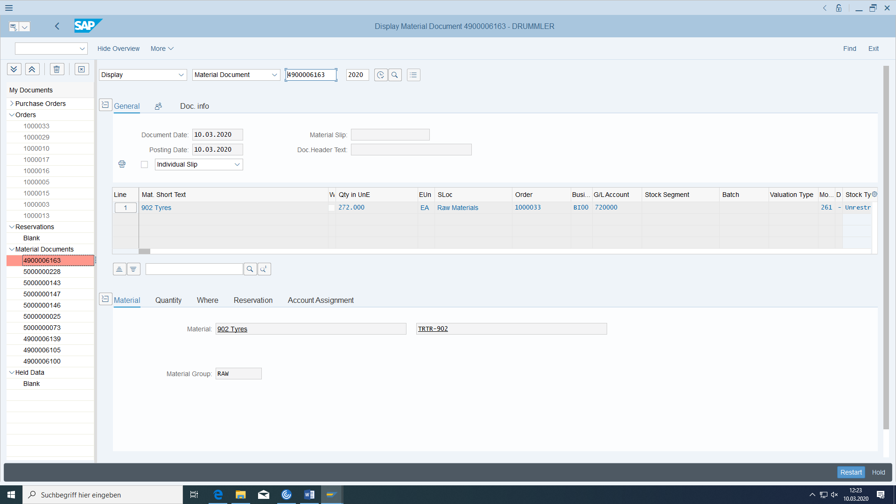

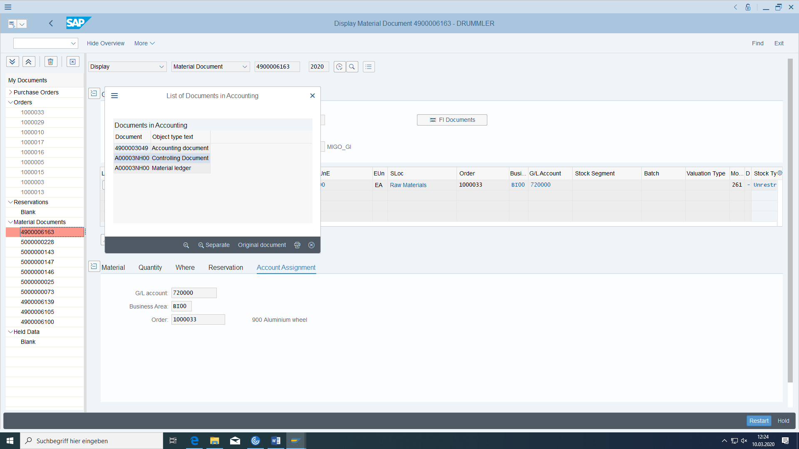

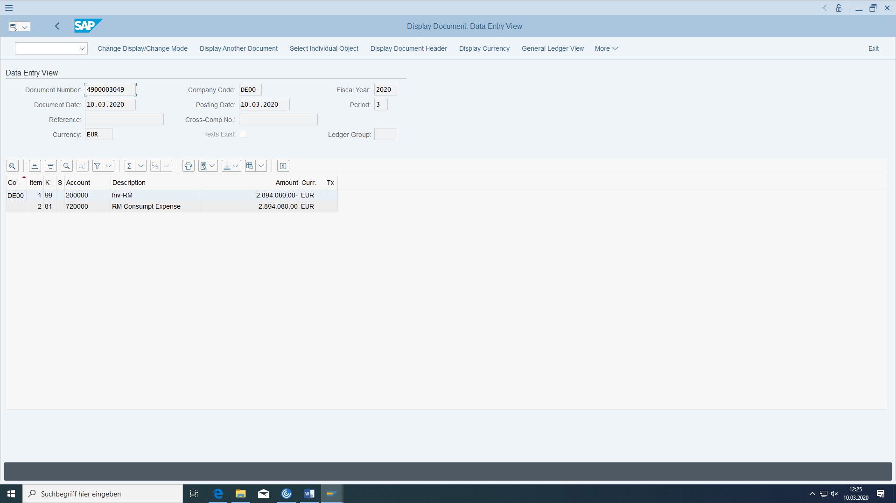

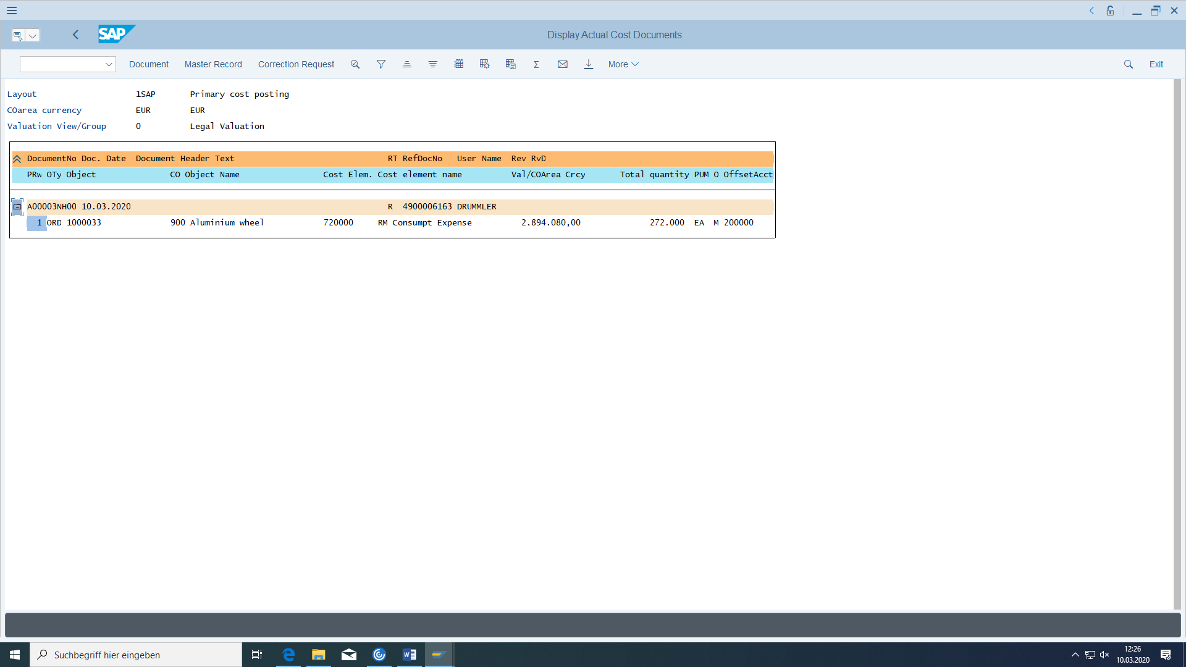

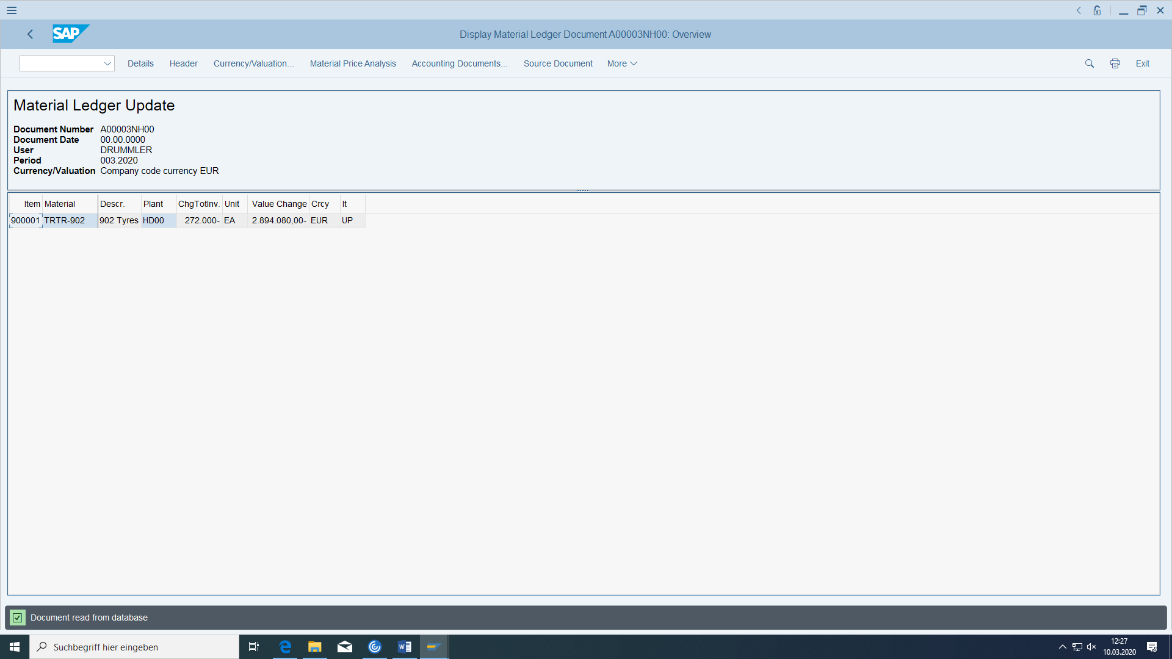

The production order collect all costs:

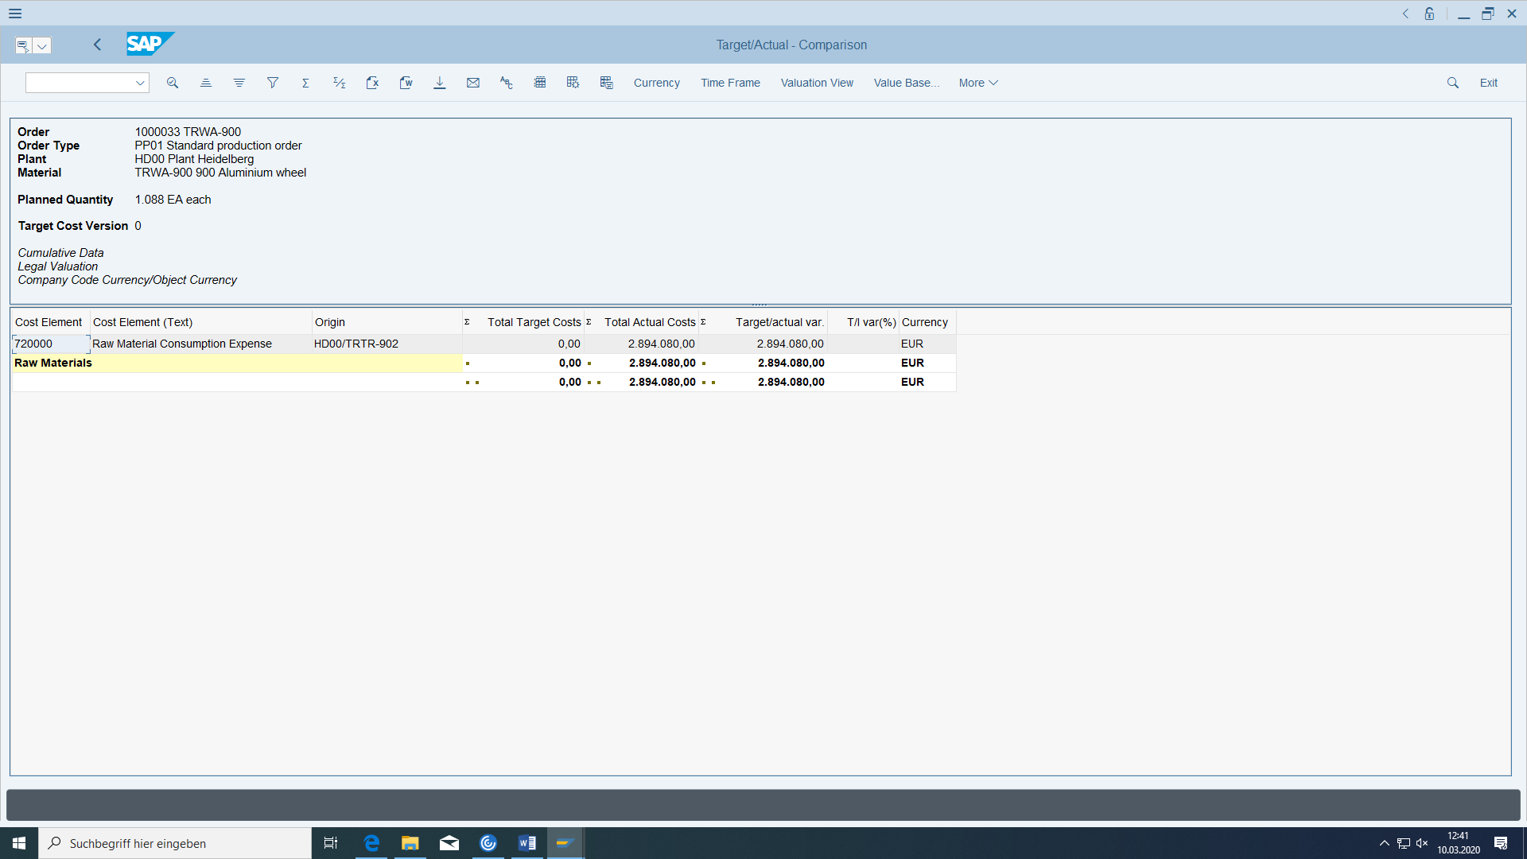

## Confirmation of the operations of the production order

You can confirm the step after you have carried out an operation.

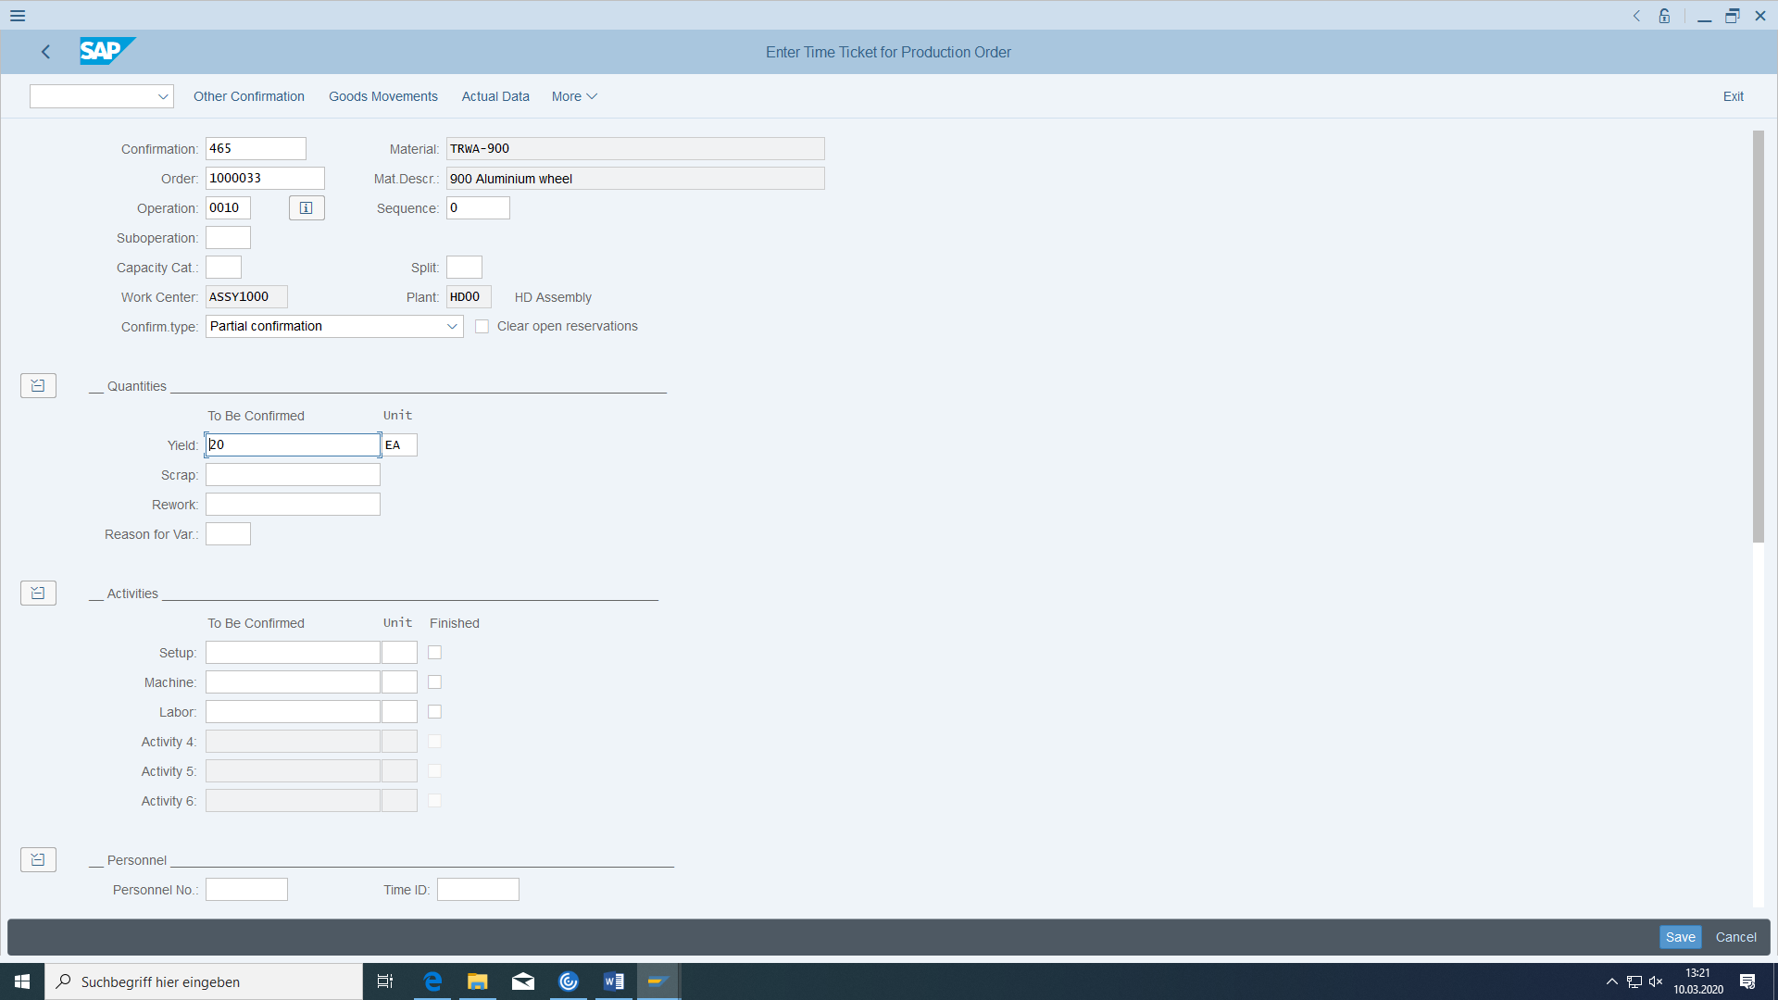

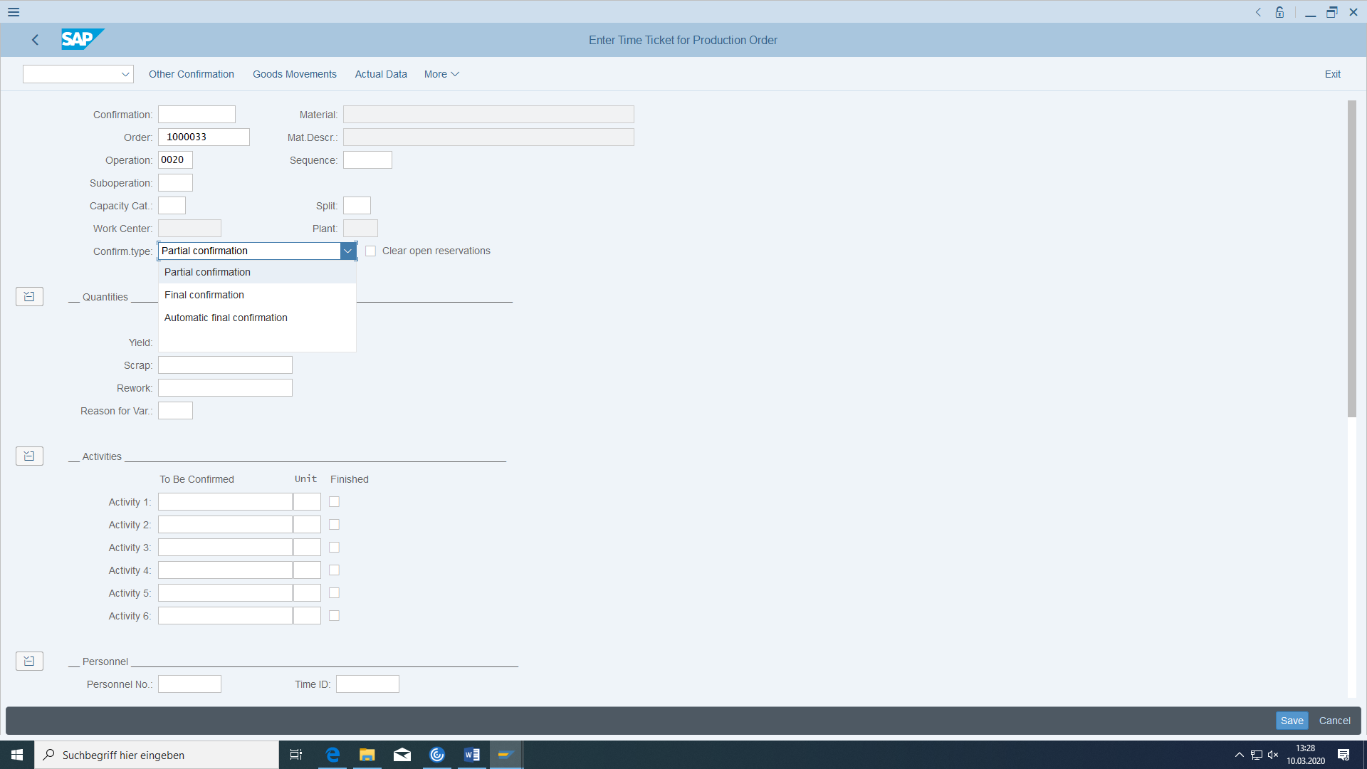

In the last operation, the confirmation could have caused also an automatic goods receipt for the production order (but this is not the case for our operation).

## Goods receipt of the production order

In our example, the goods receipt posting was not made automatically with the confirmation of the last operation. Therefore, we must explicitly post the stock receipt. Movement type 101 is used for this.

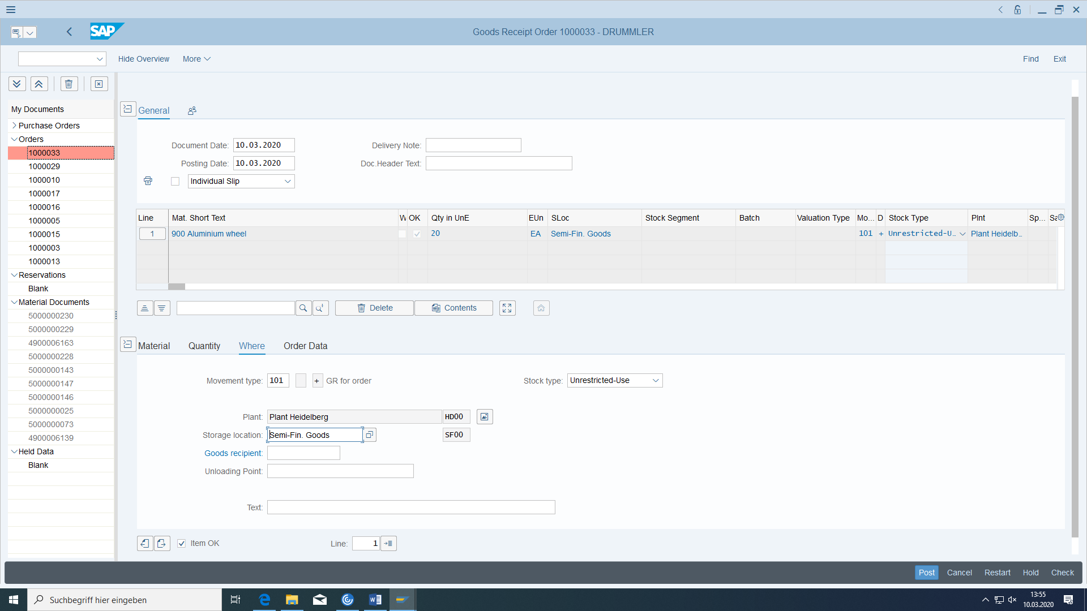

Post.

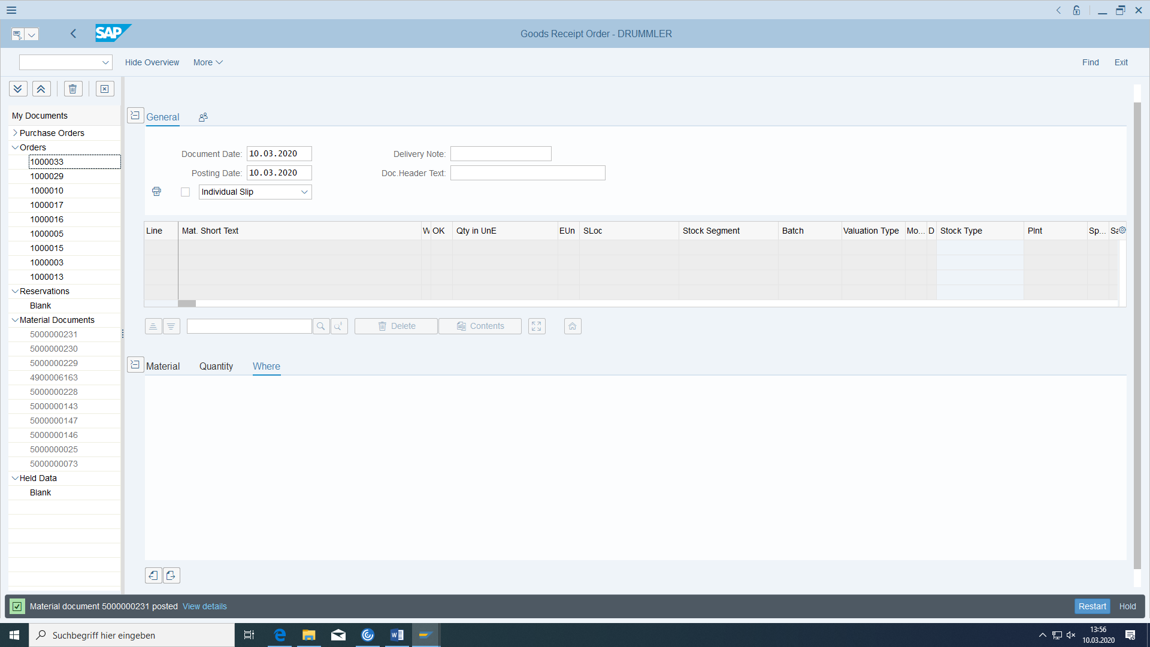

This results in the following situation:

Before:

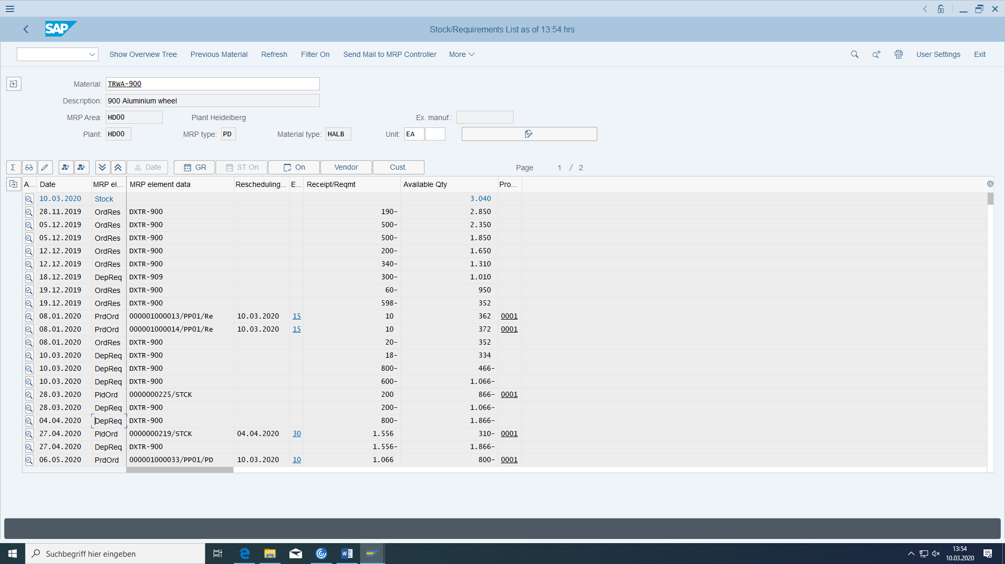

After:

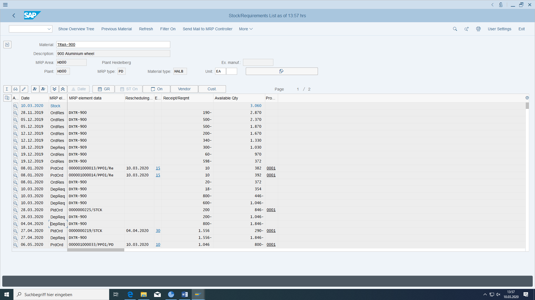

Open quantity for the order is reduced, but the physical warehouse stock has increased in the same amount.

In addition to the material document

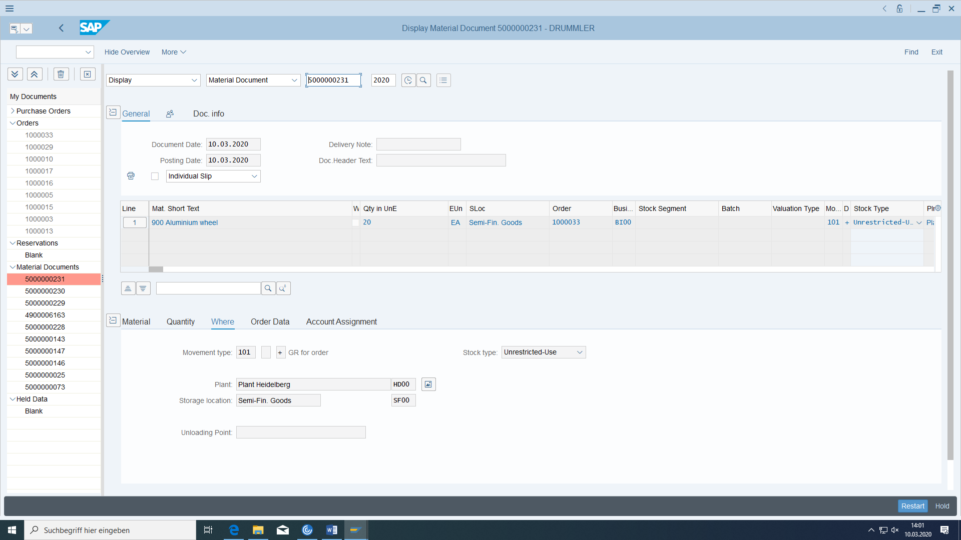

an accounting document and a cost accounting document were created:

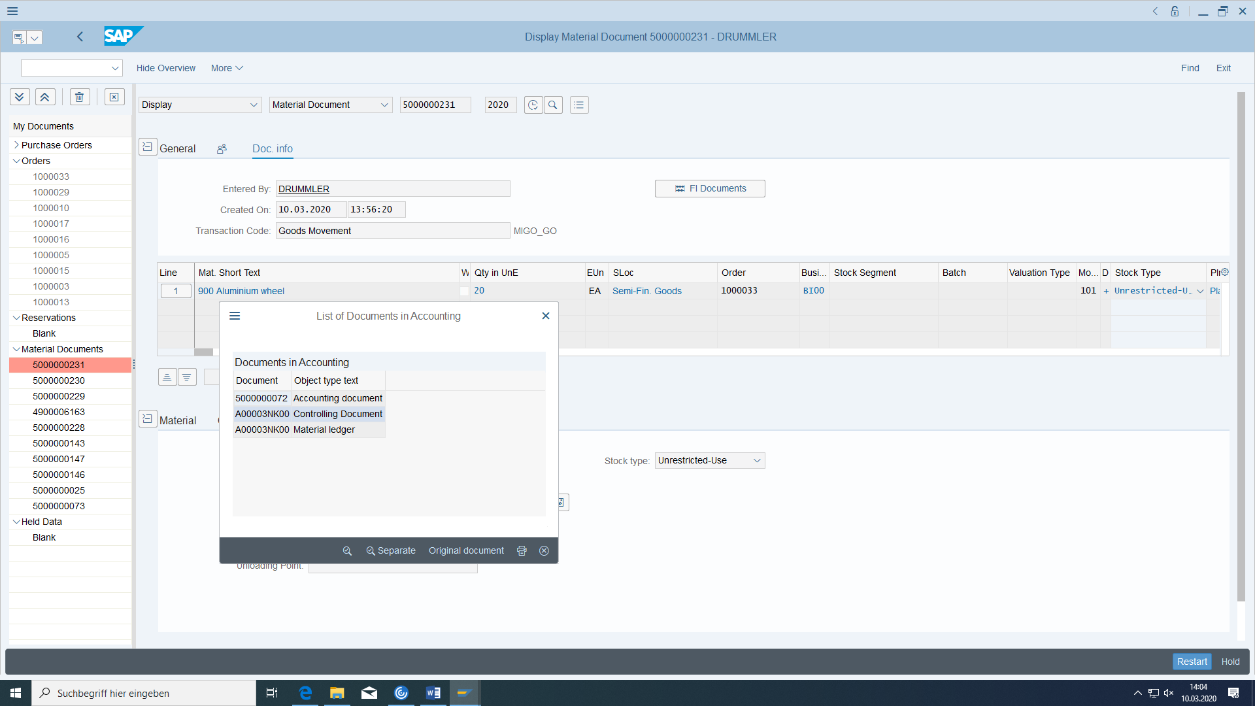

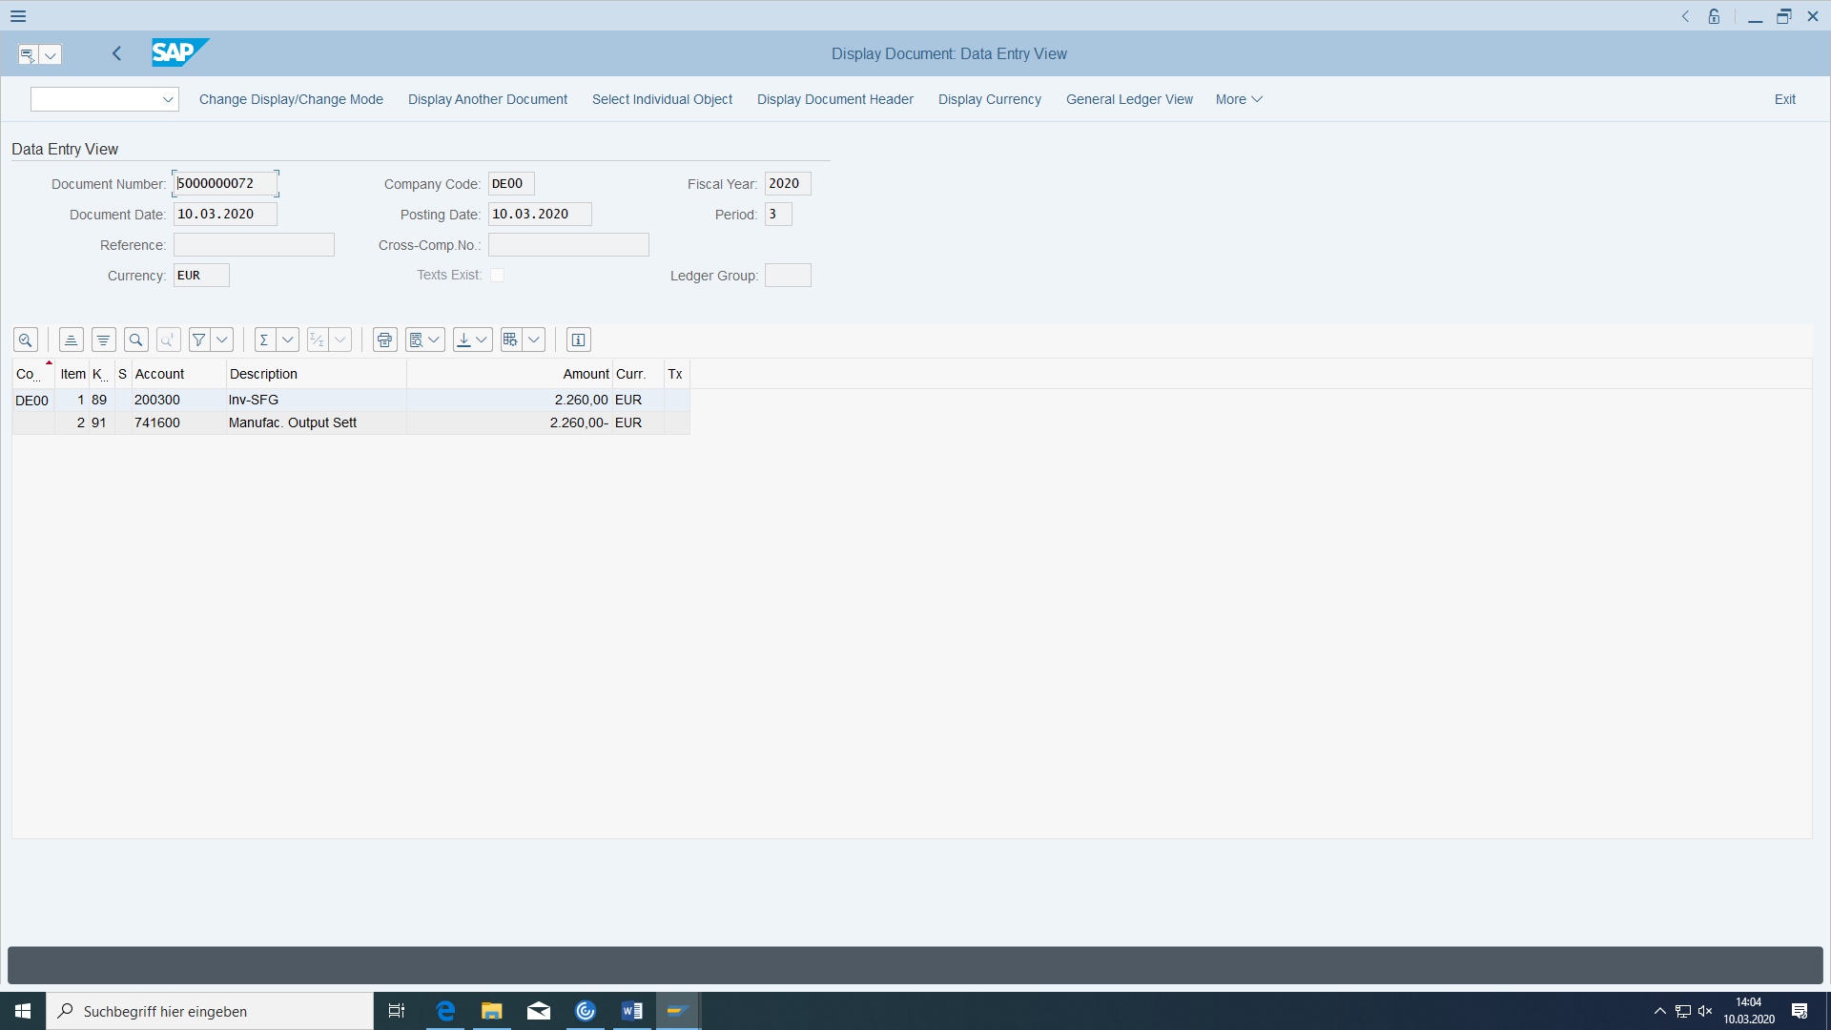

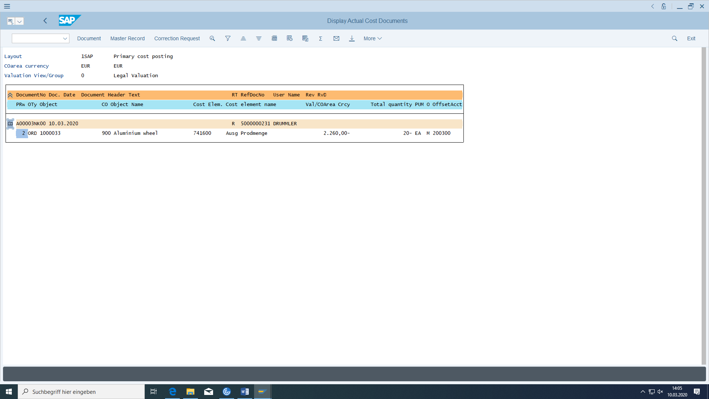

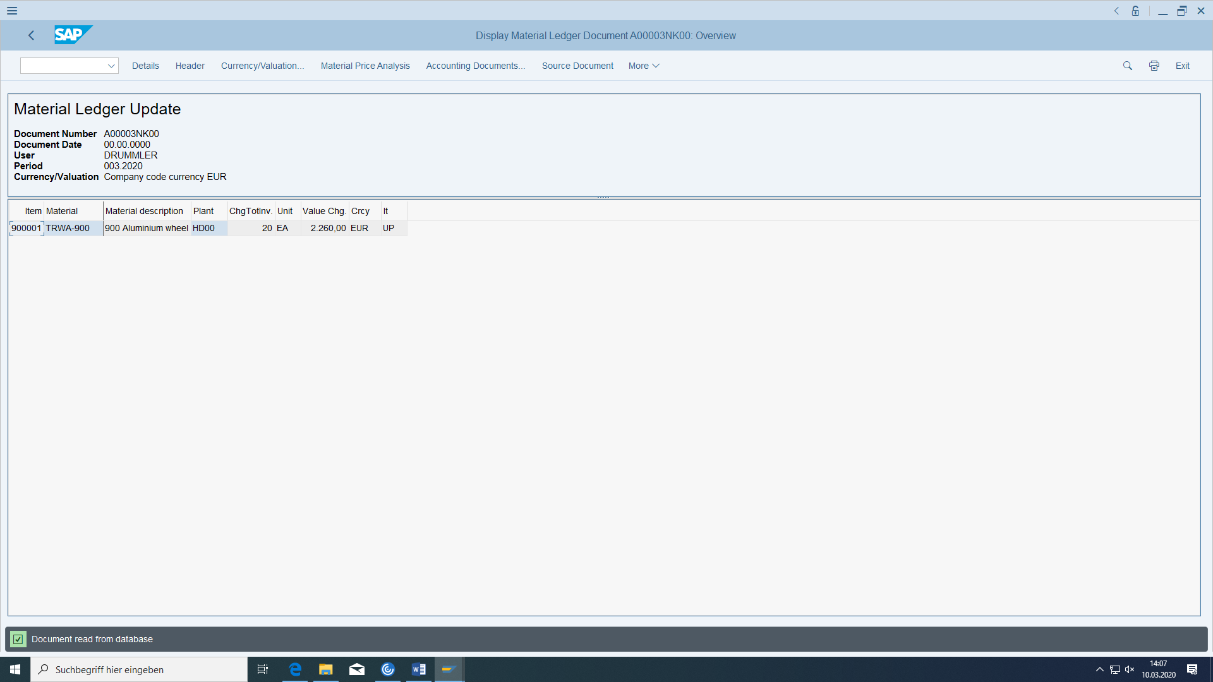

In the production order, check whether all actual costs from material consumption (goods issue) and Plant (confirmation/goods receipt) have been allocated (Cost Object Controlling).

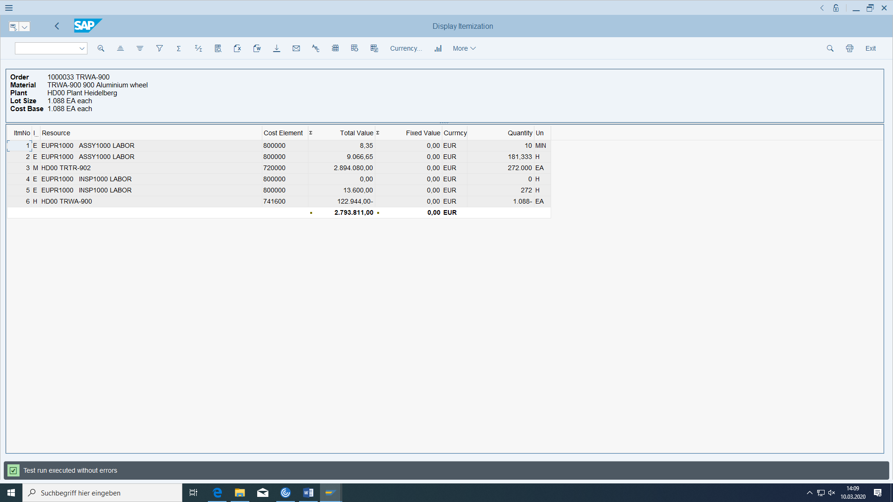

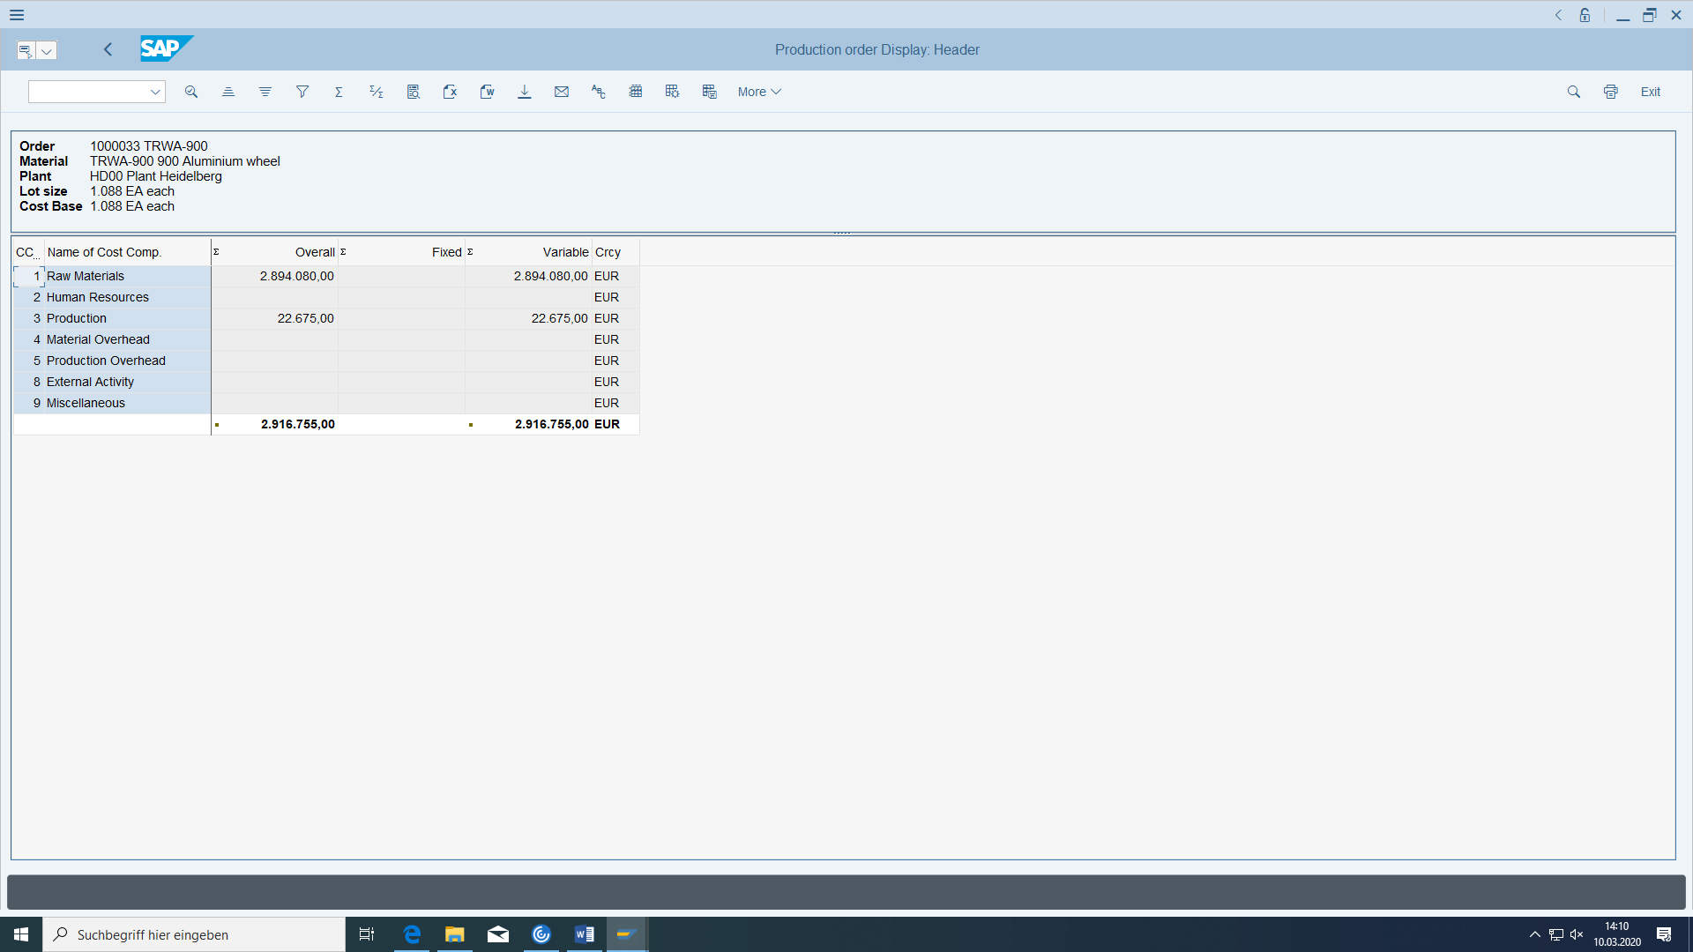

## Settlement of the production order and cost variance

The accounting and cost accounting credit for the production order does not take place until the (periodic) order settlement. As a test, you can check at any time whether the target costs of the production order match the actual costs (for example, more component consumption than planned in the BOM). Perform this check:

Before check OKV6 in customizing:

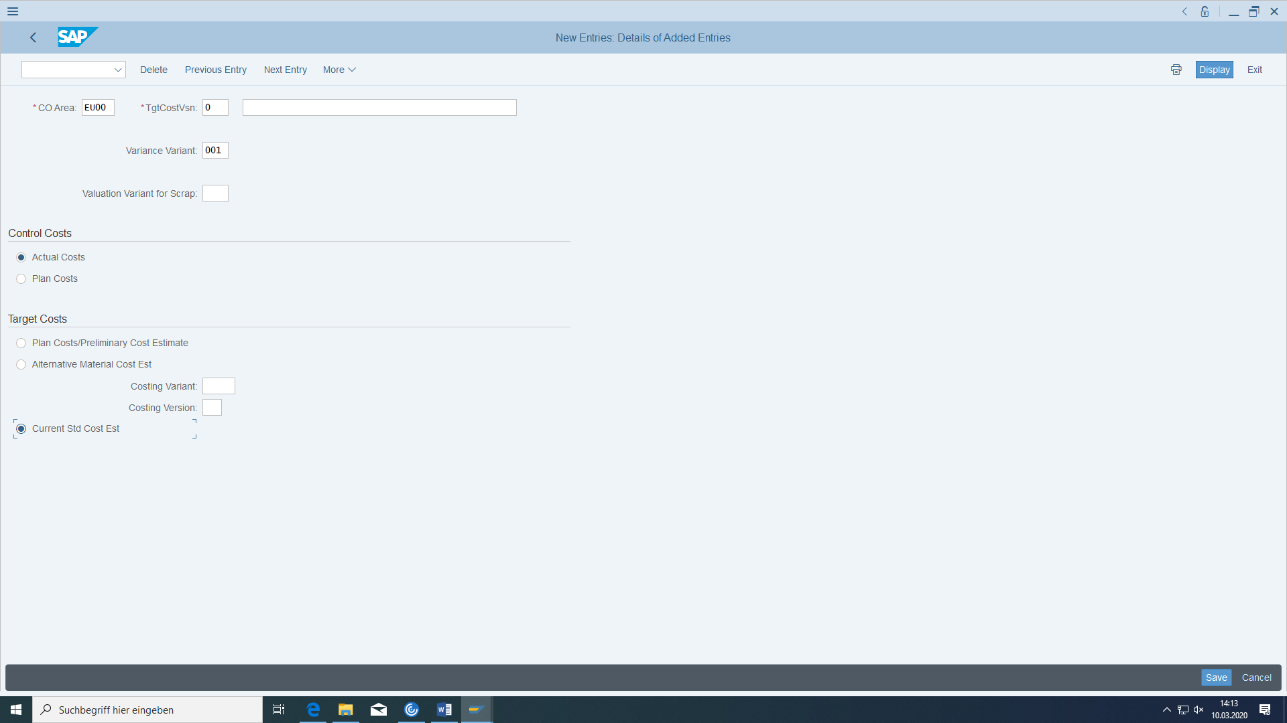

You can see the settlement in the header rules:

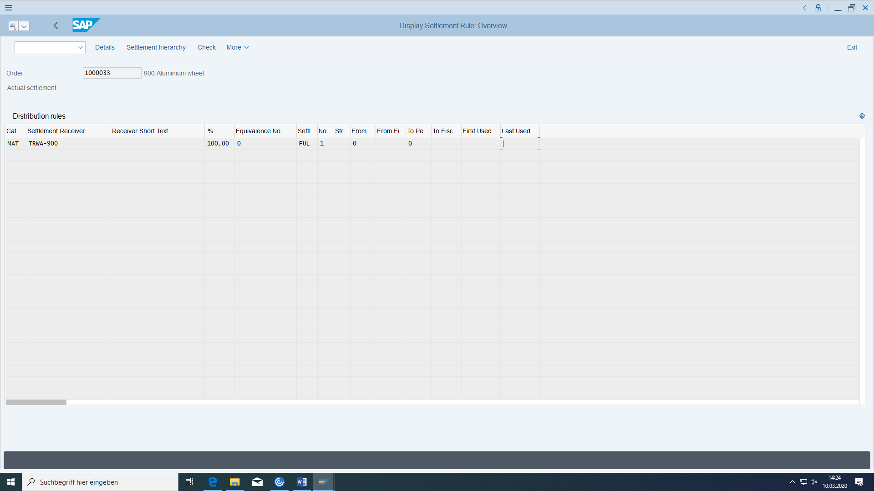

So all costs gathered in the production order will be transferred to the material.

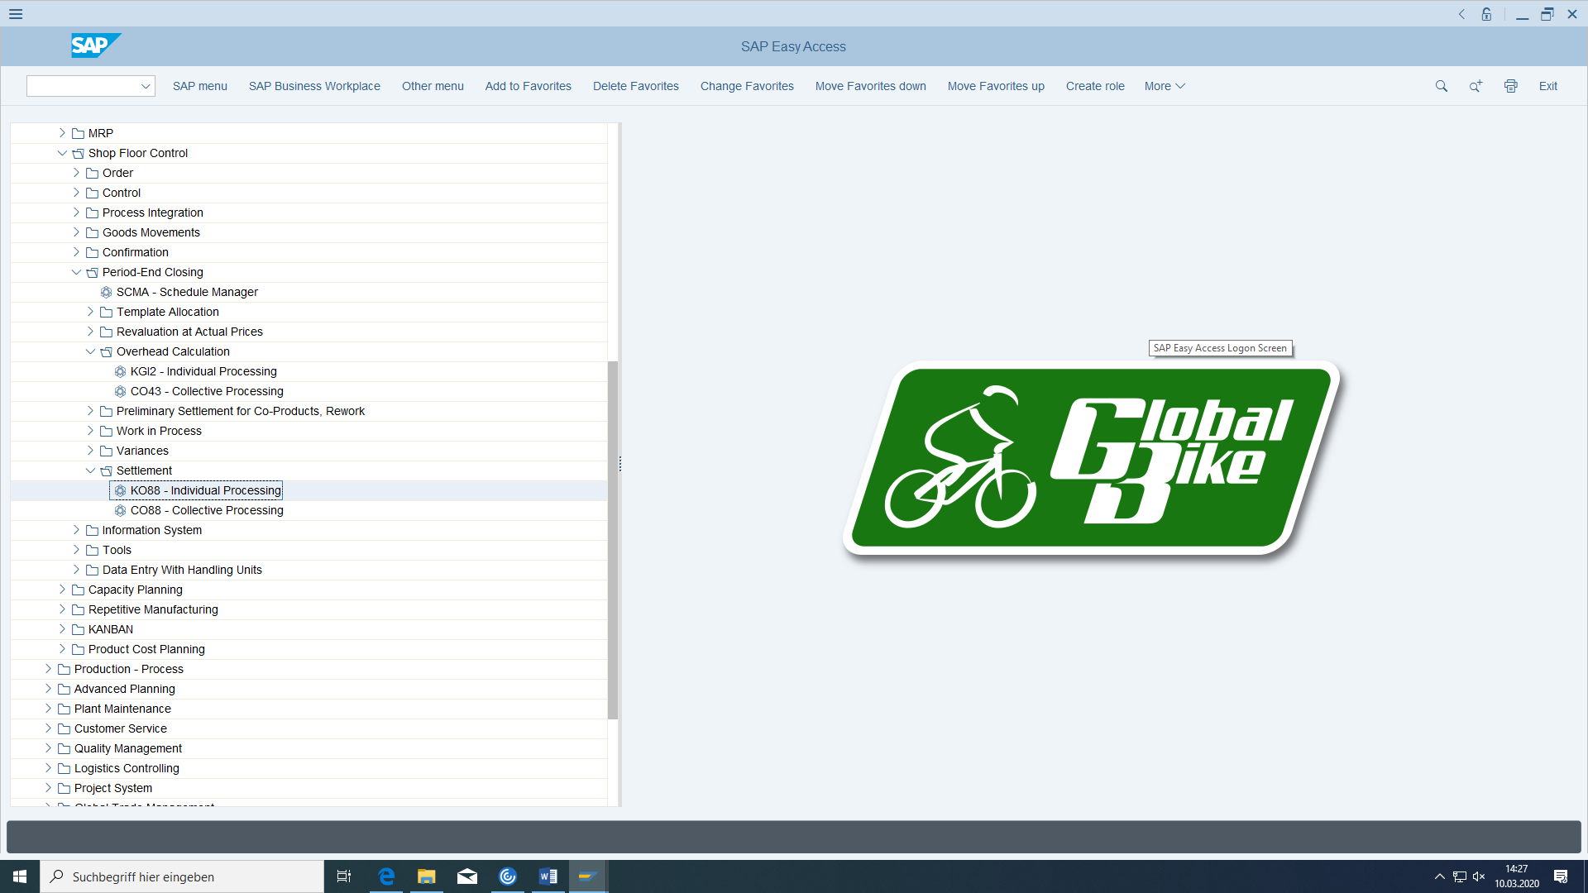

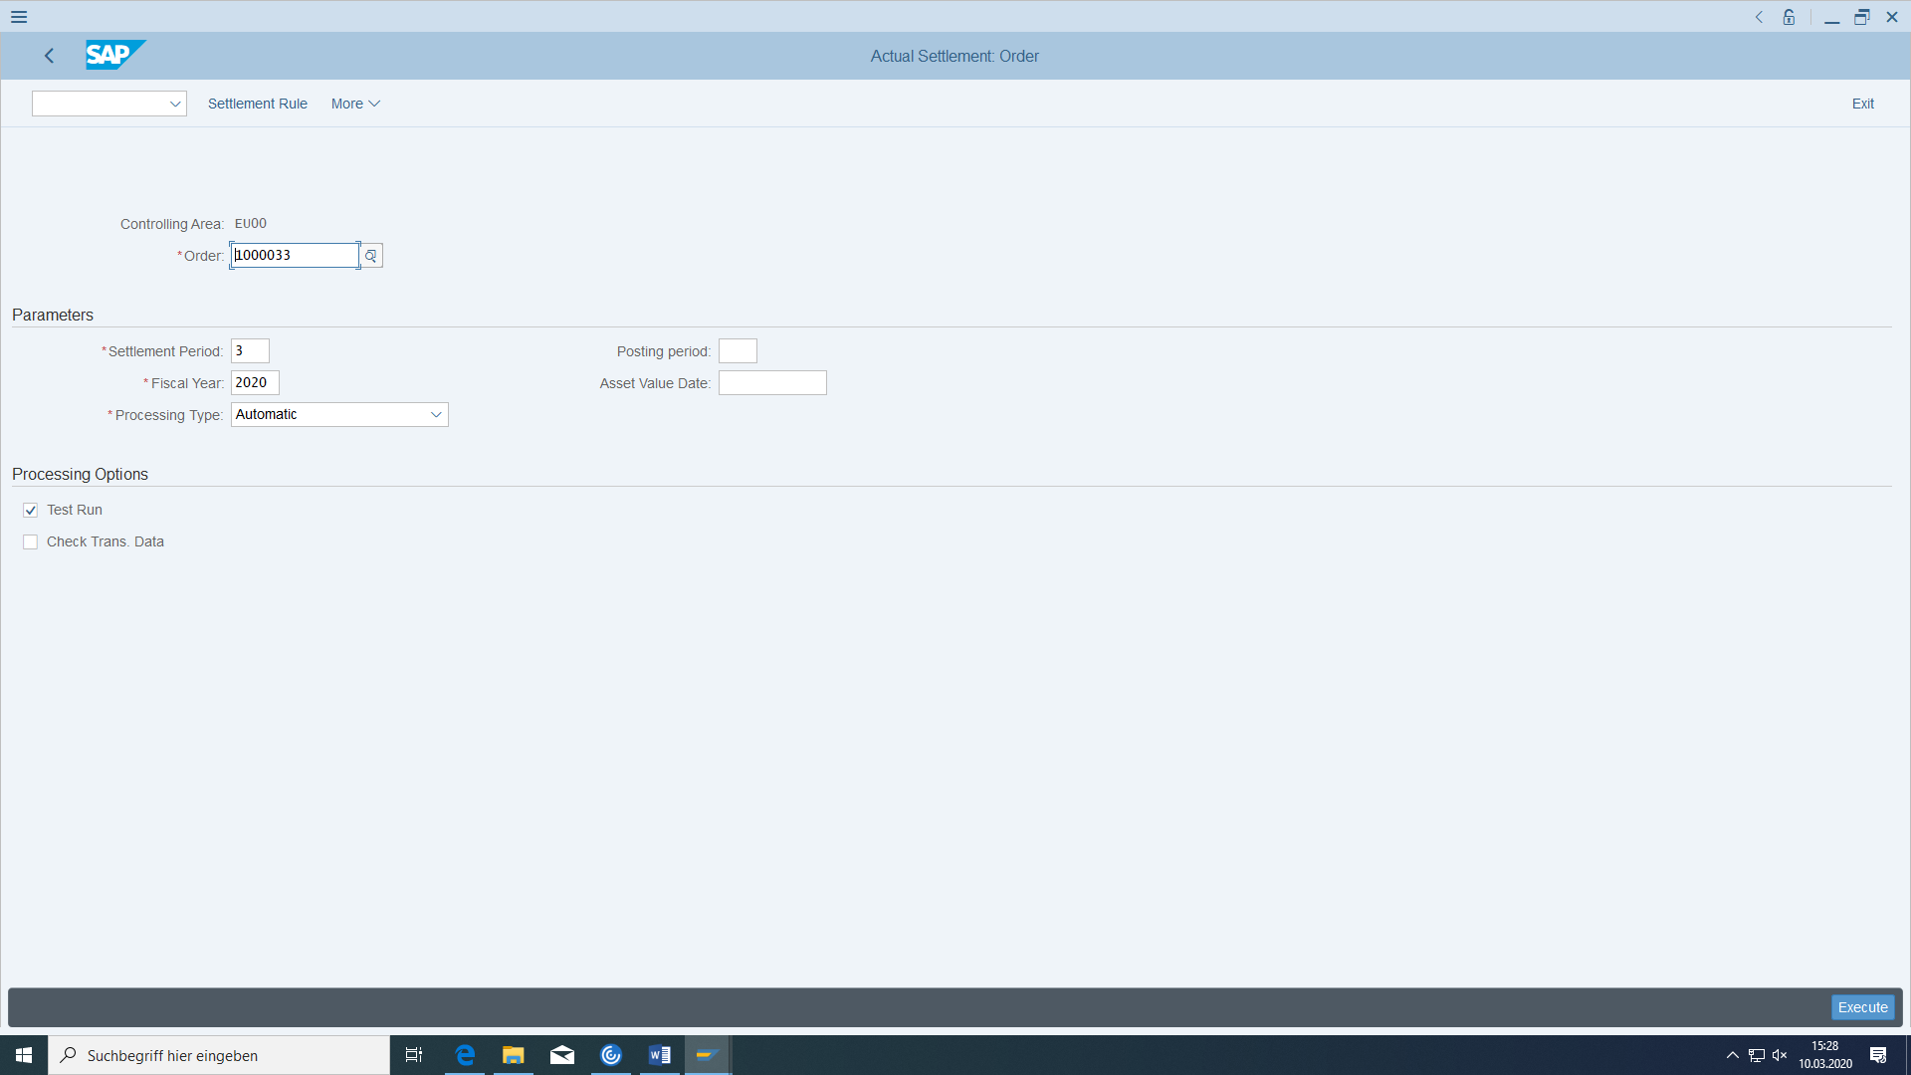

If you get

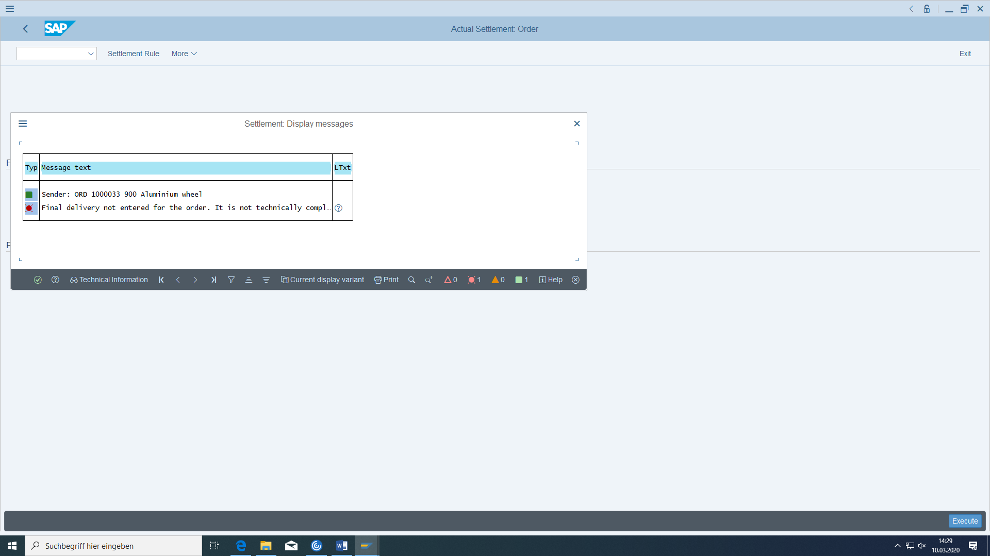

You use the wrong settlement period or fiscal year

Or

You should:

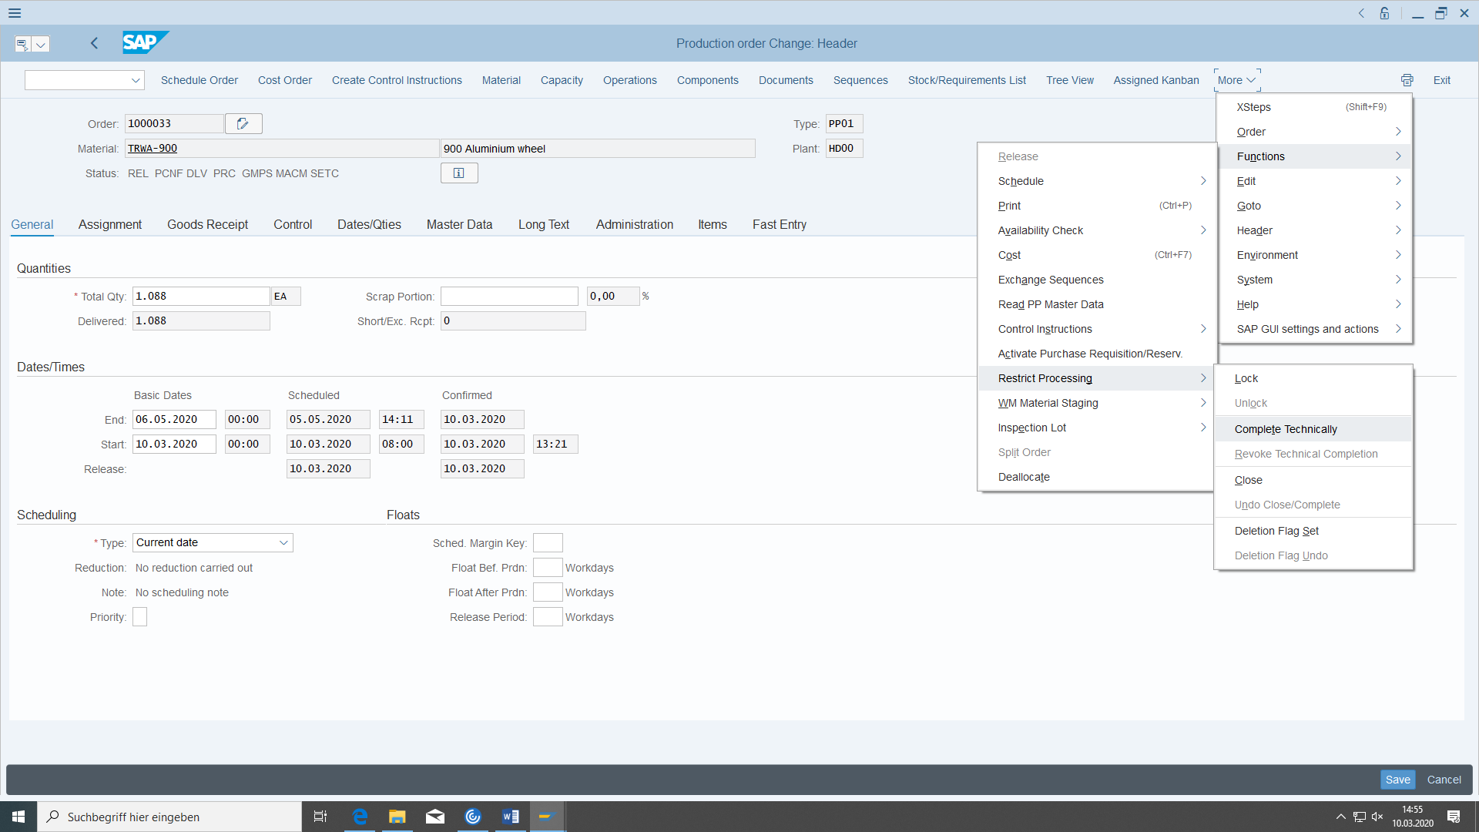

**If everything works you should do it with Test Run flag not set.**

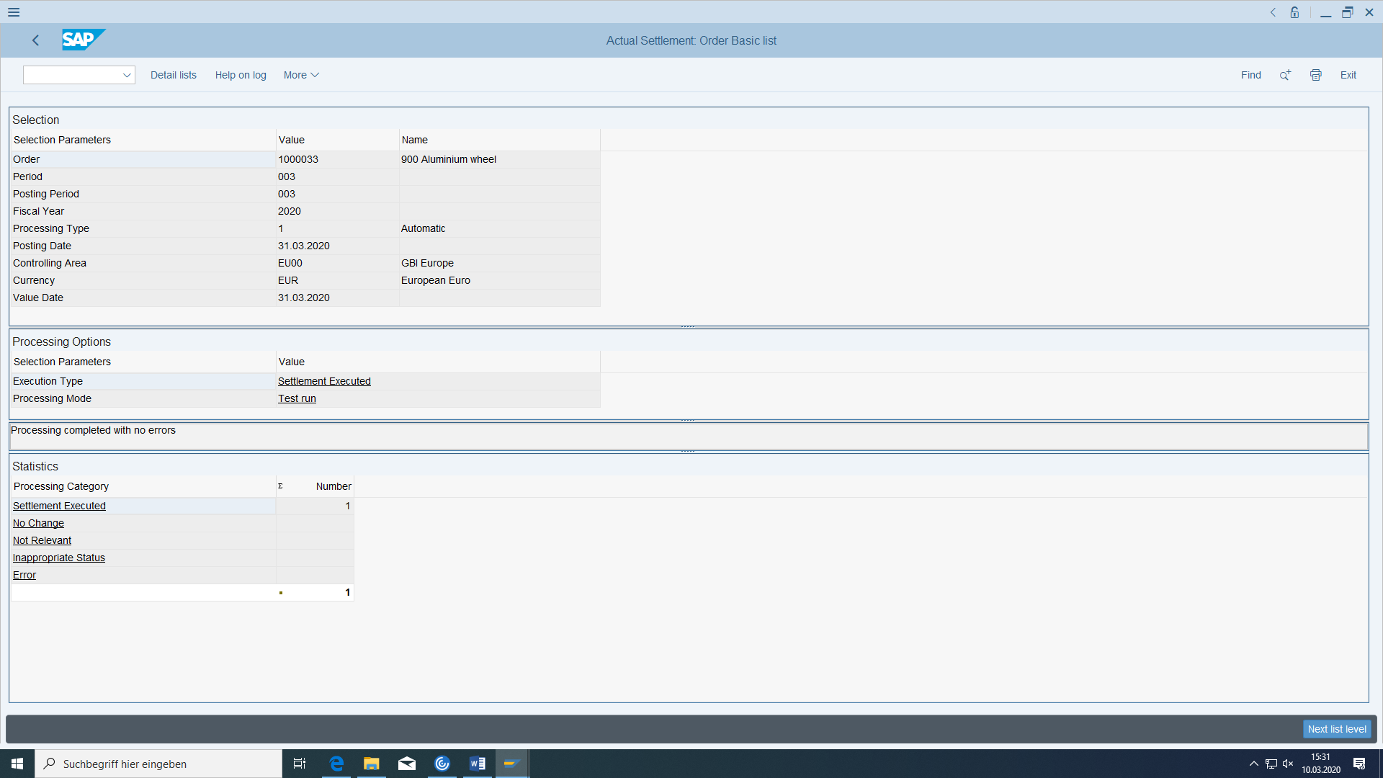

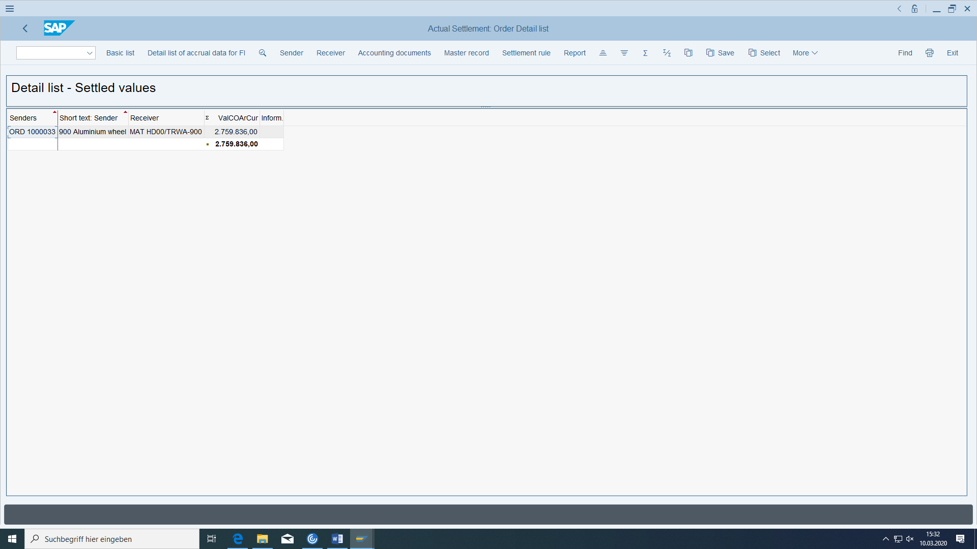

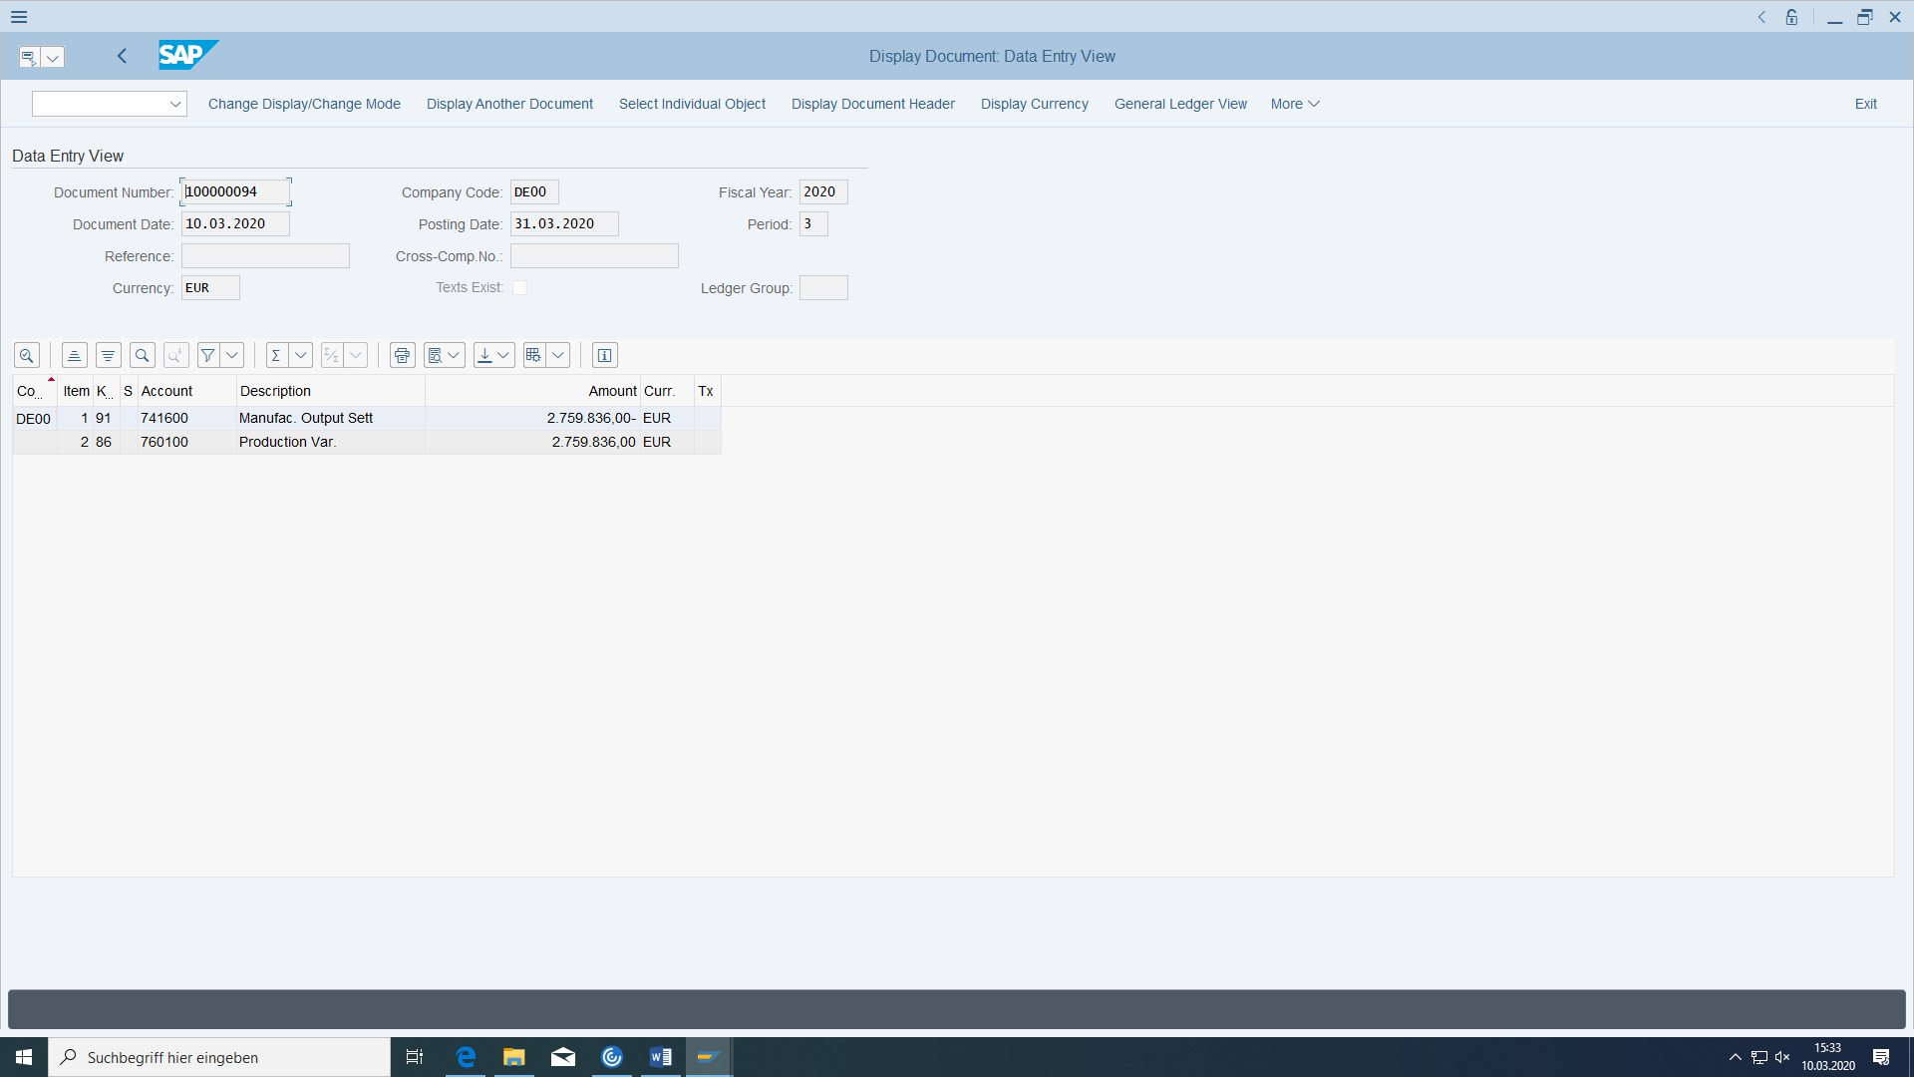

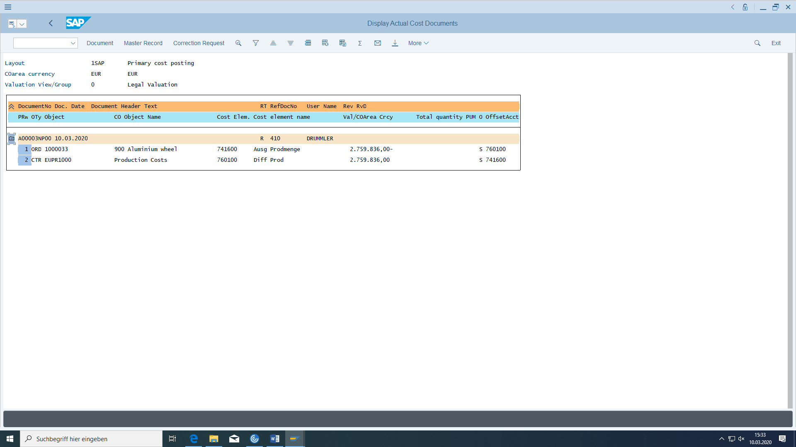

# Production of the end product Deluxe Touring Bike

Now we go one level higher. Do everything you did for TRWA-xxx also with the the material DXTR-xxx. There are only some slight differences. The production order is now for the bike instead the wheel. The material component is now the wheel instead the tire. We take the component from the semi-final storage location instead of the raw material. The goods receipt for bike goes now to the finished goods storage location instead to the semi-final storage location

The warehouse stock could also be increased unplanned using MIGO with movement key 521 (receipt without order) to continue with the delivery of the sales order. Then you do not have to create the production order for this material as well (only if time is short) and bring the stock for the wheel to an amount, you need to take as material for producing the bike. (But in real life you should not do it).

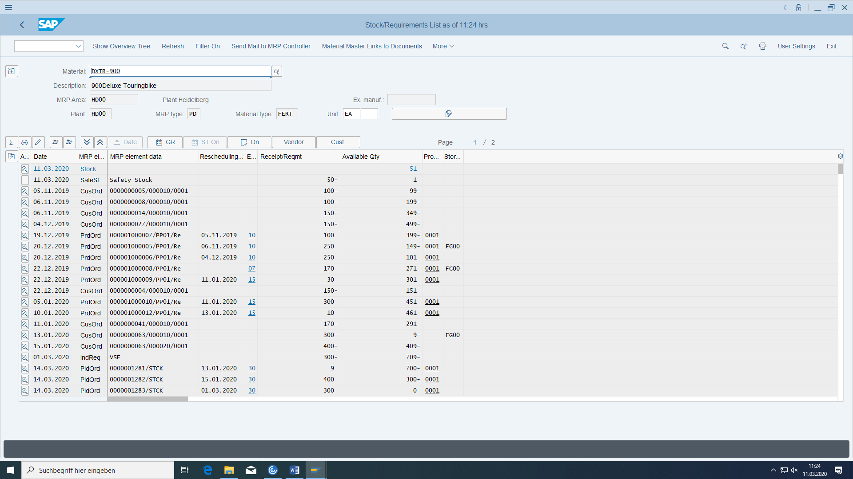

So in this example we don’t have enough bikes to deliver to the customer.

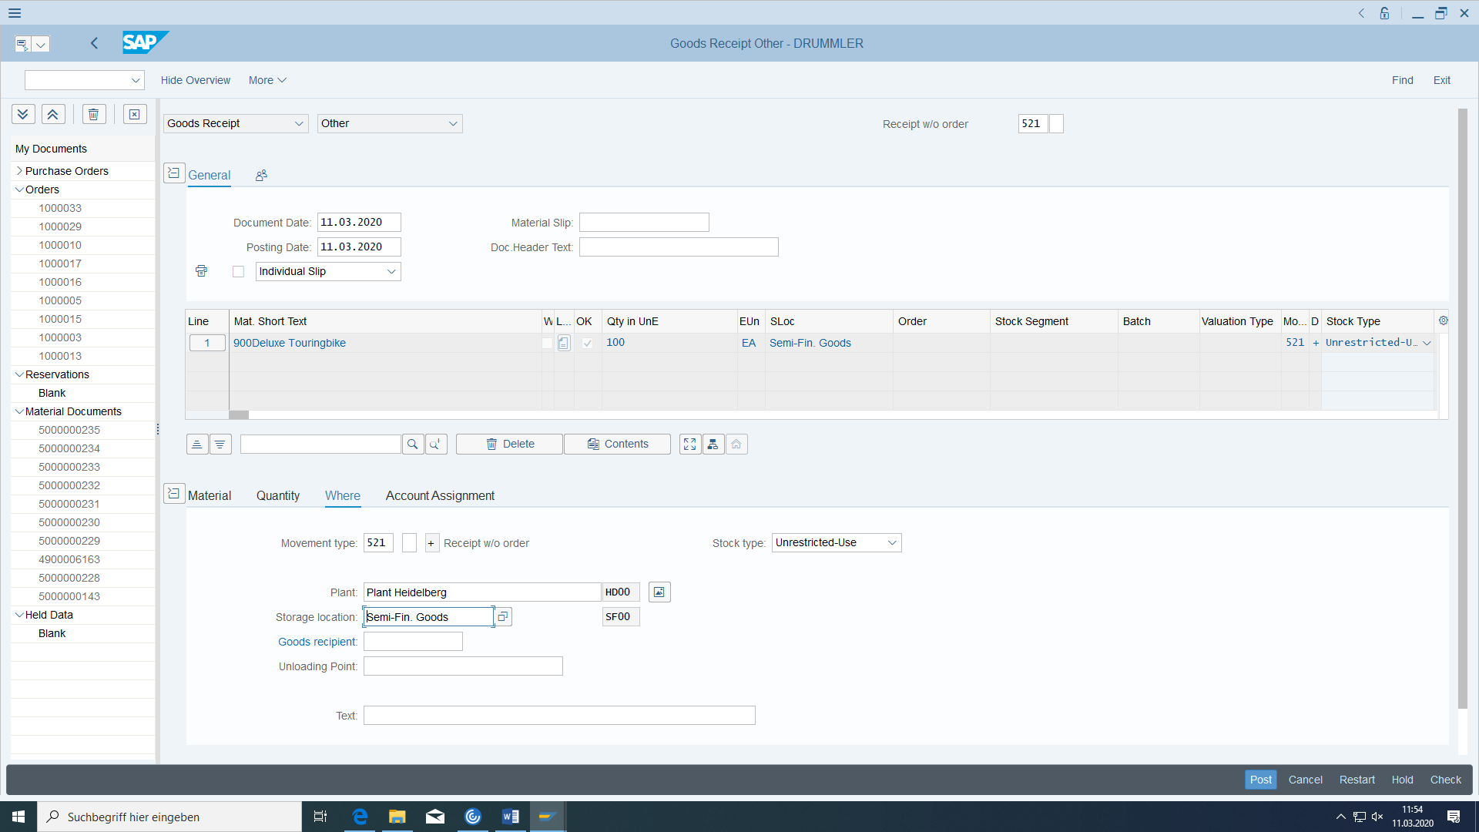

After Post:

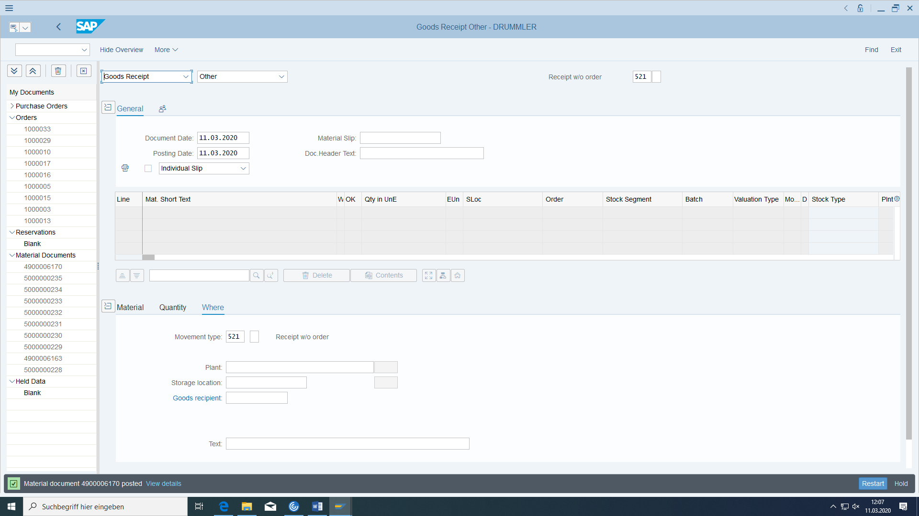

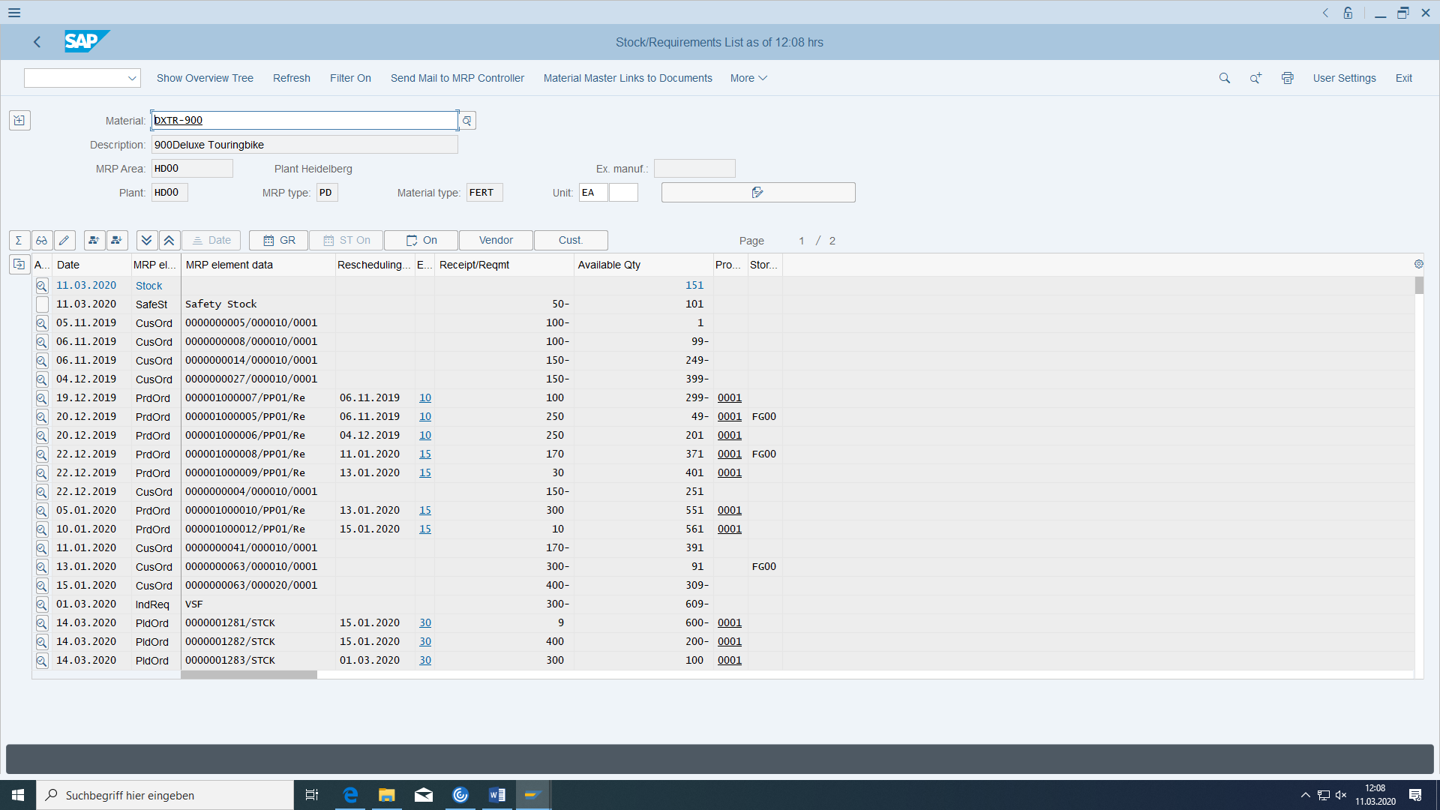

So the stock amount increased (without production!)

In customizing has to be defined before:

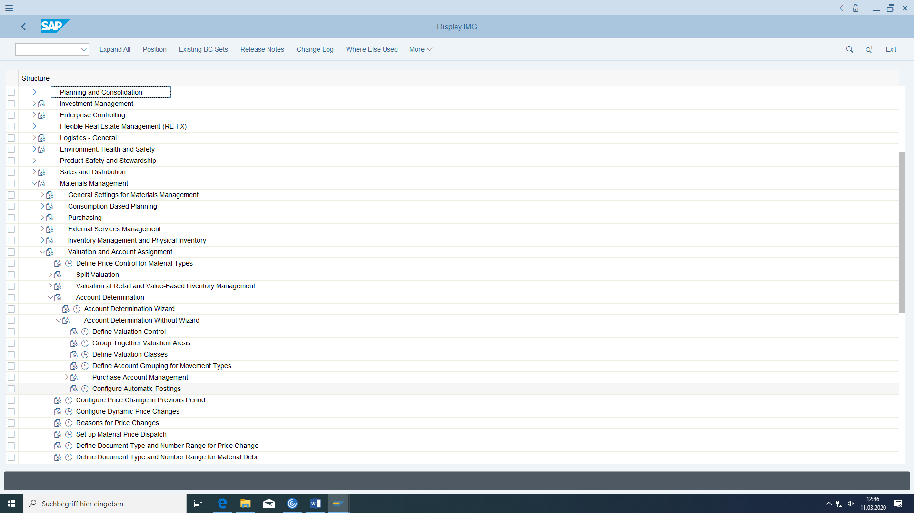

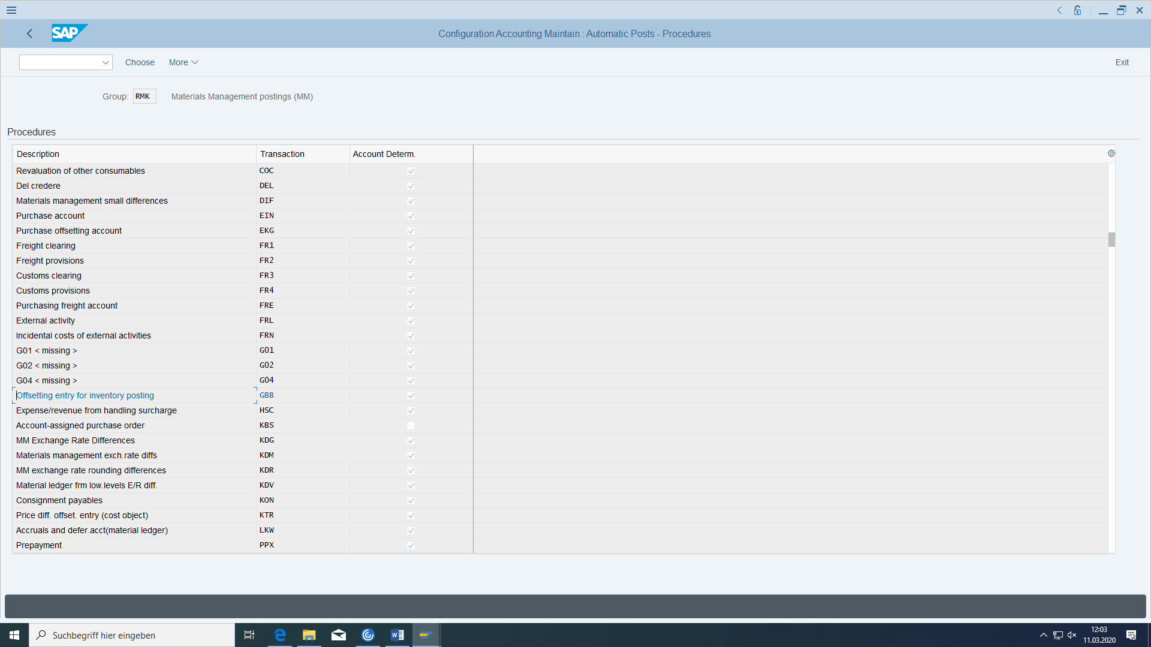

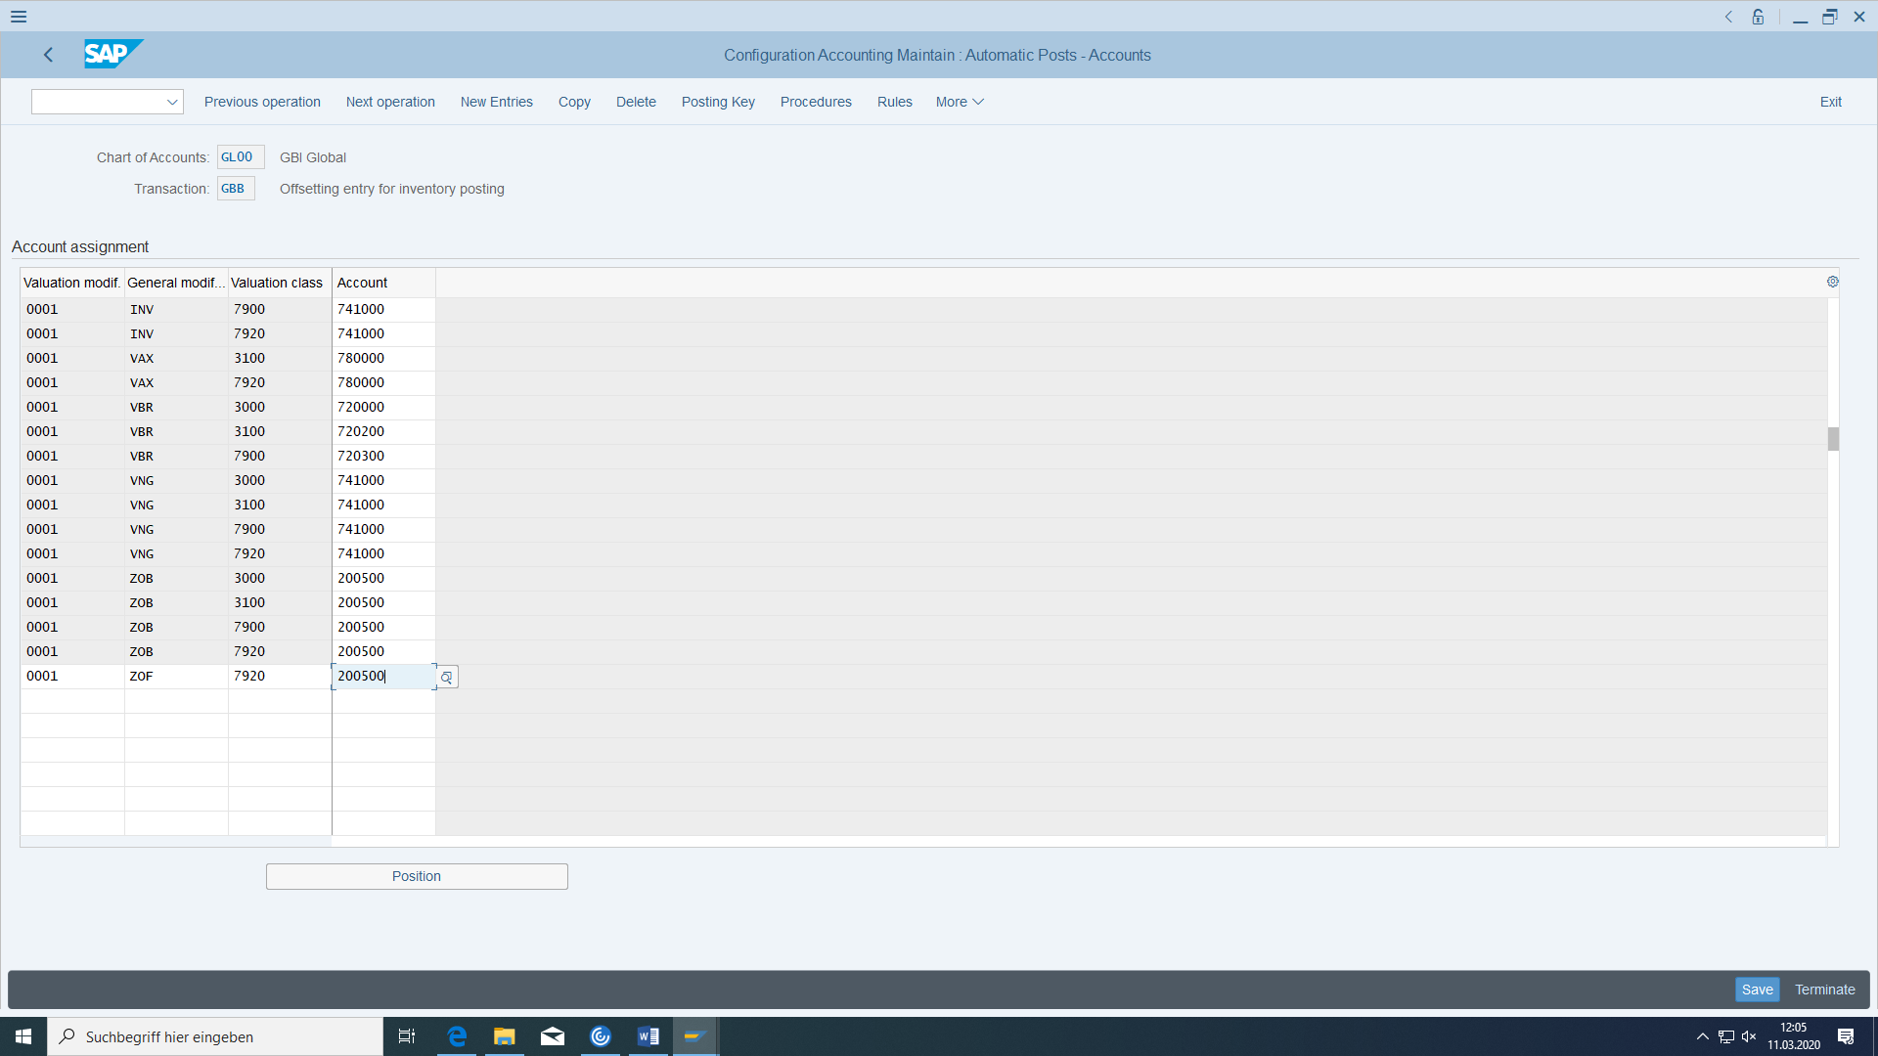

# Delivery of the sales order

|  |  |  |
| --- | --- | --- |
| Create delivery for sales order | Logistics > Distribution > Shipping and Transportation > Delivery > Create > Single document > with reference to sales order | VL01N |
| Picking and goods issue | Logistics > Distribution > Shipping and Transportation > Order picking > Create transport order > Single document | VL02N |

## Create delivery for sales order

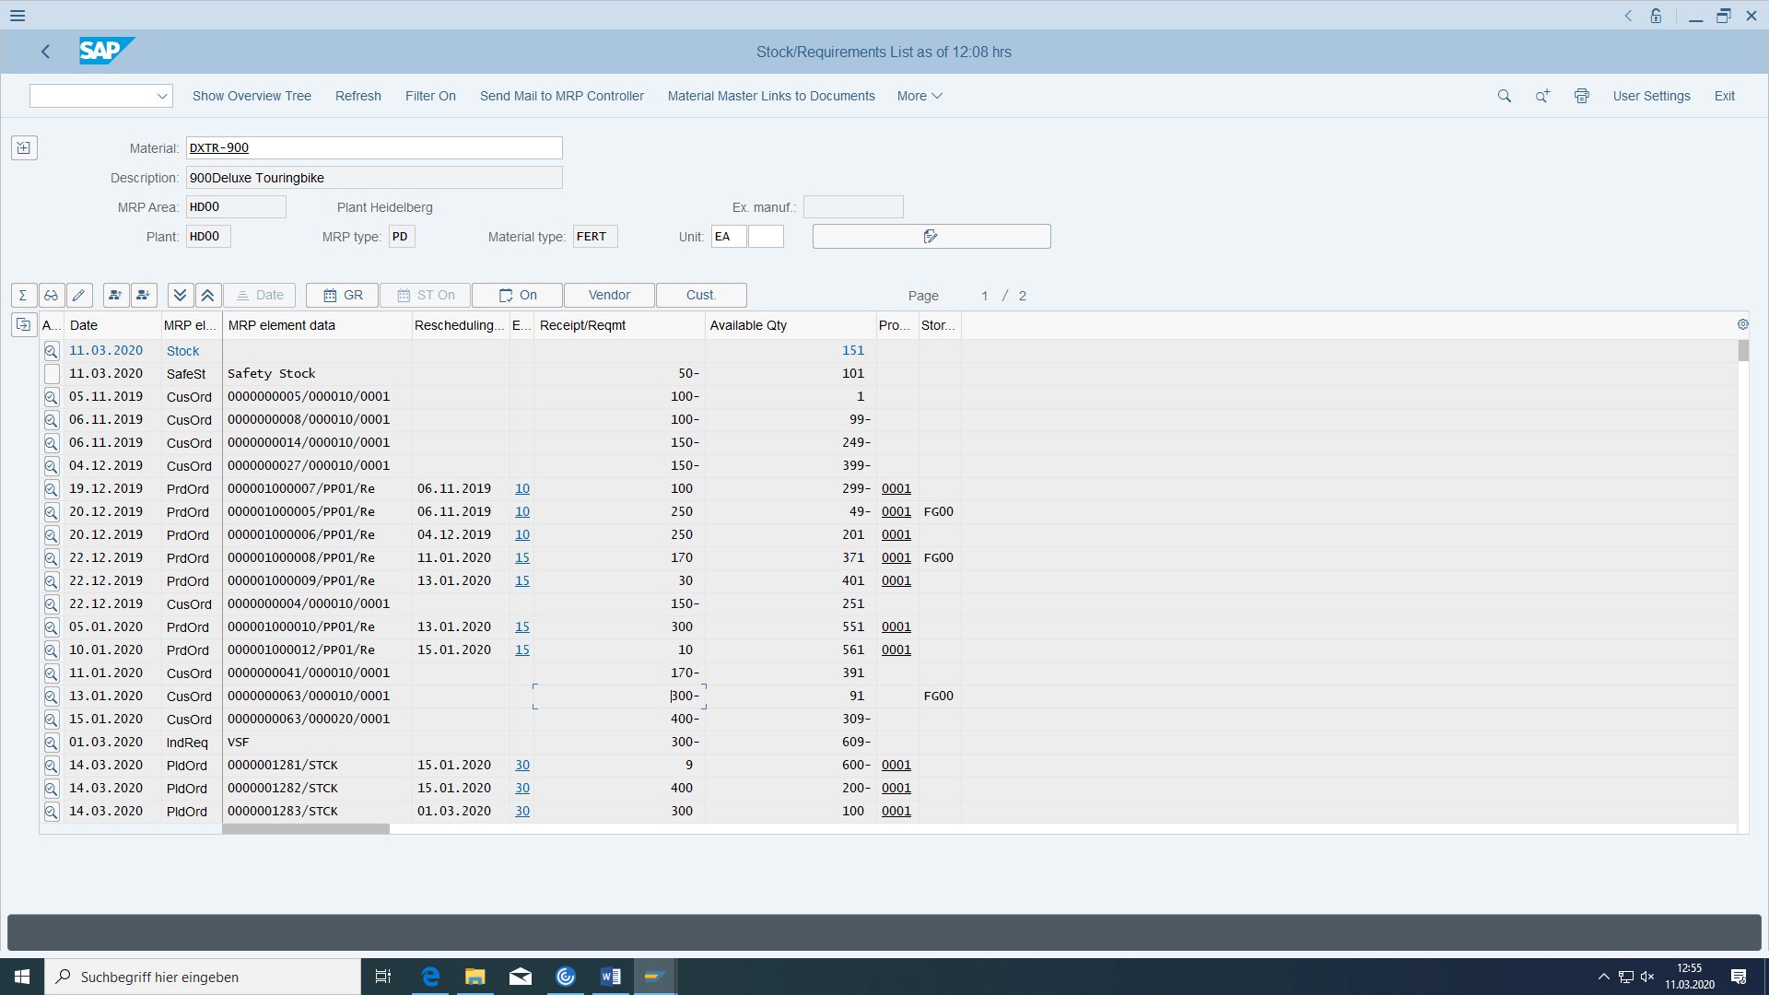

Let’s continue with our customer order 63. We cant deliver all now what the customer wanted, because we have in our example only a stock amount of 151. And because of our availability check group in material (taken automatically in order position) the quantity has to be available also at the date of the delivery (because of this I have to increase my stock amount more).

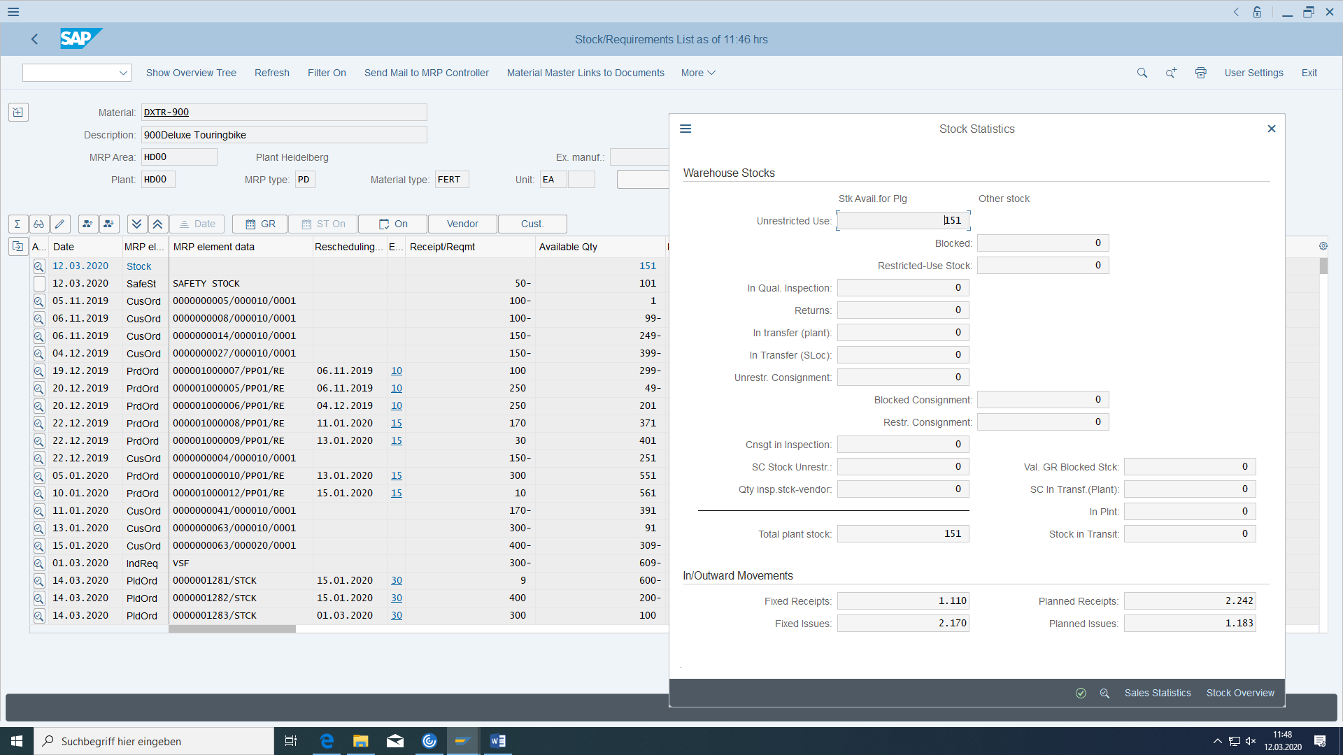

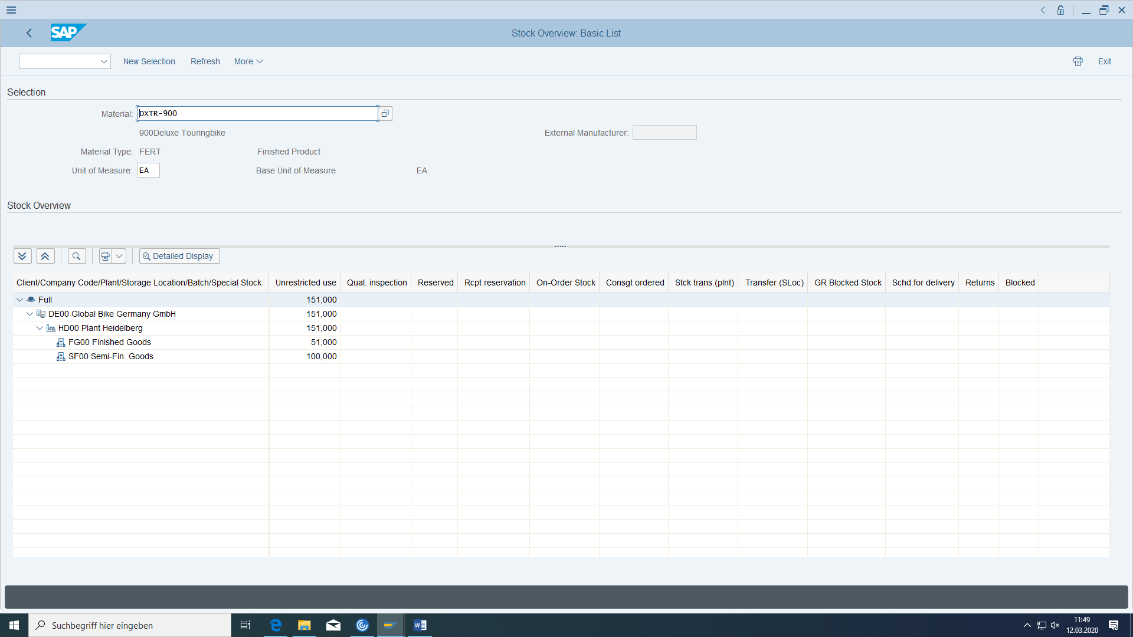

The material has been manufactured. Now you can send it to the the customer. To do this, switch to the transaction for creating the delivery for the order.

Within the delivery you will create picking and goods issue.

Select the shipping point VS Heidelberg, as selection date the last day of the following month and the number of your sales order. Confirm with 'Enter':

The system displays the items to be delivered. Save your entries and note the number of the delivery.

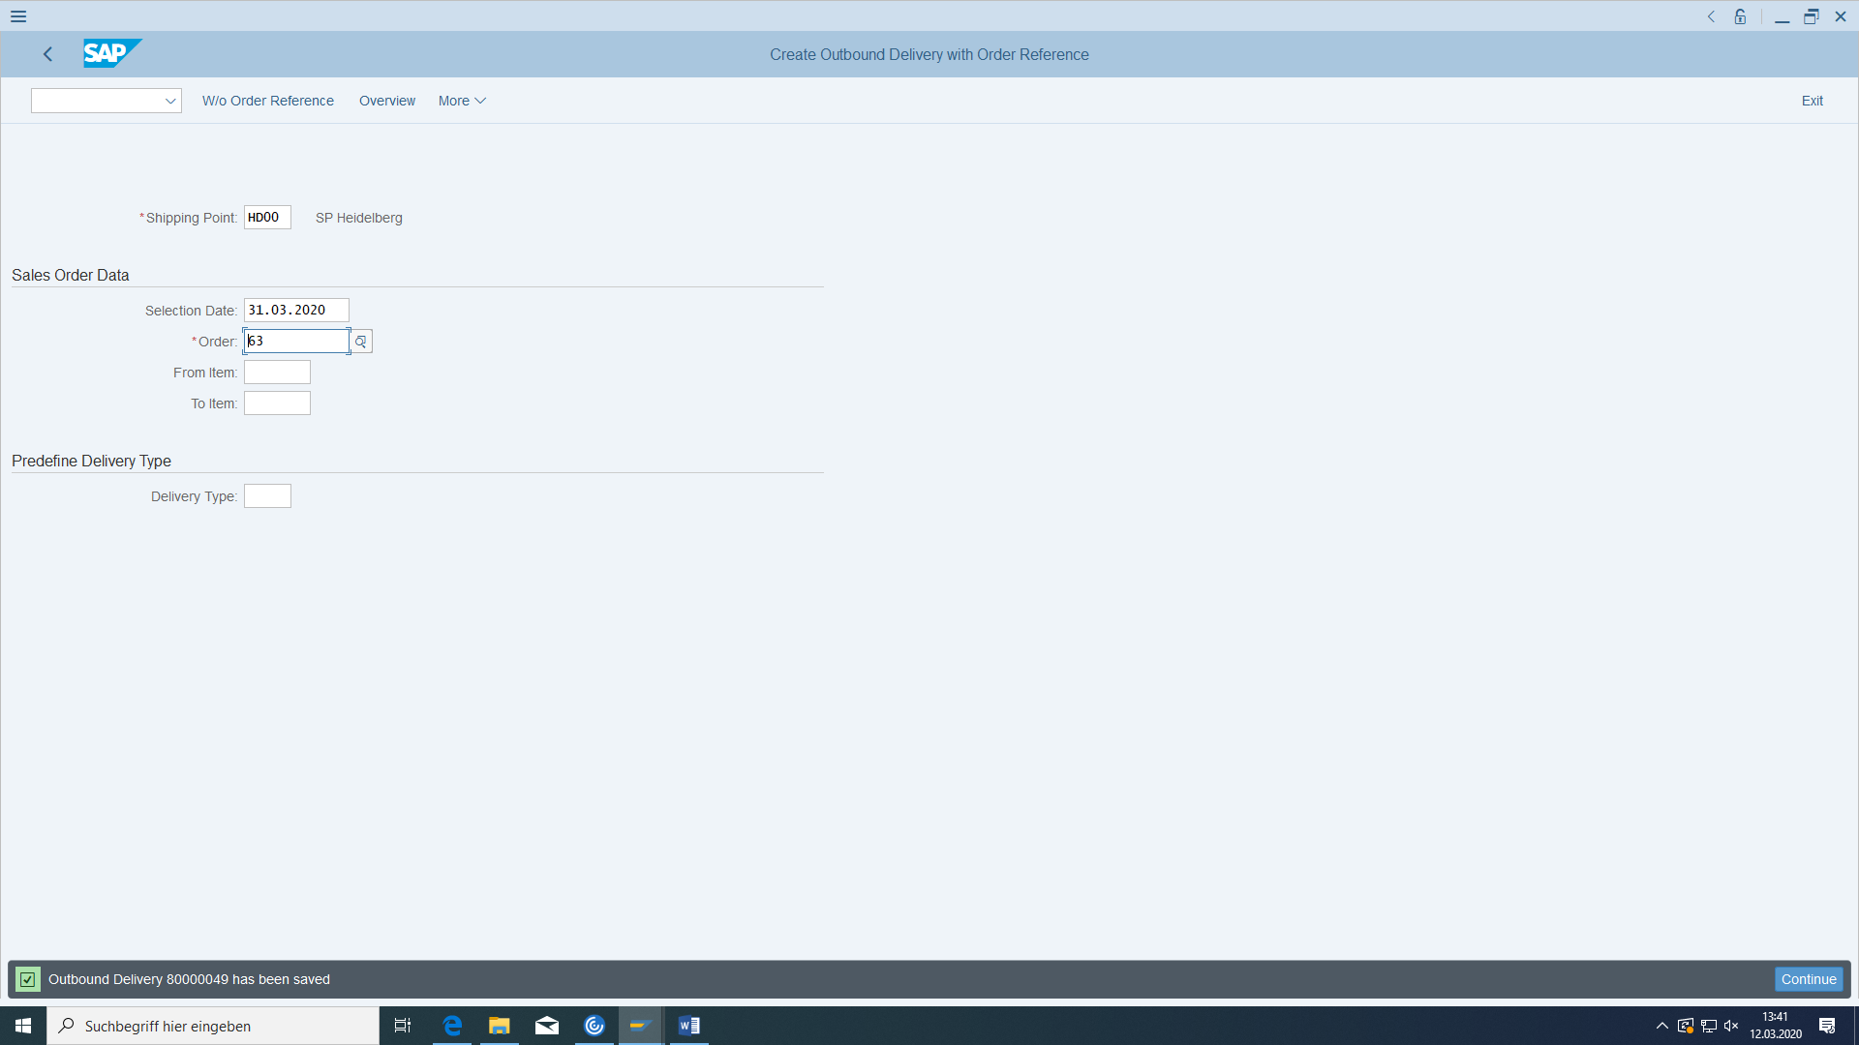

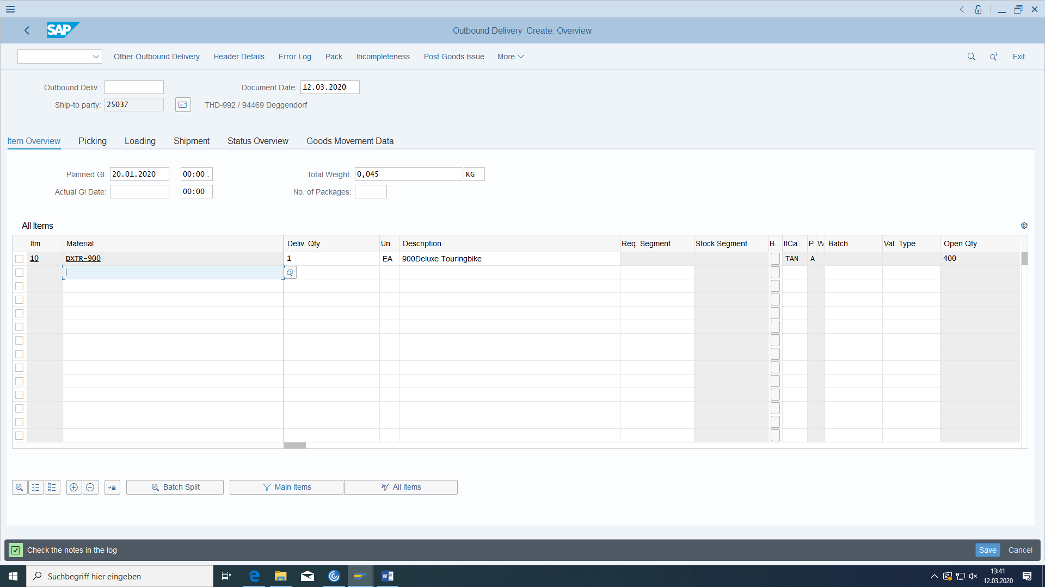



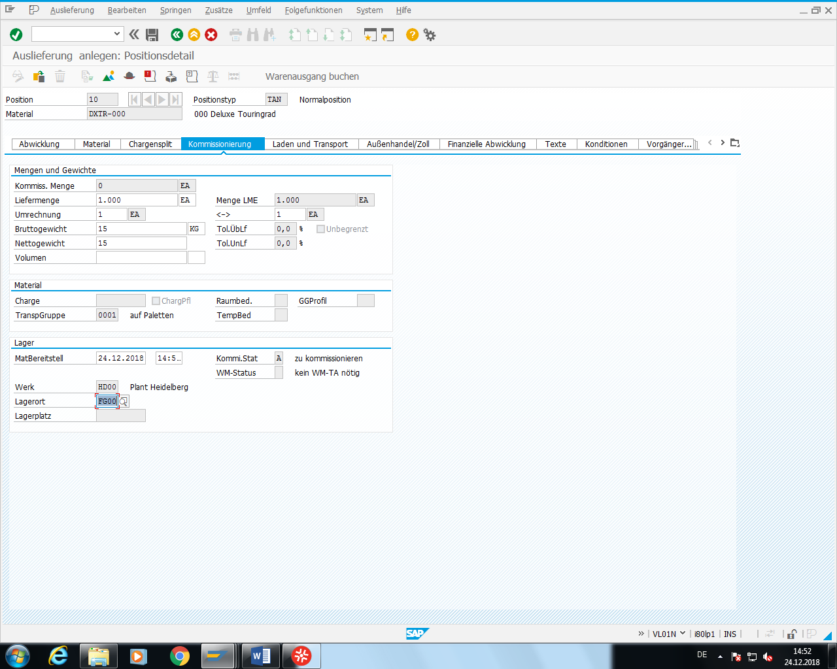

Delivery: ______________________

## Picking and goods issue

First enter via VL02N the picking amount, then post the goods issue.

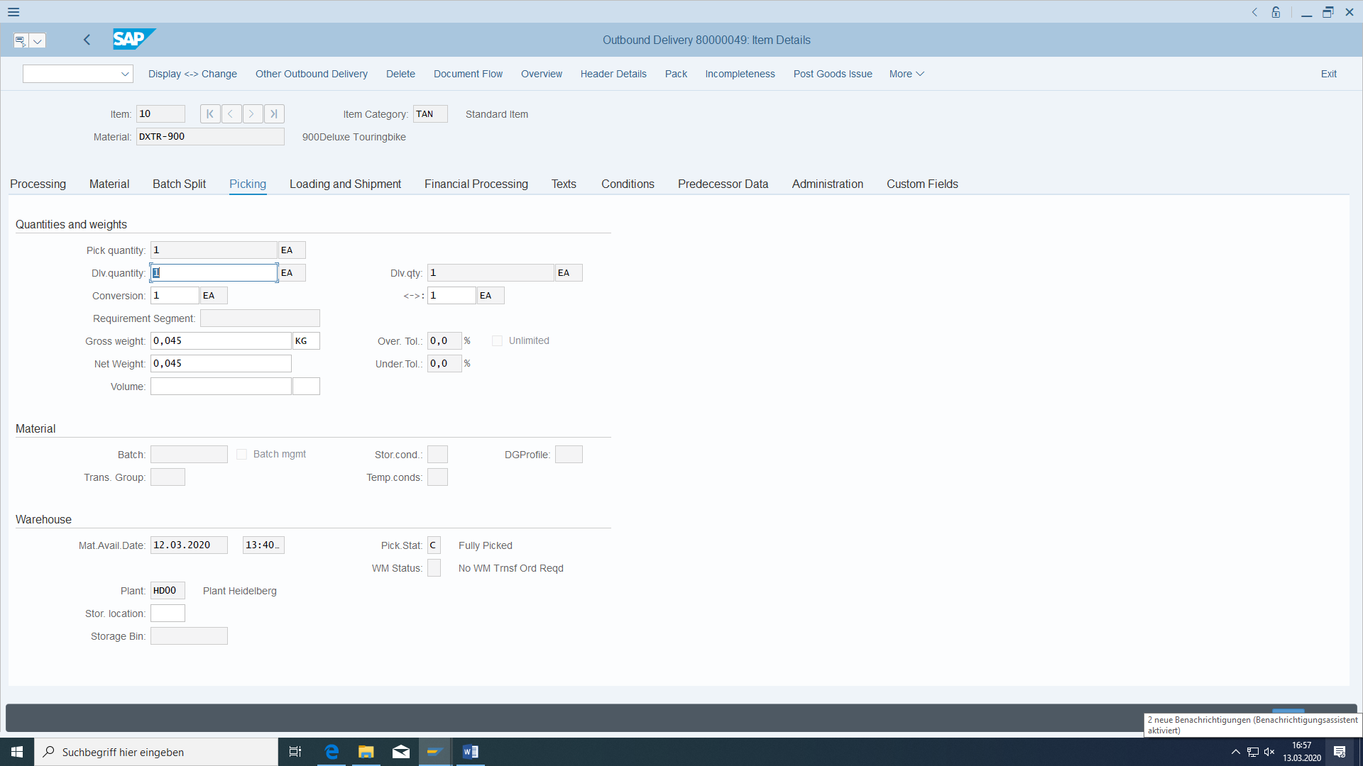

After Save, enter again the delivery:

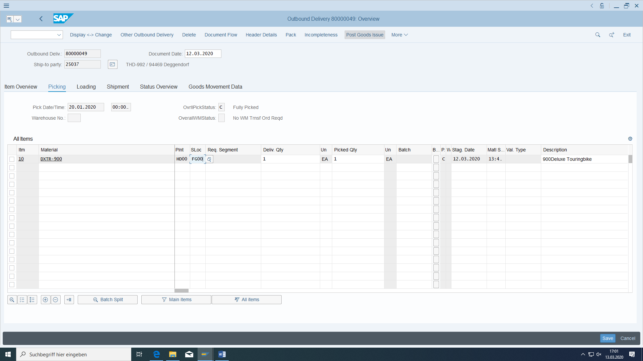

And dont forget the storage location.

View document flow in customer order:

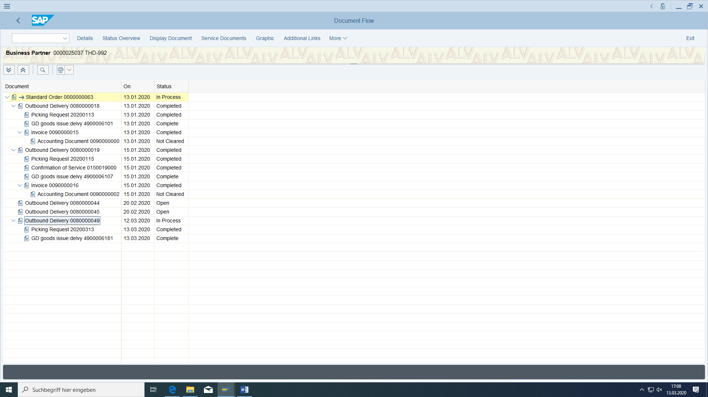

A goods issue document is created in MM (the material document no you can see in the document flow above in the last row: 4900006181):

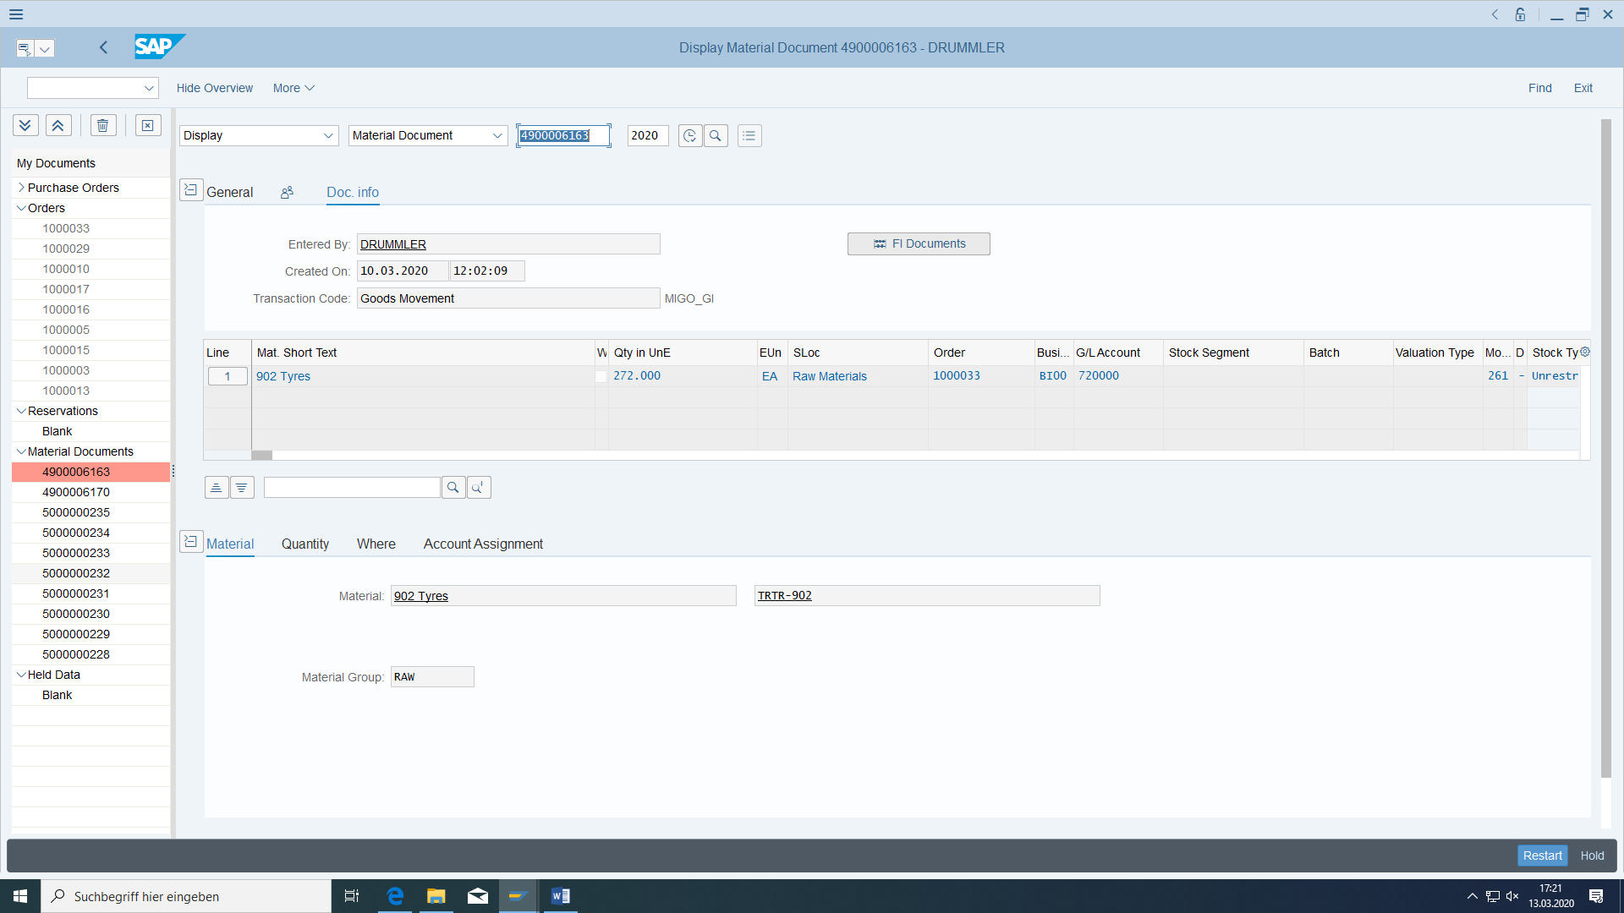

and posted in FI:

Material ledger:

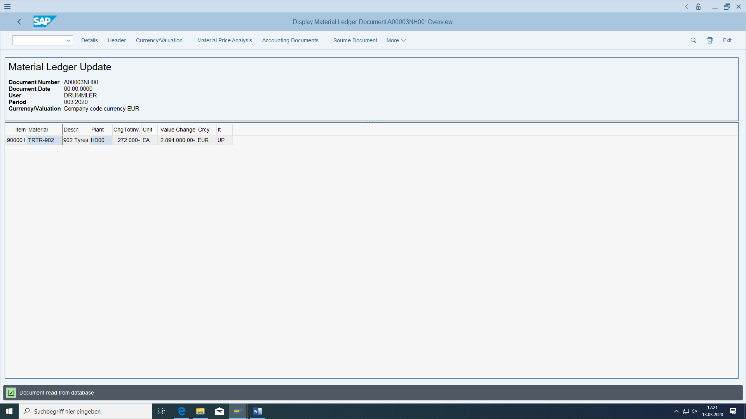

Accounting:

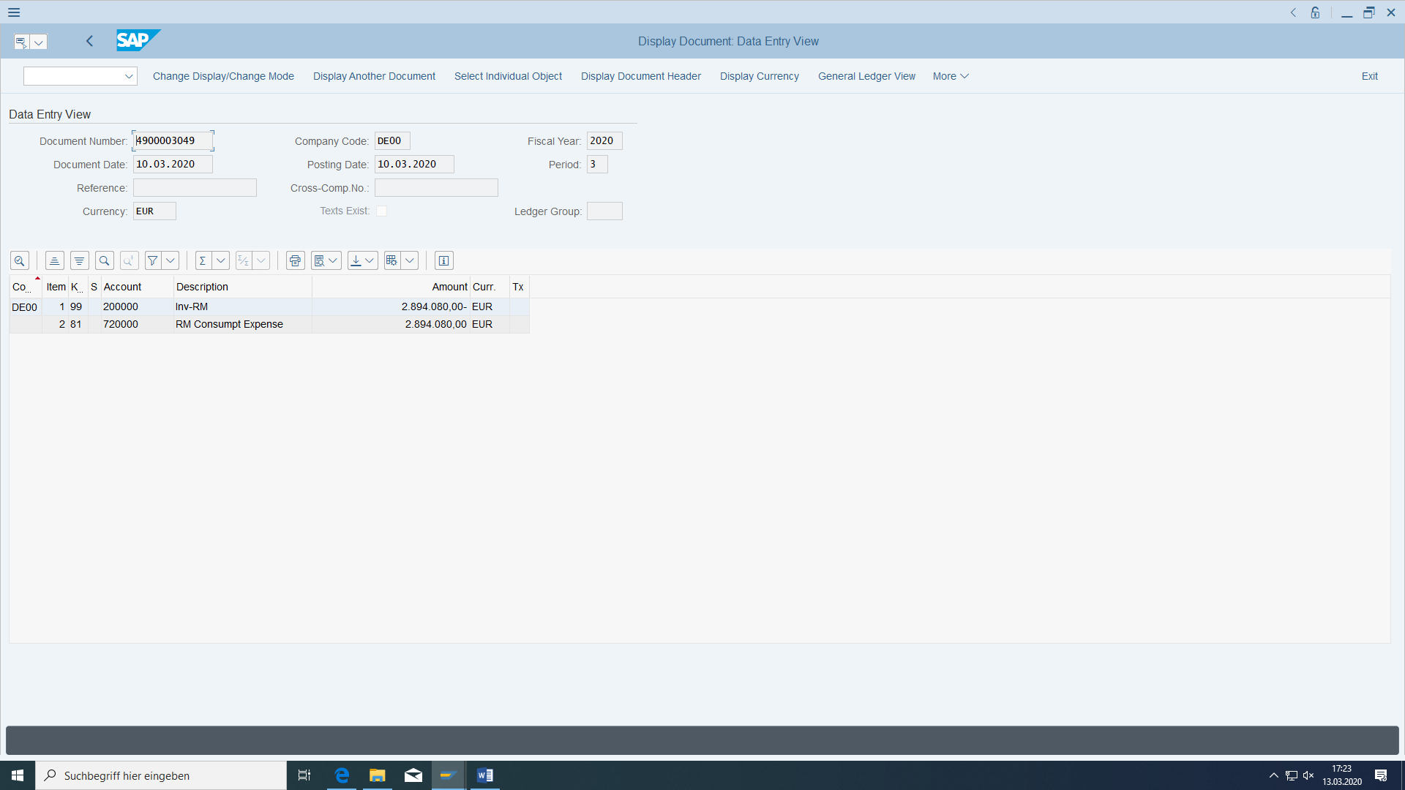

Controlling:

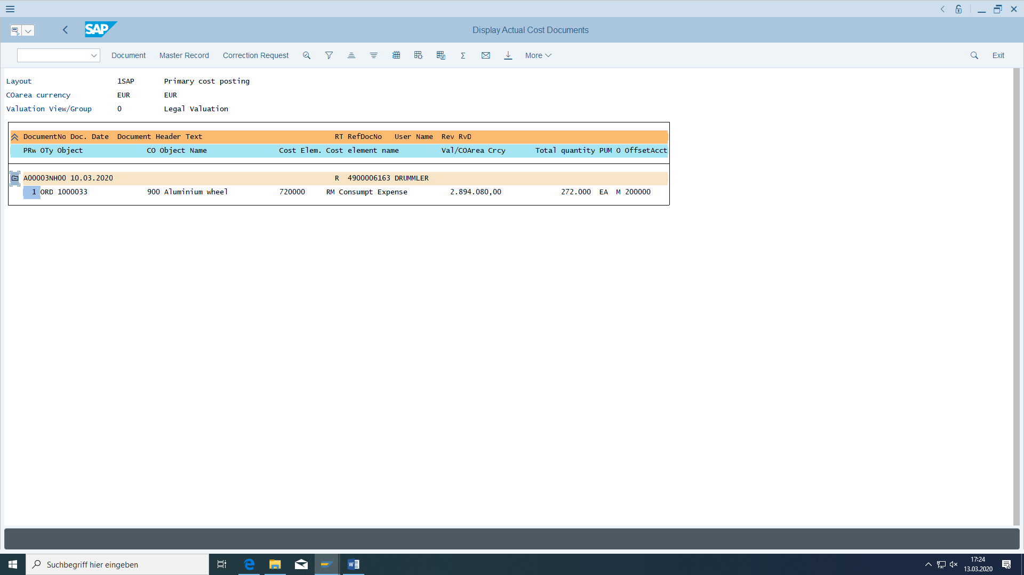

Also check whether the sales order is no longer relevant (or less) to requirements and whether the warehouse stock has been reduced:

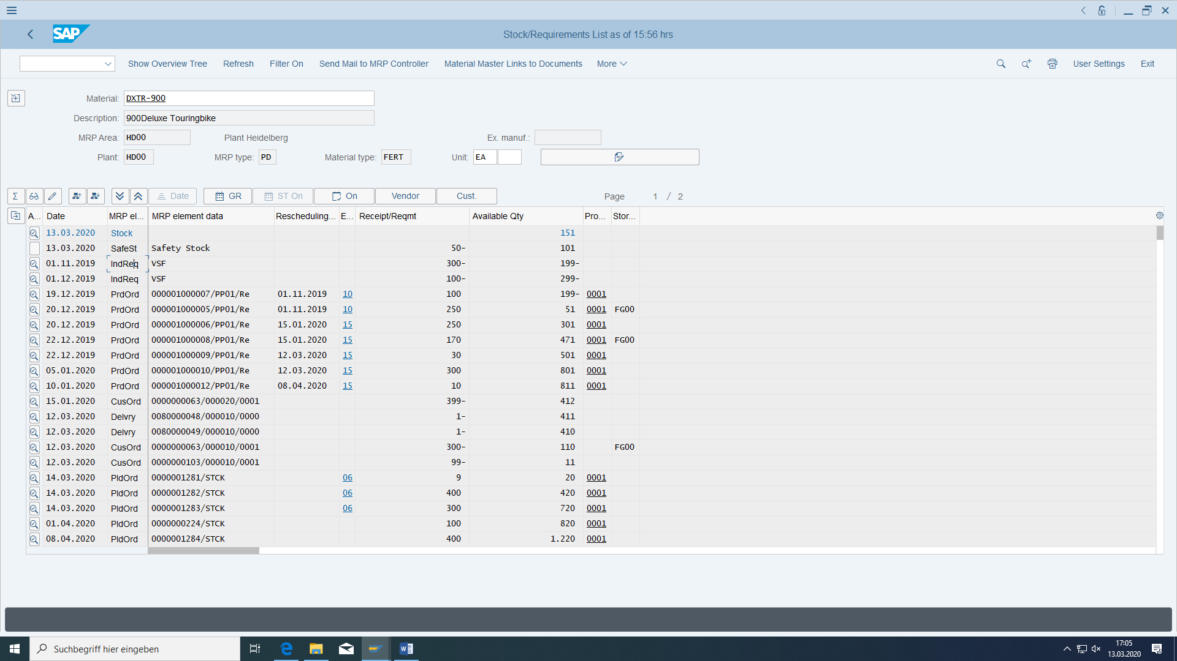

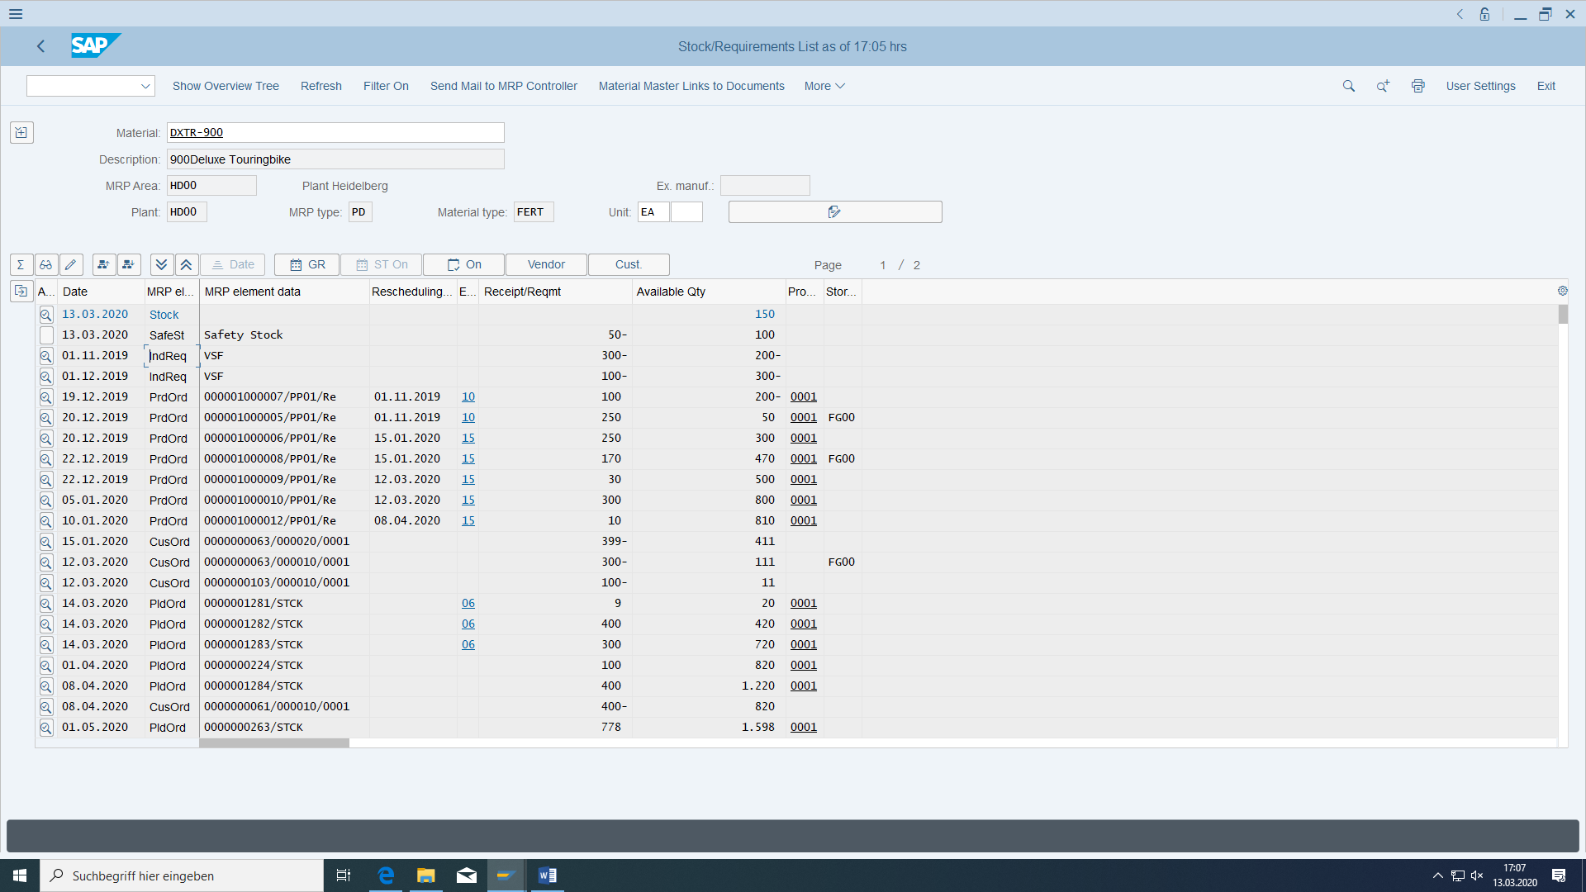

# Invoicing

|  |  |  |
| --- | --- | --- |
| invoicing | Logistics > Sales > Invoicing > Invoicing > Create > Create | VF01 |
| Display sales document flow | Logistics > Distribution > Sales > Order > Advertisements | VA03 |

Switch to the transaction for creating the billing document.

In the Document column, enter the number of your delivery and press Enter:

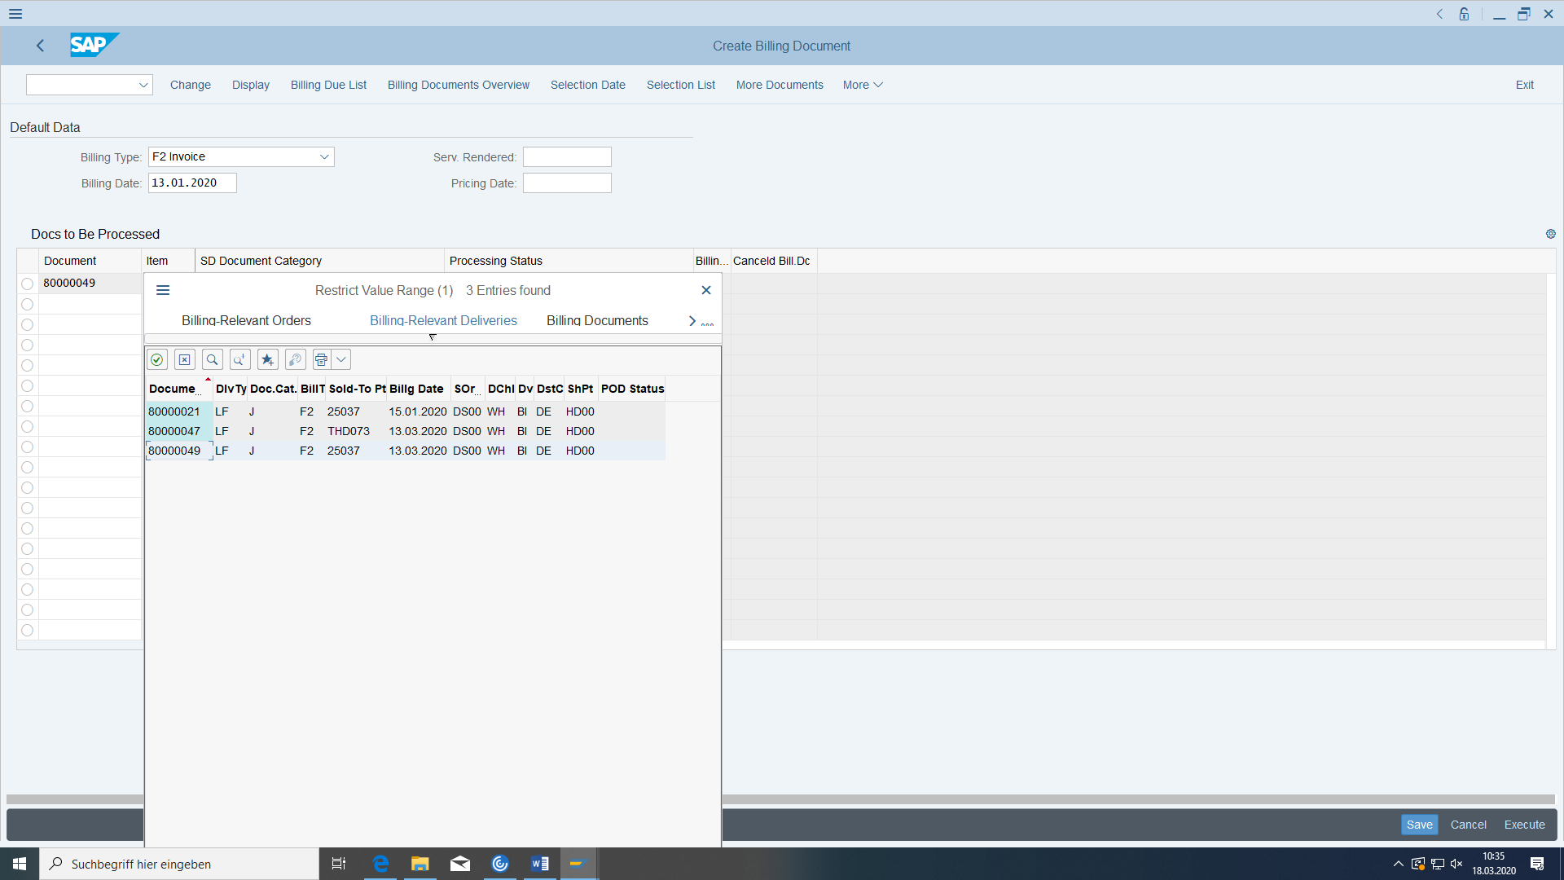

If problems look:

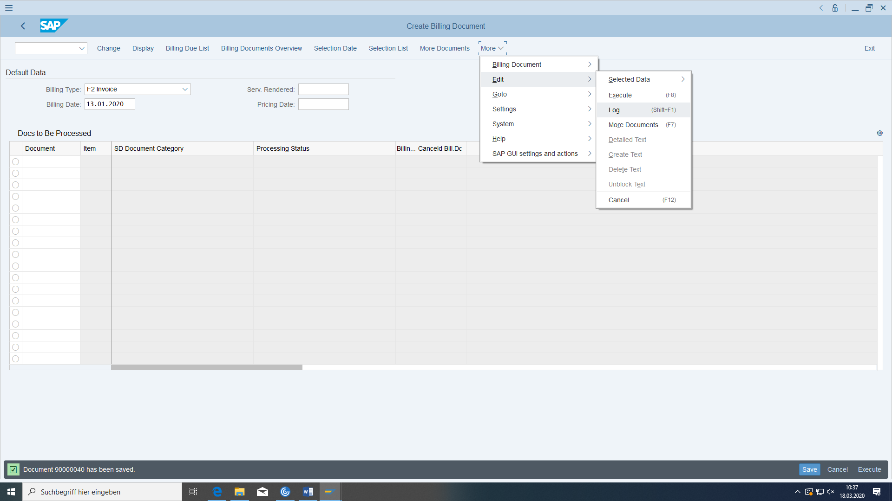

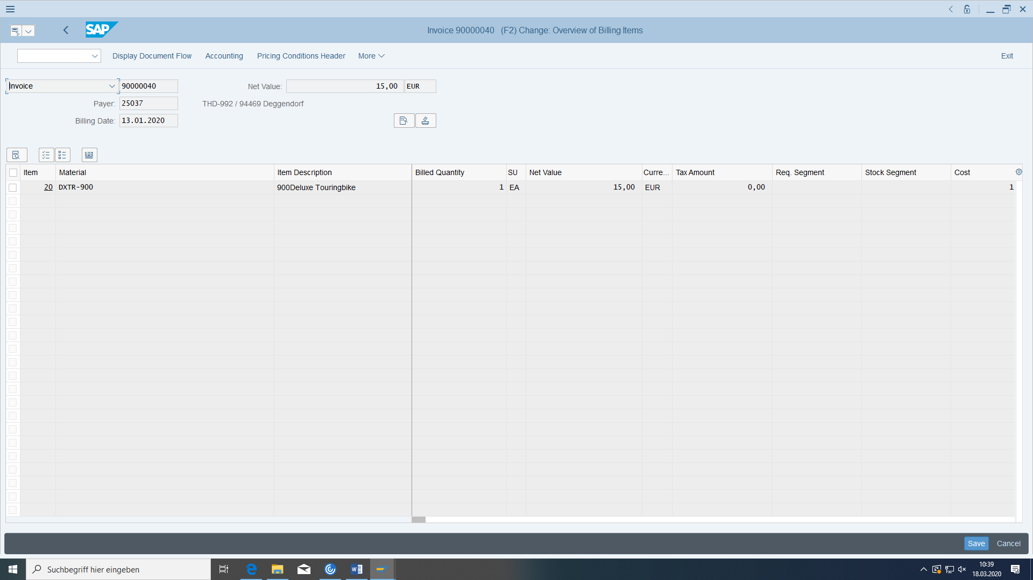

The system informs you about invoice items and amount. Choose Save and make a note of the number.

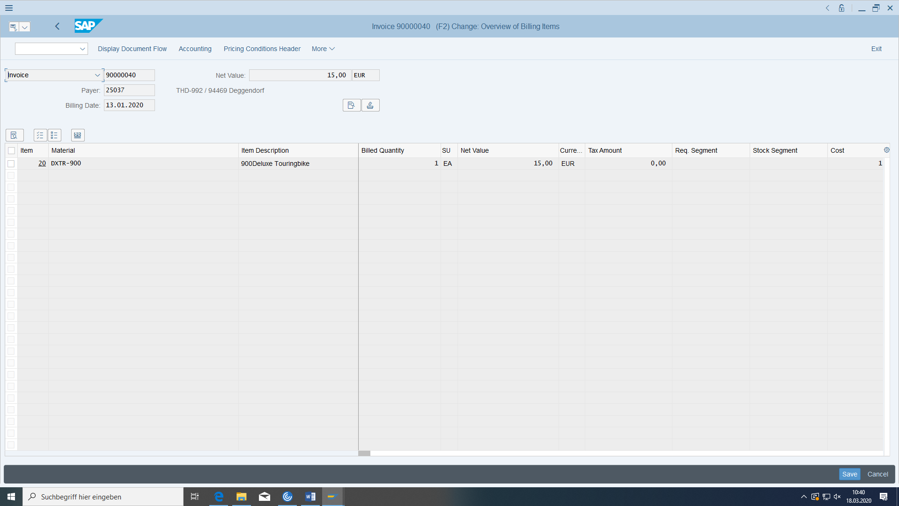

Look at the document flow of the order:

Note that all documents that have been created so far.

An invoice can also refer to several deliveries.

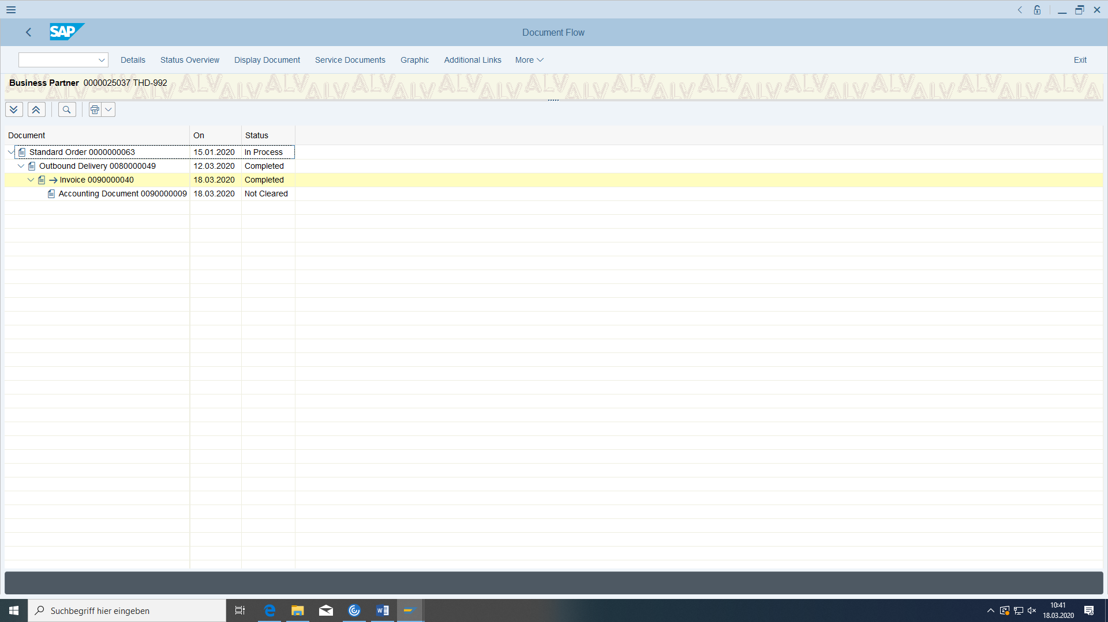

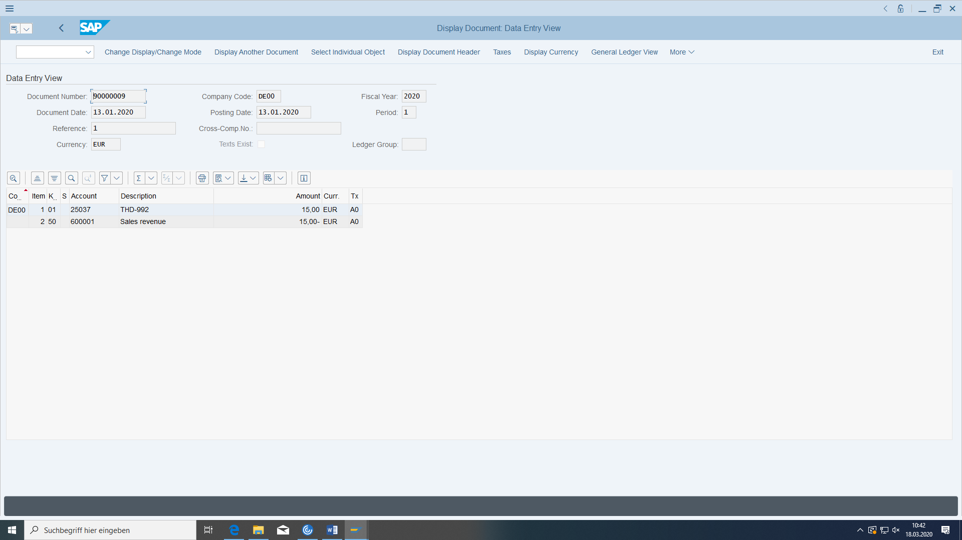

FI: Customer receivable to sales revenue account

If it has not been released to FI:

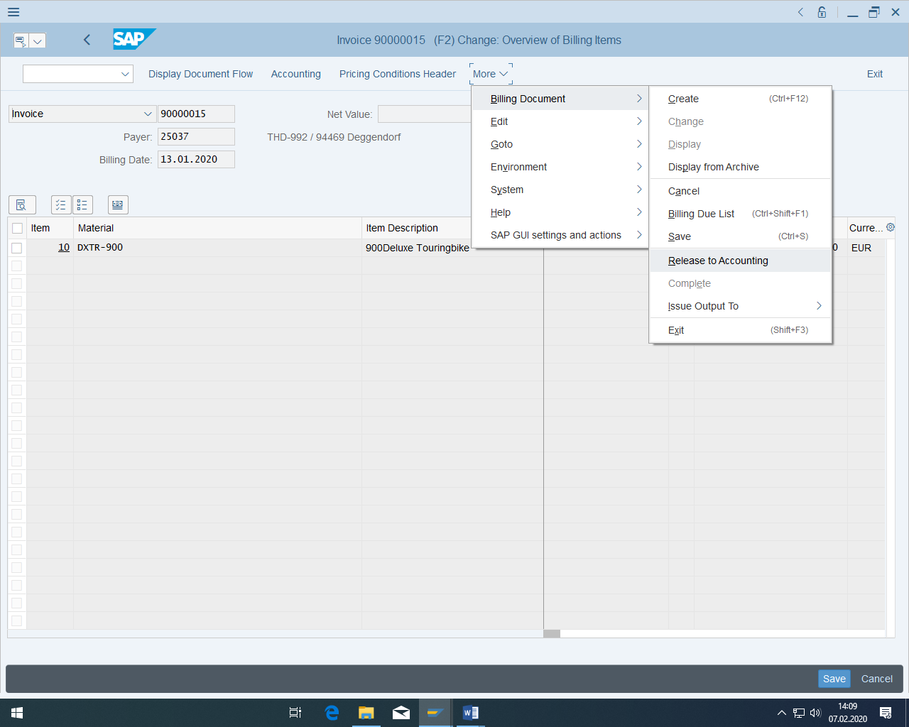

The payer (here: 25037) has to exist in company code.

Invoice: _______________________________

# Post incoming payment

|  |  |  |
| --- | --- | --- |
| Post incoming payment | Accounting > Financial accounting > General ledger > Posting > Incoming payments | F-06 |

Choose the transaction for posting the incoming payment. Enter the current date as the document date, the bank account 'Bank account' (100000) and the amount just determined.

Under 'Selection of open items', select your customer as the account and 'Debitors' as the account type (D). Confirm with 'Enter'.

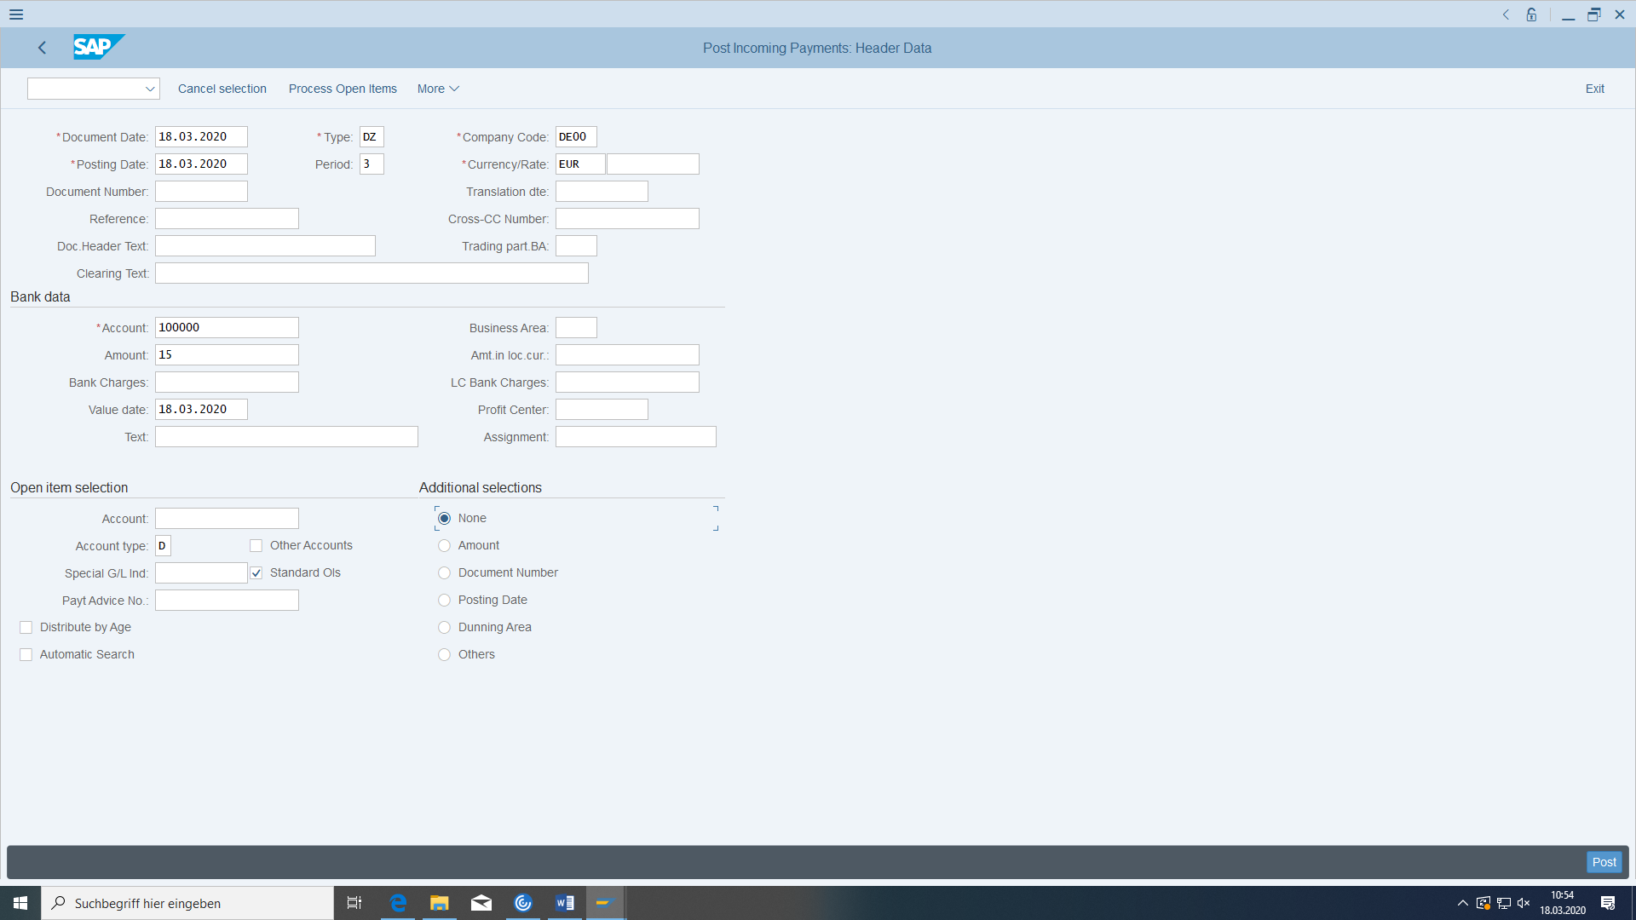

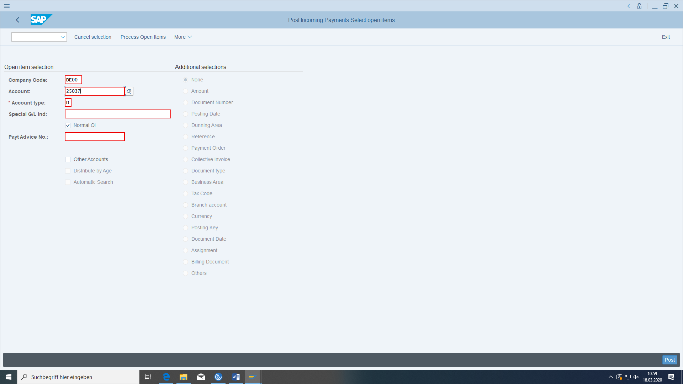

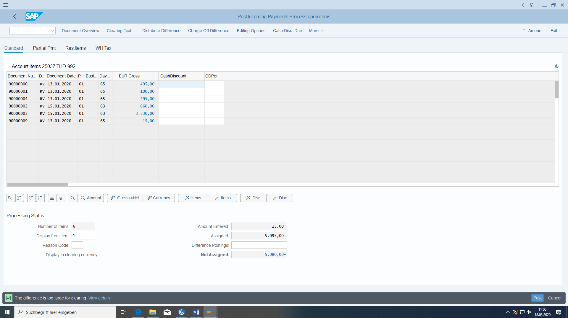

If there are smaller payment differences (according to the tolerance group), these are automatically cleared. If these are larger, you can either post a partial payment manually (that is, the item is not cleared) or create a new open residual item in the amount of the payment difference and clear the open invoice at the same time.

Post the incoming payment with Save.

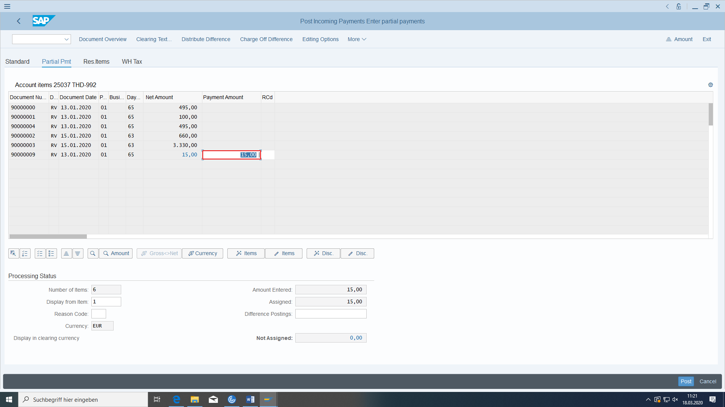

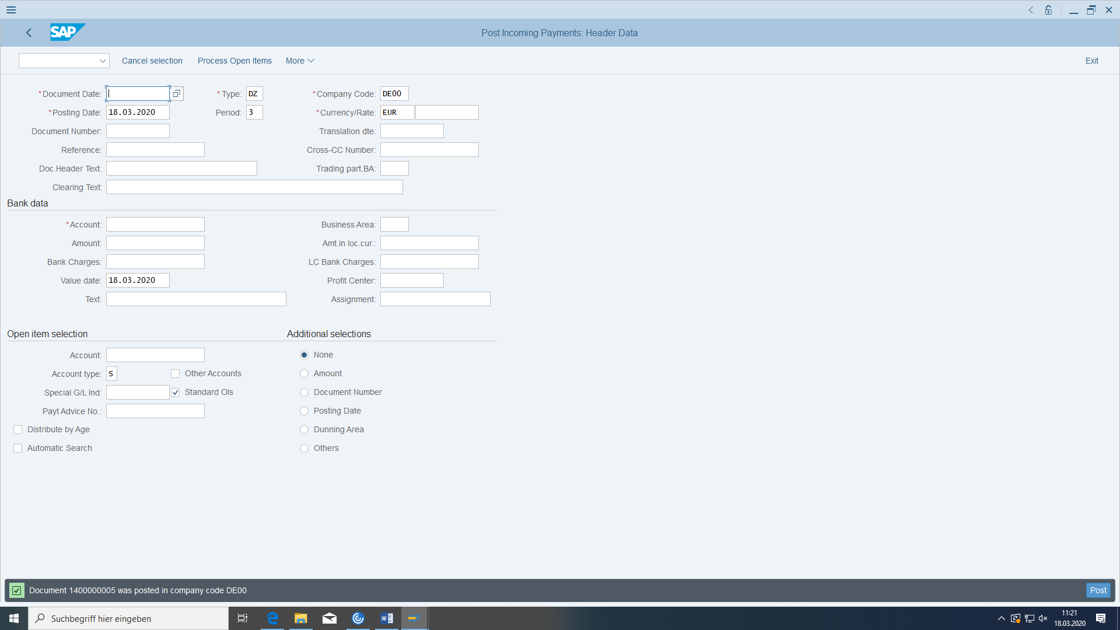

This **posts** in FI:

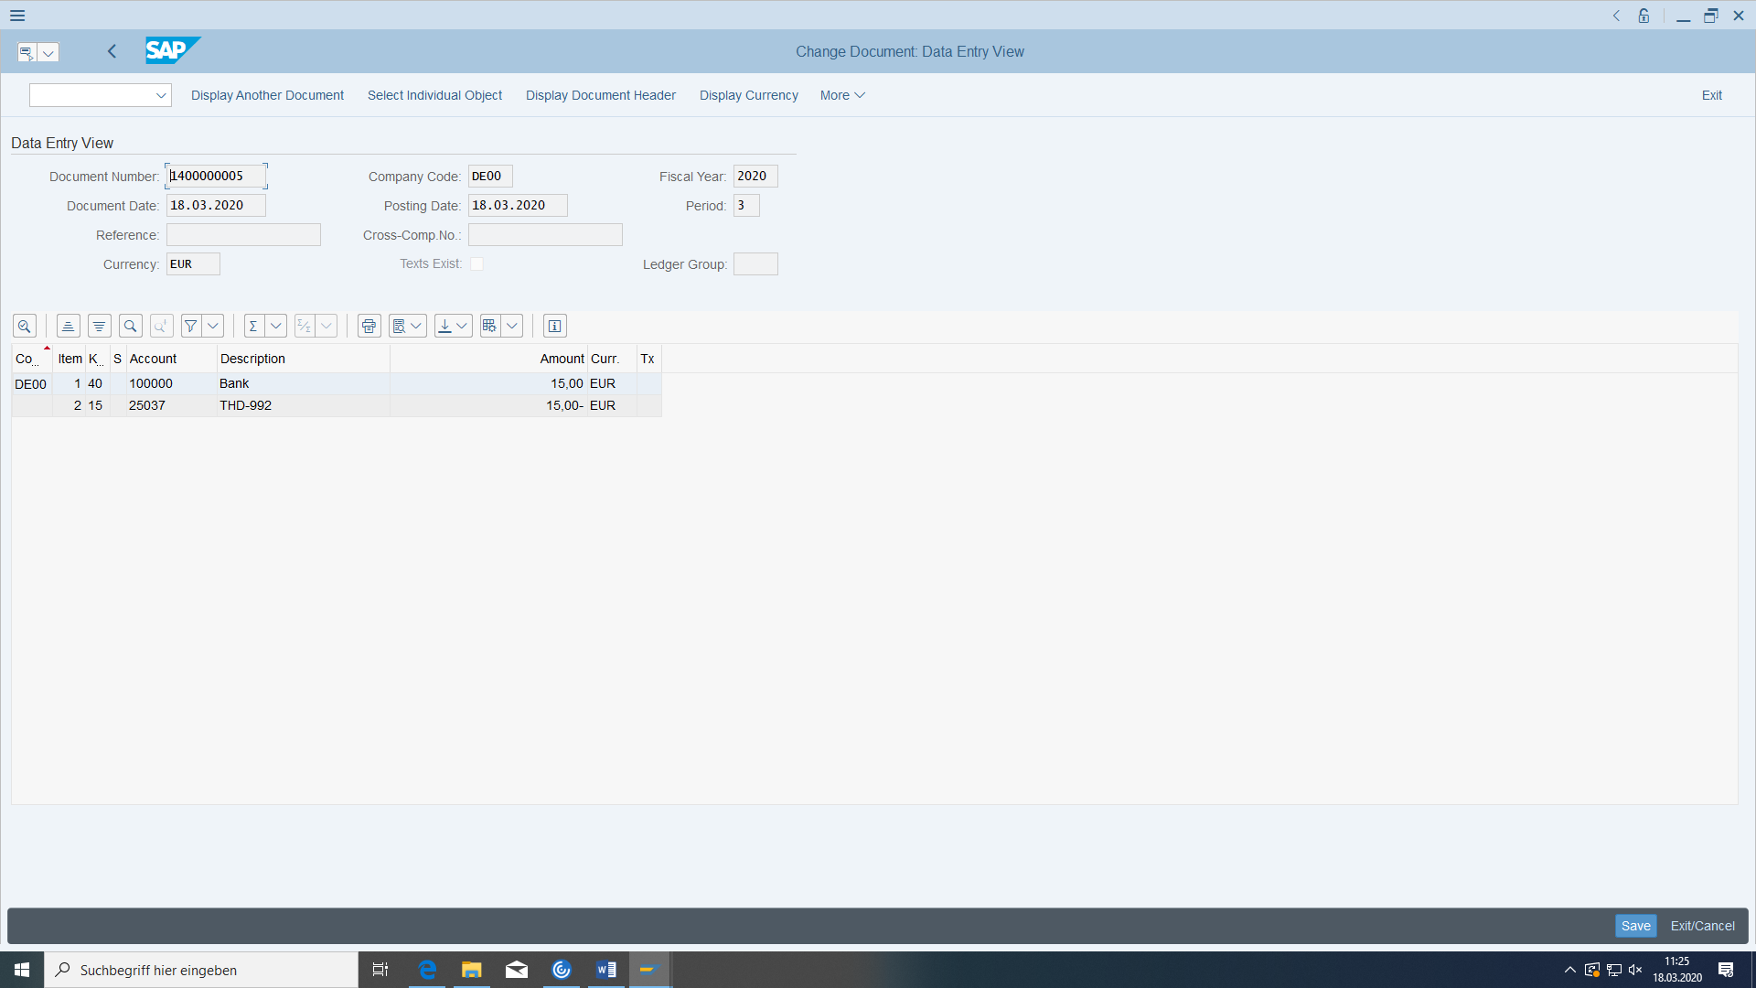

Bank to customer

Transaction FBR2:

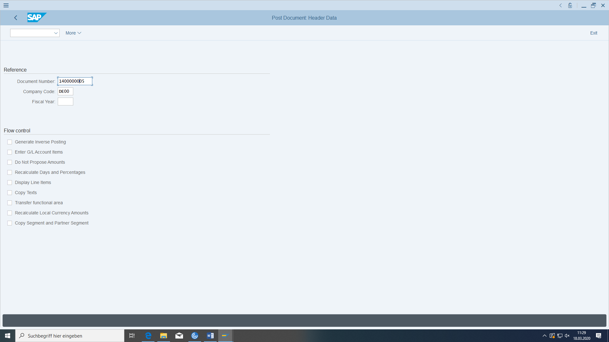

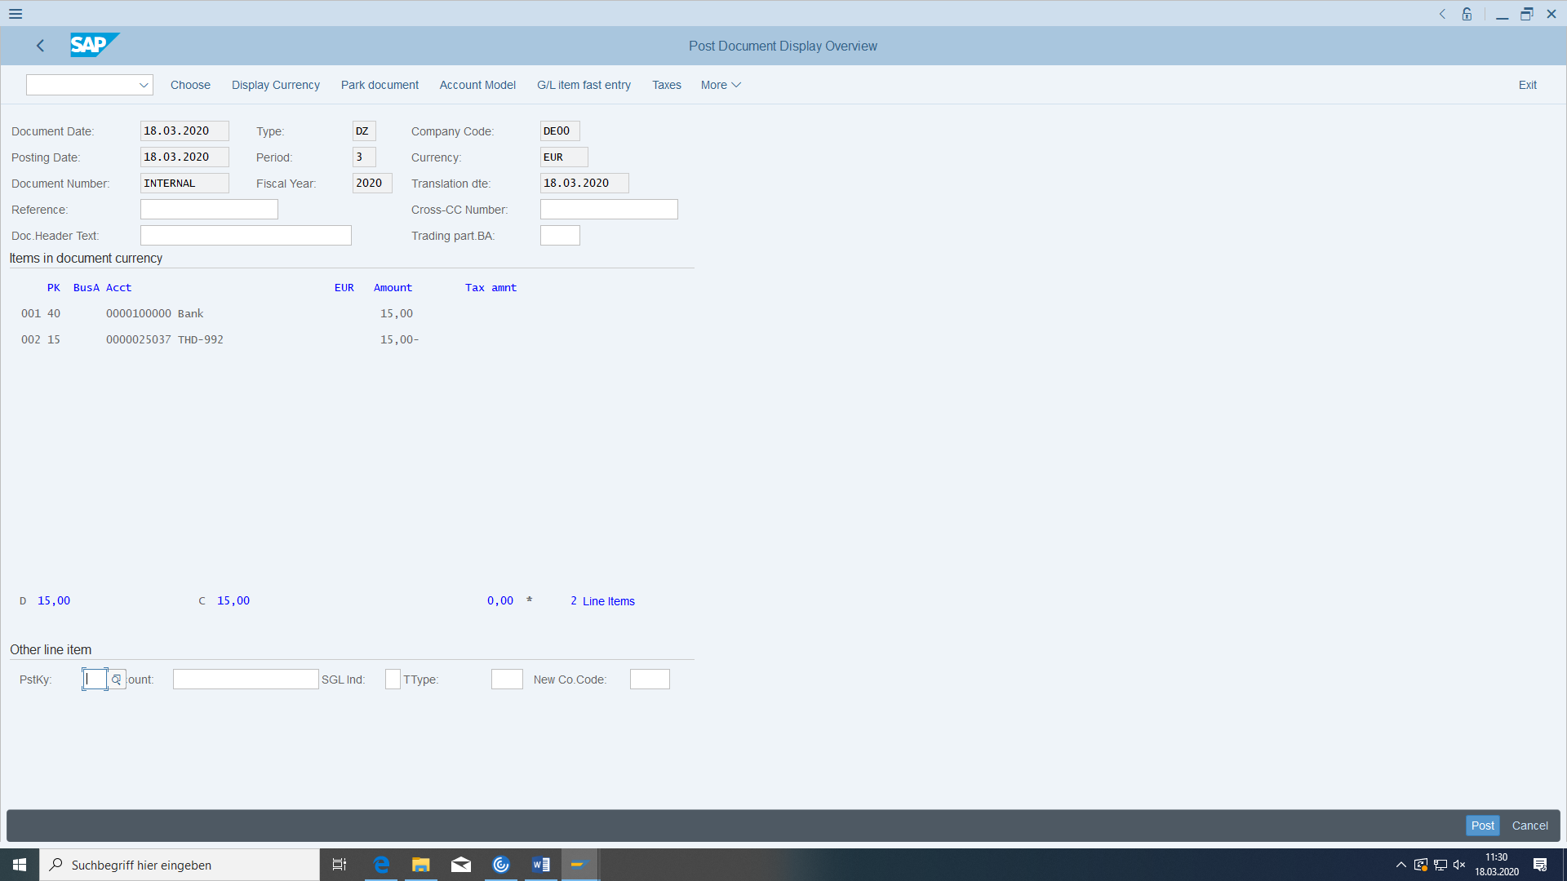

Find the payment to the customer in FI:

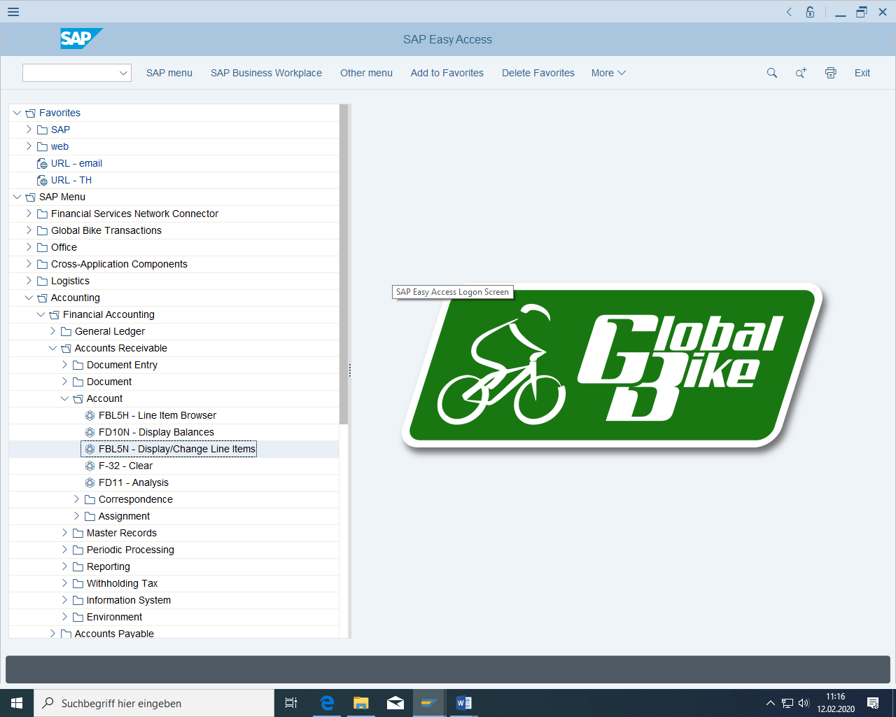

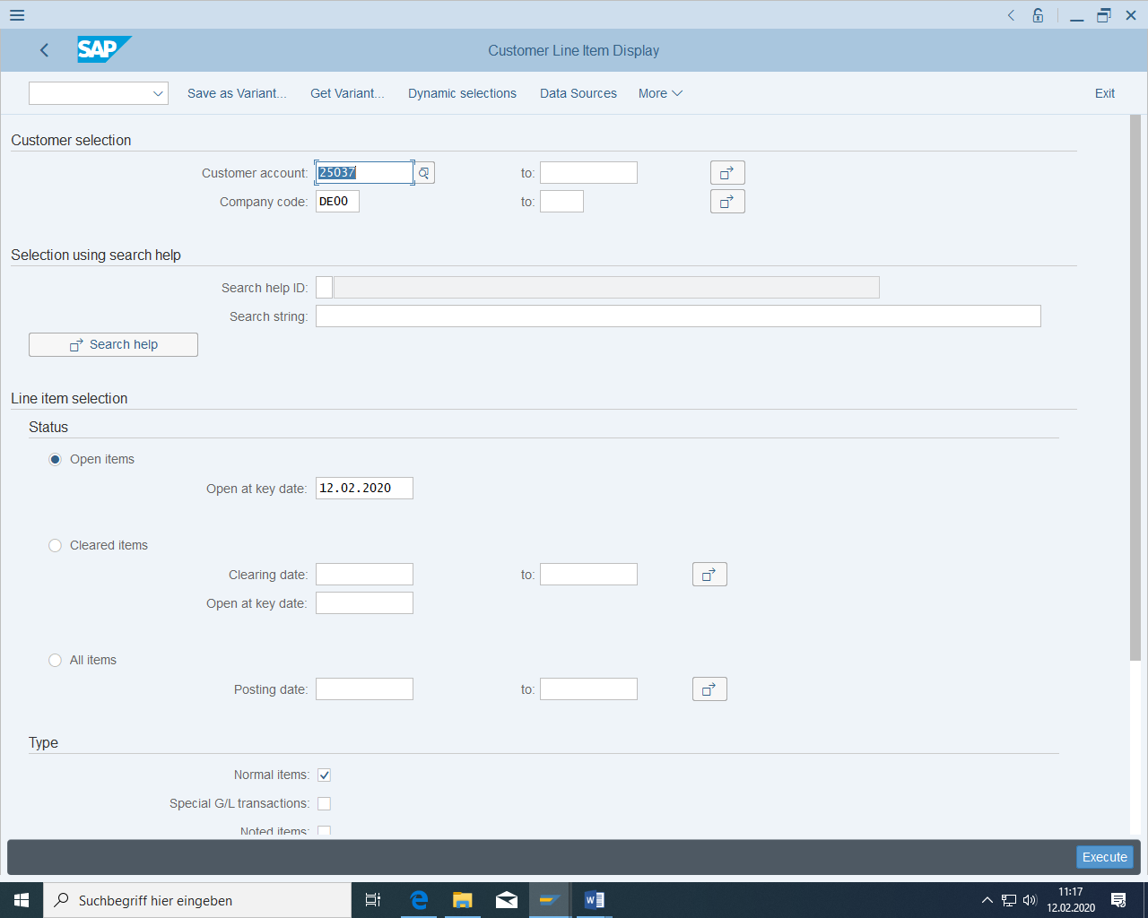

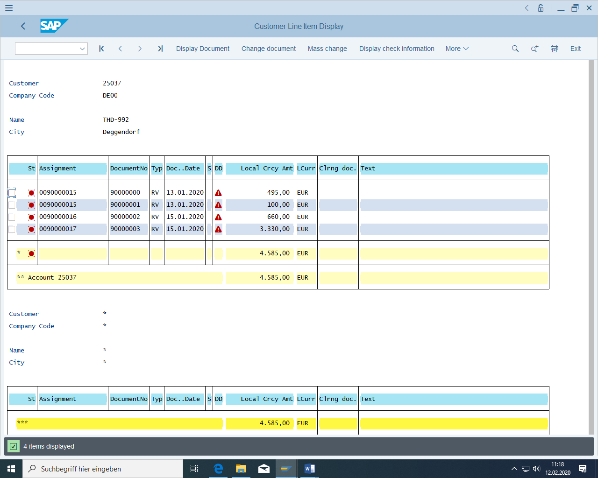

Call up the document overview for the individual row:

Check:

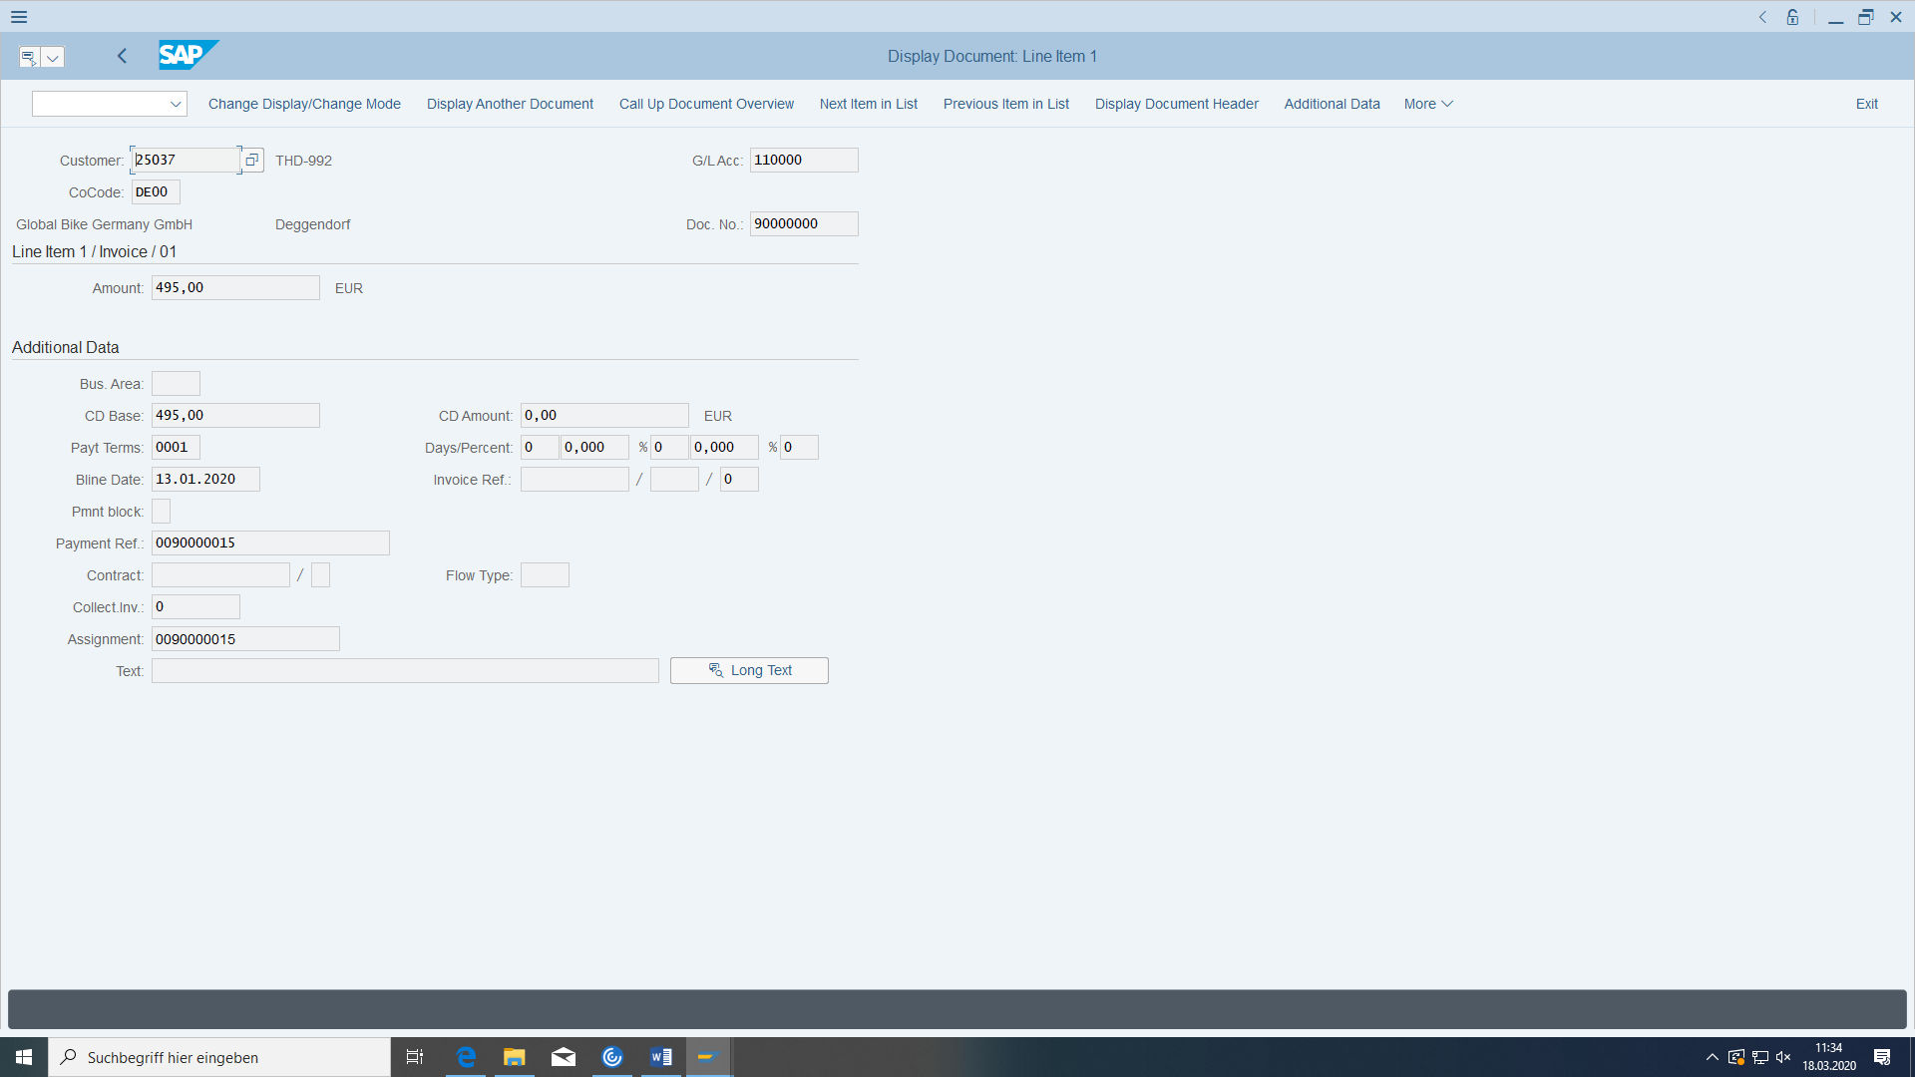

Payment in Accounting Documents:

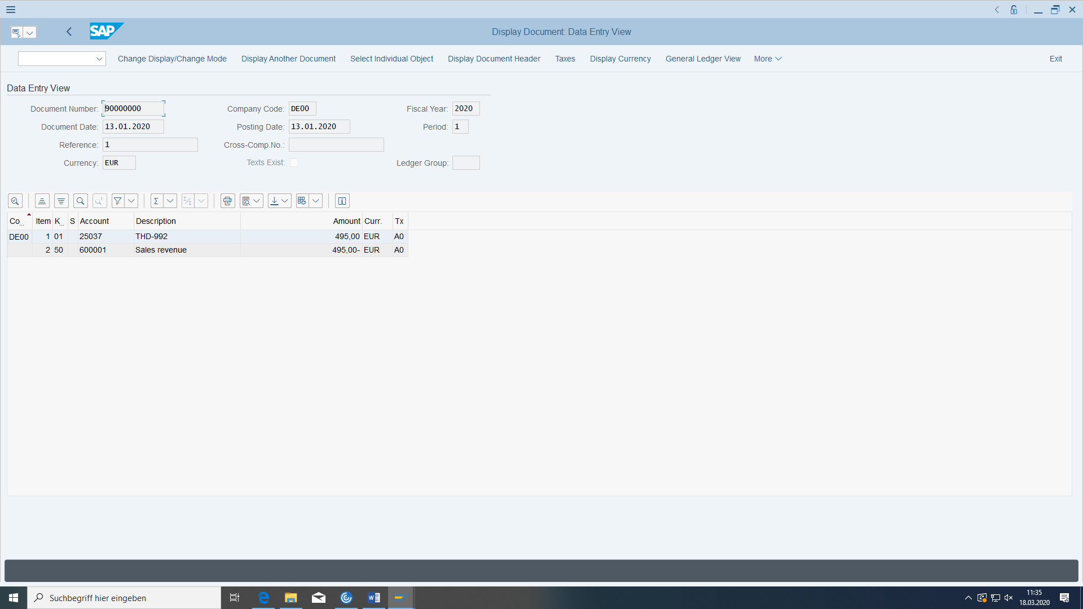

Then look at the **document flow** via UMFELD in the sales order. What documents are there?

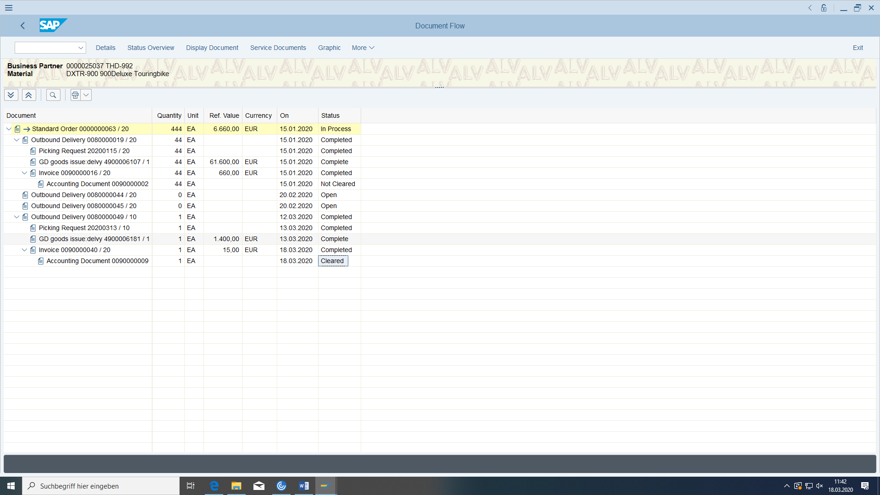

Now it is cleared.

# Finance



Figure 10: Organization of the financial sector

## Posting Incoming Invoices Without Invoice Verification

### Basic

#### preconditions

You need your vendor from the MM case study.

#### task

Below you enter an invoice from your vendor.

#### Required transactions

|  |  |  |
| --- | --- | --- |
| **transaction** | **menu path** | **TAC** |
| Display General Ledger Balances | Accounting > Financial accounting > General ledger > Account > Display balances | FS10N |
| Enter invoice | Accounting > Financial Accounting > Accounts payable > Document Entry > Invoice | FB60 |
| Display invoice document | Accounting > Finance > Accounts payable > Receipt > Advertisements | FB03 |
| Display vendor balances | Accounting > Financials > Accounts payable > Account > Display balances | FK10N |
| Display vendor items | Accounting > Financials > Accounts payable > Account > Display/change items | FBL1N |

#### Data for this example

|  |  |  |
| --- | --- | --- |
| **fields** | **basic data** | **Description** |
| company code | DE00 |  |
| currency | € |  |
| document type | KR |  |
| document date | Current date -2 |  |
| posting date | Current date |  |
| vendor account | Your vendor | The vendor number from the master data case study |

### Display current status of general ledger balances (payables)

Before you post the vendor invoice, check the balances of your payables account. To do this, switch to the transaction for displaying general ledger balances. You want to display the balances for G/L account 300000 in company code DE00 for the current fiscal year.

The account you find in the financial data of the vendor:

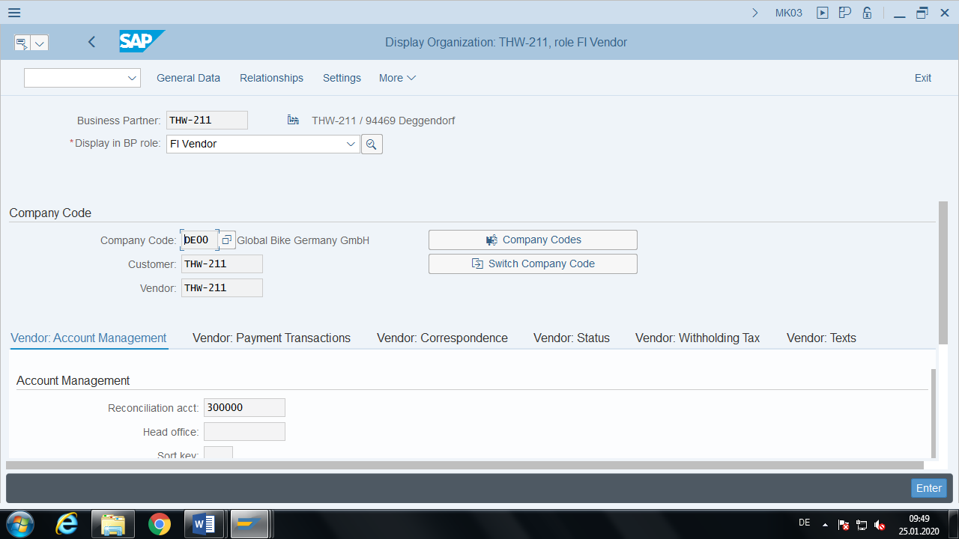

In german version at Kreditor BP role:

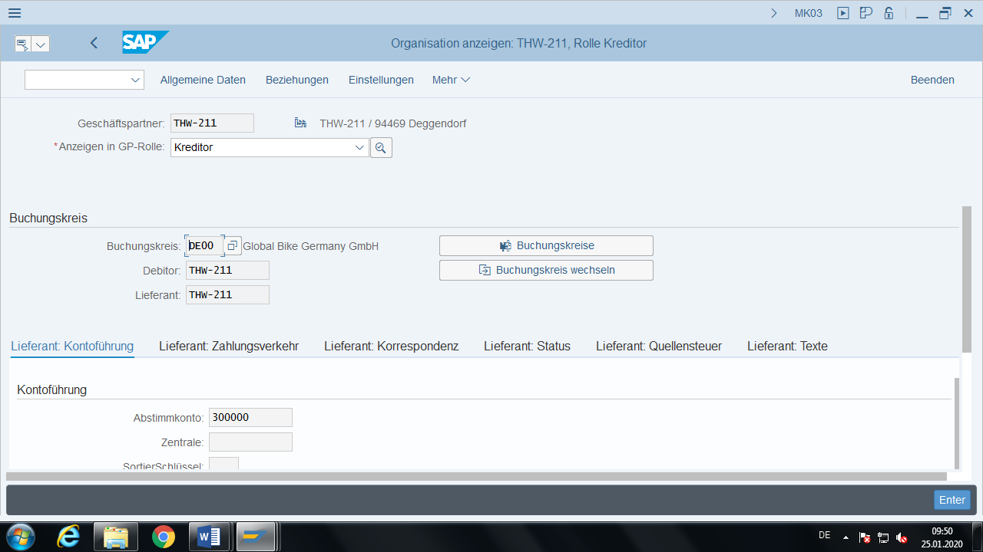

G/L account in GL00 or company code DE00

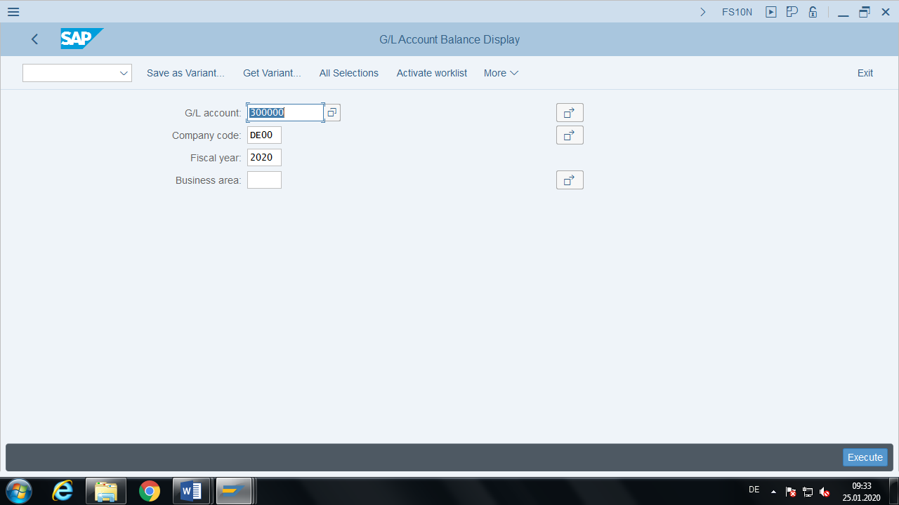

All information about this account you get with KA06

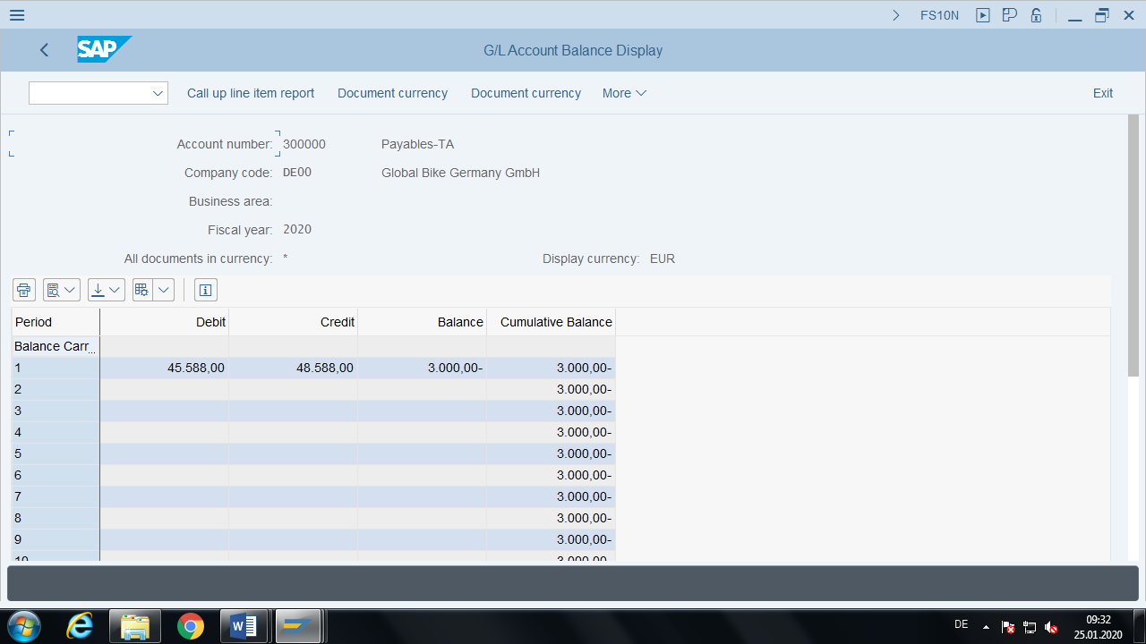

DClick on an value:

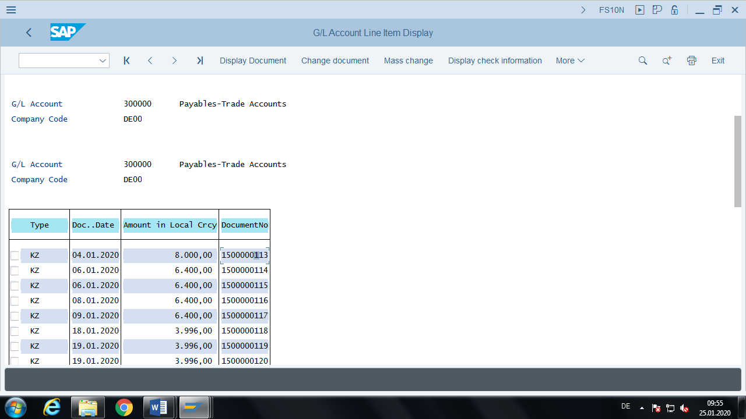

DC on a line:

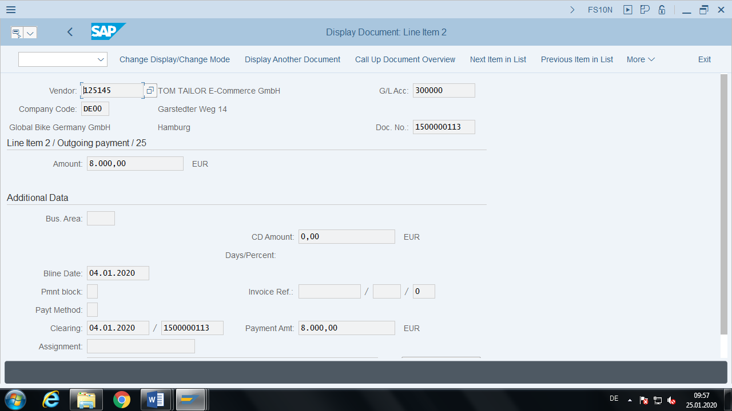

Note the balance of the current period:

___________________________________________________________________

Tip: Open a new mode and leave this transaction open for later checks.

### Enter Standard FI Invoice

You now want to enter a new invoice from your vendor. In the corresponding screen, you will find the document header in the upper part and the line items in the lower part. Now enter the following header data: The document date is 2 days before the current date. The document type is KR, the company code is DE00, and the posting date is the current date. You use € as the currency and you can assign any reference number for the vendor.

We're here in accounting now. Each posting consists of debit and credit. This time you need two line items with corresponding posting keys. All positions must, of course, balance each other out.

The liability to your supplier and the corporate bank account are changed.

For the account, enter the number of your vendor.

You can change the company code:

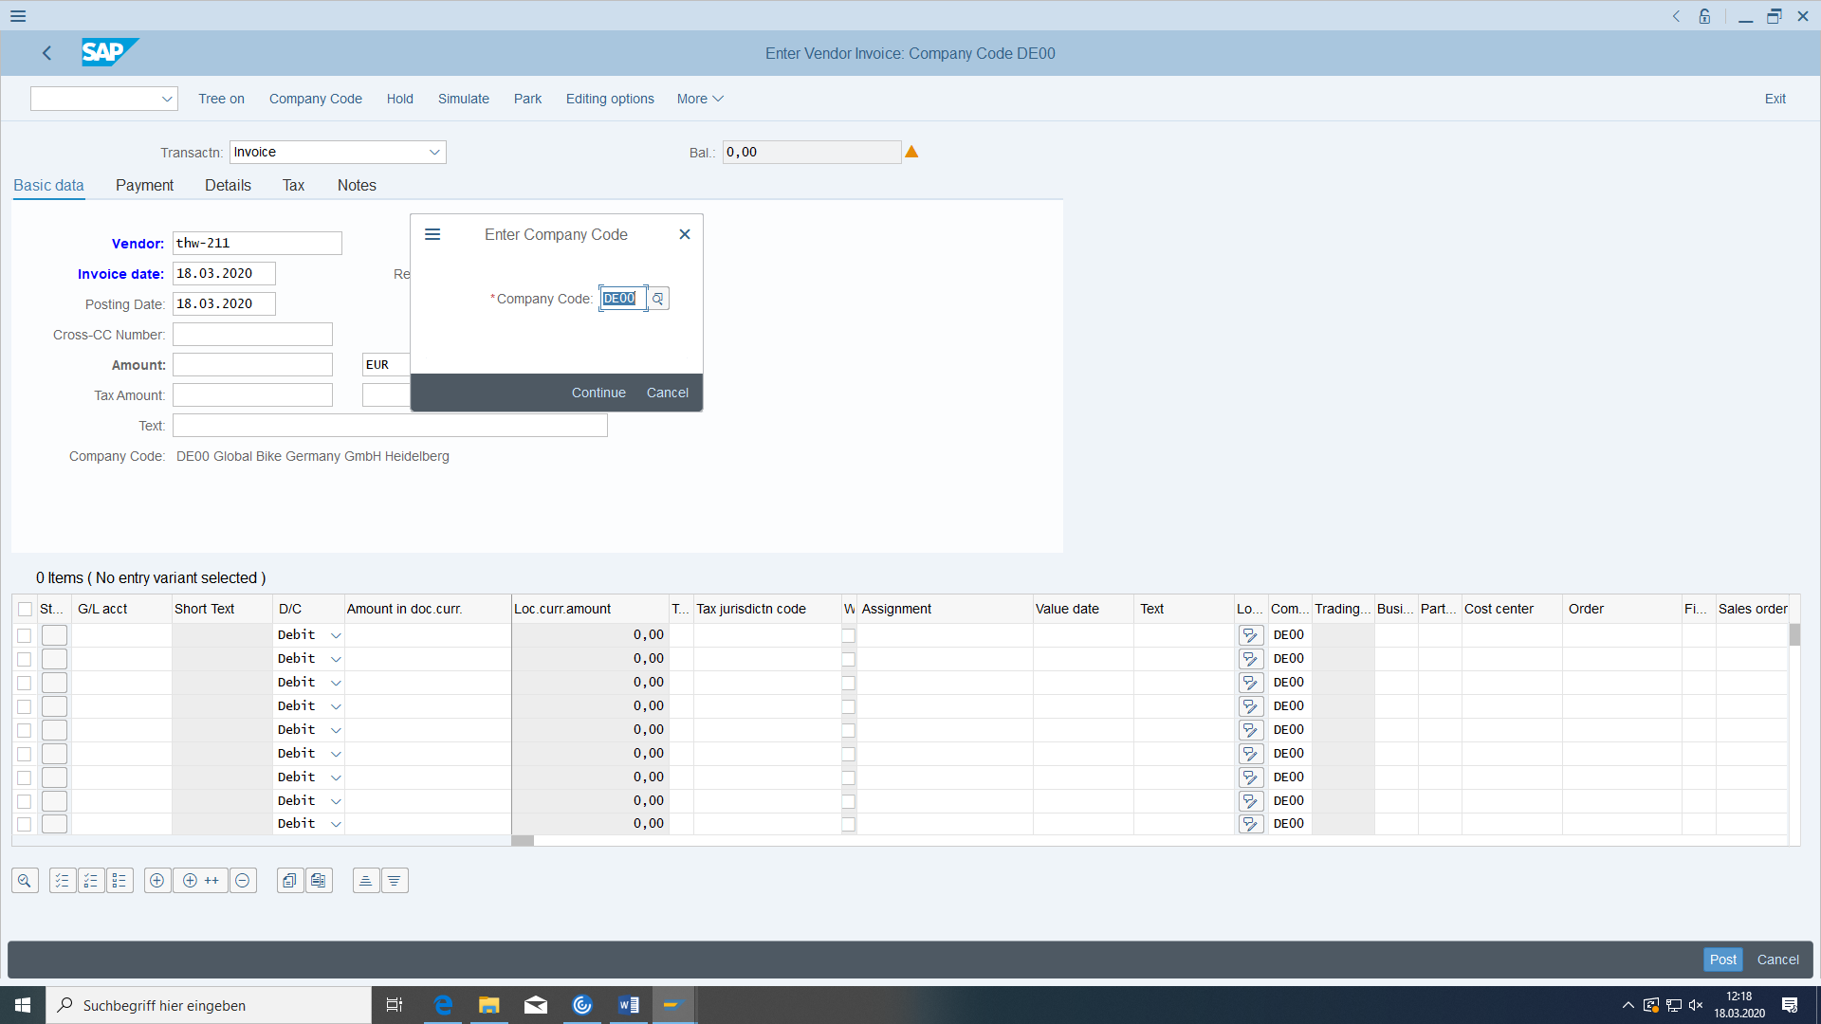

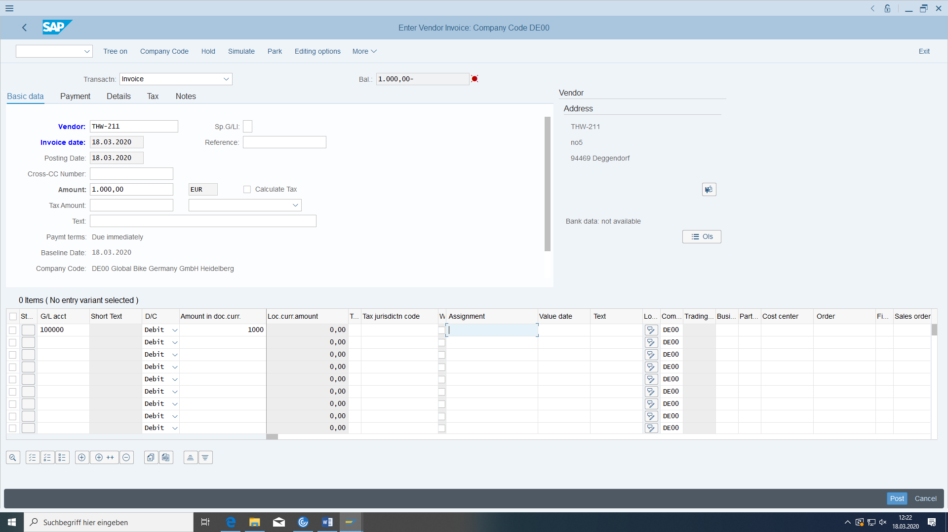

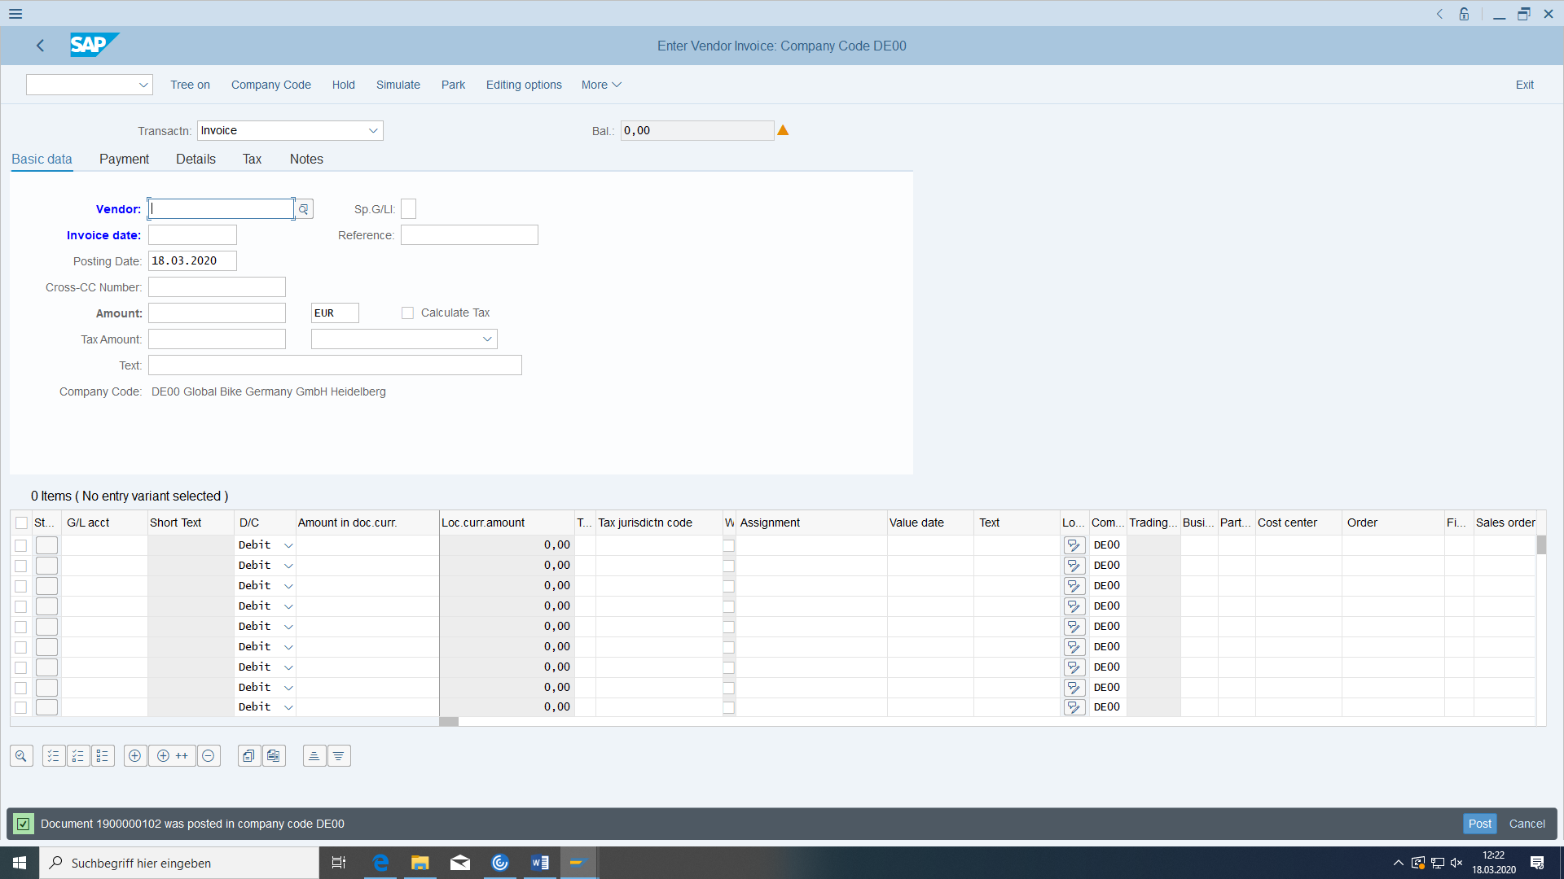

Display the document with FB03:

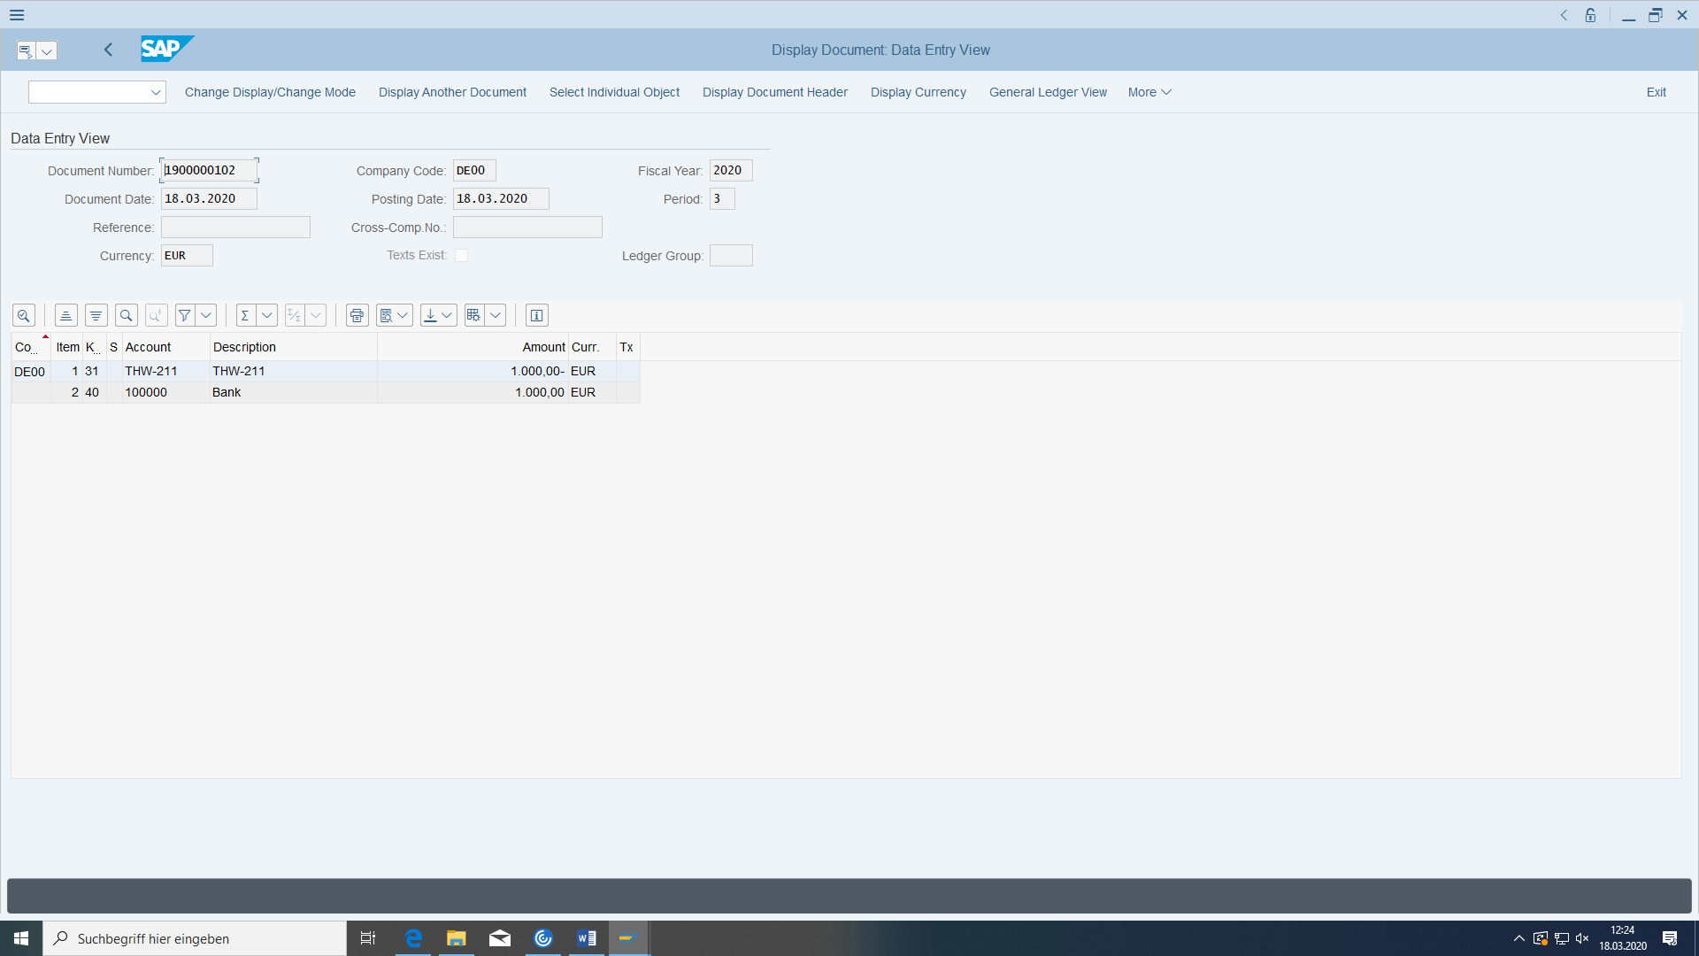

### Display current status of general ledger balances (payables)

Look at the changes in relation to before and analyse them.

# Controlling

## Carry out product costing

### Basic

#### Preconditions

The materials, BOM, and routing for the wheel must have been created.

#### Task

Product costing is to be carried out for the wheel, that is, the production price for the wheel is determined on the basis of the material master data and the data from the routing, together with the purchase prices of the components.

#### Required transactions

|  |  |  |
| --- | --- | --- |
| **transaction** | **menu path** | **TAC** |
| Creating a Material Cost Estimate with Quantity Structure | Accounting > Controlling > Product cost controlling > Product cost planning > Material costing > Calculation with quantity structure > Create | CK11N |
| Price update | Accounting > Controlling > Product Cost Controlling > Product Cost Planning > Material Costing > Price Update | CK24 |
| Display material | Logistics > Materials management > Material master > Material > Ads > Ads current status | MM03 |

#### Data for this example

|  |  |  |
| --- | --- | --- |
| **fields** | **basic data** | **Description** |
| Plant | HD00 |  |
| Material | DXTR-### |  |

### Carry out product costing

(The message "No reservation possible in period 0x/20yy" always appears if no goods receipt has been carried out).

On the Create Material Cost Estimate with Quantity Structure screen, choose your end product. Enter costing variant PPC1 (standard cost estimate (mat)), costing version 1 and costing lot size 1 on the tab page 'Costing data'.:

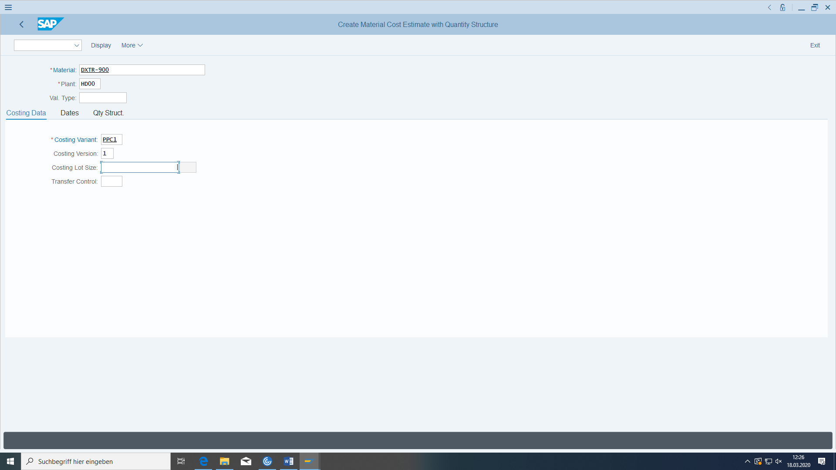

On the tab page 'Dates', change the default 'Costing date from' to the current date and copy the other date entries with 'Enter' (or use the current date as well). The material is now costed by the system with reference to the BOM and routing.

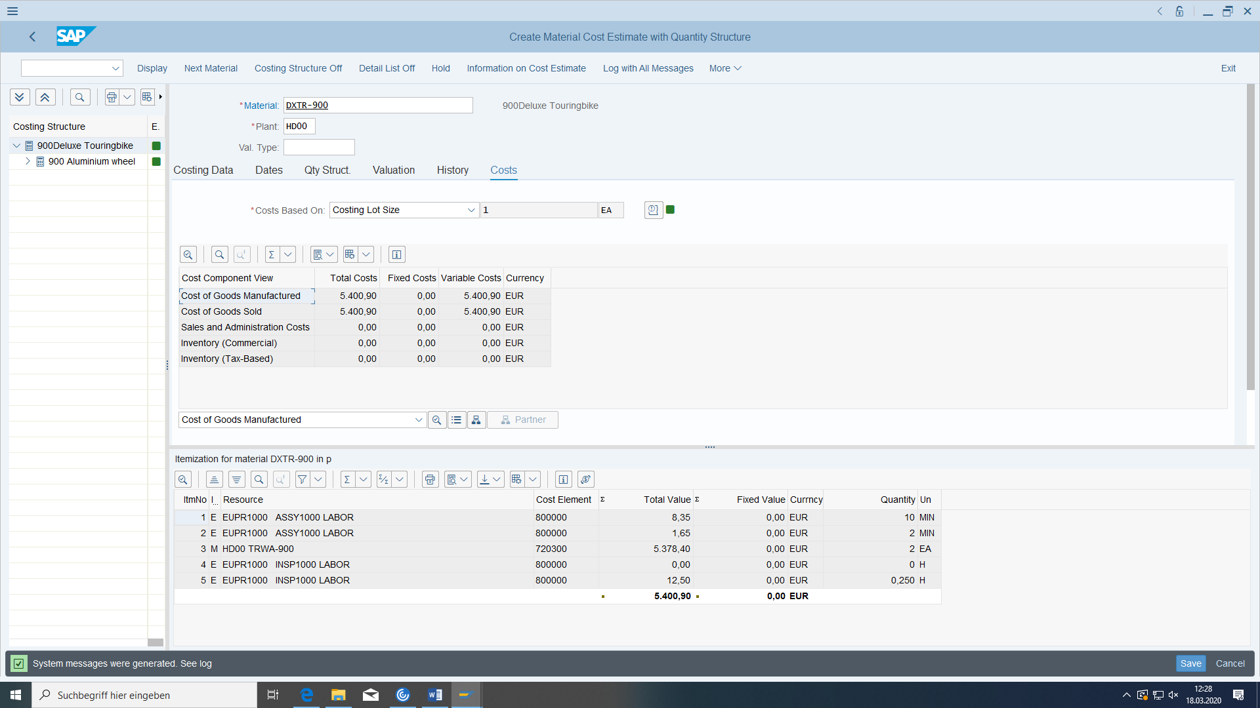

The valuated BOM is displayed in the upper half of the screen. In the lower half of the screen, you can display either the itemization or the cost elements:

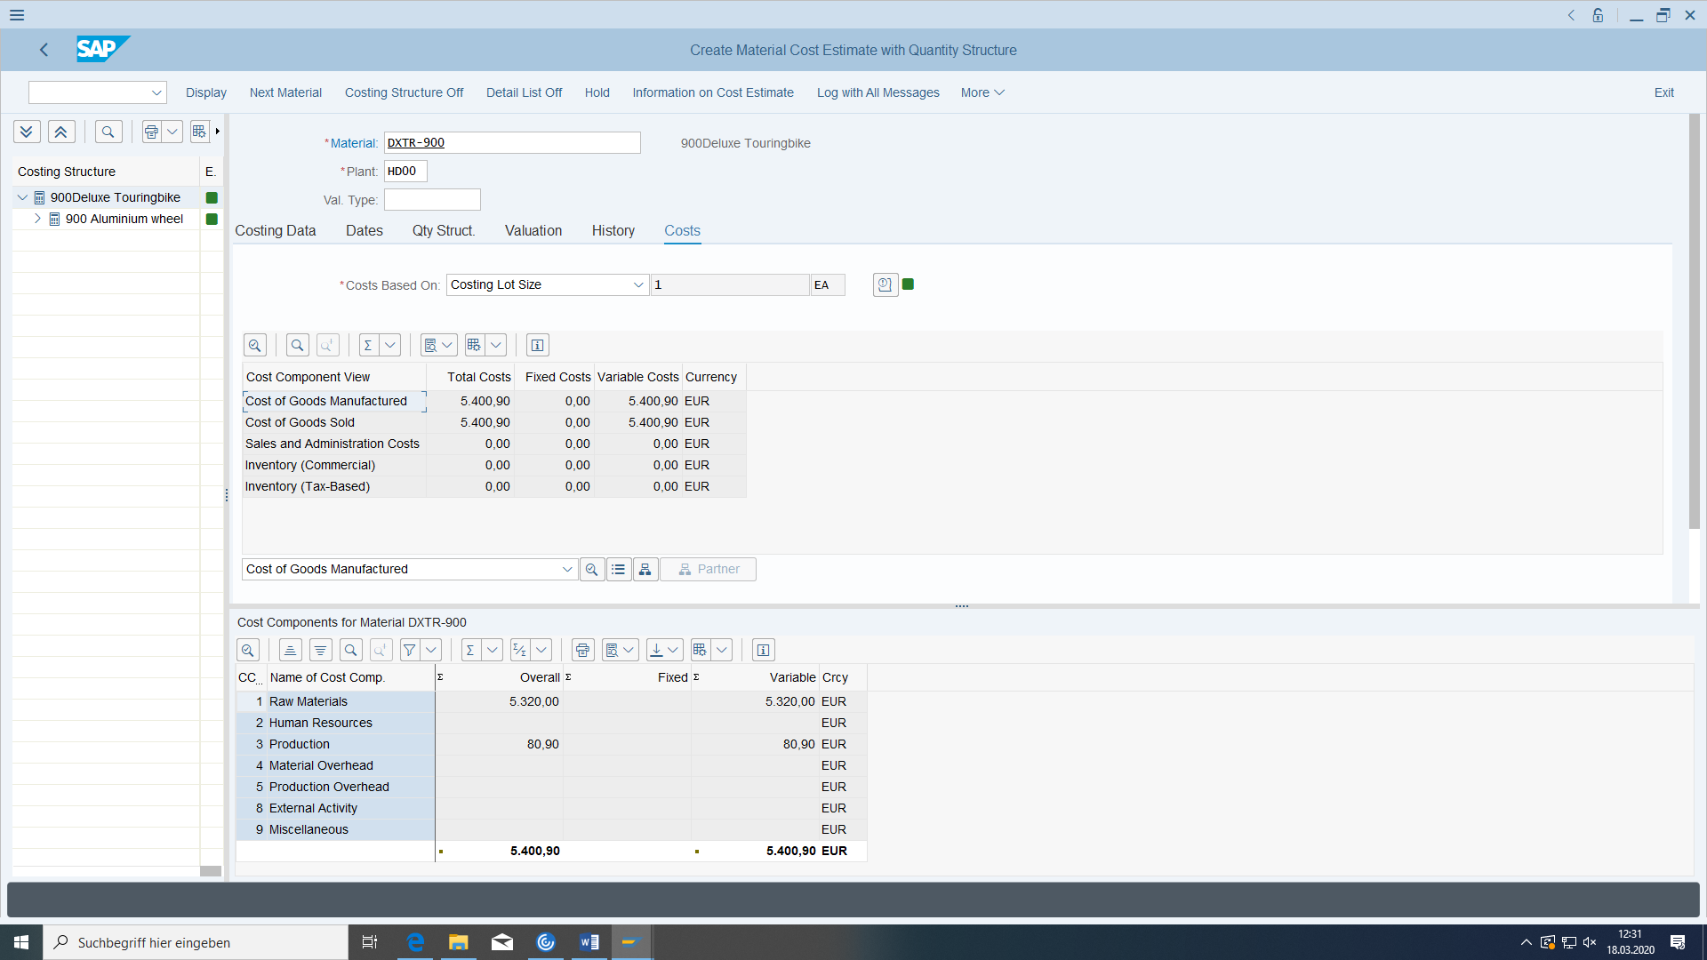

Save your cost estimate.

Now execute Price Update.

Select the current period (current month), company code DE00, plant HD00, and your end product. Please state **ONLY YOUR** material

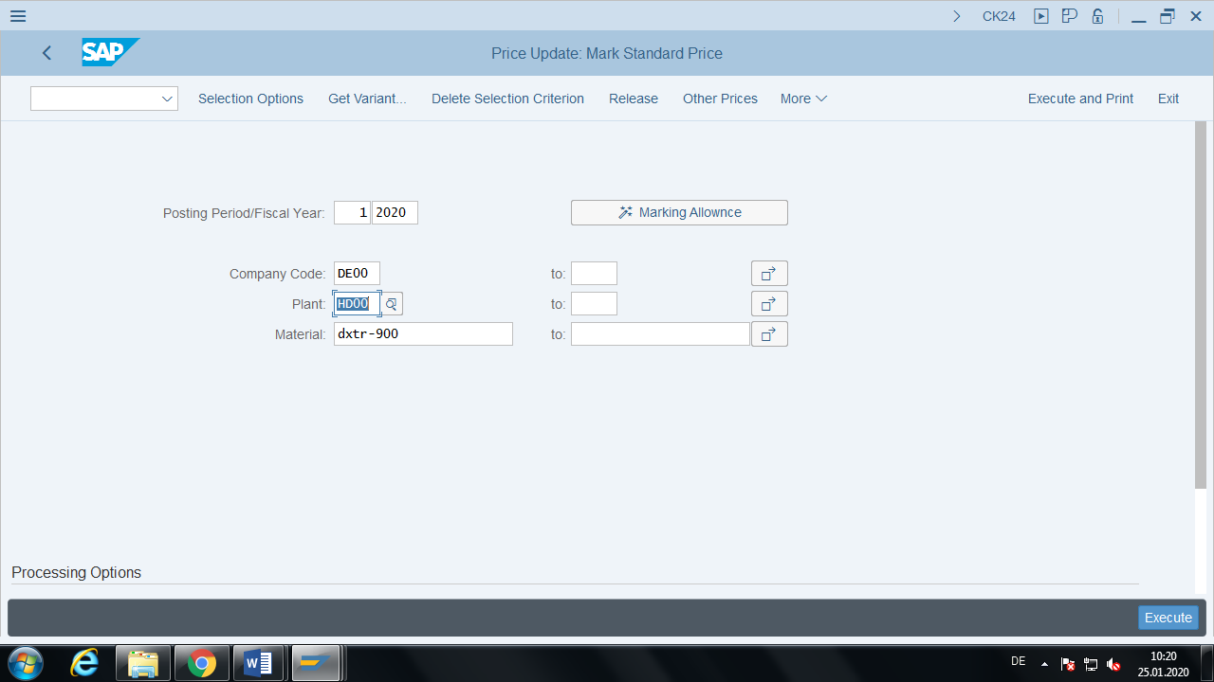

Then execute the reservation by clicking on the 'Execute' button or pressing 'F8'. The following warning appears ('Messages have occurred > see log). If everything worked, the following text should appear in the log (displayed by clicking on the log icon): '1 of 1 materials were successfully updated 1'.

You can view the result of the preregistration in the **material master. In** the SAP menu tree, choose Material Display Current Status. Choose your material and select the Costing 2 view. Enter HD00 as the plant. In the left costing column (future), you see the previously generated marking of the future planned price for the current period.

## Cost center accounting

### Basic

#### Preconditions

#### Task

You want to create a secondary cost element for a new service cost center. The latter will allocate its residual costs to two production cost centers at the end of the period. The new cost center provides services for other cost centers, but has also caused costs.

#### Required transactions

|  |  |  |
| --- | --- | --- |
| **transaction** | **menu path** | **TAC** |
| Create (secondary) cost element | Accounting > Controlling > Cost Center Accounting > Master Data > Cost Element > Individual Processing > Create secondary | KA06 |
| Display cost element | Accounting > Controlling > Cost Center Accounting > Master Data > Cost Element > Individual Processing > Display | KA03 |
| Display G/L Account | Accounting > Financial accounting > General ledger > Master data > Individual processing > In the chart of accounts | FSP0 |
| Create cost center | Accounting > Controlling > Cost Center Accounting > Master Data > Cost Center > Individual Processing > Create | KS01 |
| Create activity type | Accounting > Controlling > Cost center accounting > Master data > Activity type > Individual processing > Create | KL01 |
| Price for service type | Accounting > Controlling > Cost Center Accounting > Planning > Service Performance/Tariffs > Change | KP26 |
| Set planner profile | Accounting > Controlling > Cost center accounting > Planning > Set planner profile | KP04 |
| Entering Activity Allocation | Accounting > Controlling > Cost center accounting > Actual postings > Activity allocation > Capturing | KB21N |
| Enter expense on cost center with cost posting | Accounting > Financial accounting > General ledger > Posting > Enter G/L account document | FB50 |
| Create assessment cycle | Accounting > Controlling > Cost center accounting > Period-end closing > Individual functions > Allocations > Allocation | KSU5 |
| Actual/Plan Variance Report for Cost Center | Accounting > Controlling > Cost center accounting > Information systems > Reports on cost center accounting > Plan/actual comparisons > Cost centers: Actual/Plan/Variance | S_ALR_87013611 |

#### Data for this example

|  |  |  |
| --- | --- | --- |
| **fields** | **basic data** | **Description** |
| controlling area | EU00 |  |
| company code | DE00 |  |

### Master data

#### Create secondary cost element

Create the secondary cost element 91-### "Development color ###" for internal activity or process allocation. Other Controlling objects (cost centers, production orders) are then debited according to costs, depending on how many activity units they have used from the auxiliary cost center. They are used solely to allocate the costs incurred to the other Controlling objects, but are not the actual costs incurred in the service cost center.

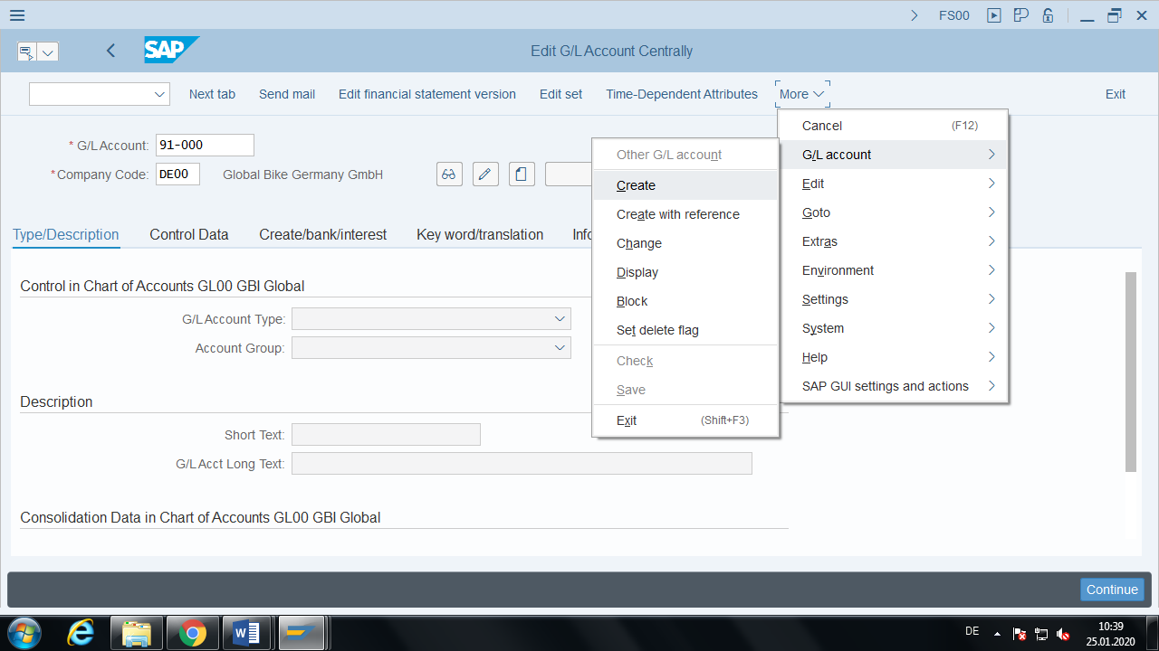

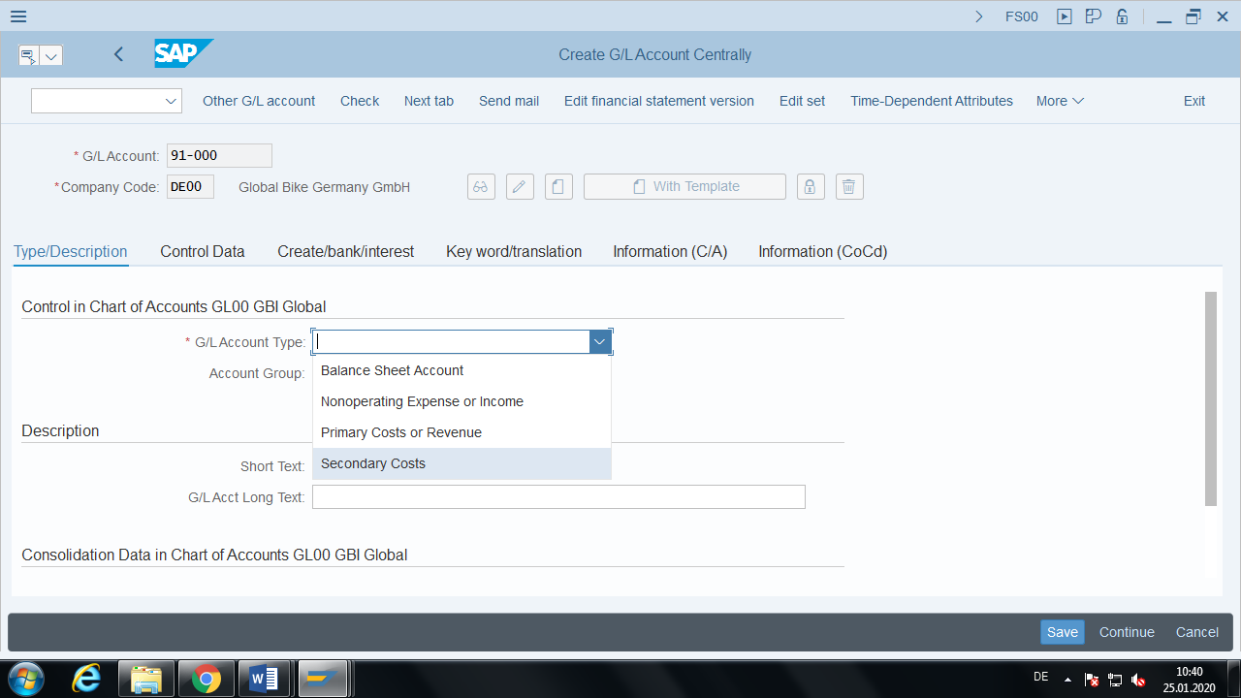

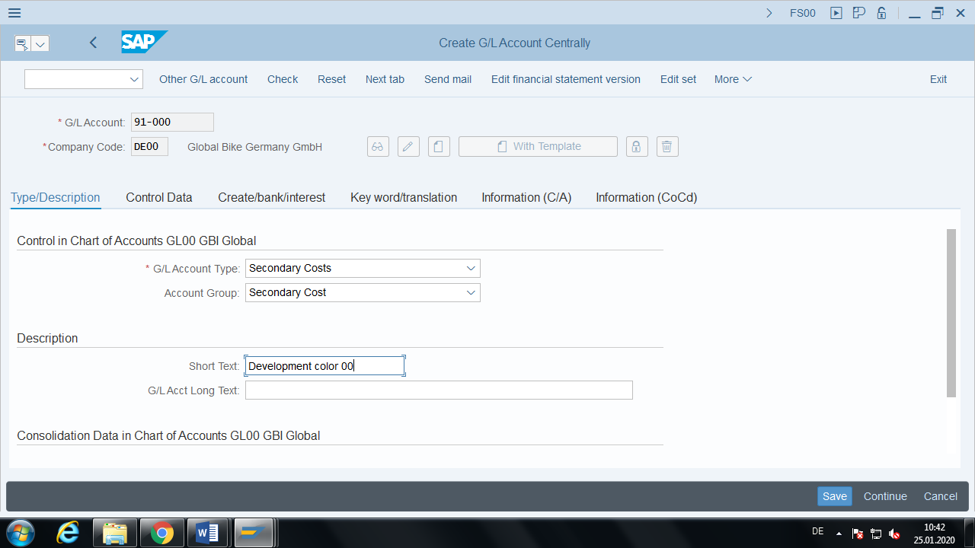

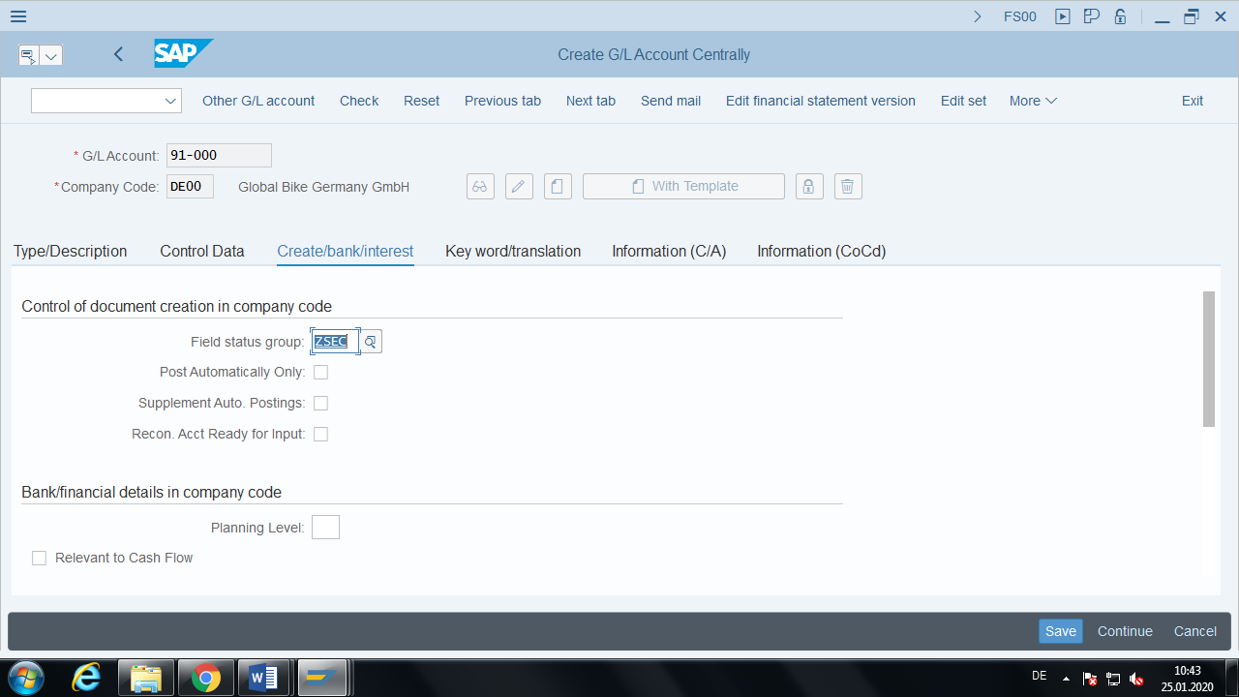

Very important:

It must be category **Internal activity allocation**

#### Create auxiliary cost center

Create the service cost center DEVEL-xxx "Development ###" in the business area Bicycles, no profit center, in the hierarchy area Production, in Euro. You yourself are responsible for this cost center. No (planed) revenues may be posted to this cost center.

Very important: it must have **Service cost center** category.

#### Create activity type

The new cost center is to be used as an auxiliary and development cost center for other cost centers. The activity CAD### "CADDrawing ###" is created with

Service cost center

wage hours in **hours**

manual entry and manual allocation

regard to the secondary cost element 91-### you created above as an auxiliary cost element.

#### Set planner profile

Set the planner profile SAPEASY.

#### Service type price

The hourly rate for the development activity is 75€ for all periods of the current fiscal year of the auxiliary cost center ENTW-#### "Development ###" (Attention: Period always starts on the 1st of a month, then cost center must already be valid).

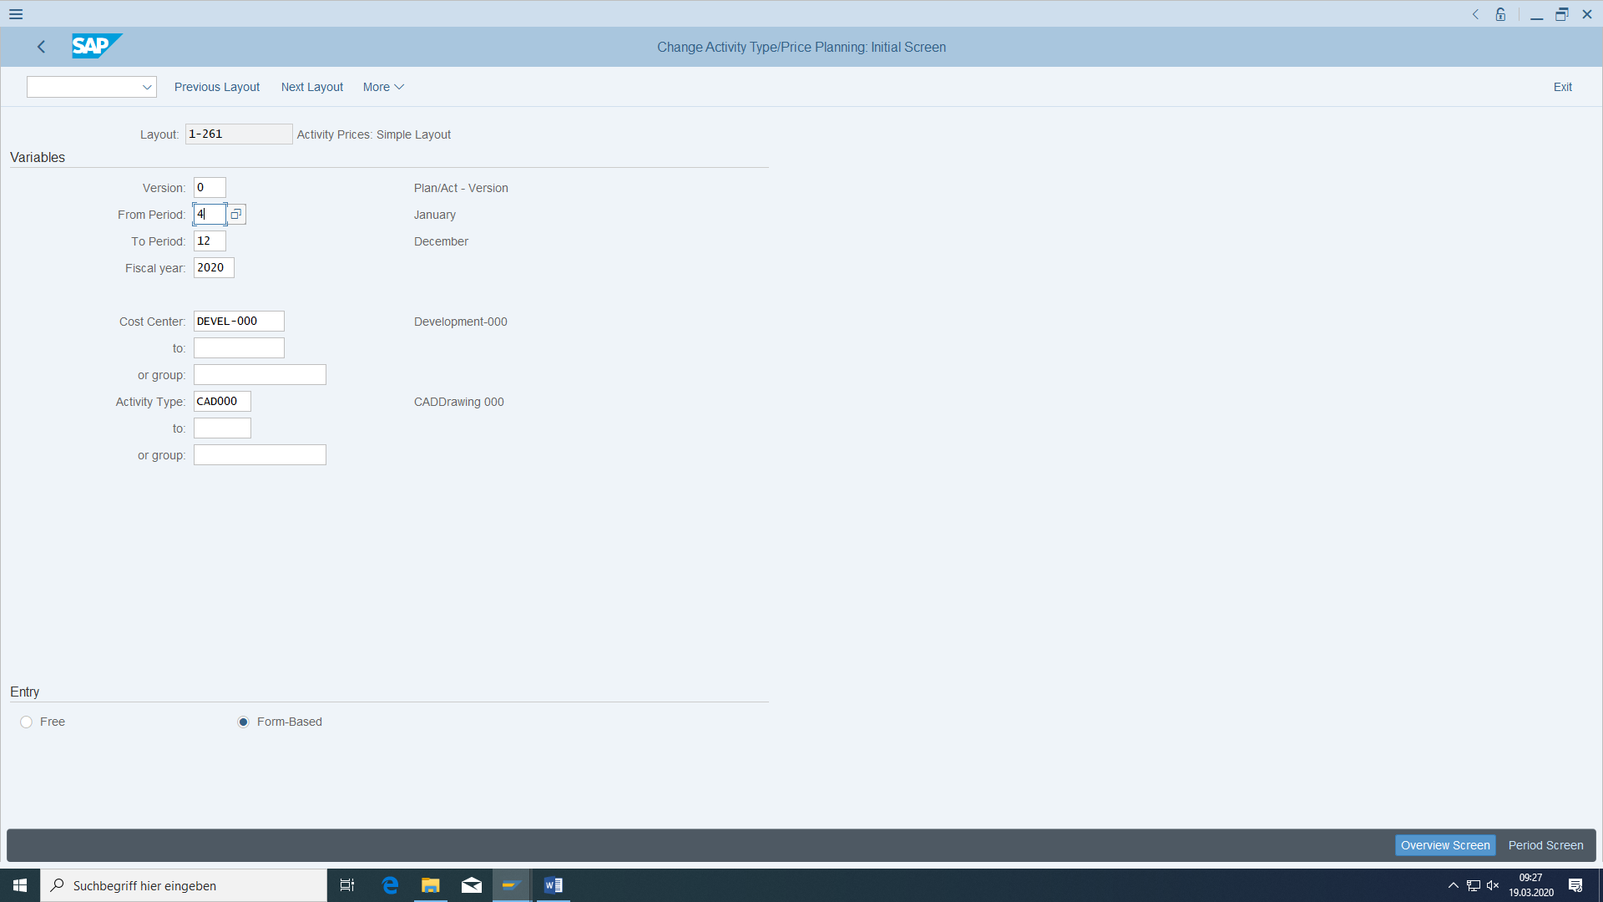

Very important: start always with the **actual month + 1**

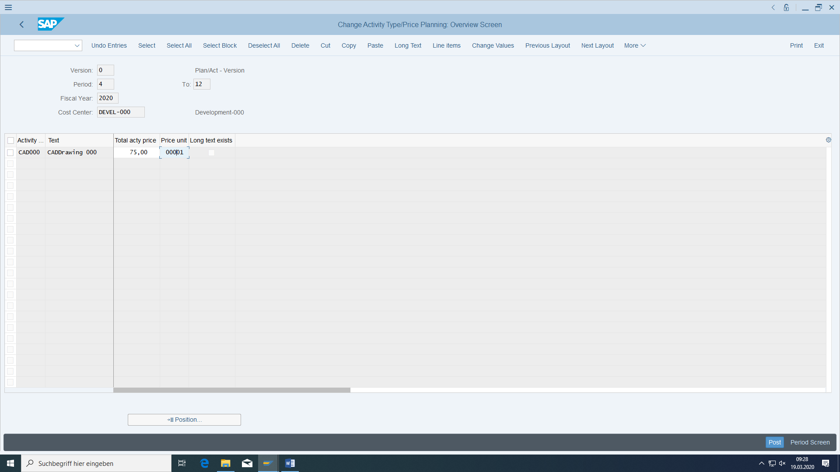

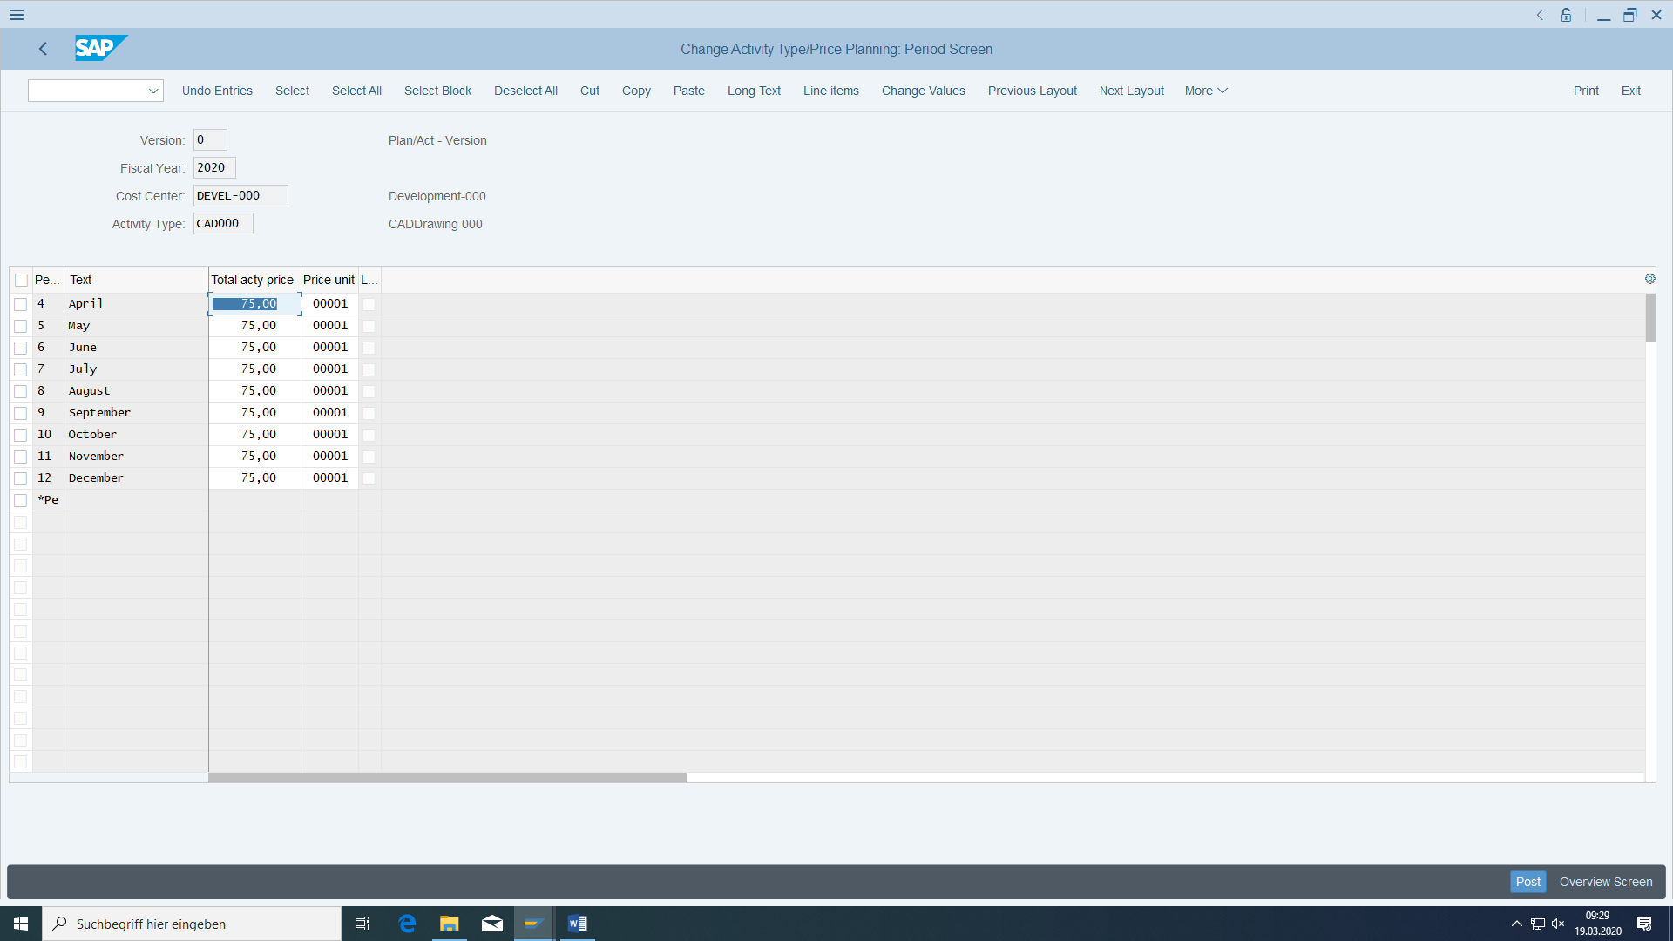

### Transaction data

#### Service provision

The development department worked 50 (development) hours for the Internal services department (also Service cost center category). Post this direct service performance using the screen variant "Cost center and list entry". Make sure that the date specifications are in the periods of the tariffs entered.

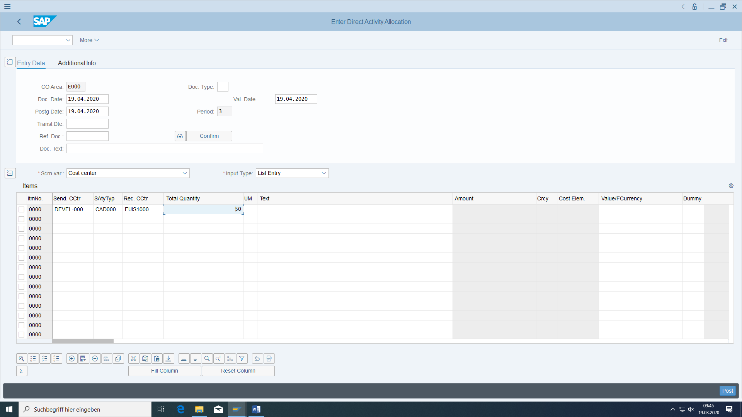

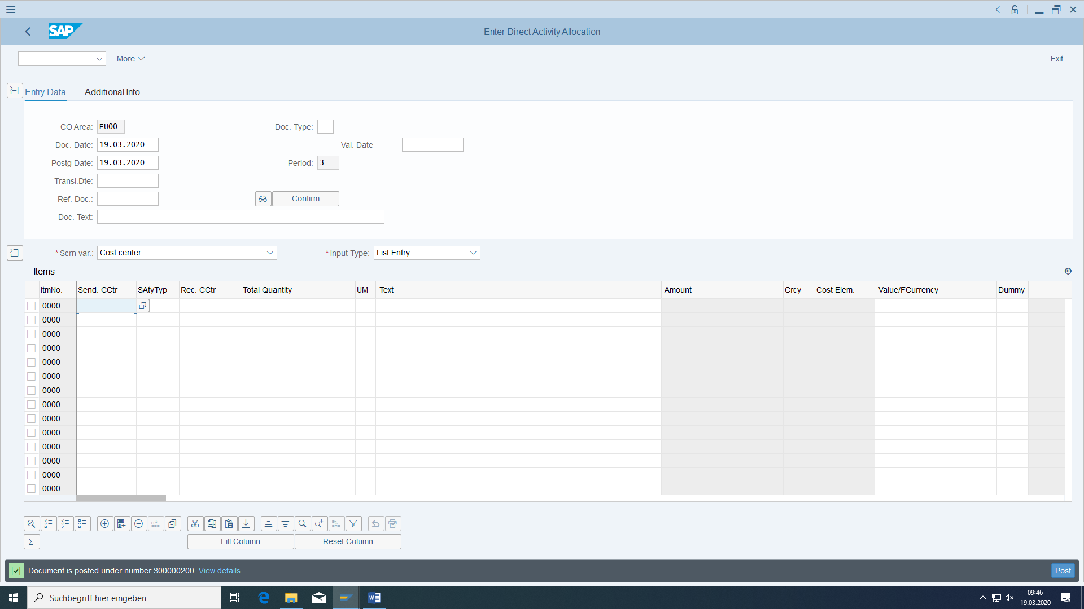

#### Record expenditure (= primary costs) for auxiliary cost center

You must link the "Consumption of consumables and supplies" expense account with our auxiliary cost center so that a **cost posting** is also triggered.

The development department bought auxiliary and operating materials for 7000€ (into the material stock) and paid via your bank account and used them afterwards. No tax. Enter the debit and credit postings.

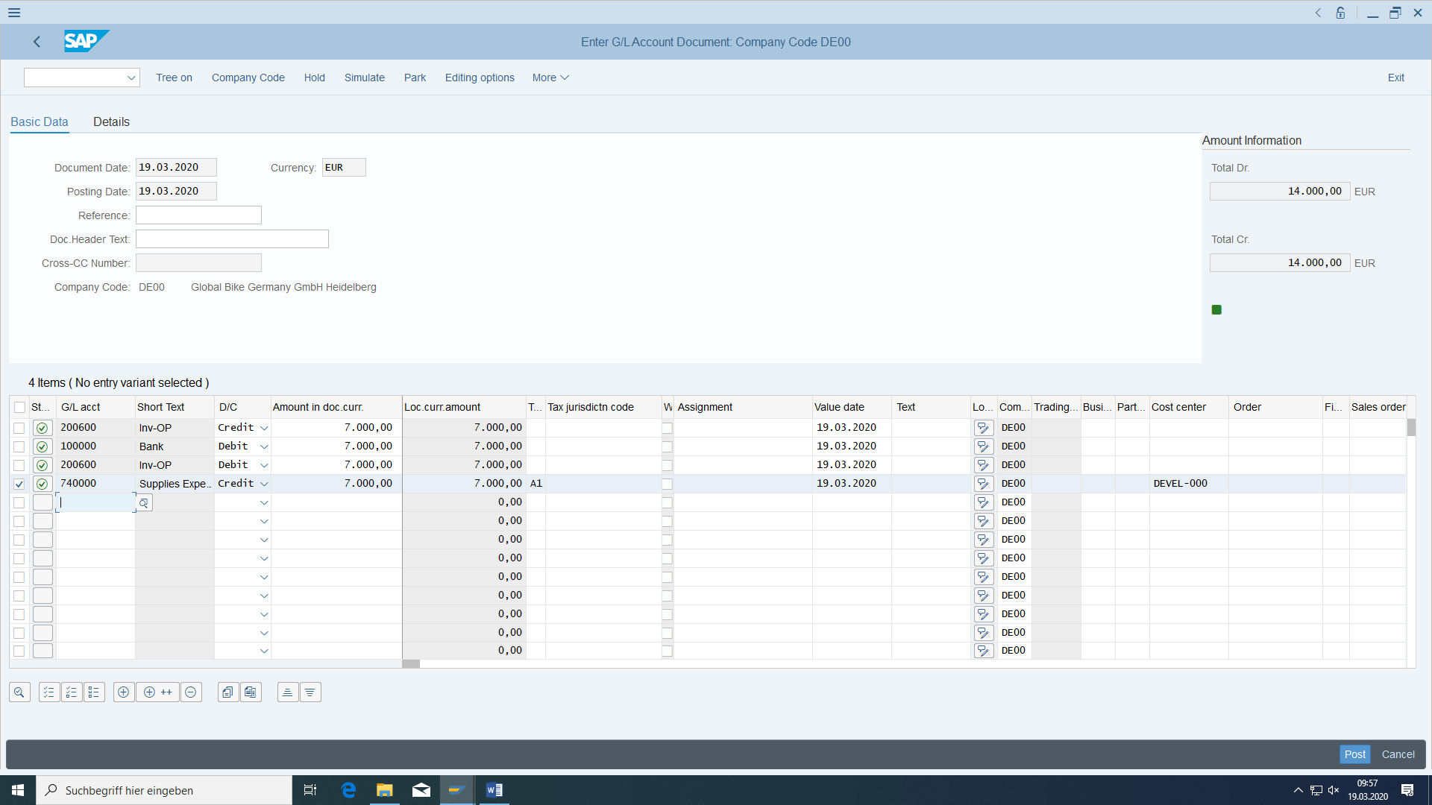

Simulate whether the posting is correct. Post the document afterwards.

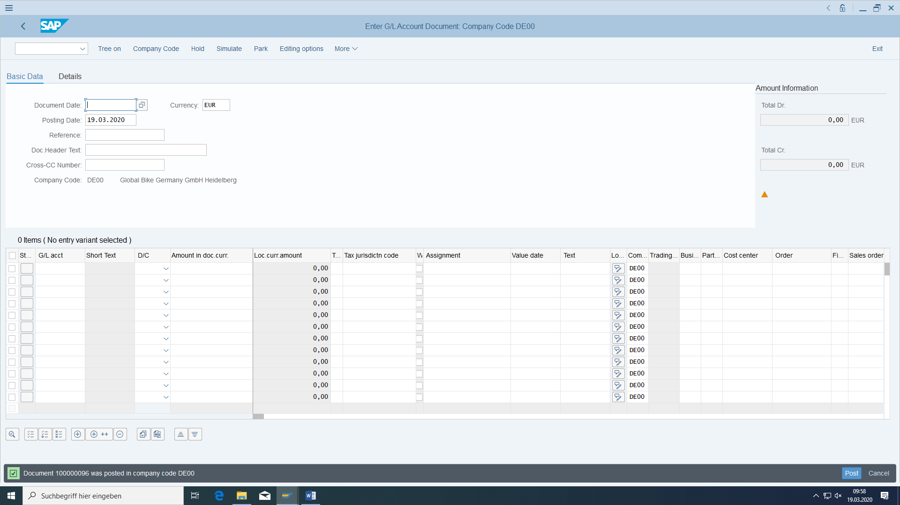

#### Actual situation

##### Create assessment cycle

At the end of the period, you want to allocate all remaining costs to the production cost centers with KSU5: Actual assessment cycle IU-### with the date of the first day of the current fiscal year.

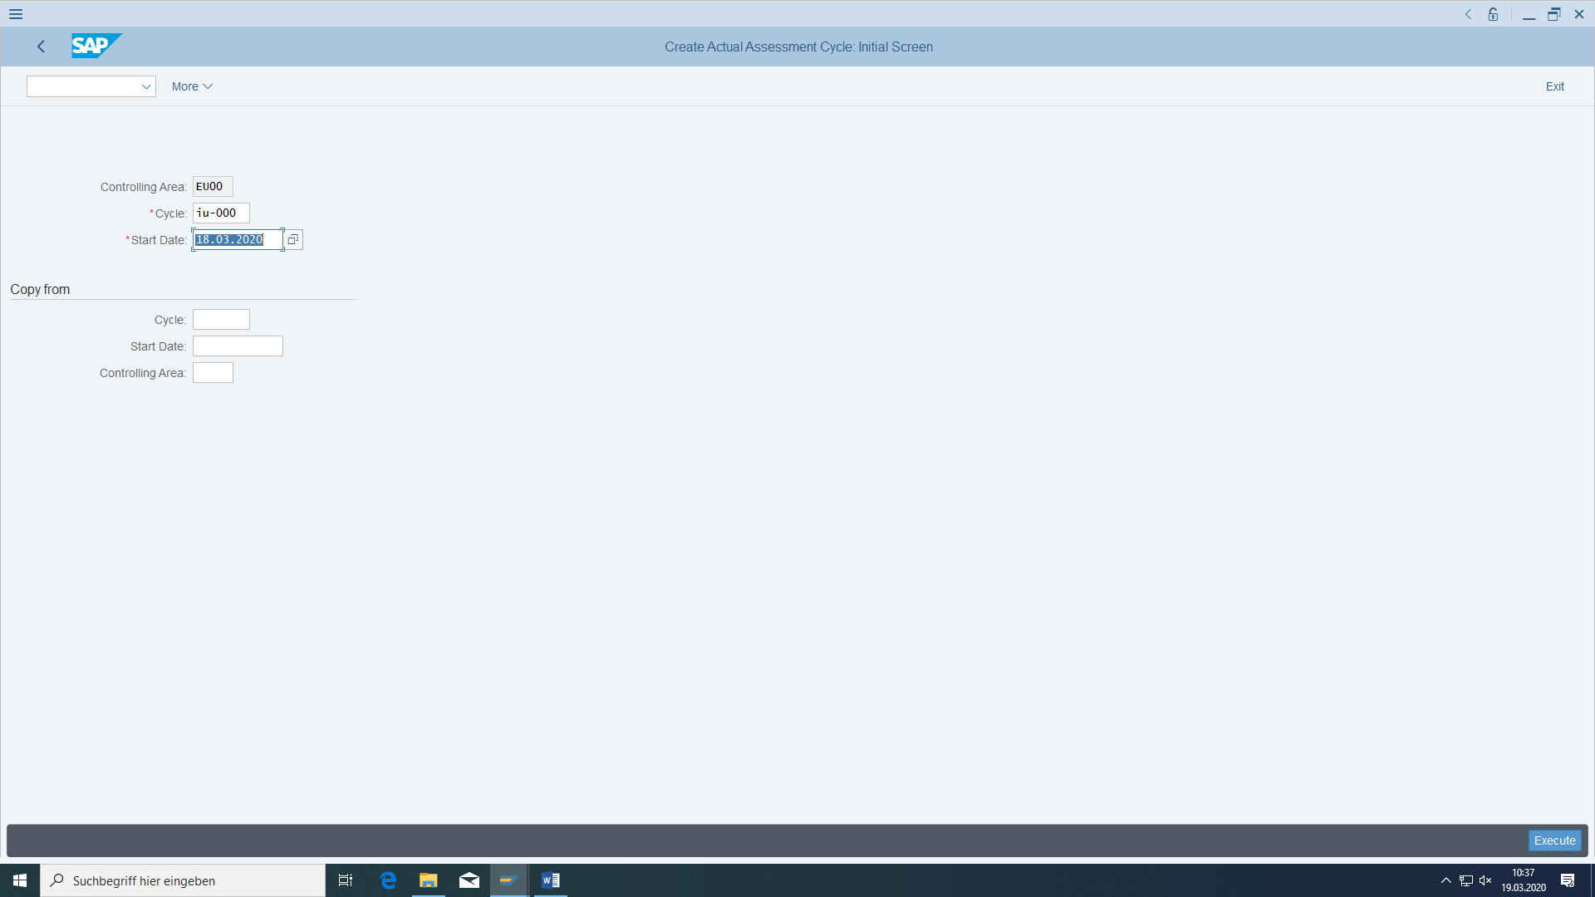

For one cycle will be one haeder and as many segments as many receivers of costs (here two).

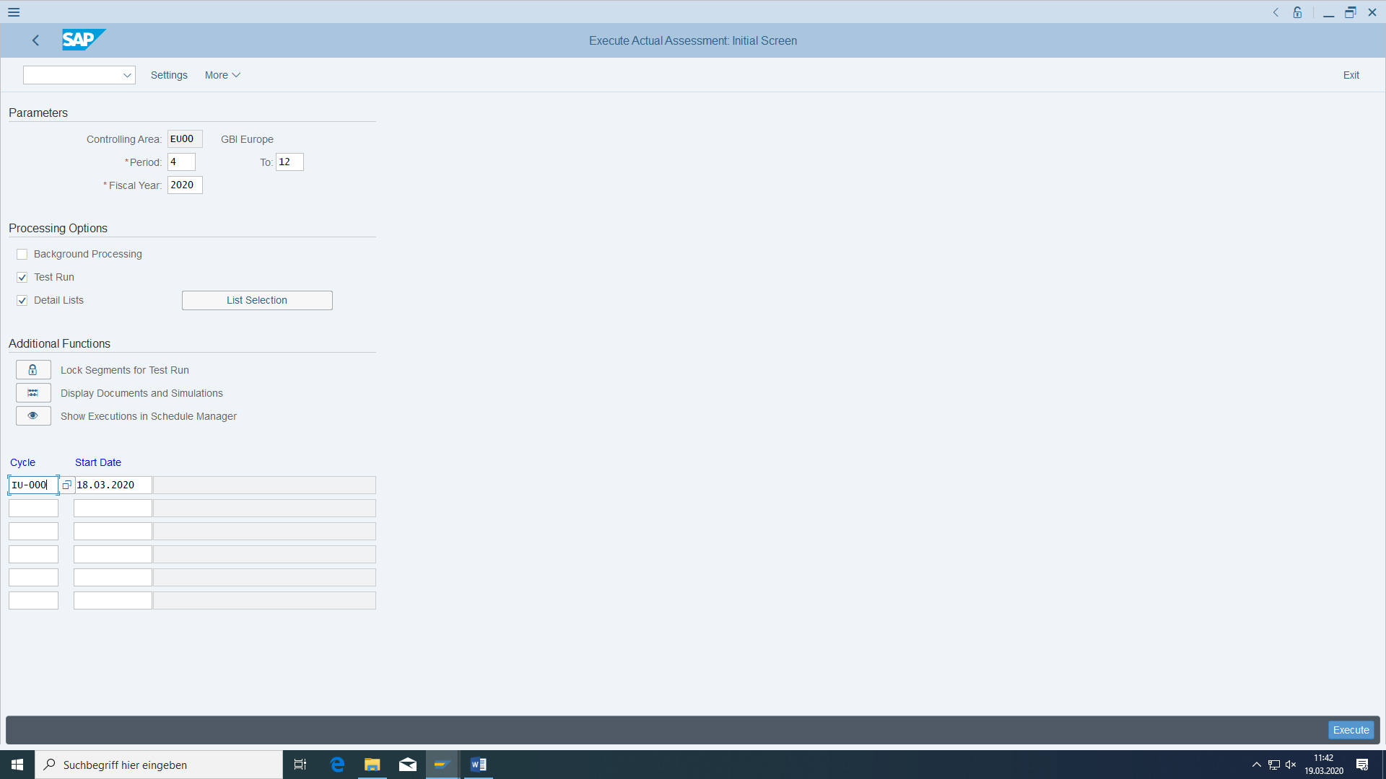

From actual month + 1.

Then create the cycle run group Group ### via Goto:.

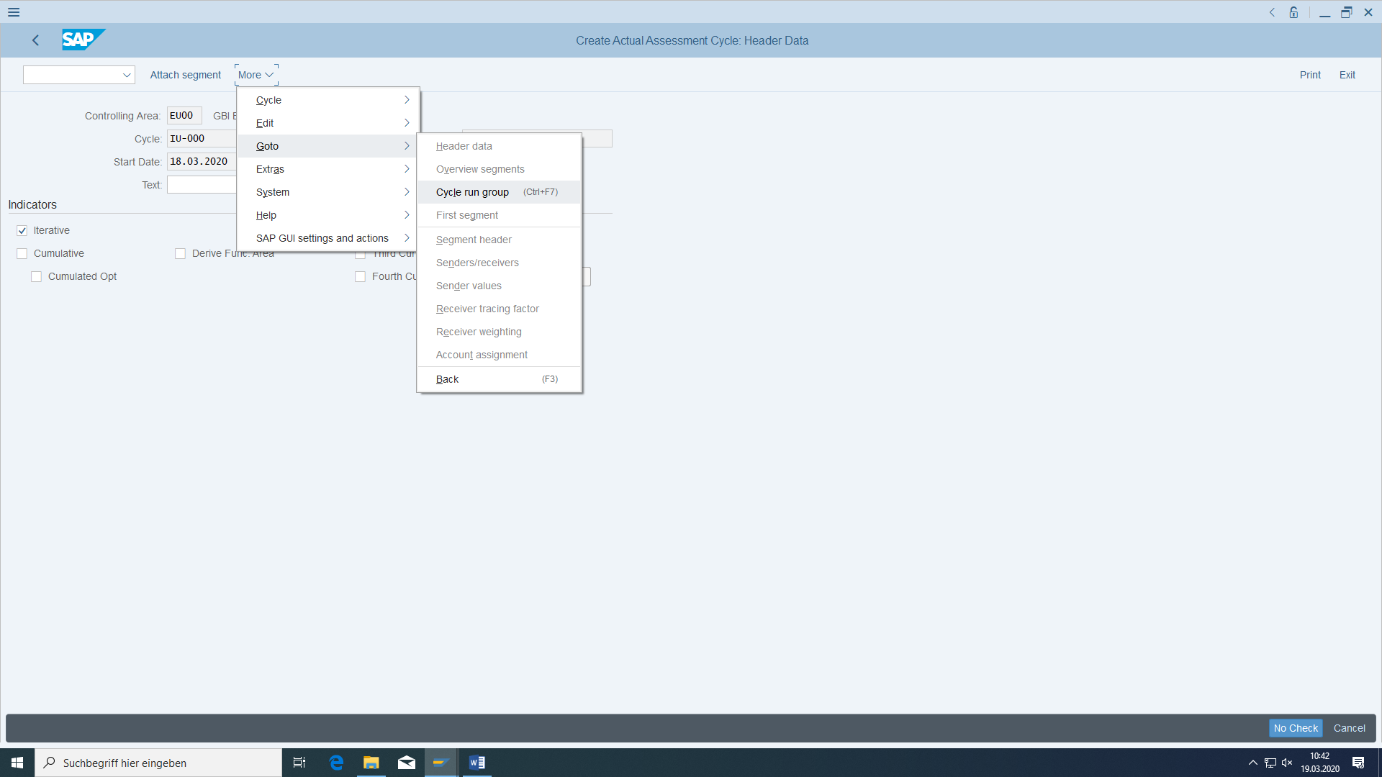

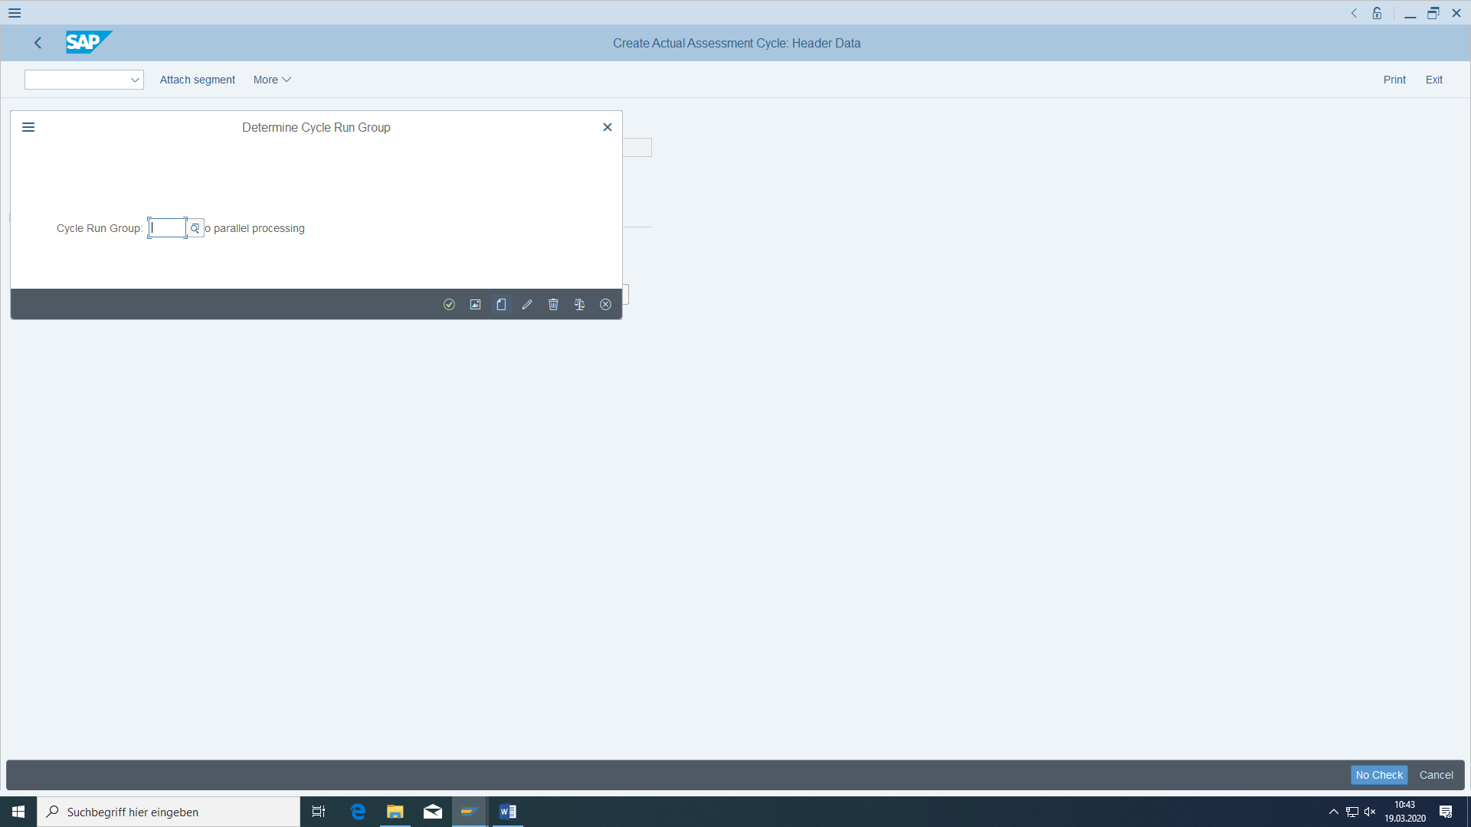

Create GROUP ###

Append segment SEGM-### "Recirculation development xxx" with assessment cost element "Assessment KS-KA-103" with 100% of the posted actual amounts and fixed percentage rates for the receivers.

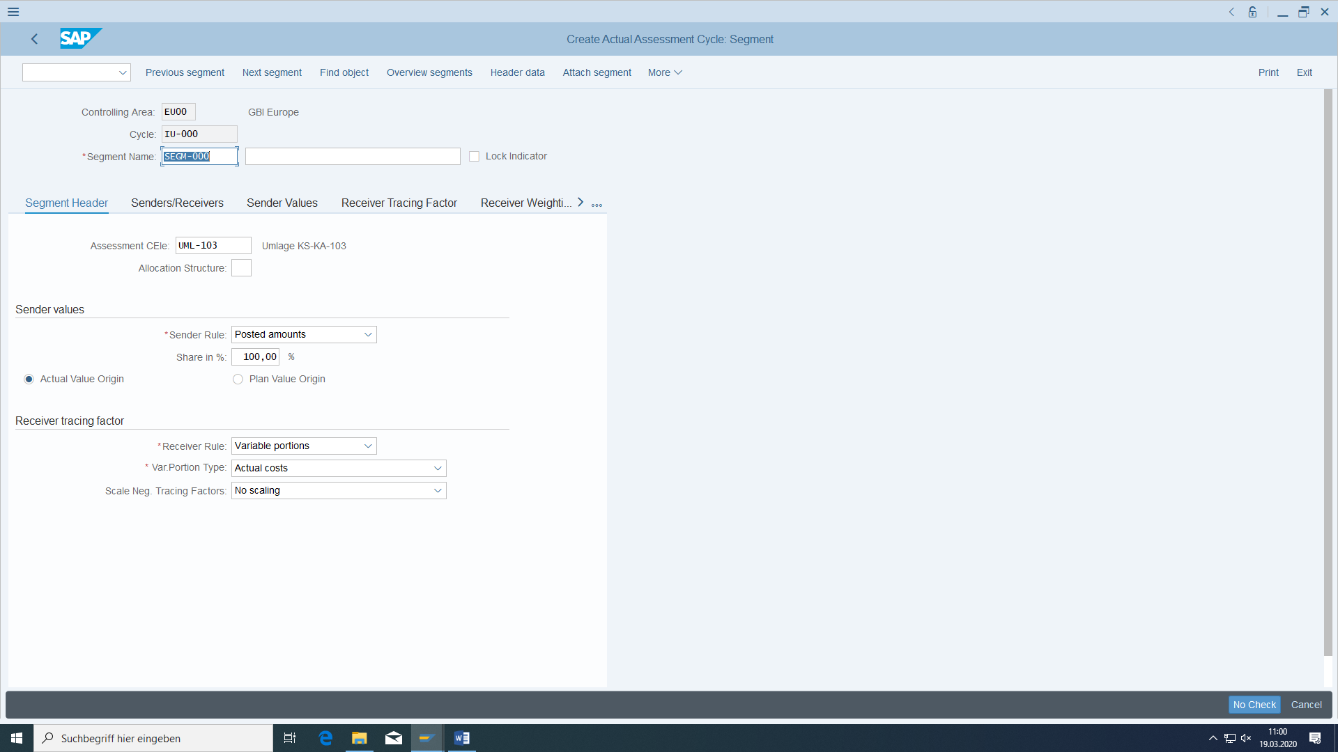

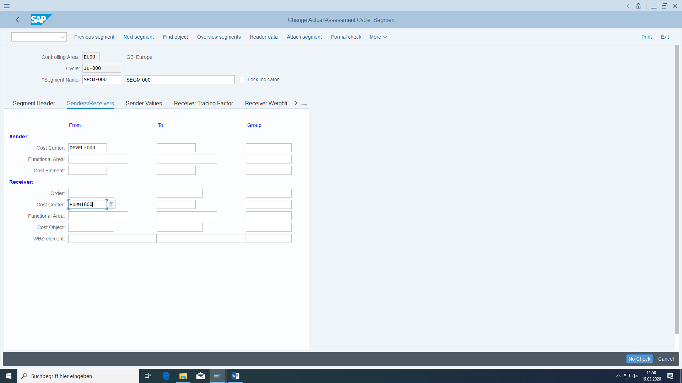

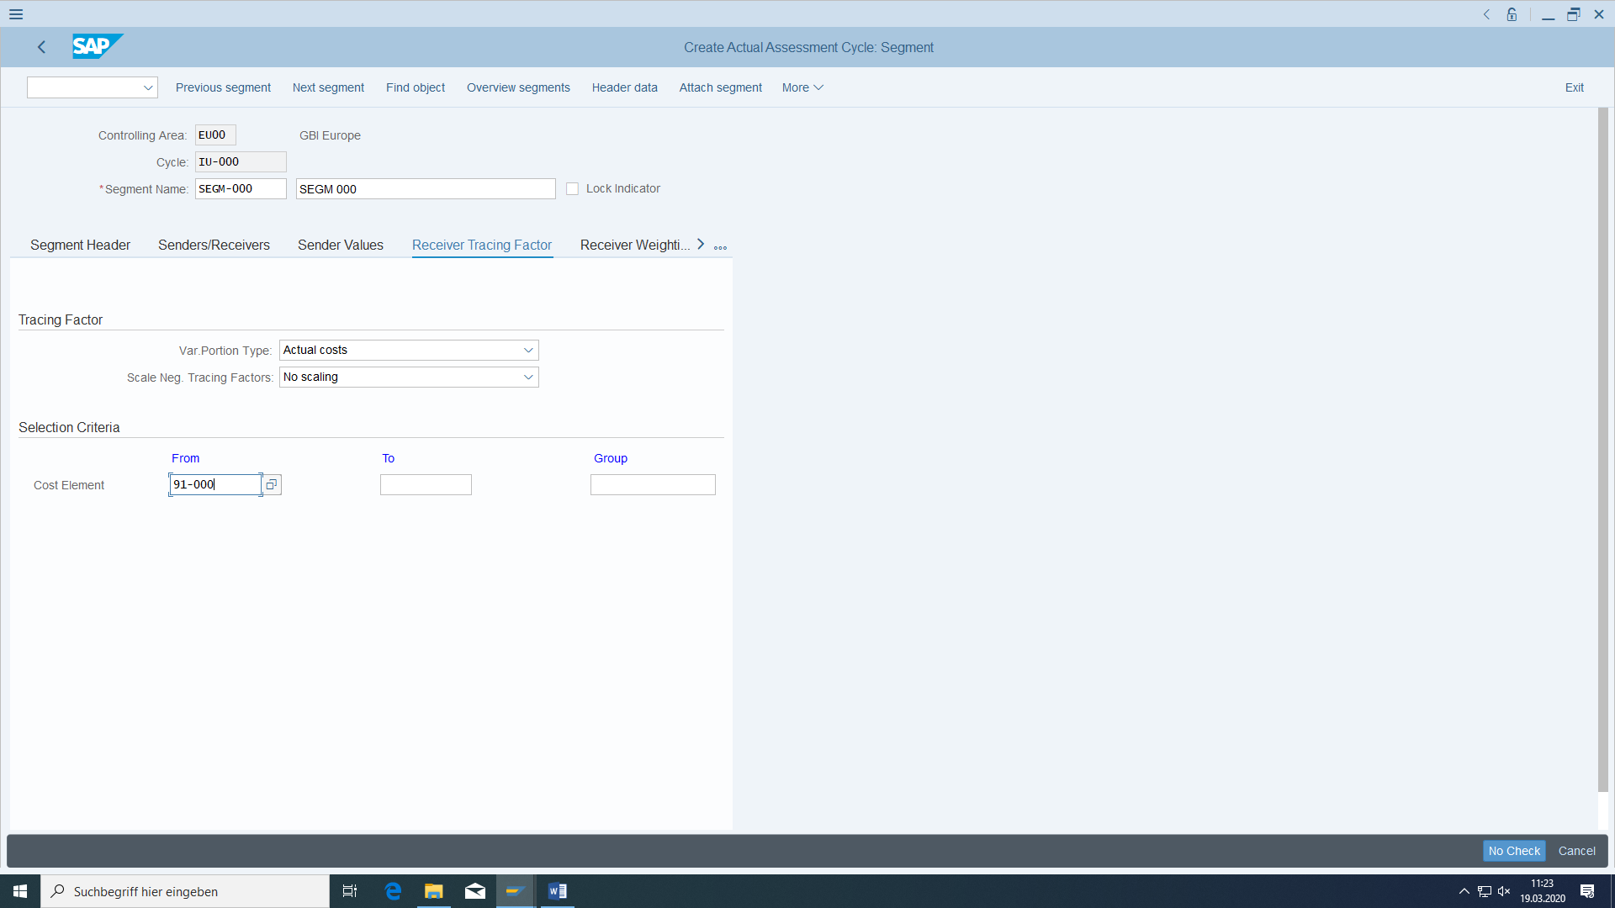

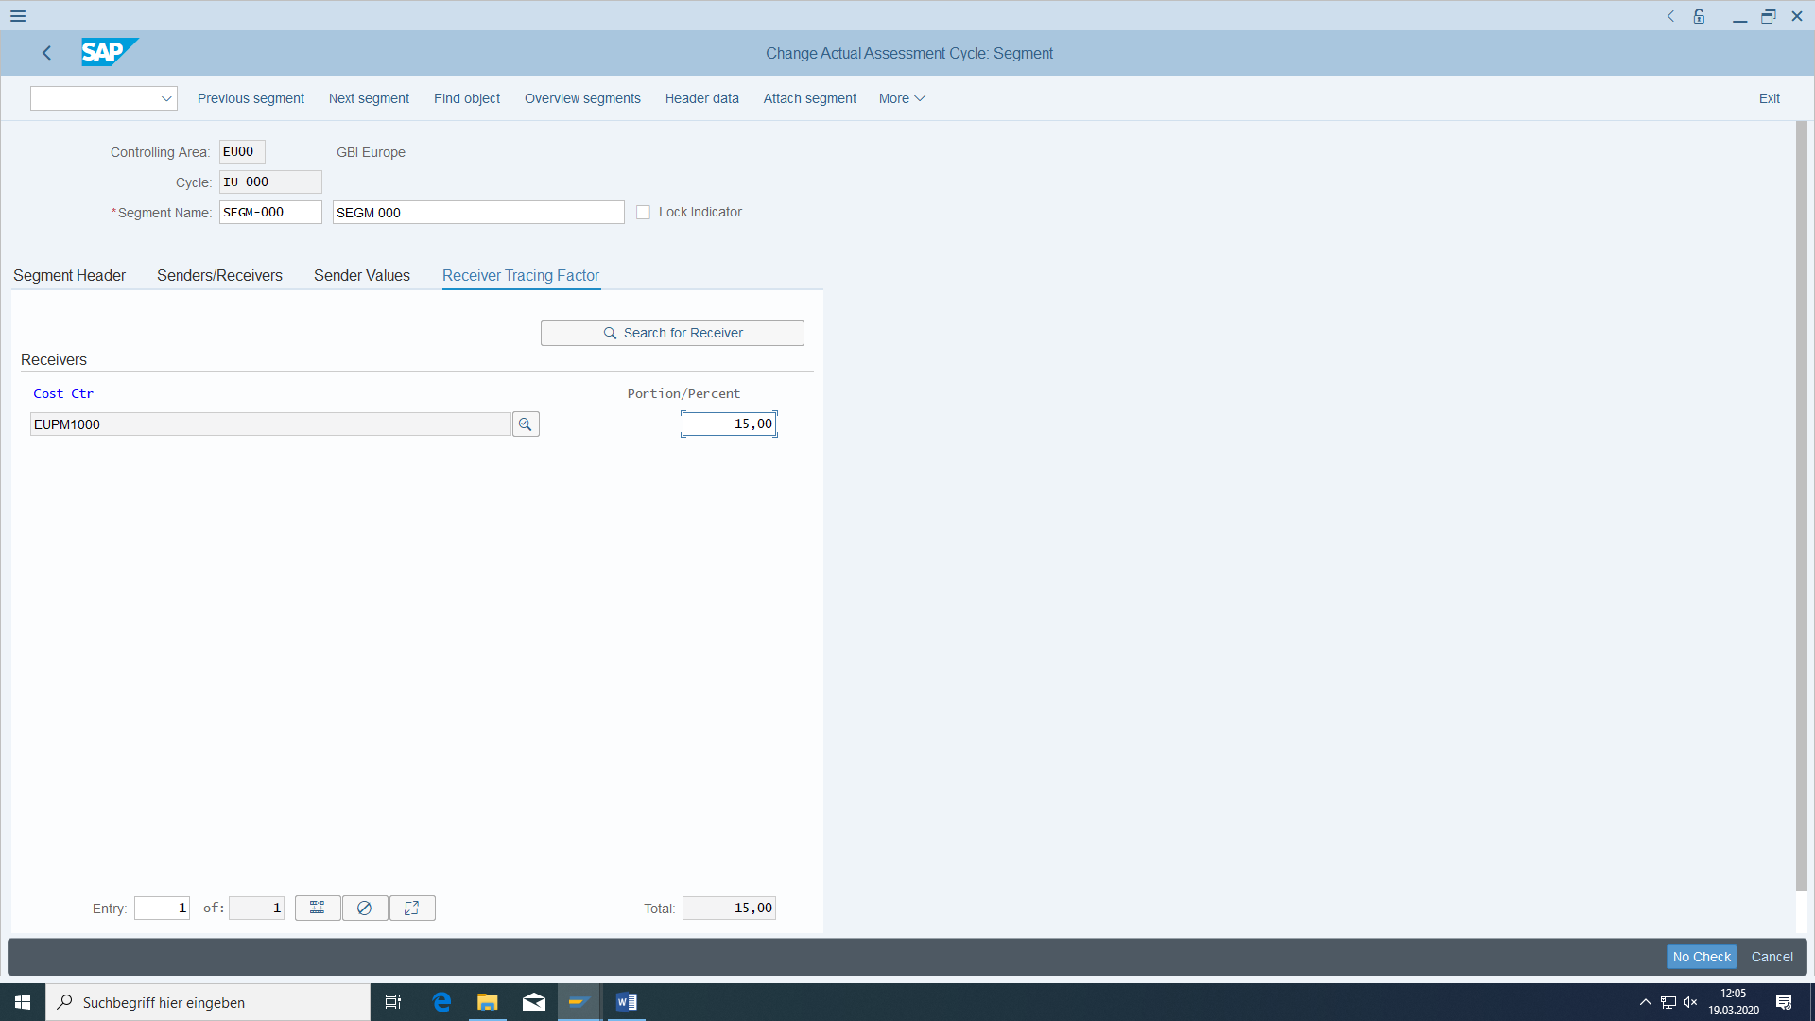

The cost center EUPM1000 should receive 15%, the cost center EURP1000 85% of the development work.

Second segment for cost center EURP1000 that also is a receiver.

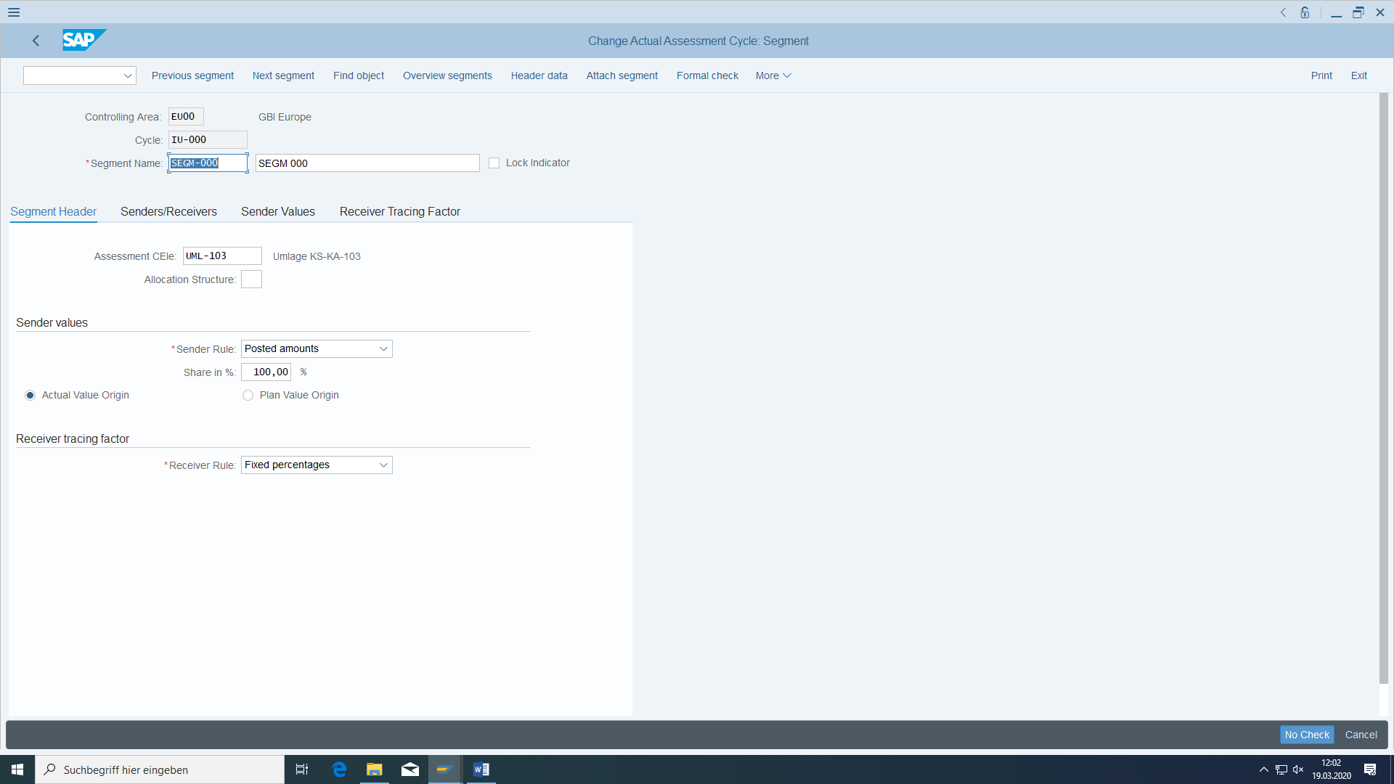

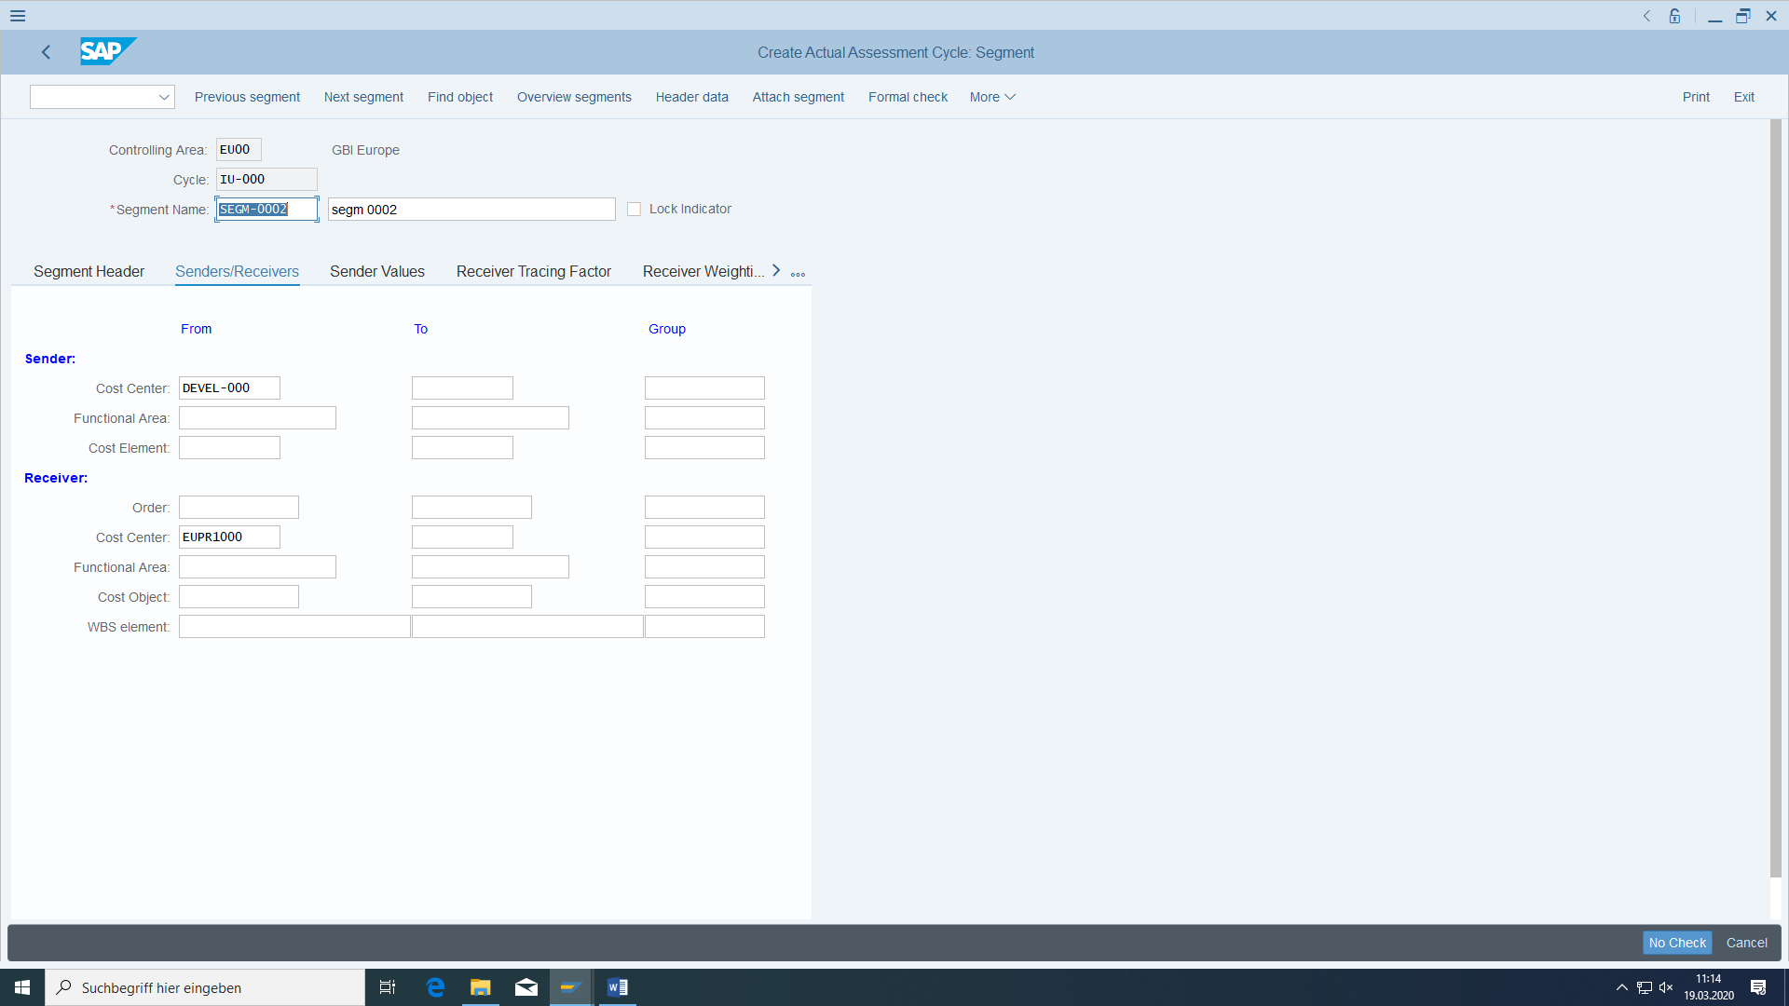

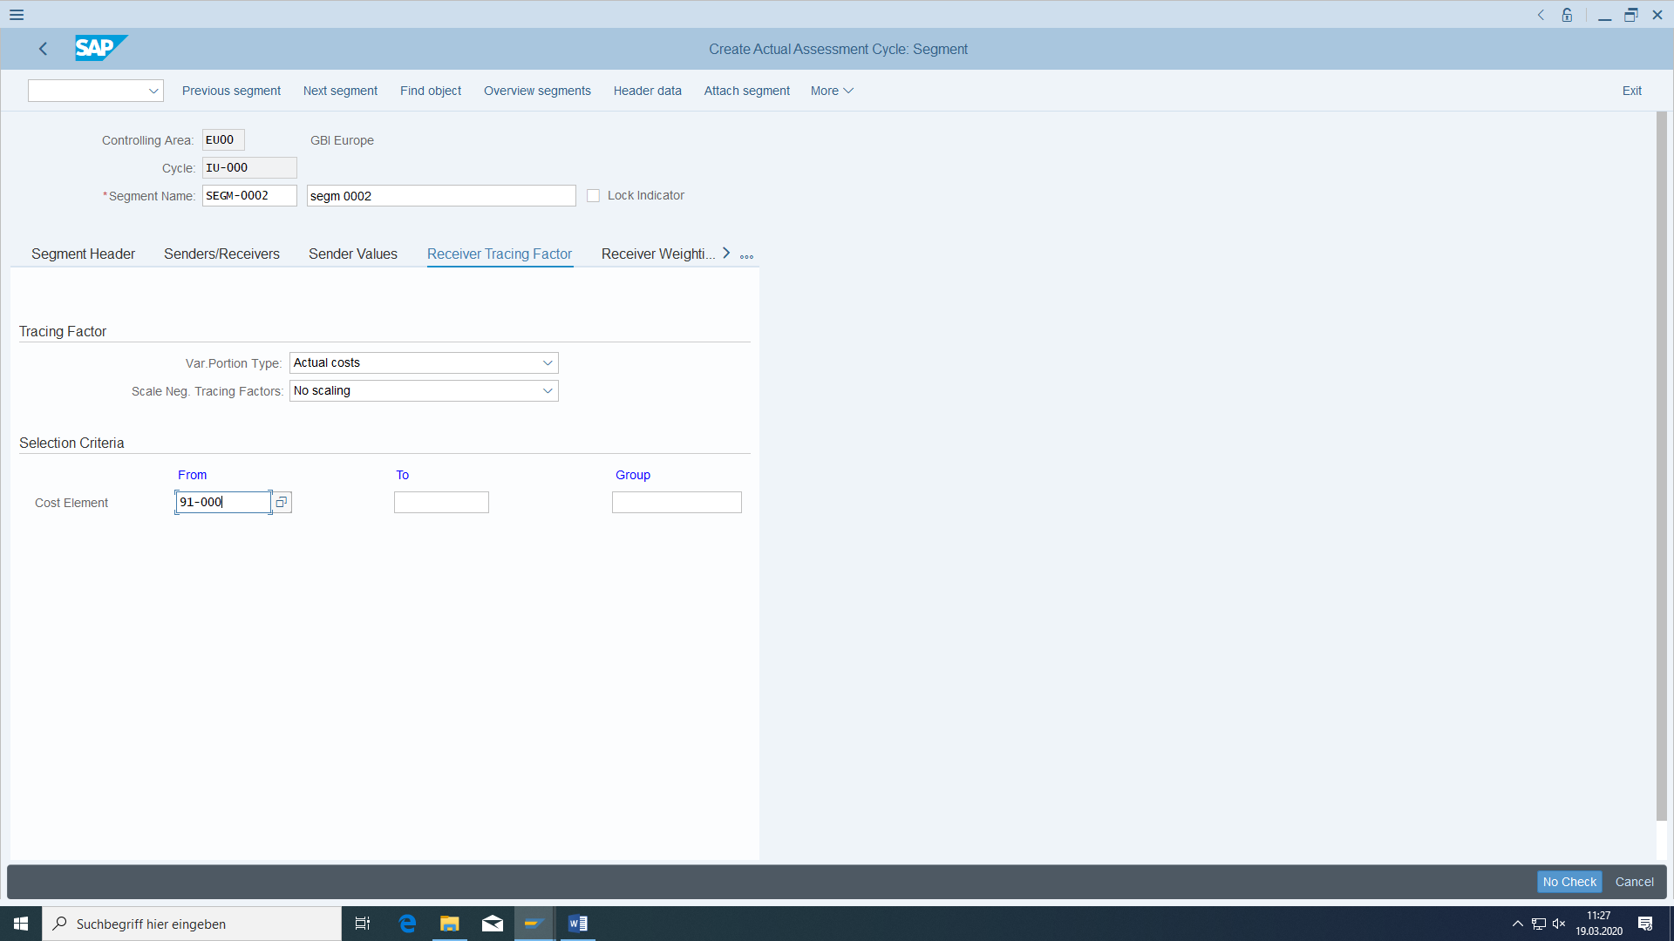

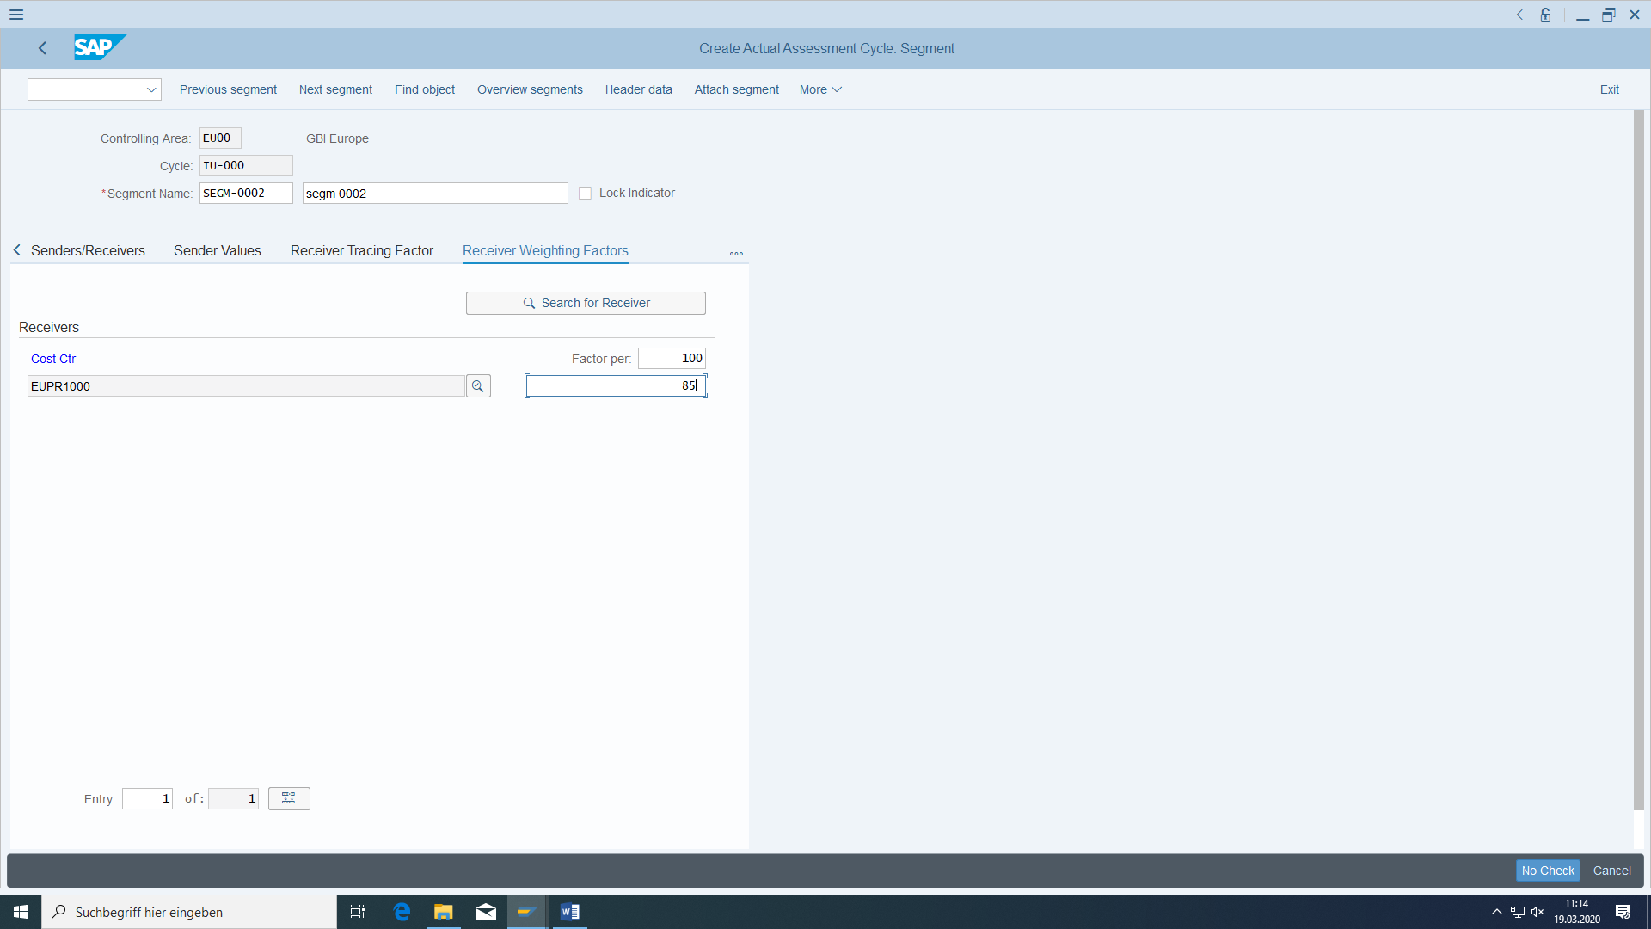

Check the segment header for correctness (Formal check):

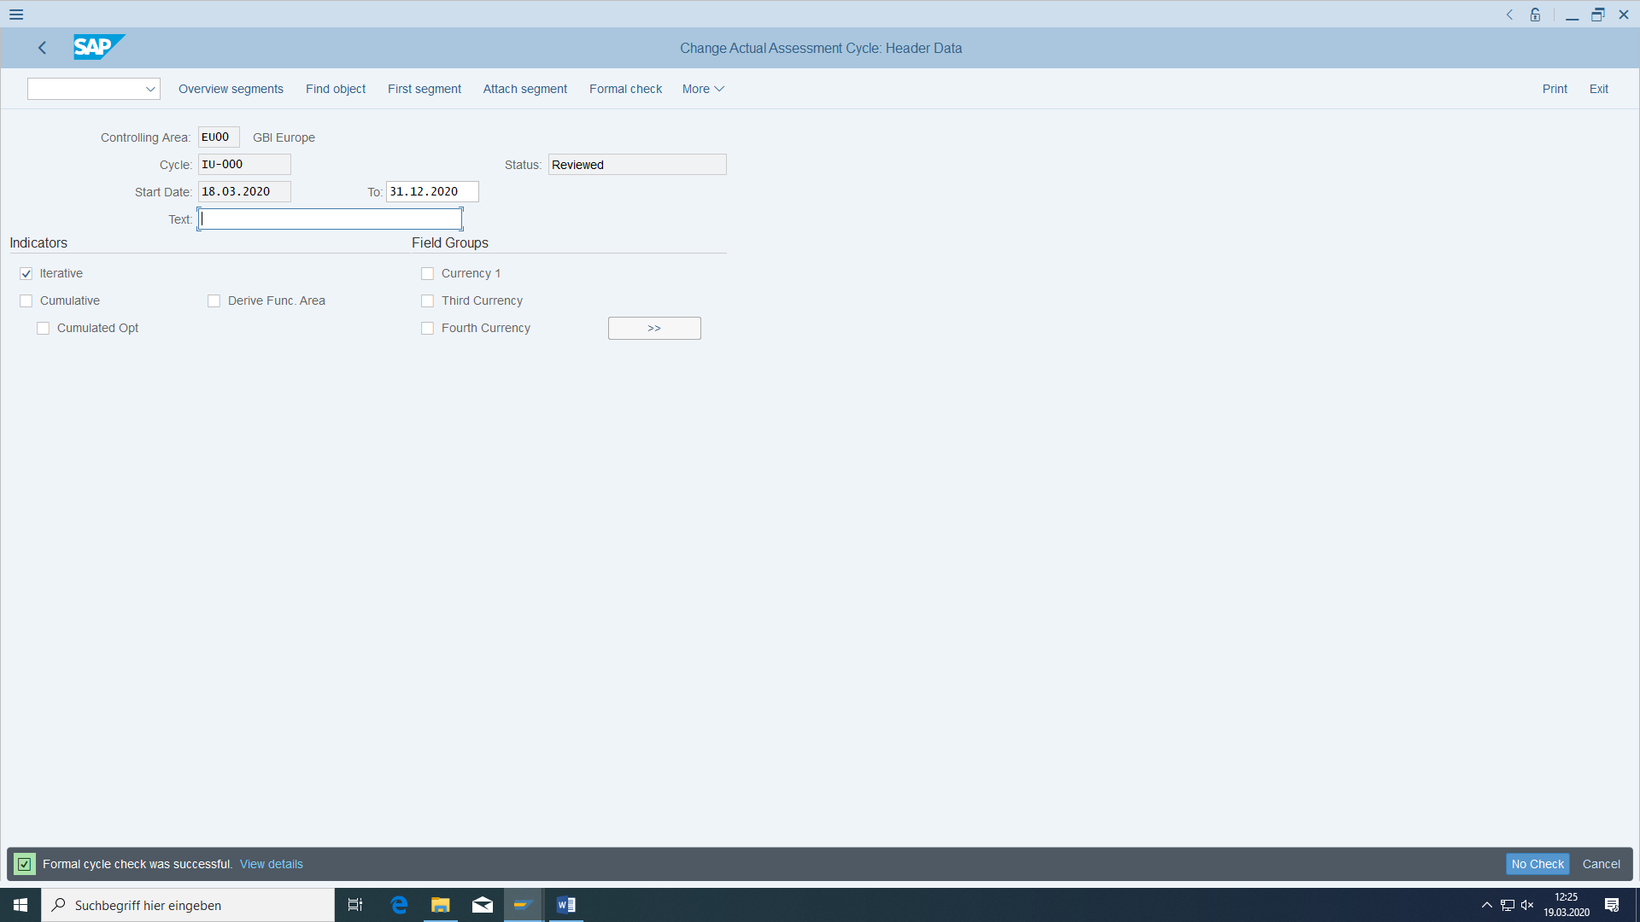

##### Perform actual adjustment

Go back to the first screen and first carry out a test run for the current period and with detail lists.

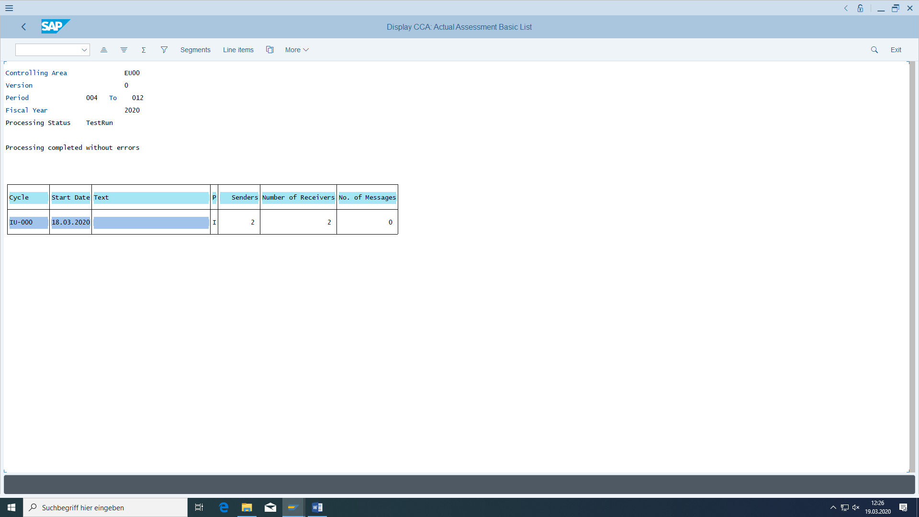

After double click:

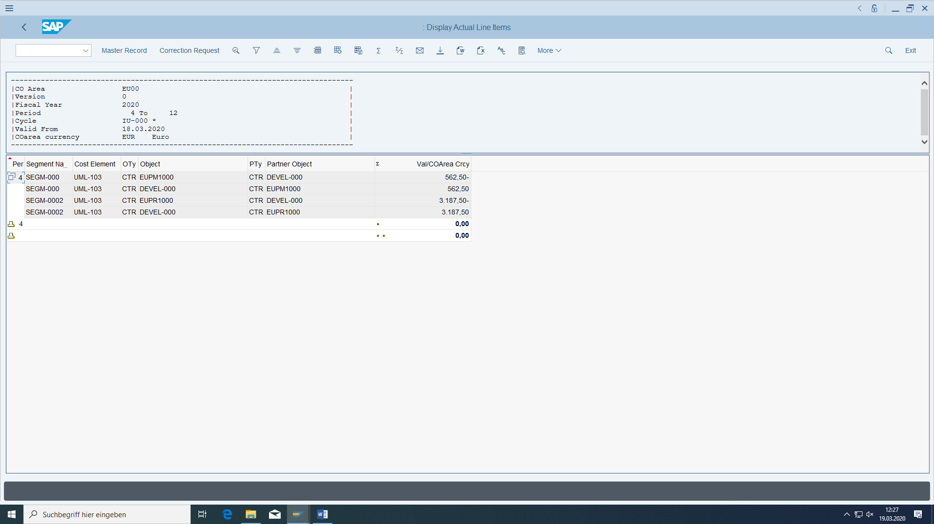

Look for the results in cost center E4200:

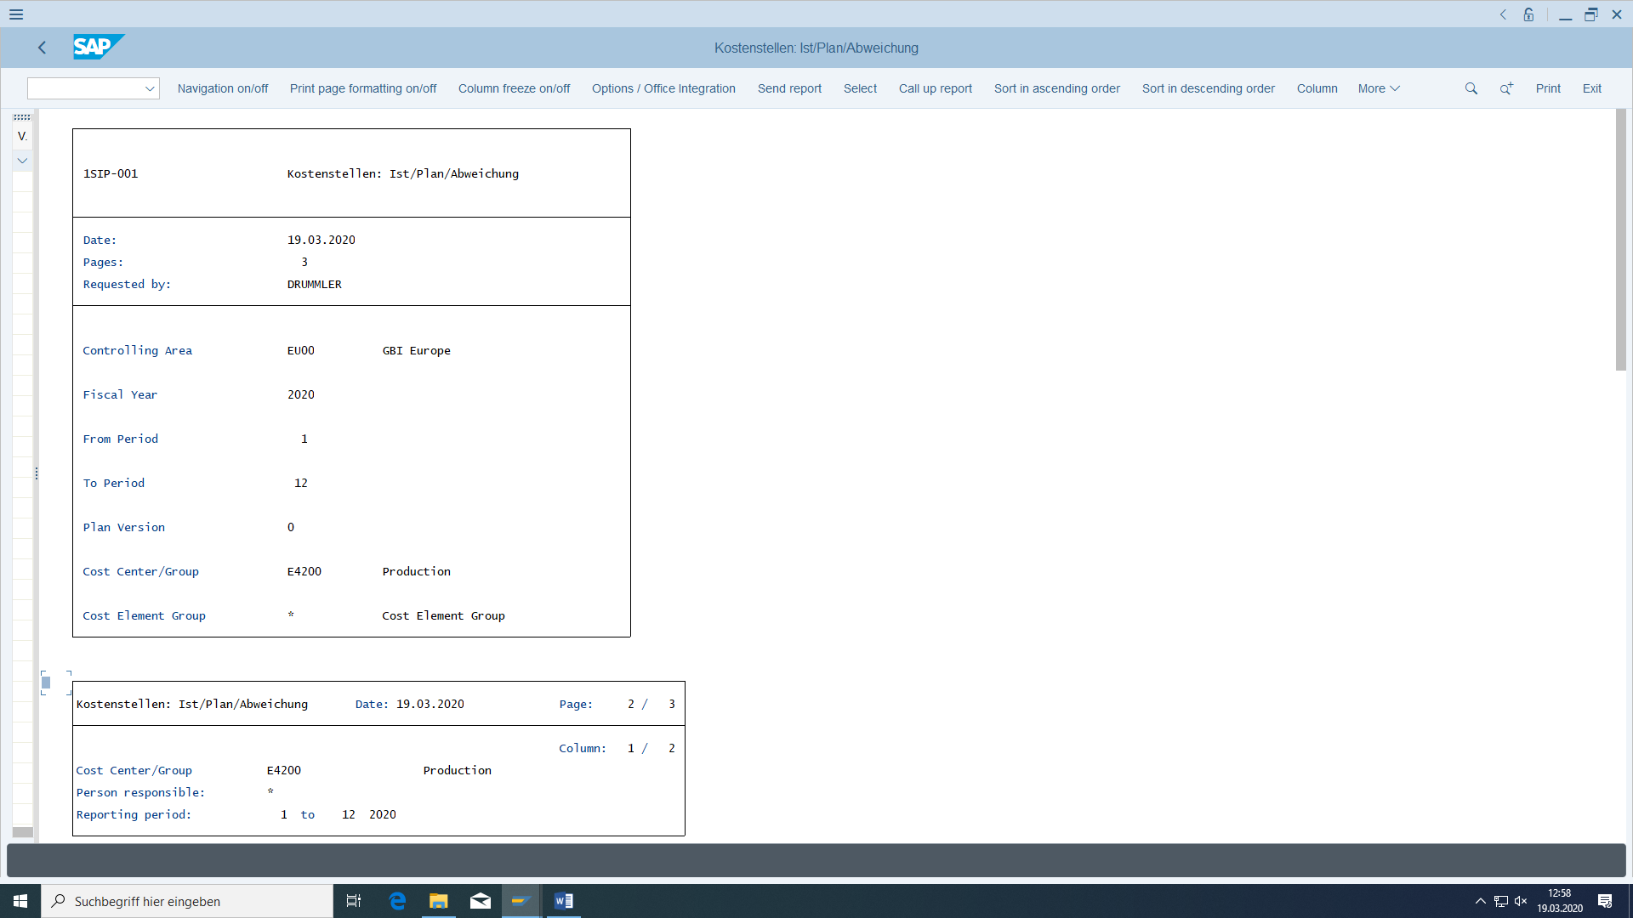

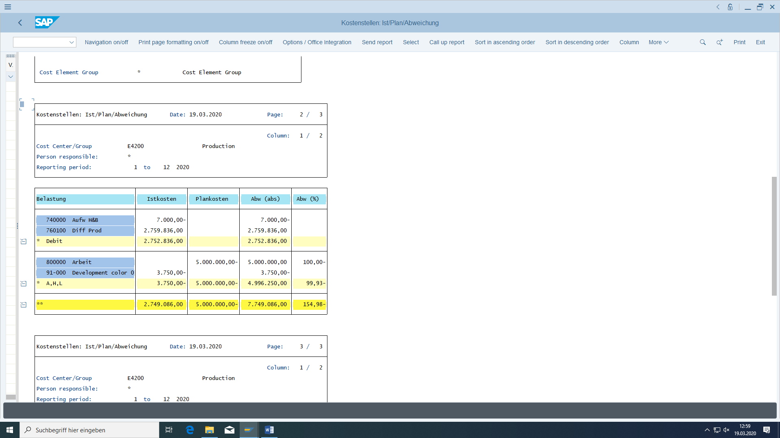

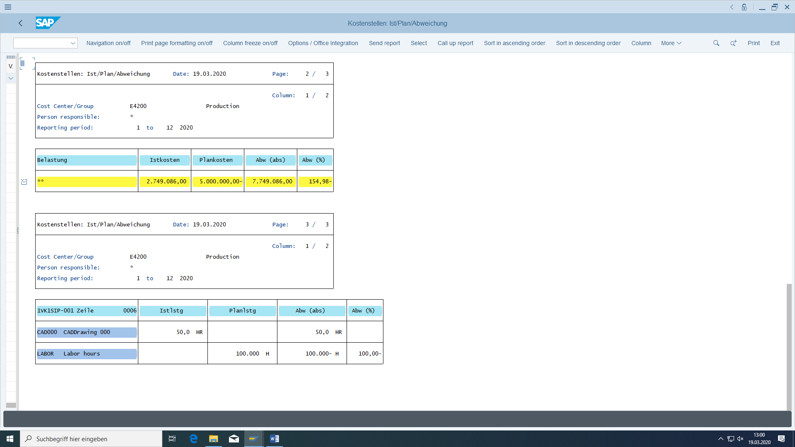

# Control Questions

Should we allow negative stock amounts?

How should customer orders reduce sales forecast?

Is it useful to control the availability of stock when entering a customer order?

Should we consider the stock amount or the available stock amount at outbound delivery of a material?

When will be the components stock amount reduced at retrograde material removal?

Should we test the stock availability the moment we want to create a production order?

Is it possible to see an outbound delivery in the MD04?